Social Media App

# Create a new project and connect to Firebase

* Create a new Project, name this app as Social Network
* 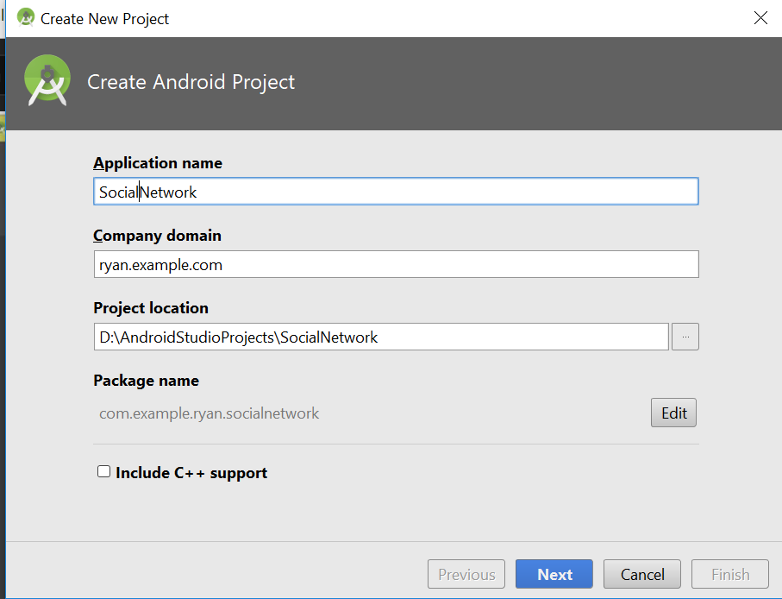
* Select Android 5.0 Nougat
* 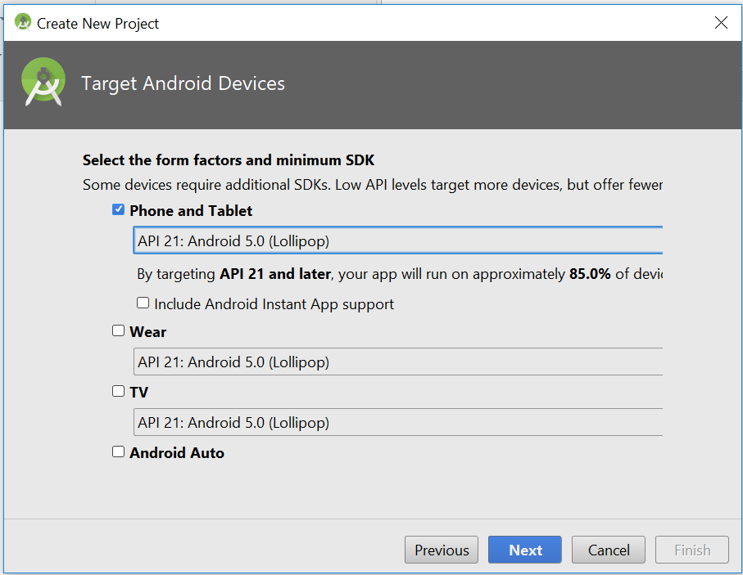
* Click on Empty activity then click next
* Error appear
* Error:Execution failed for task ':app:preDebugAndroidTestBuild'.
* > Conflict with dependency 'com.android.support:support-annotations' in project ':app'. Resolved versions for app (26.1.0) and test app (27.1.1) differ. See https://d.android.com/r/tools/test-apk-dependency-conflicts.html for details.
* Add this line in the gradle
* 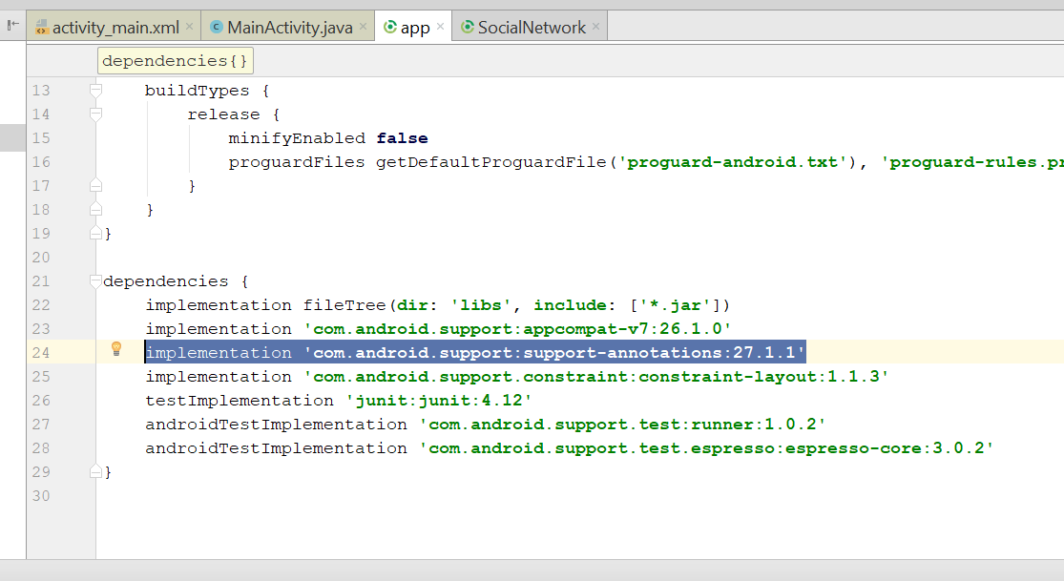
* Make sure you are sign in
* 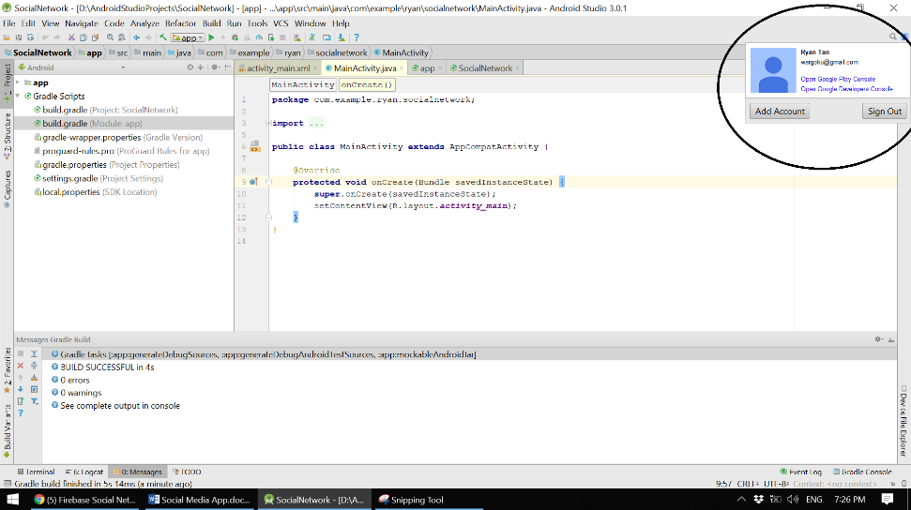
* Click on tools > Firebase
* You will see this
* 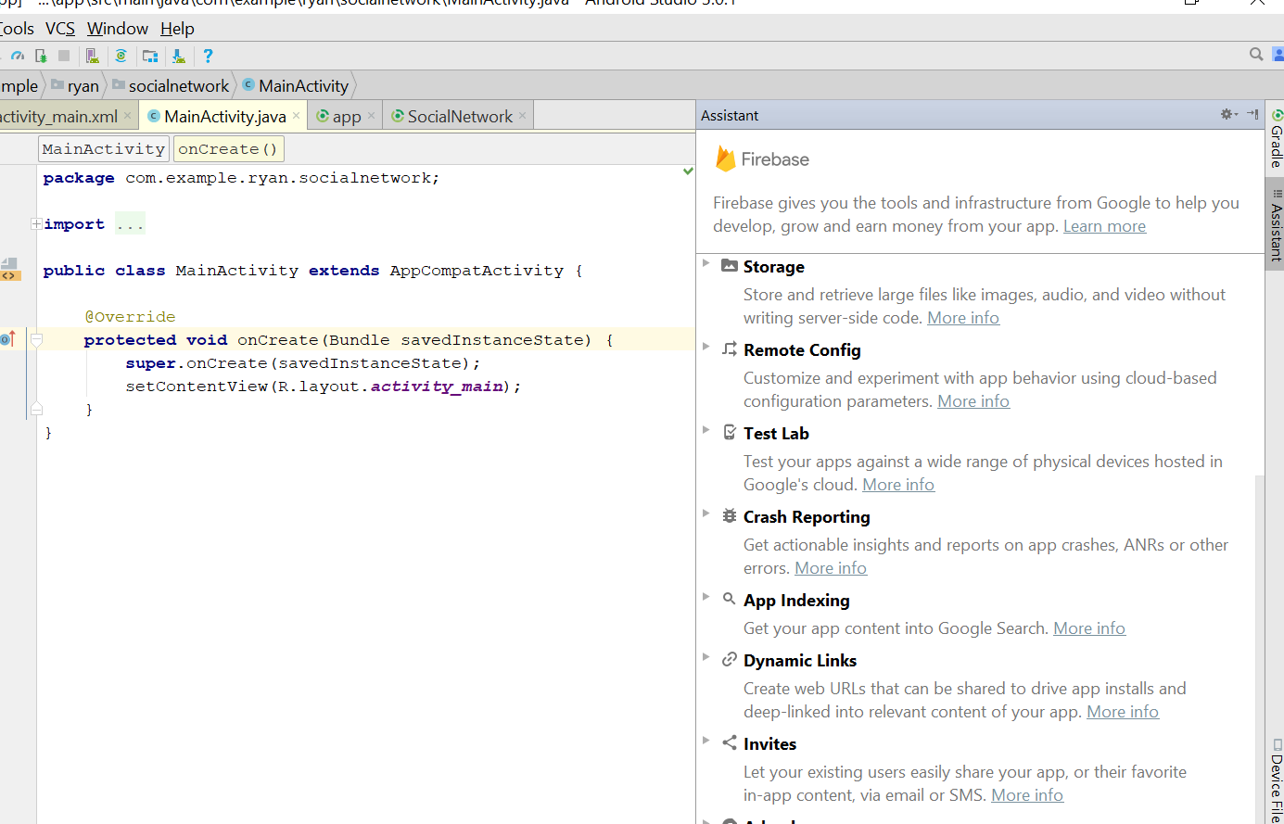
* Click on Email Authentication
* 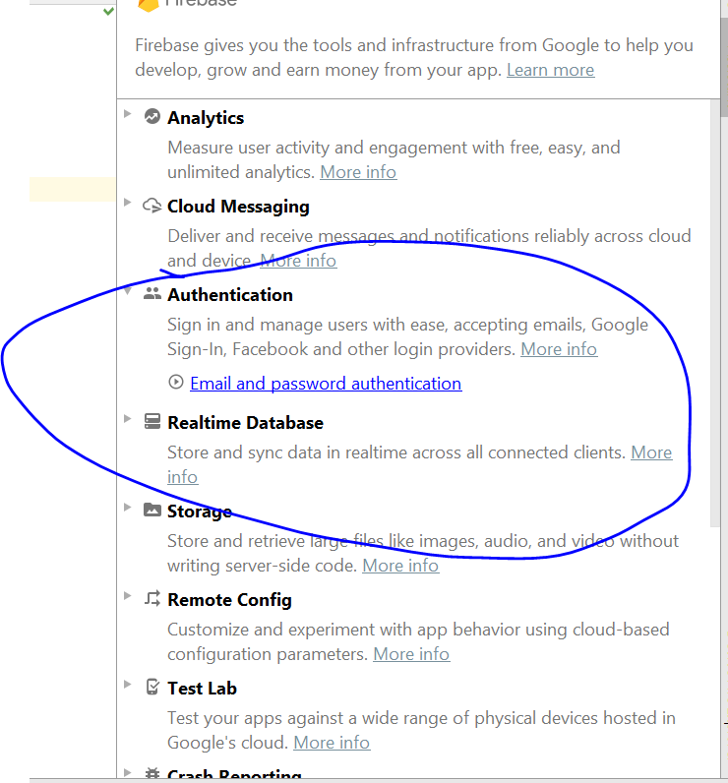
* Click on connect to Database
* 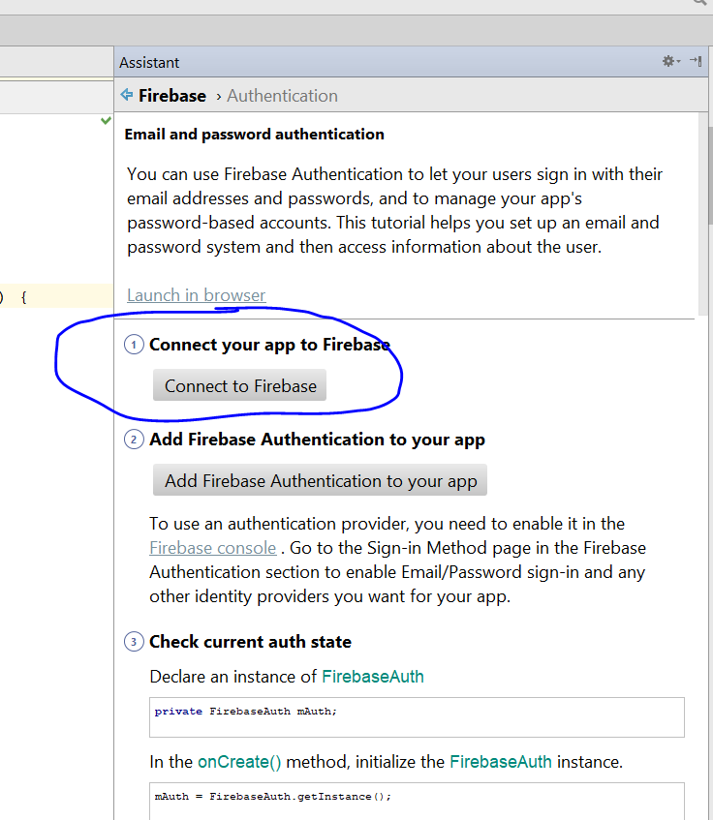
* Give it a name, call it poster
* 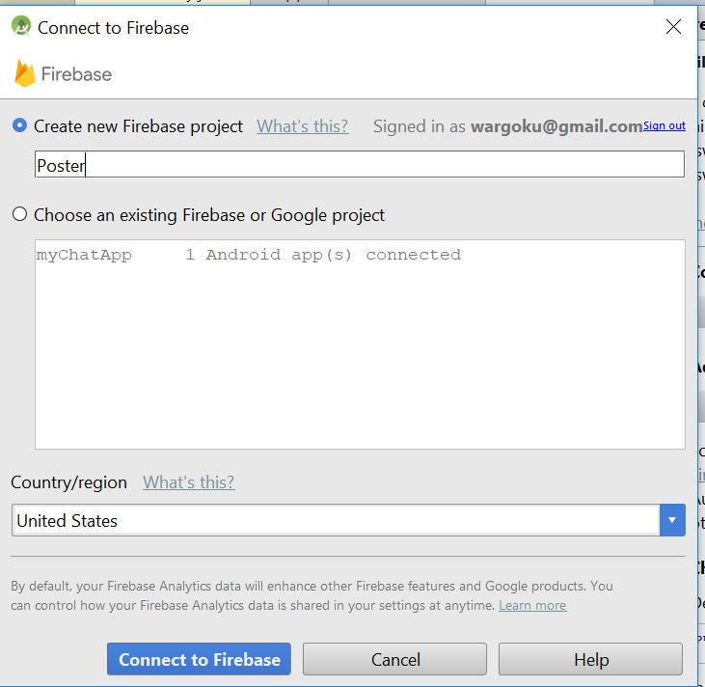
* Click on this
* 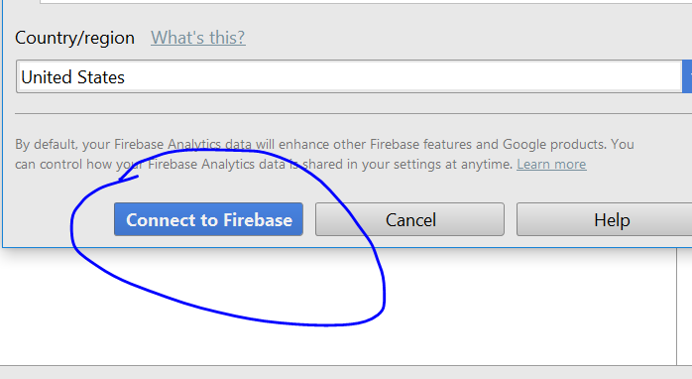
* This connect sign appear, mean it is connected
* 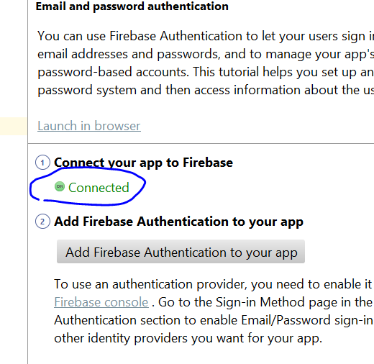
* Now click on, “Add Firebase Authentication to your app”
* Click on Accept changes
* 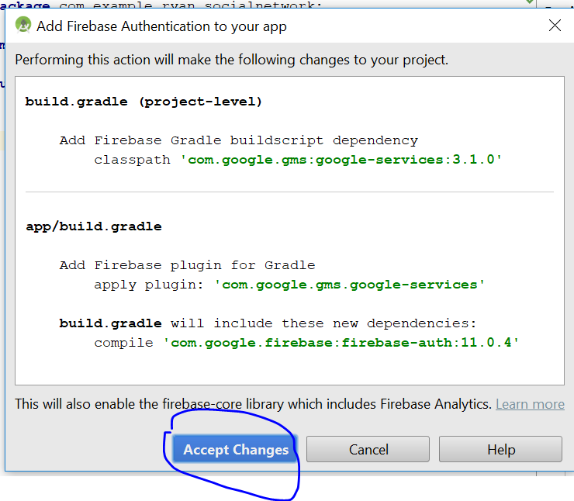
* Now everything is alright
* 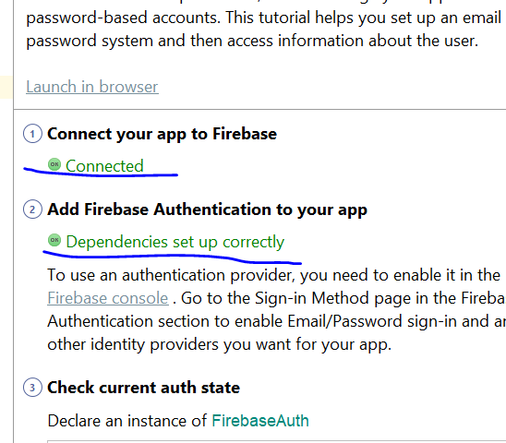
* Click on back, then go real time database, then click “Save and retrieve Data”
* Click on Add realtime database to your app
* 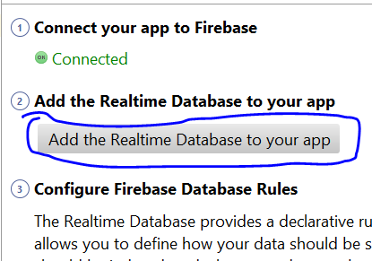
* Accept changes then u wait a while
* Now go to storage, > add cloud storage to your app
* 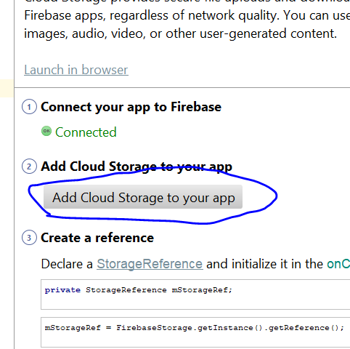
* Accept change and wait a while
* Now, go the firebase website and verify it is connect to the firebase
* You should see this
* 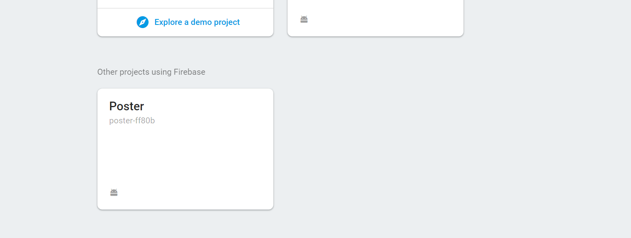
* That is all

# Create a navigation drawer

* Go to Activity_main.xml
* You should see this
* 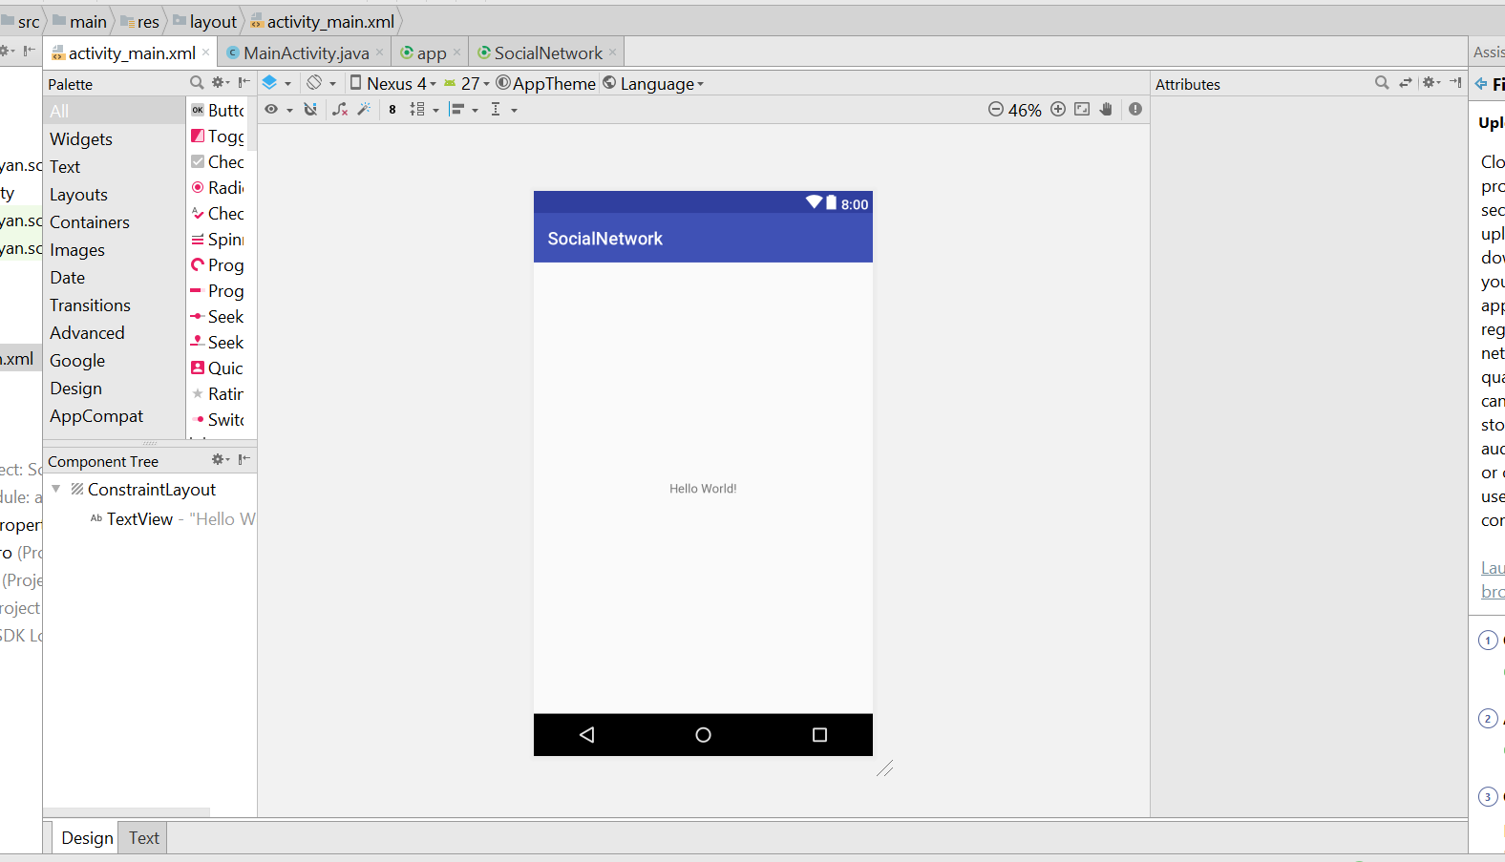
* Now change the layout to Relative Layout
* Remove the text, then save
* Now go to style
* 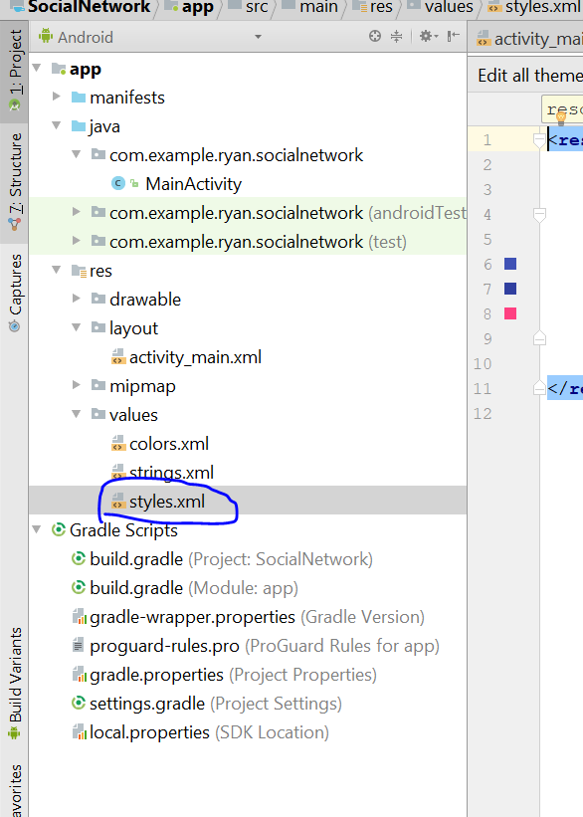
* Change this to no ActionBar
* 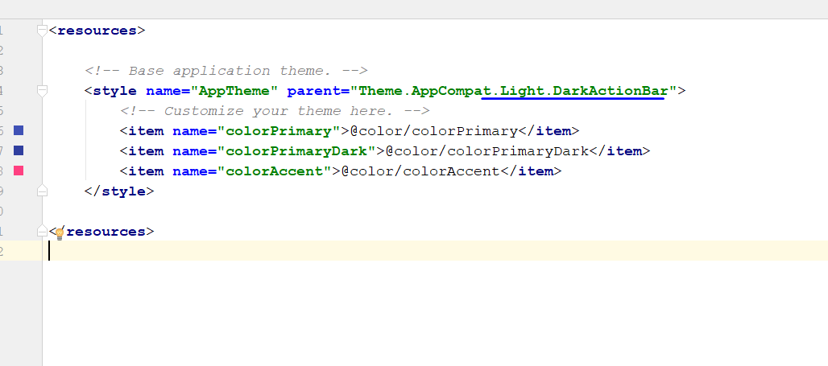
* Now go to colour> change the colour primary to #ed4c54
* Change Primary dark colour to #67c415
* Then change the colour accent to #E9EBEE
* It shld look like this
* 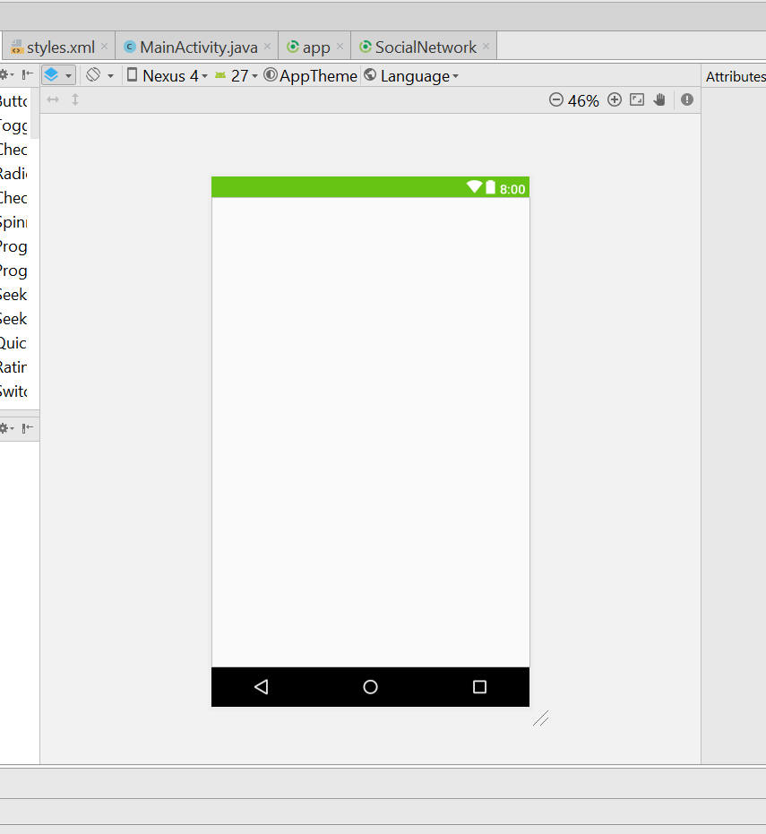
* Go to the gradle
* Add this line onto the App.gradle
* implementation 'com.android.support:design:26.+'
* then sync
* 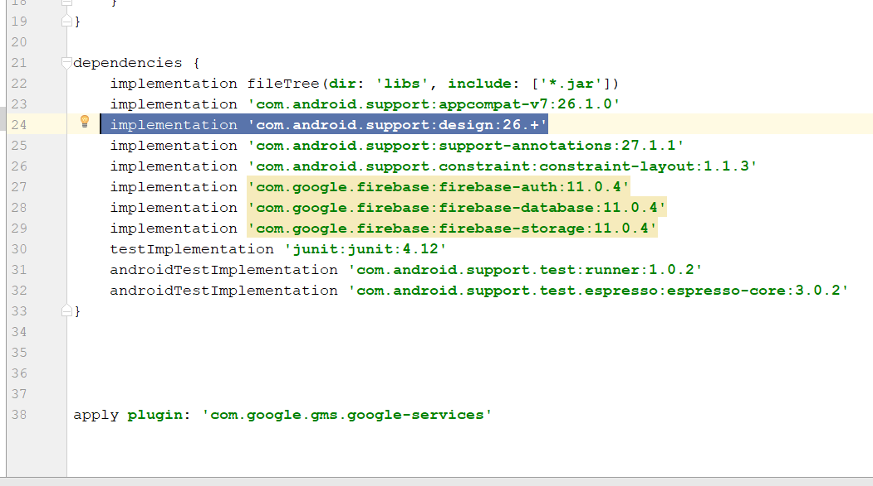
* Now go the activity_main.xml, change the layout from relative layout to drawer layout
* 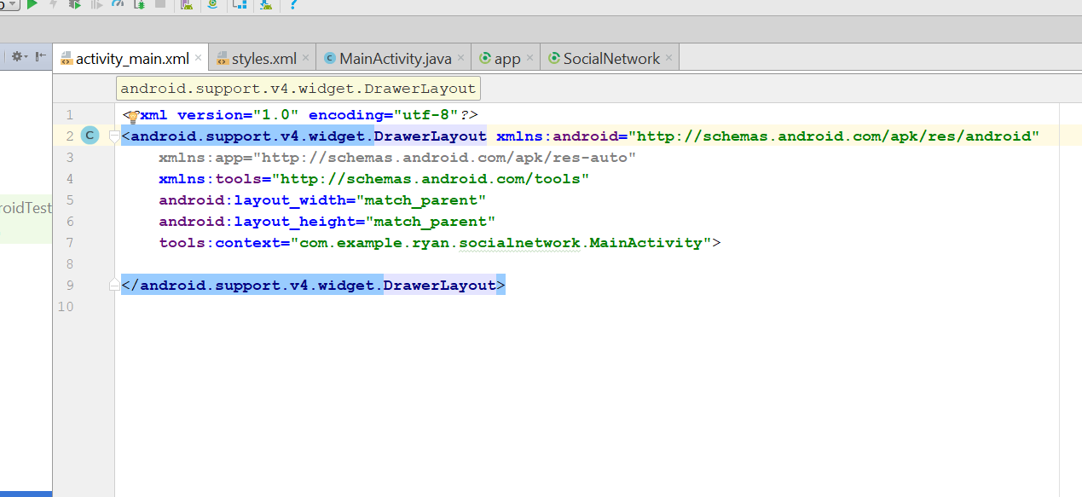
* Add a Relative layout inside
* 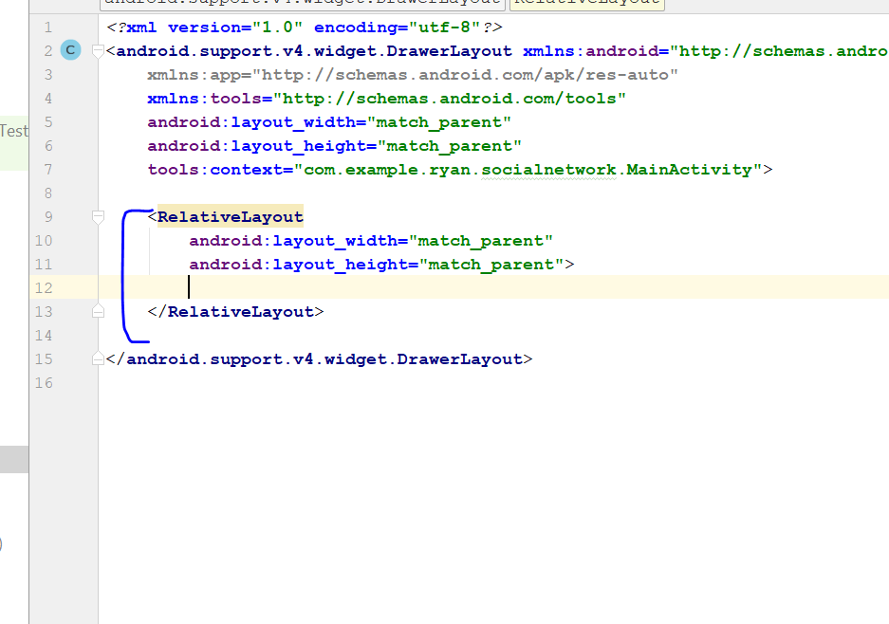
* Now drag and drop a frame layout
* 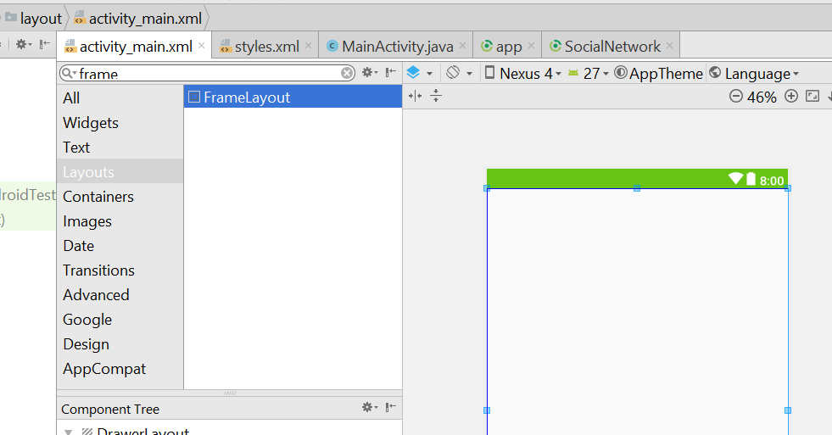
* Give it a id, main_container
* Now drag and drop a recycle_view in the Framelayout
* For now, it should at least look like this
* 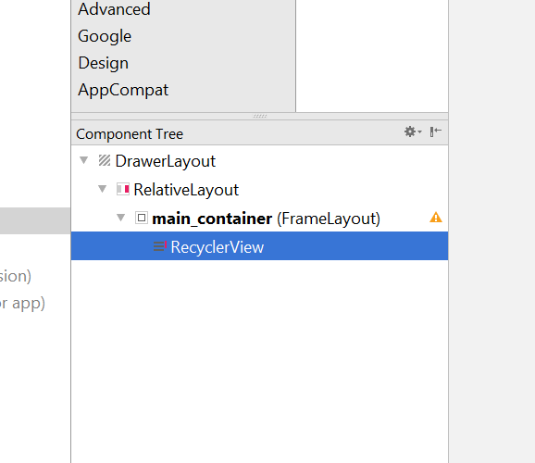
* We give it a name – **all_user_post_list** for the RecyclerView
* 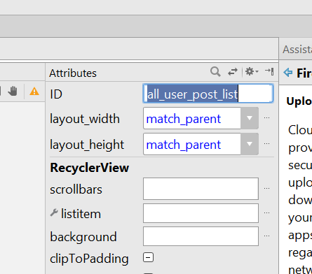
* Now add a Navigation View
* This is the code
* <android.support.design.widget.NavigationView  
   android:layout_width="wrap_content"  
   android:layout_height="match_parent"  
   android:layout_gravity="start"  
   android:layout_marginBottom="3dp">  
    
    
  </android.support.design.widget.NavigationView>
* Add in to the activity_main.xml
* 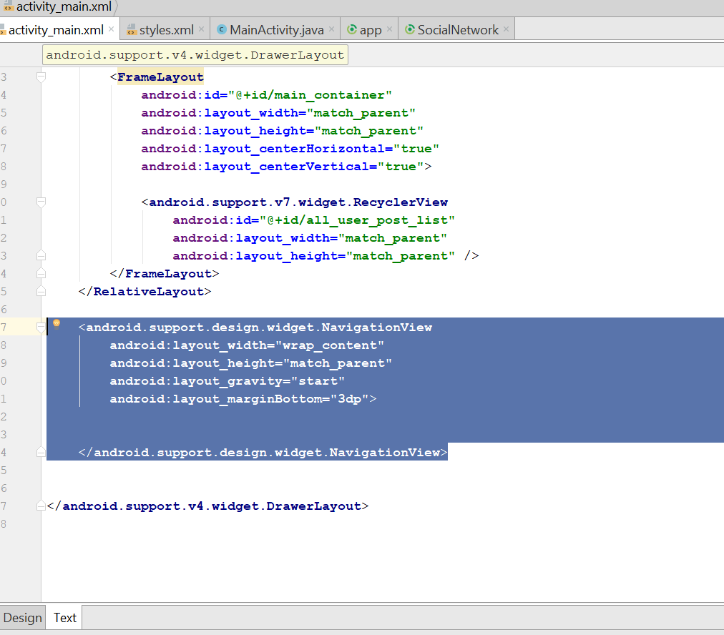
* Go res> right click> new> Android Resource Directory
* You will see this
* 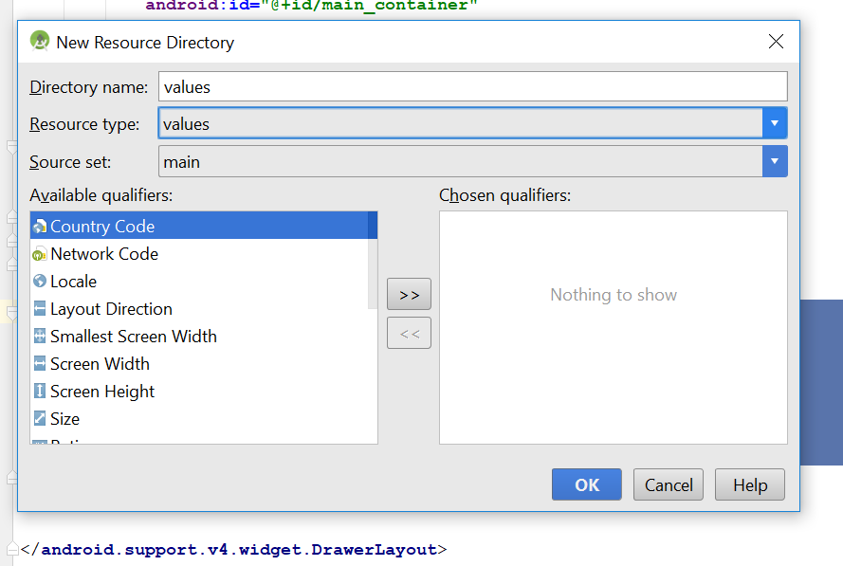
* Name it as menu, click ok
* You should see this here
* 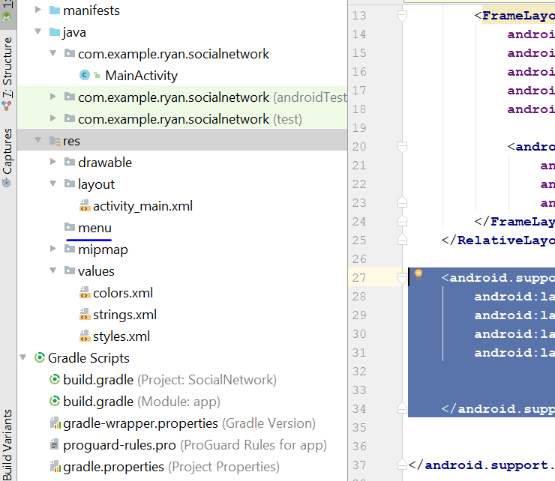
* Right click on menu > click new > menu resource file
* Name it as navigation_menu
* 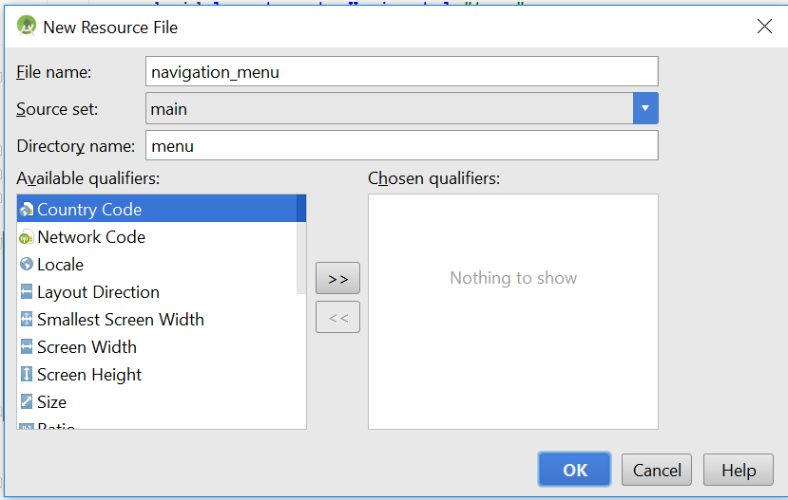
* You should see this
* 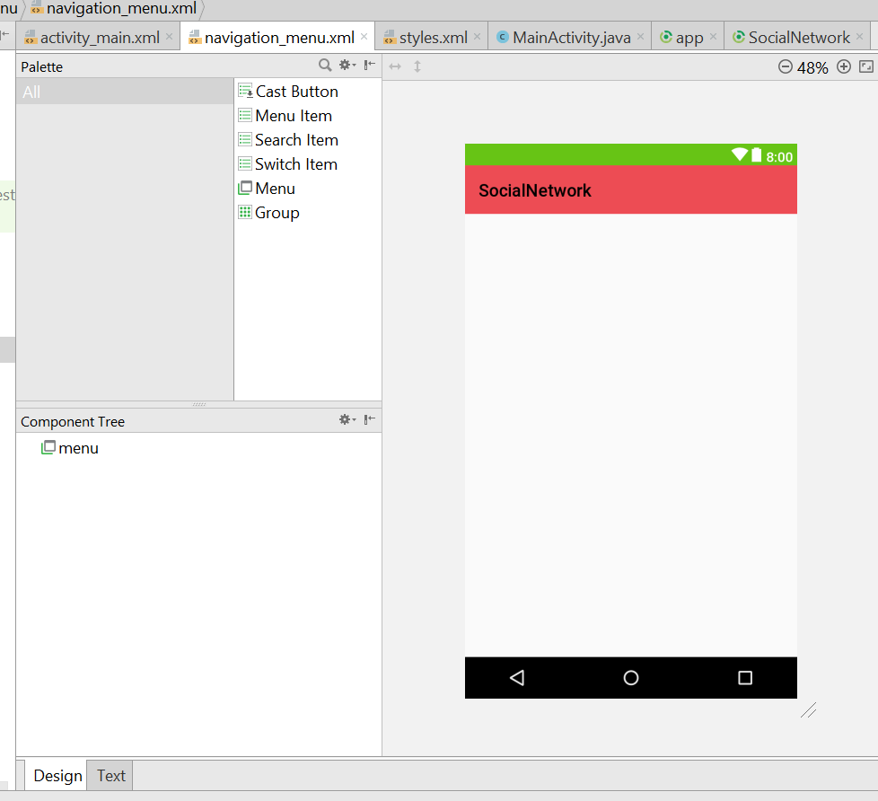
* Click this
* 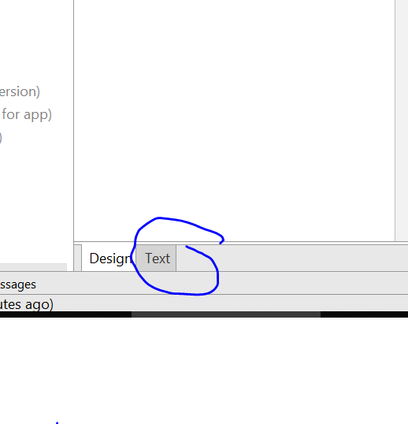
* The code is like that
* <item android:id="@+id/nav_home"  
   android:title="Home"/>  
   <item android:id="@+id/nav_friends"  
   android:title="Friends"/>  
   <item android:id="@+id/nav_find_friends"  
   android:title="Find Friends"/>  
   <item android:id="@+id/nav_messages"  
   android:title="Messages"/>  
   <item android:id="@+id/nav_settings"  
   android:title="Settings"/>  
   <item android:id="@+id/nav_logout"  
   android:title="Logout"/>
* 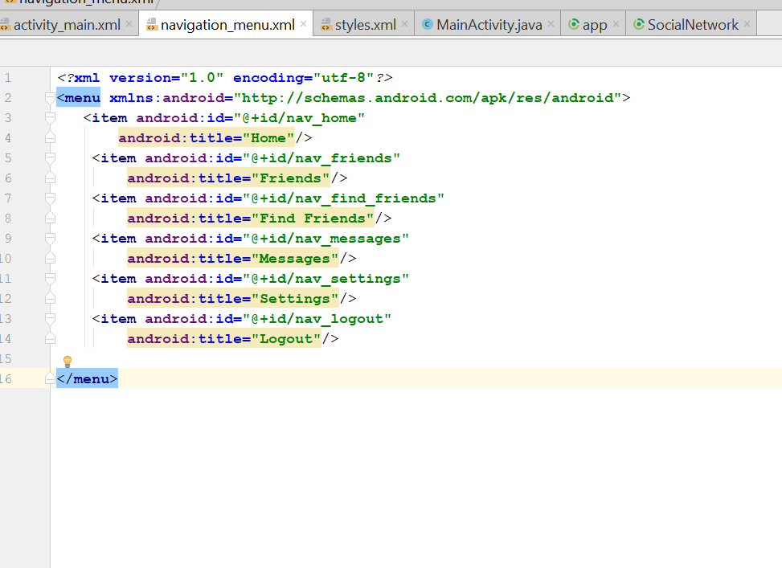
* It should look like that
* 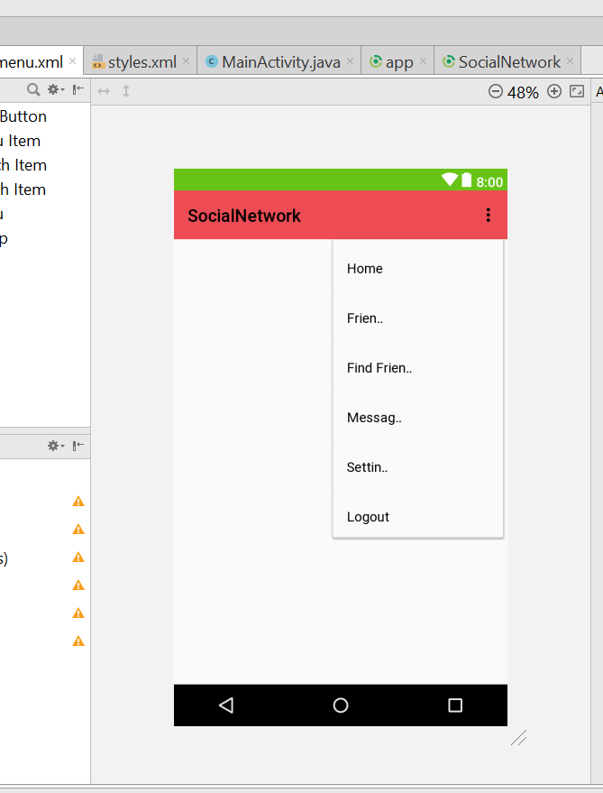
* Add this to the activity_main.xml
* <android.support.design.widget.NavigationView  
   android:layout_width="wrap_content"  
   android:layout_height="match_parent"  
   android:layout_gravity="start"  
   android:layout_marginBottom="3dp"  
   app:menu="@menu/navigation_menu"  
   >
* The new code for NavigationView
* Rebuild and run

# Navigation header

* Download social media icon first, click on the link on the youtube
* Paste all the icon in the drawable folder
* 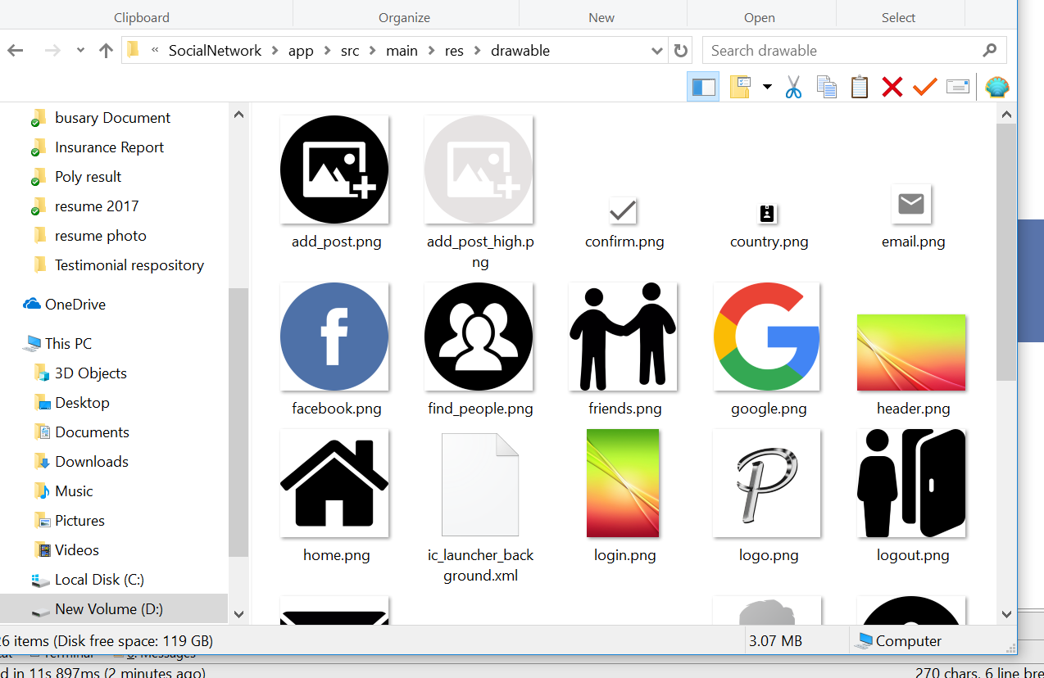
* Continue from the navigation_menu.xml
* This will be the new code of the navigation_menu.xml
* *<?*xml version="1.0" encoding="utf-8"*?>*<menu xmlns:android="http://schemas.android.com/apk/res/android">  
   <item android:id="@+id/nav_post"  
   android:title="Add New Post"  
   android:icon="@drawable/add_post"/>  
   <item android:id="@+id/nav_profile"  
   android:title="Profile"  
   android:icon="@drawable/profile_icon"/>  
   <item android:id="@+id/nav_home"  
   android:title="Home"  
   android:icon="@drawable/home"  
   />  
   <item android:id="@+id/nav_friends"  
   android:title="Friends"  
   android:icon="@drawable/friends"  
   />  
   <item android:id="@+id/nav_find_friends"  
   android:title="Find Friends"  
   android:icon="@drawable/find_people"  
   />  
   <item android:id="@+id/nav_messages"  
   android:title="Messages"  
   android:icon="@drawable/messages"  
   />  
   <item android:id="@+id/nav_settings"  
   android:title="Settings"  
   android:icon="@drawable/settings"  
    
   />  
   <item android:id="@+id/nav_logout"  
   android:title="Logout"  
   android:icon="@drawable/logout"  
    
   />  
    
  </menu>
* Rebuild and run ur app, you should see your icon on the header
* Now go to layout, right click > new> layout resource file
* Name as navigation_header.xml
* 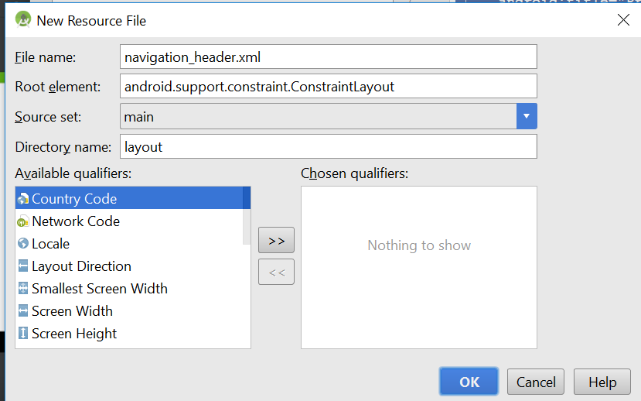
* Click okay
* Change the layout to relative_layout
* Write this
* *<?*xml version="1.0" encoding="utf-8"*?>*<RelativeLayout  
   xmlns:android="http://schemas.android.com/apk/res/android"  
   android:layout_width="match_parent"  
   android:layout_height="200dp"  
   android:background="@drawable/header"  
   >  
    
  </RelativeLayout>
* Then go to this link to get the library
* <https://github.com/hdodenhof/CircleImageView>
* Ctrl + C, copy this
* 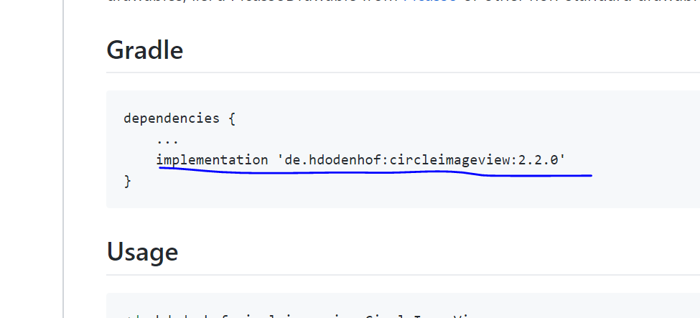
* implementation 'de.hdodenhof:circleimageview:2.2.0'
* go to app.gradle
* then paste it here
* 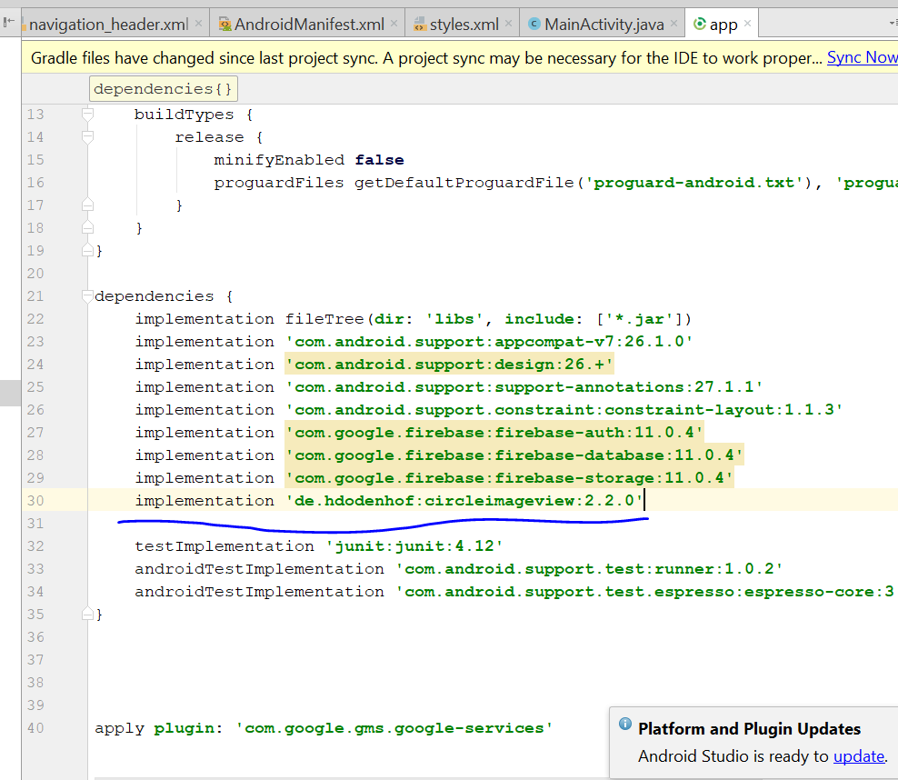
* Then u sync now
* Add this code to the navigation_header.xml
* <de.hdodenhof.circleimageview.CircleImageView  
   android:layout_width="150dp"  
   android:layout_height="150dp"  
   android:src="@drawable/profile"  
   app:civ_border_width="2dp"  
   app:civ_border_color="@color/colorPrimaryDark"/>
* 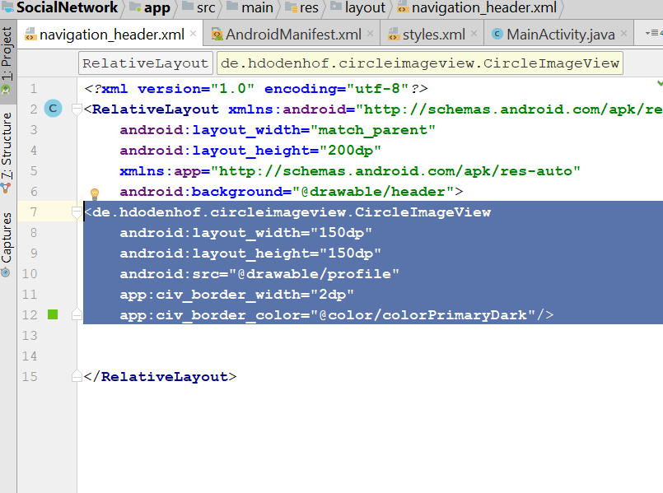
* Now go to design
* You should see this
* 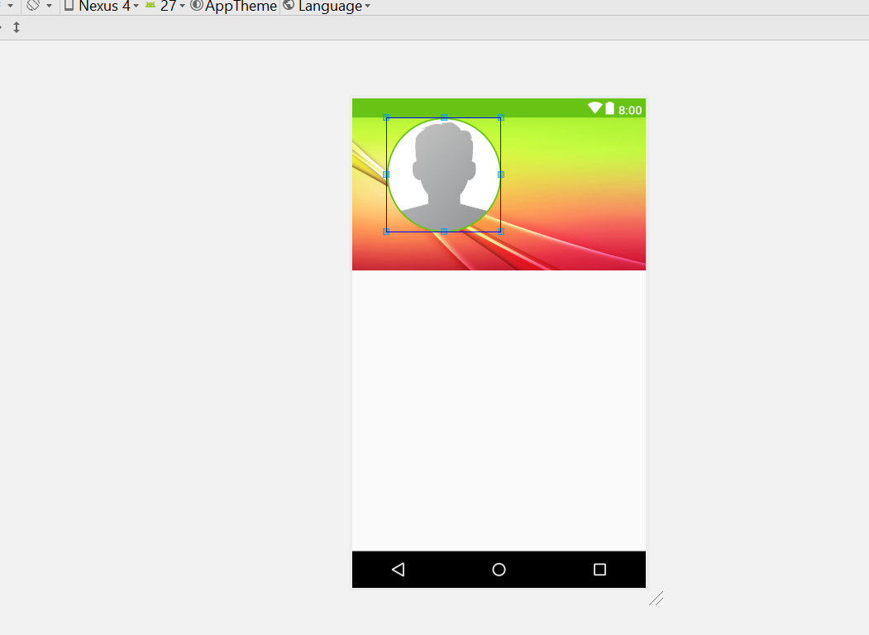
* Drag to the right a bit
* Now drag a textView below the profile pic
* 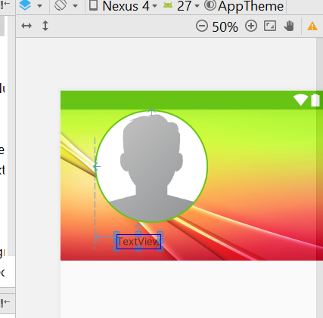
* Change textsize to 16sp and change the text to username
* 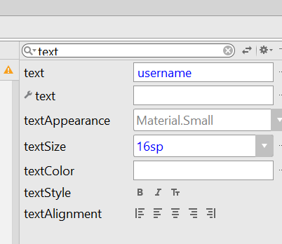
* Textcolour change to background light
* Width change to 135dp
* Now click on the profile, change the layout margin to this.
* 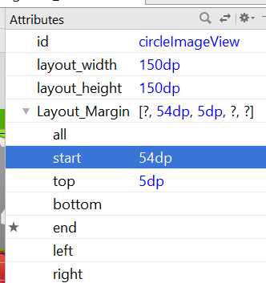
* Click on textview, Top margin should be 10dp
* Then textalignment is centre
* Change the id of the profile circleView to nav_profile_image
* Change the id of the textview to nav_user_full_name
* You should see something like this
* 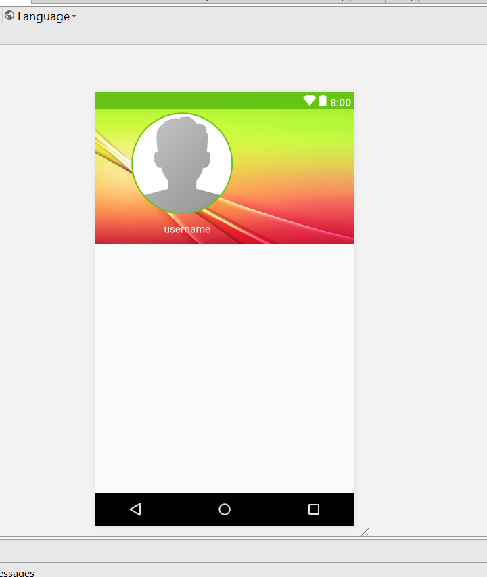
* Go to the activity_main.xml
* Assign id to this
* 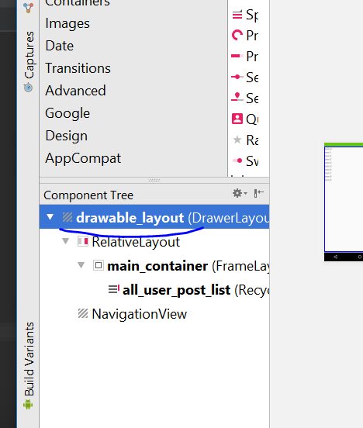
* The id will be drawable_layout
* For the Navigation View, the id will be **navigation_view**
* Now go to MainActivity
* Add this
* private NavigationView navigationView;  
  private DrawerLayout drawerLayout;  
  private RecyclerView postList;
* then go to the onCreate Method
* add this
* **drawerLayout** = (DrawerLayout)findViewById(R.id.***drawable_layout***);  
  **navigationView** = (NavigationView) findViewById(R.id.***navigation_view***);  
  View navView = **navigationView**.inflateHeaderView(R.layout.***navigation_header***);  
    
    
  **navigationView**.setNavigationItemSelectedListener(**new** NavigationView.OnNavigationItemSelectedListener() {  
   @Override  
   **public boolean** onNavigationItemSelected(@NonNull MenuItem item) {  
    
   UserMenuSelector(item);  
    
   **return false**;  
   }  
  });
* 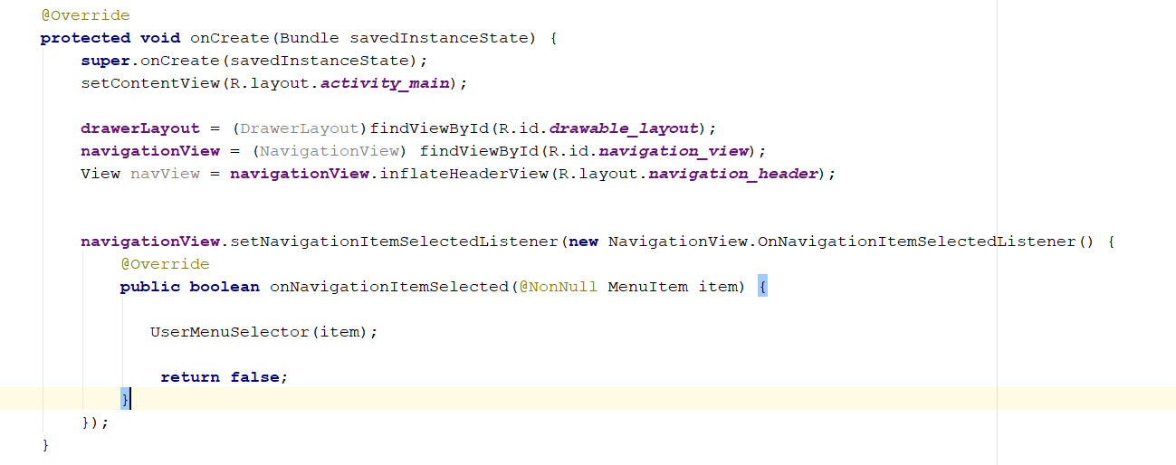
* and add this method below
* **private void** UserMenuSelector(MenuItem item) {  
    
   **switch**(item.getItemId())  
   {  
   **case** R.id.***nav_profile***:  
   Toast.*makeText*(**this**, **"Profile"**, Toast.***LENGTH_SHORT***).show();  
   **break**;  
   **case** R.id.***nav_home***:  
   Toast.*makeText*(**this**, **"Home"**, Toast.***LENGTH_SHORT***).show();  
   **break**;  
   **case** R.id.***nav_friends***:  
   Toast.*makeText*(**this**, **"Friend List"**, Toast.***LENGTH_SHORT***).show();  
   **break**;  
   **case** R.id.***nav_find_friends***:  
   Toast.*makeText*(**this**, **"Find Friends"**, Toast.***LENGTH_SHORT***).show();  
   **break**;  
   **case** R.id.***nav_messages***:  
   Toast.*makeText*(**this**, **"Message"**, Toast.***LENGTH_SHORT***).show();  
   **break**;  
   **case** R.id.***nav_settings***:  
   Toast.*makeText*(**this**, **"Setting"**, Toast.***LENGTH_SHORT***).show();  
   **break**;  
   **case** R.id.***nav_logout***:  
   Toast.*makeText*(**this**, **"Logout"**, Toast.***LENGTH_SHORT***).show();  
   **break**;  
   }  
  }
* rebuild and run
* Now add the appbar layout
* Go to Activity_main.xml
* Go to layout>new>layout resource file
* 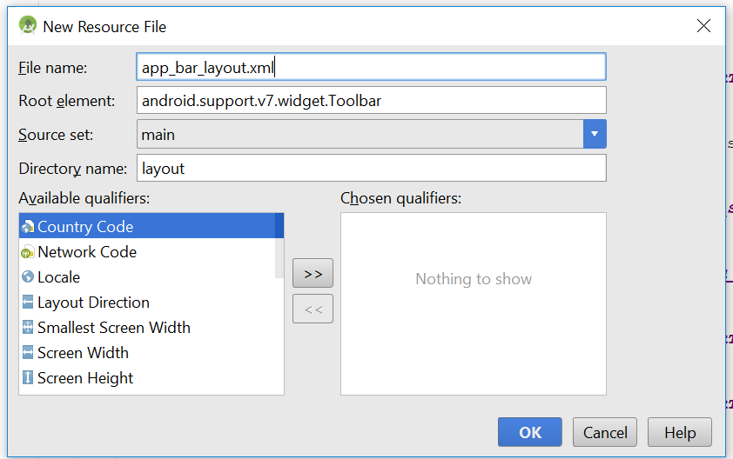
* Change the root element that look above
* Change the file name to app_bar_layout.xml
* Go to text and change the code behind
* <android.support.v7.widget.Toolbar xmlns:android="http://schemas.android.com/apk/res/android"  
   android:id="@+id/main_app_bar"  
   android:layout_width="match_parent"  
   android:layout_height="wrap_content"  
   android:background="@color/colorPrimaryDark">  
    
    
    
  </android.support.v7.widget.Toolbar>
* 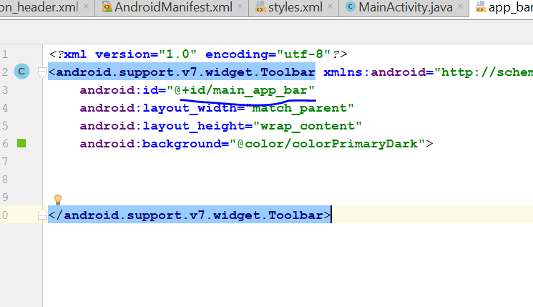
* Id will be main_app_bar
* Now go activity_main.xml
* Add this line
* 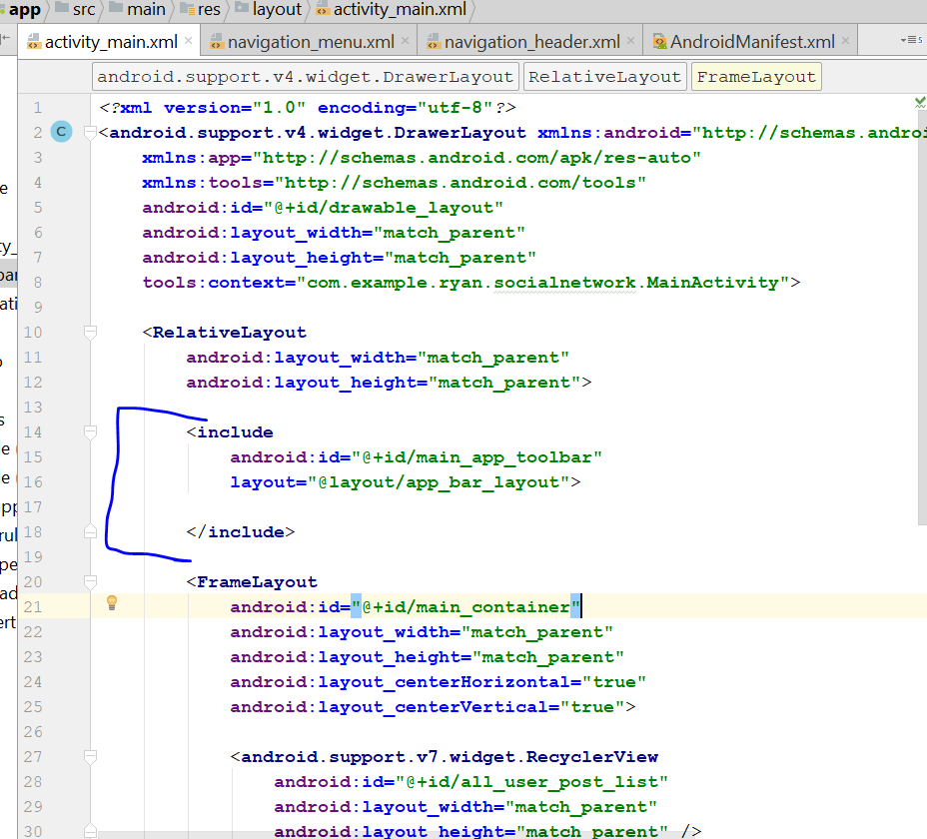
* <include  
   android:id="@+id/main_page_toolbar"  
   layout="@layout/app_bar_layout">  
    
  </include>
* Now go to MainActivity.java
* Add this
* **import** android.support.v7.widget.Toolbar;
* private Toolbar mToolbar;
* on the Oncreate(), add this
* **mToolbar** = (Toolbar) findViewById(R.id.***main_page_toolbar***);
* setSupportActionBar(**mToolbar**);
* getSupportActionBar().setTitle(**"Home"**);
* Rebuild and Run, you see the word home on the top
* Now go to activity_main.xml again
* Click on main_container
* 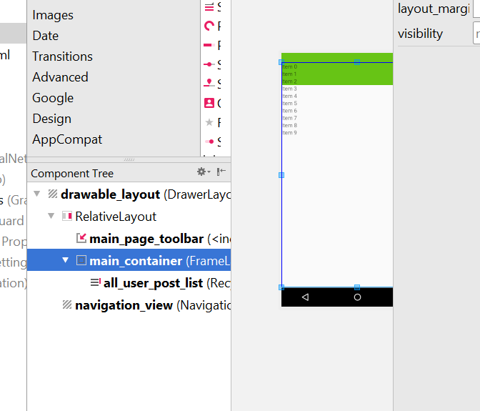
* Move it slightly below the toolbar
* 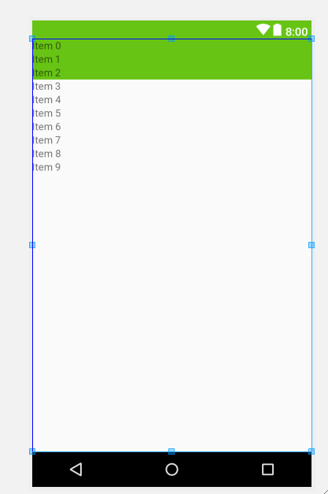
* 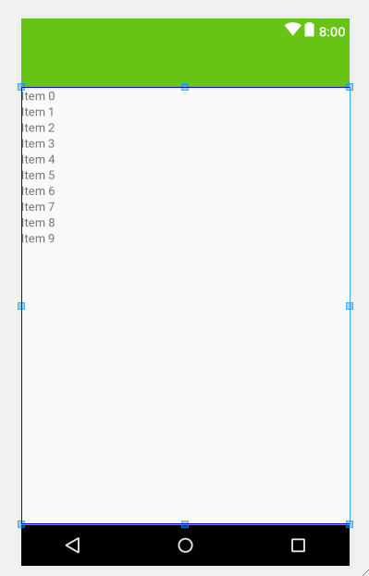
* Now go to MainActivity
* Add this
* private ActionBarDrawerToggle actionBarDrawerToggle;
* Now to string.xml
* Add this
* <String name="draw_open">Drawer Open</String>  
  <String name="draw_close">Drawer Close</String>
* So it should look like this
* 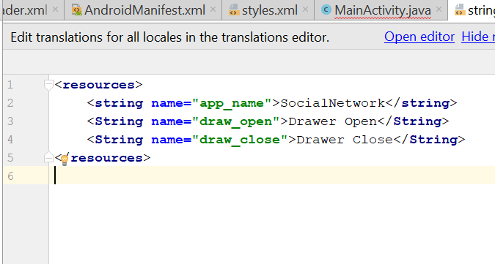
* then now go to the onCreate()
* add this
* **actionBarDrawerToggle** = **new** ActionBarDrawerToggle(MainActivity.**this**, **drawerLayout**, R.string.***draw_open***, R.string.***draw_close***);  
  **drawerLayout**.addDrawerListener(**actionBarDrawerToggle**);  
  **actionBarDrawerToggle**.syncState();  
  getSupportActionBar().setDisplayHomeAsUpEnabled(**true**);
* 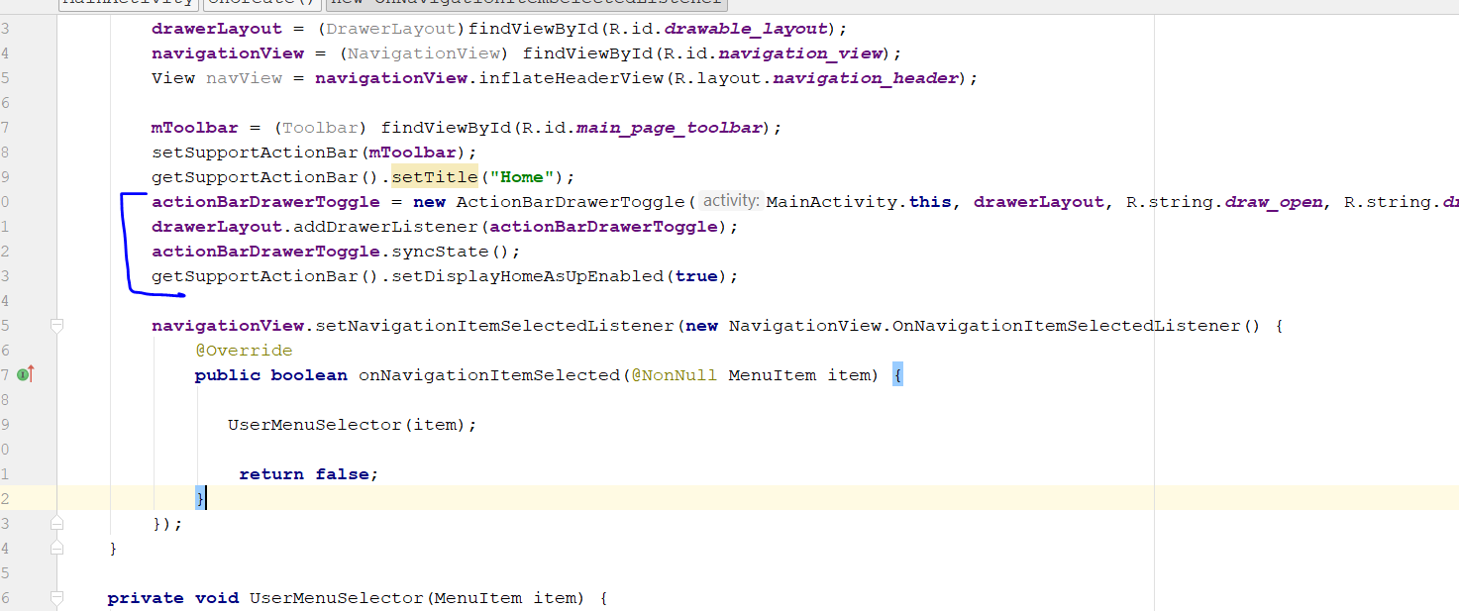
* Add this
* @Override  
  **public boolean** onOptionsItemSelected(MenuItem item) {  
    
   **if**(**actionBarDrawerToggle**.onOptionsItemSelected(item))  
   {  
   **return true**;  
   }
* 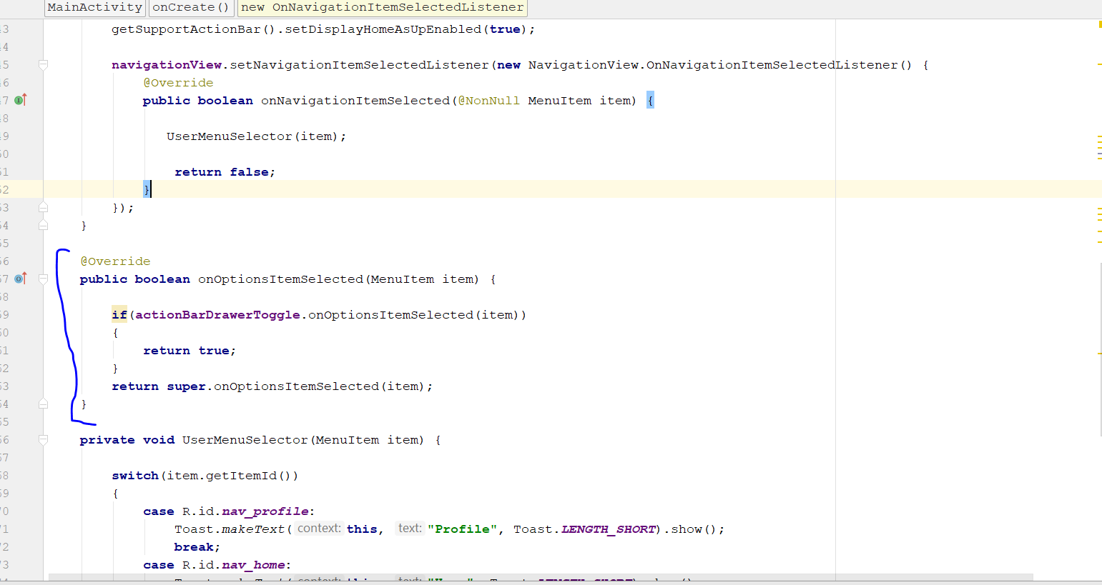
* Rebuild and Run
* You should see a 3 line here
* 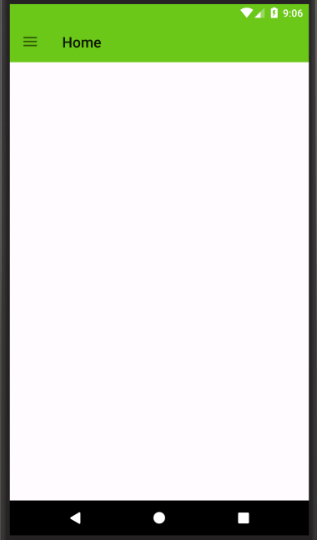
* Tap on it
* 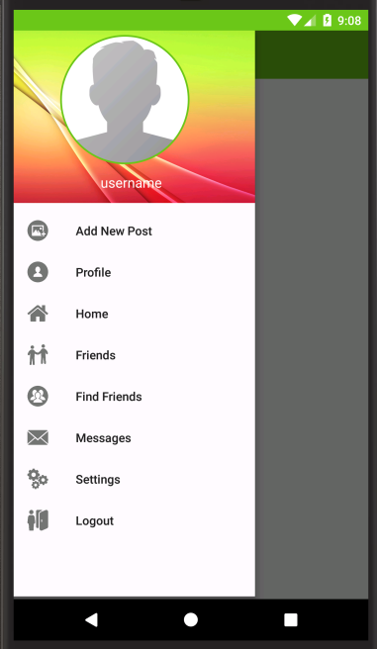
* You are done
* Now change the colour
* Go to app_bar_layer.xml
* Add this
* android:theme="@style/ThemeOverlay.AppCompat.Dark.ActionBar"
* 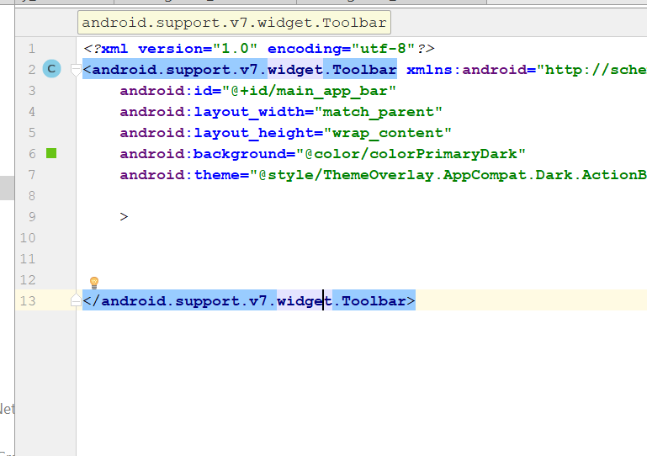
* Now the word “Home” should come white

# Create Login Activity

* Create a empty Activity
* Call it RegisterActivity
* 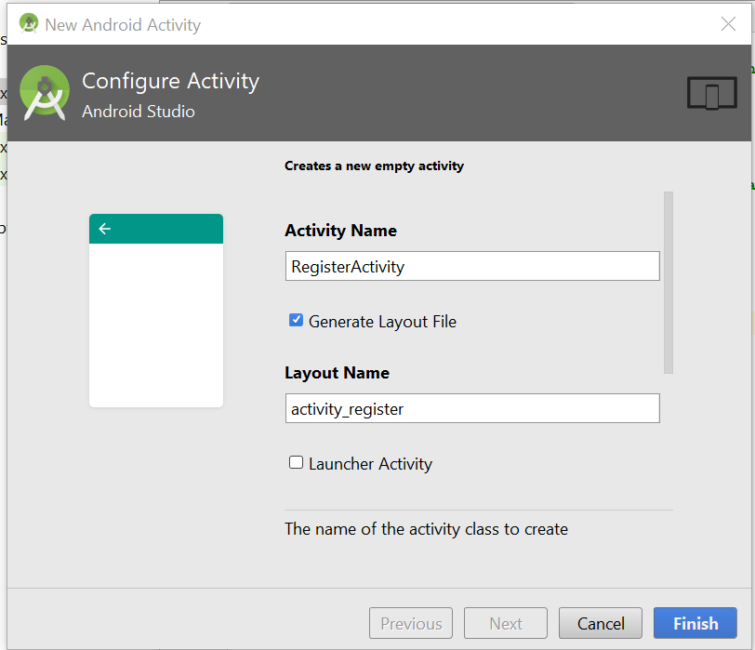
* Go to activity_register.xml
* Change the layout to Relative
* 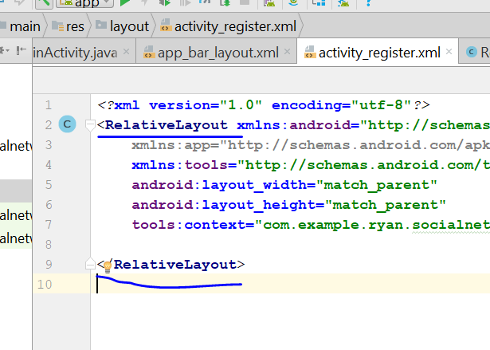
* Now go to drawable folder > new > Drawable Resource file
* Name it as inputs.xml
* 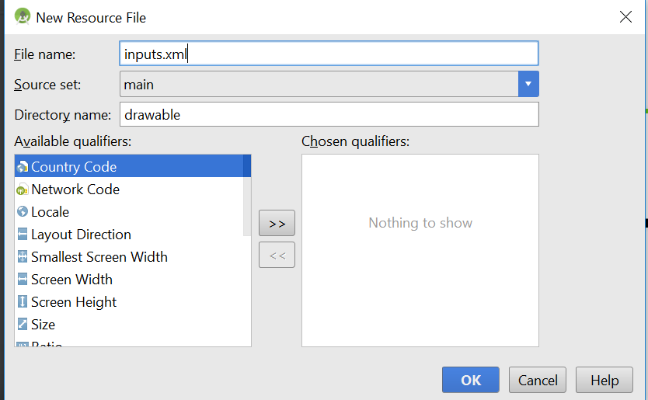
* Click ok, then go to TEXT
* 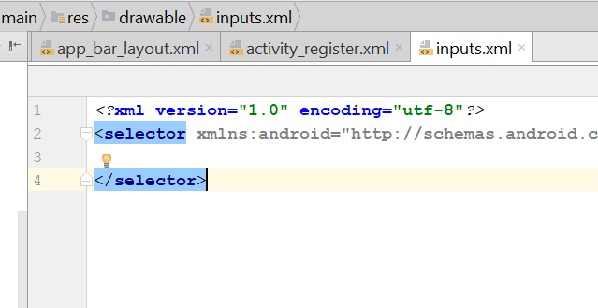
* Change the “Selector” to “Shape”
* It will look like this
* *<?*xml version="1.0" encoding="utf-8"*?>*<shape xmlns:android="http://schemas.android.com/apk/res/android">  
    
   <solid android:color="#ffffff"/>  
   <corners android:radius="30dp"></corners>  
  </shape>
* Now create a button by drawable>new> drawable resource file
* Name it as button.xml
* 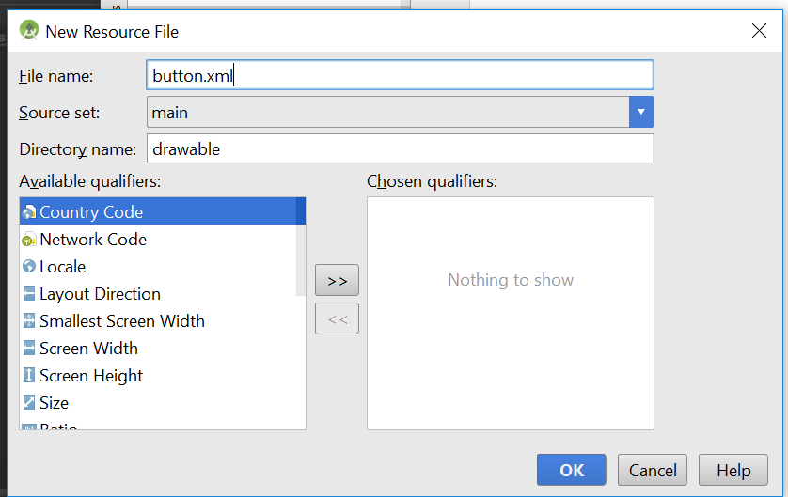
* Go to the code, TEXT
* 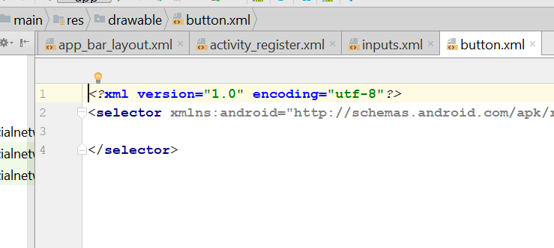
* Change selector to shape again
* 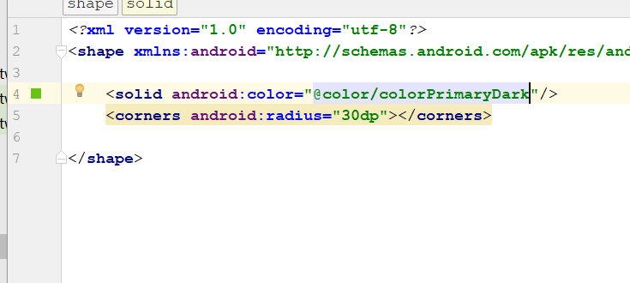
* *<?*xml version="1.0" encoding="utf-8"*?>*<shape xmlns:android="http://schemas.android.com/apk/res/android">  
    
   <solid android:color="@color/colorPrimaryDark"/>  
   <corners android:radius="30dp"></corners>  
    
  </shape>
* Save it, now it become green
* Now go to activity_register.xml
* Then put one image_view
* You will see this
* 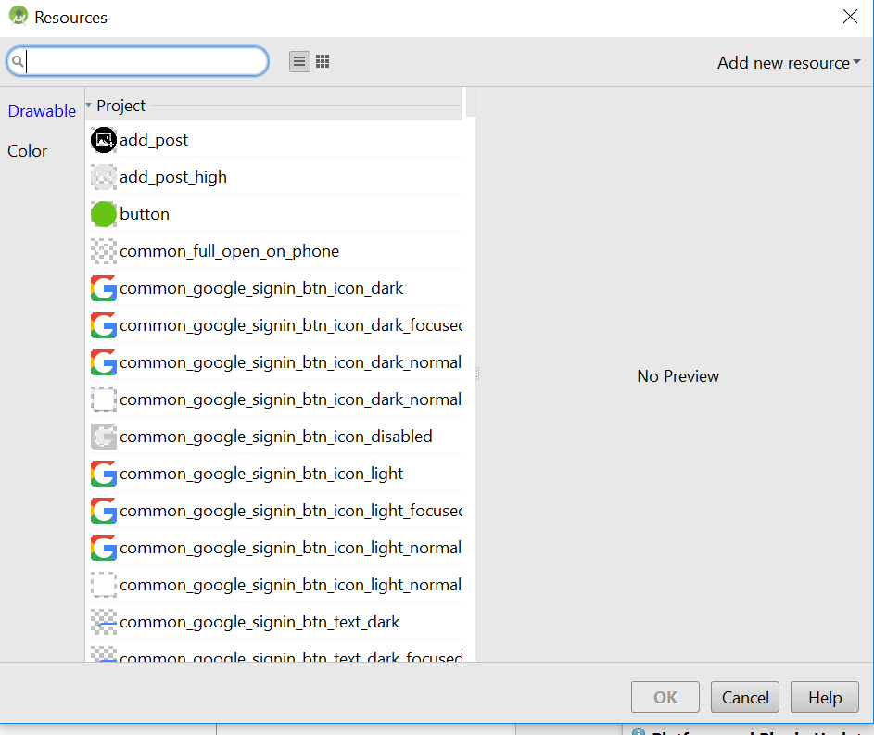
* Type logo
* You will see this icon
* 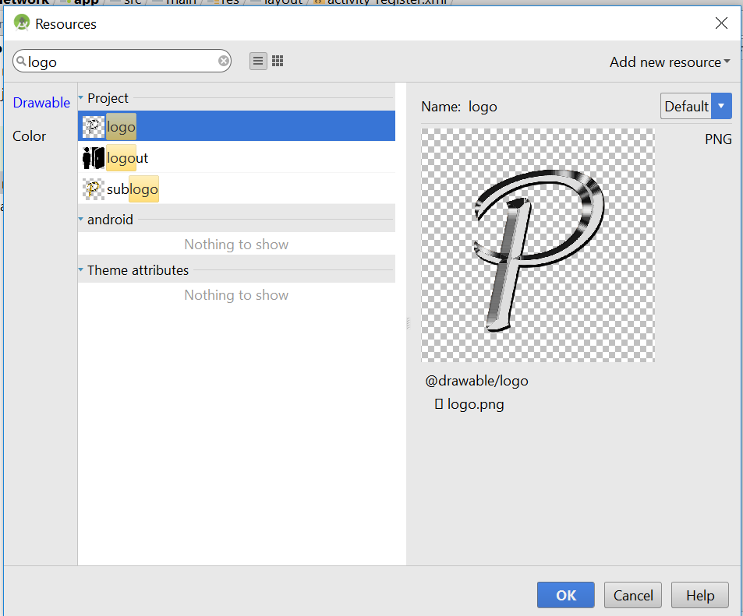
* Change the width and height to 150dp
* 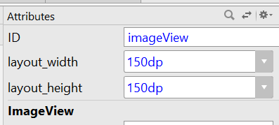
* It should look like this now
* 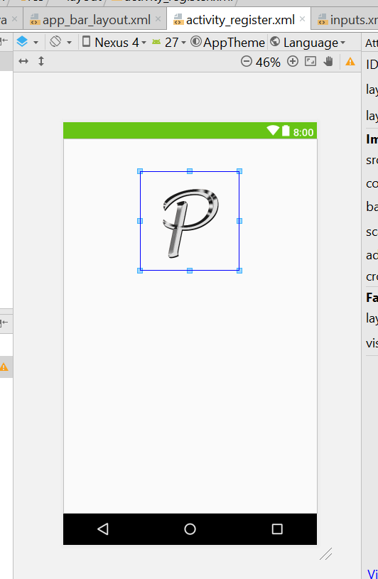
* Search for email, drag and drop the email into the xml
* 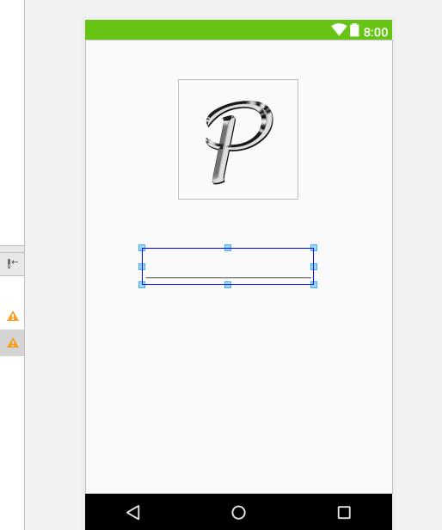
* Width of the edittext change to Match Parent
* Add the hint as “Email”
* Now search for password, drag and drop, same thing the width change to match parent
* Add the hint “Password”
* Then drag another Password field, and name it as Confirm Password
* Now drag and drop the button
* Text change to CREATE ACCOUNT
* 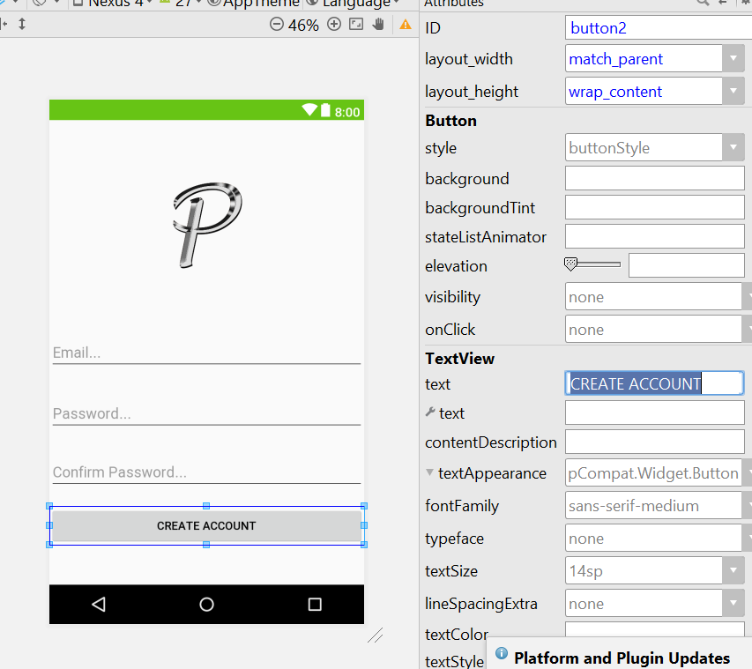
* Now go to activity_register.xml, add this line
* android:background="@drawable/login"
* 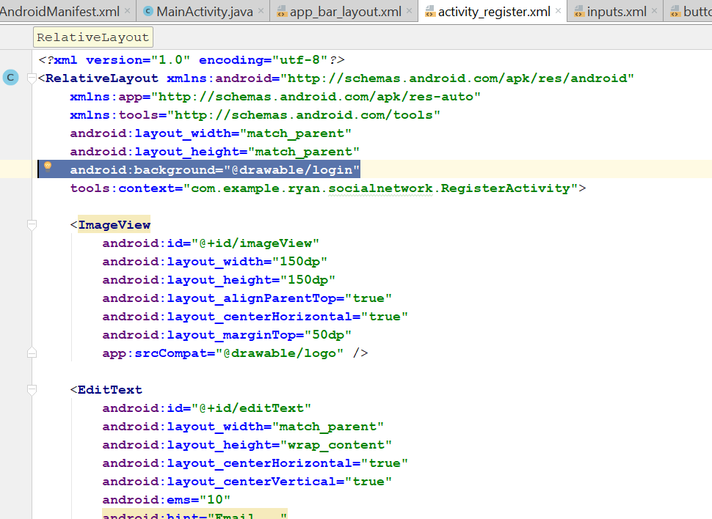
* So now the xml should look like this
* 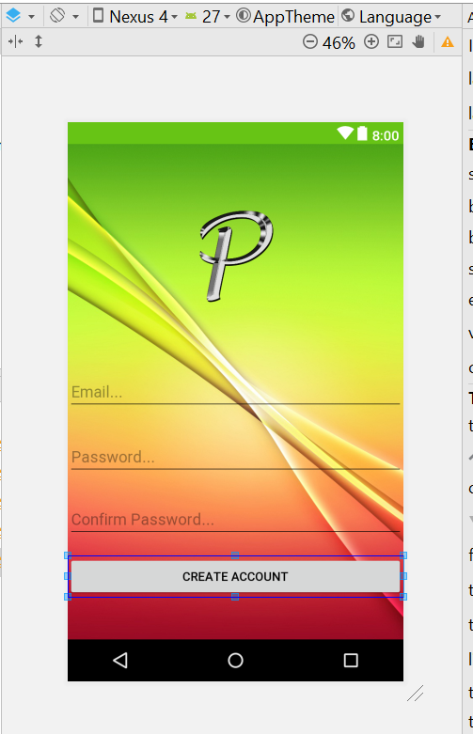
* Next change the background of each edit Text
* 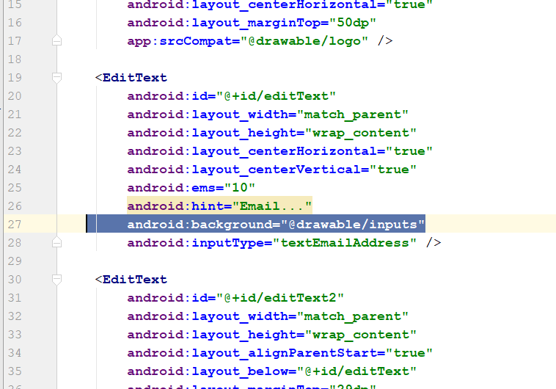
* android:background="@drawable/inputs"
* android:padding="10dp"  
  android:drawableLeft="@drawable/email"
* add it to all the edittext and password field
* for password, add this
* android:padding="10dp"  
  android:drawableLeft="@drawable/password"
* now set the margine, the login will be 10dp from the top
* the textfield will be 5dp from the top
* the password field will be 5dp from the top
* Now go the XML, and add this line
* Add this
* android:background="@drawable/button"
* 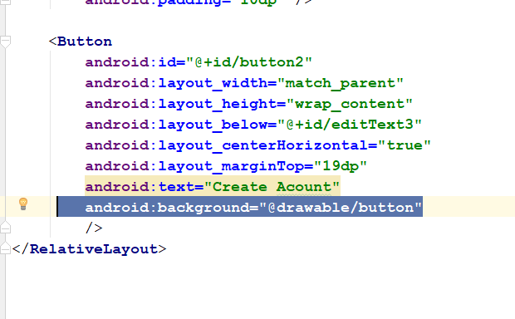
* Padding will be 15dp
* For the button layout margin
* 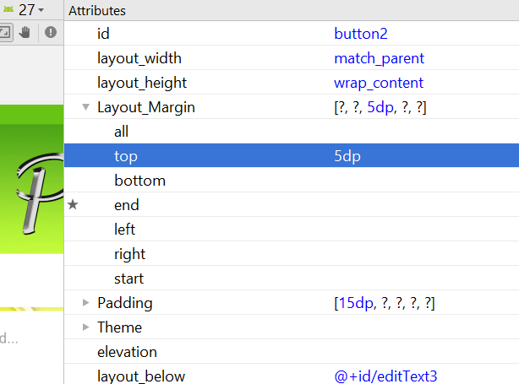
* Change to 5dp from the top
* Textsize change to 22sp
* Text colour change to background light
* Now become like that
* 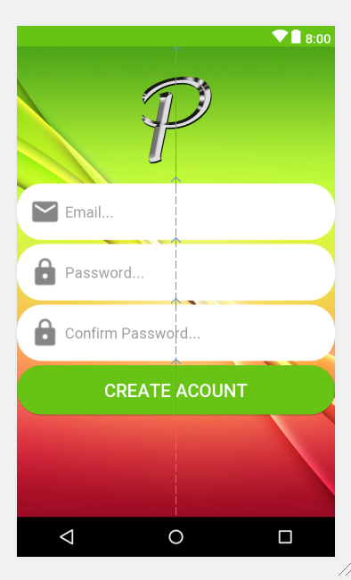
* We can assign some id for it
* For the icon id, assign **register_icon**
* For the email field, id is **register_email**
* For the password field, id is **register_password**
* For the confirm password field, id is **register_confirm_password**
* For the button field, id is **register_create_account**
* Now create a new activity
* Call it LoginActivity
* Go to Activity_layout.xml
* Change the layout to relative layout
* Copy and replace this new xml code
* *<?*xml version="1.0" encoding="utf-8"*?>*<RelativeLayout xmlns:android="http://schemas.android.com/apk/res/android"  
   xmlns:app="http://schemas.android.com/apk/res-auto"  
   xmlns:tools="http://schemas.android.com/tools"  
   android:layout_width="match_parent"  
   android:layout_height="match_parent"  
   android:background="@drawable/login"  
   tools:context="com.example.ryan.socialnetwork.LoginActivity">  
    
   <ImageView  
   android:id="@+id/login_icon"  
   android:layout_width="150dp"  
   android:layout_height="150dp"  
   android:layout_alignParentTop="true"  
   android:layout_centerHorizontal="true"  
   android:layout_marginTop="10dp"  
   app:srcCompat="@drawable/logo" />  
    
   <EditText  
   android:id="@+id/login_email"  
   android:layout_width="match_parent"  
   android:layout_height="wrap_content"  
   android:layout_alignParentStart="true"  
   android:layout_below="@+id/login_icon"  
   android:layout_marginTop="5dp"  
   android:background="@drawable/inputs"  
   android:drawableLeft="@drawable/email"  
   android:ems="10"  
   android:hint="Email..."  
   android:inputType="textEmailAddress"  
   android:padding="10dp" />  
    
   <EditText  
   android:id="@+id/login_password"  
   android:layout_width="match_parent"  
   android:layout_height="wrap_content"  
   android:layout_alignParentStart="true"  
   android:layout_below="@+id/login_email"  
   android:layout_marginTop="5dp"  
   android:background="@drawable/inputs"  
   android:drawableLeft="@drawable/password"  
   android:ems="10"  
   android:hint="Password..."  
   android:inputType="textPassword"  
   android:padding="10dp" />  
    
   <Button  
   android:id="@+id/login_button"  
   android:layout_width="match_parent"  
   android:layout_height="wrap_content"  
   android:layout_alignParentStart="true"  
   android:layout_below="@+id/login_password"  
   android:layout_marginTop="5dp"  
   android:background="@drawable/button"  
   android:padding="15dp"  
   android:text="Login"  
   android:textColor="@android:color/background_light"  
   android:textSize="22sp" />  
    
   <TextView  
   android:id="@+id/textView"  
   android:layout_width="match_parent"  
   android:layout_height="wrap_content"  
   android:layout_below="@+id/login_button"  
   android:layout_centerHorizontal="true"  
   android:layout_marginTop="10dp"  
   android:text="Don't have an Account. Need new Account?"  
   android:textColor="@android:color/holo_red_dark"  
   android:textSize="18sp" />  
  </RelativeLayout>
* Now it look like this
* 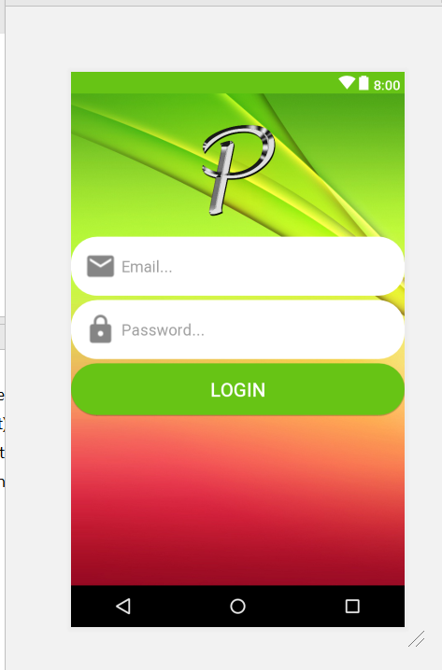
* Drag and drop a new textview and place it below the Login Button
* Change the top margin to 5dp
* 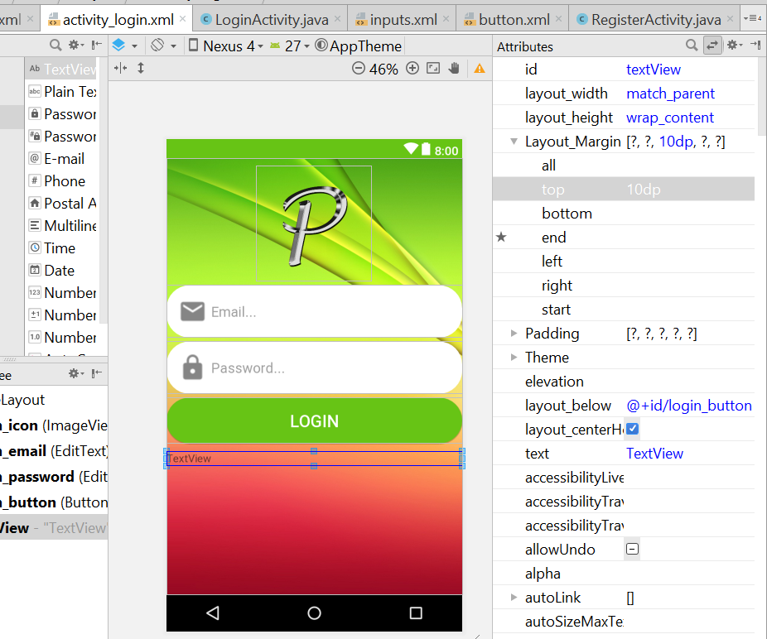
* Change the text to “Don't have an Account. Need new Account?”
* TextSize is 18sp
* Change the textcolour to holoRed_Dark
* 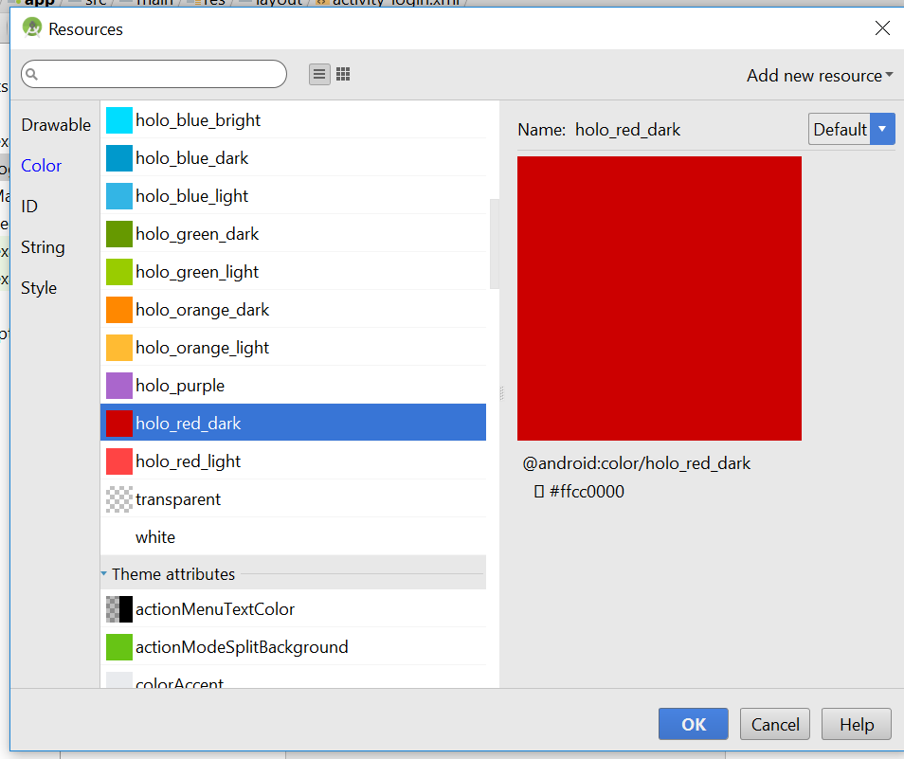
* Change the size of the icon to 110dp height and withd
* 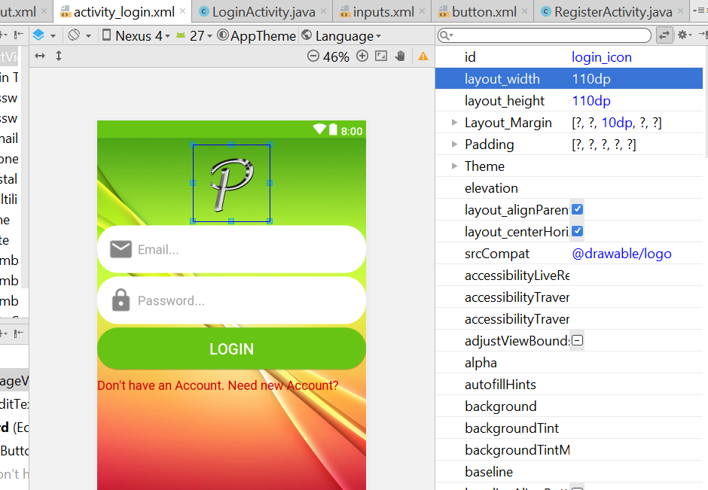
* Change the padding of the textfield to 8dp
* For the Textview, select centre alignment, and bold it
* Now look like this
* 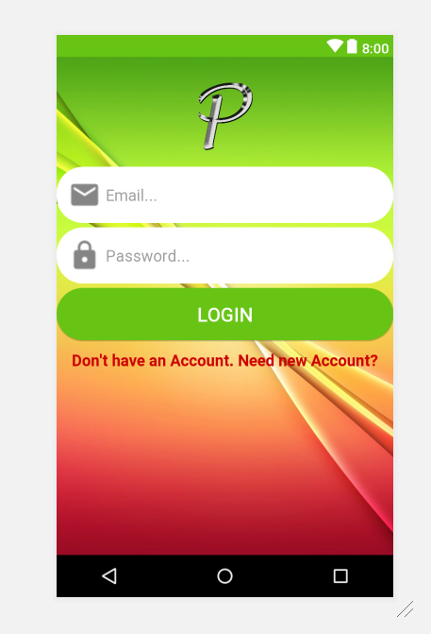
* Now drag another TextView into the centre,
* Make it centre alignment
* 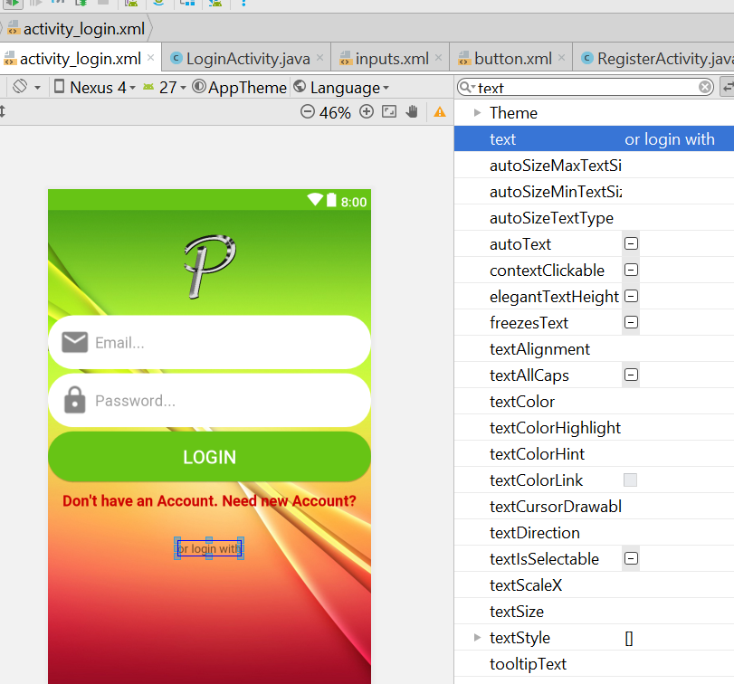
* The Text will be “Or login with”, then make it bold, then width is match parent
* Textsize change to 16sp and make it bold
* Add this code in the xml
* <LinearLayout  
   android:layout_width="match_parent"  
   android:layout_height="wrap_content"  
   android:orientation="horizontal"  
   android:layout_below="@+id/textView2"  
   >  
   <ImageView  
   android:layout_width="100dp"  
   android:layout_height="80dp"  
   android:src="@drawable/facebook"  
   android:layout_marginLeft="25dp"  
   android:layout_marginTop="8dp"  
   />  
   <ImageView  
   android:layout_width="125dp"  
   android:layout_height="105dp"  
   android:src="@drawable/twitter"  
   android:layout_marginLeft="5dp"  
    
   />  
   <ImageView  
   android:layout_width="90dp"  
   android:layout_height="75dp"  
   android:src="@drawable/google"  
   android:layout_marginLeft="15dp"  
   android:layout_marginTop="10dp"  
   />  
  </LinearLayout>
* 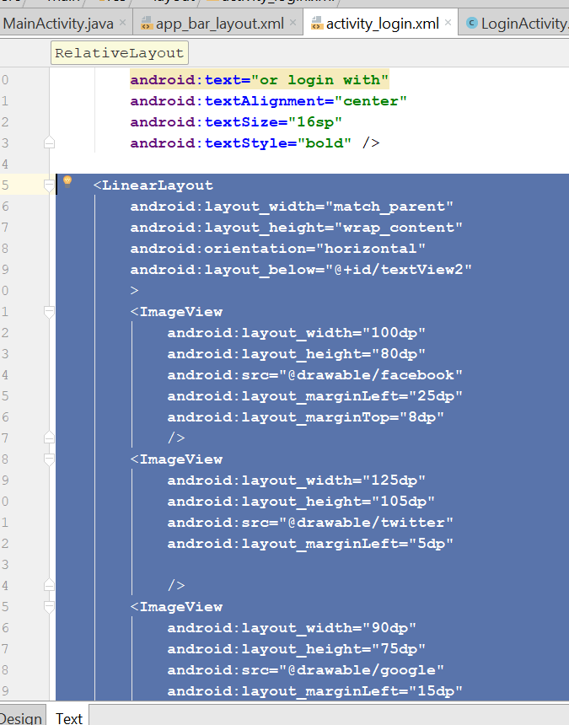
* 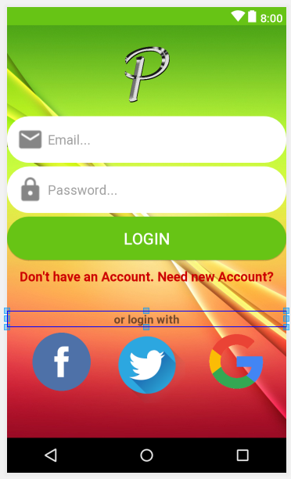
* Now give the id to every icon
* For facebook is facebook_signin_button
* For twitter is twitter_signin_button
* For google is google_signin_button
* Then for this link, add this id – “register_account_link”
* 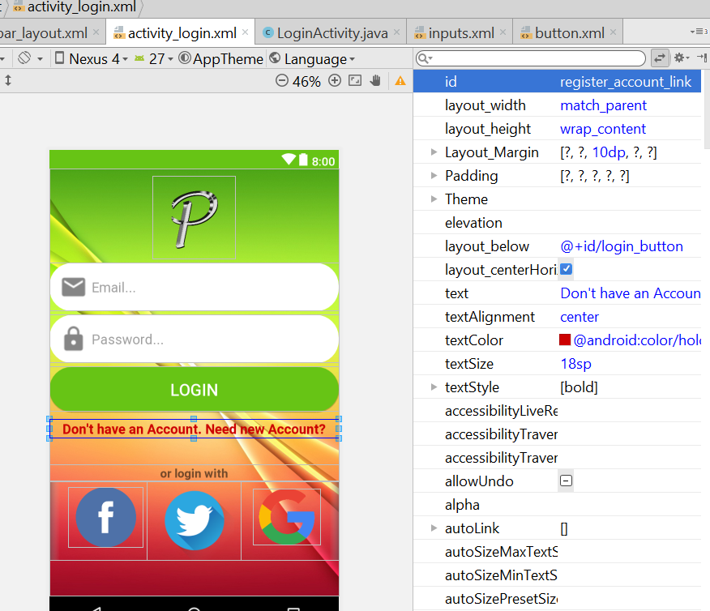
* For the linear layout, margintop is 10dp
* Now go to the Mainactivity.java
* Add this line
* **private** FirebaseAuth **mAuth**;
* Then on the onCreate() method
* Add this
* mAuth = FirebaseAuth.*getInstance*();
* Then outside the onCreate Method
* 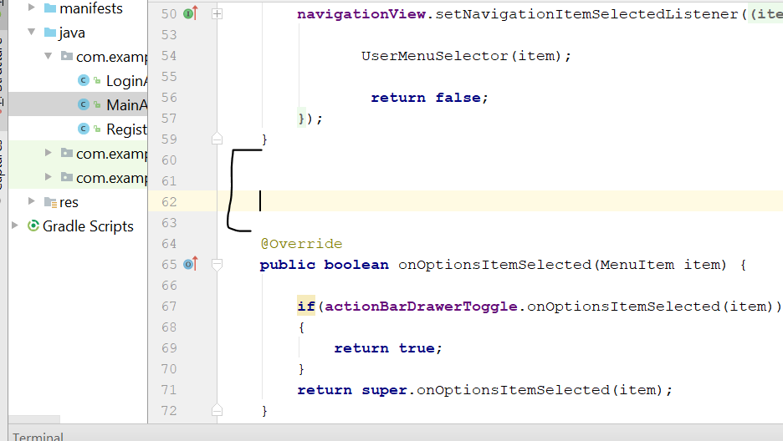
* Add this new code here
* @Override  
  **protected void** onStart() {  
   **super**.onStart();  
    
   FirebaseUser currentUser = **mAuth**.getCurrentUser();  
   **if**(currentUser == **null**)  
   {  
   SendUserToLoginActivity();  
   }  
  }  
    
  **private void** SendUserToLoginActivity() {  
   Intent loginIntent = **new** Intent(MainActivity.**this**,LoginActivity.**class**);  
   loginIntent.addFlags(Intent.***FLAG_ACTIVITY_NEW_TASK***|Intent.***FLAG_ACTIVITY_CLEAR_TASK***);  
   startActivity(loginIntent);  
   finish();  
  }
* Rebuild and run
* Now should lose to the login page automatically
* Now go to loginActivity.java
* Add this
* **private** Button **LoginButton**;  
  **private** EditText **UserEmail**, **Userpassword**;  
  **private** TextView **NeedNewAccountLink**;  
    
    
    
  @Override  
  **protected void** onCreate(Bundle savedInstanceState) {  
   **super**.onCreate(savedInstanceState);  
   setContentView(R.layout.***activity_login***);  
    
   **NeedNewAccountLink** = (TextView) findViewById(R.id.***register_account_link***);  
   **UserEmail** = (EditText) findViewById(R.id.***login_email***);  
   **Userpassword** = (EditText)findViewById(R.id.***login_password***);  
   **LoginButton** = (Button) findViewById(R.id.***login_button***);  
    
   **NeedNewAccountLink**.setOnClickListener(**new** View.OnClickListener() {  
   @Override  
   **public void** onClick(View v) {  
   SendUserToRegisterActivity();  
   }  
   });  
  }  
    
  **private void** SendUserToRegisterActivity() {  
   Intent registerIntent = **new** Intent(LoginActivity.**this**, RegisterActivity.**class**);  
   startActivity(registerIntent);  
   finish();  
  }
* rebuild and run
* You should able to go to registerAccount Page

# Setup Account

* Create new Activity – call setupActivity
* Empty Activity > SetupActivity
* NOTE: YOU HAVE TO ALLOW THE Sign In Method
* 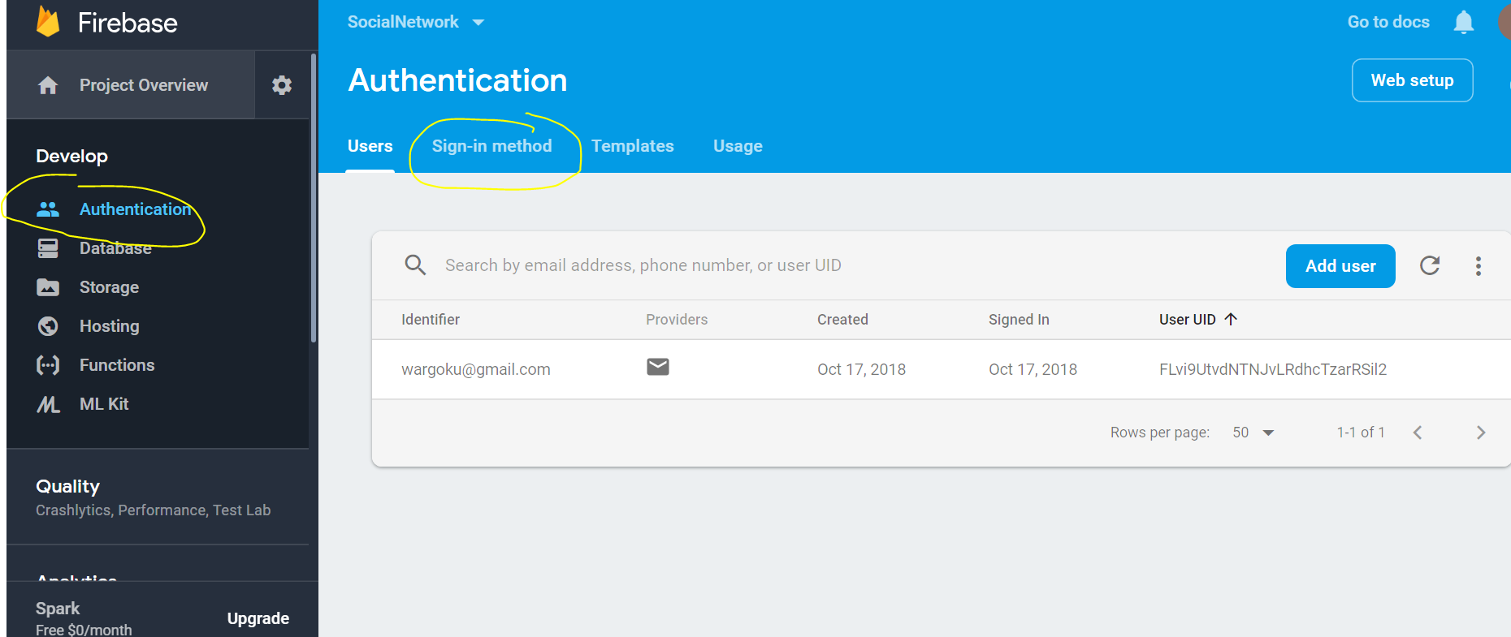
* Go to Authenication > sign in method
* 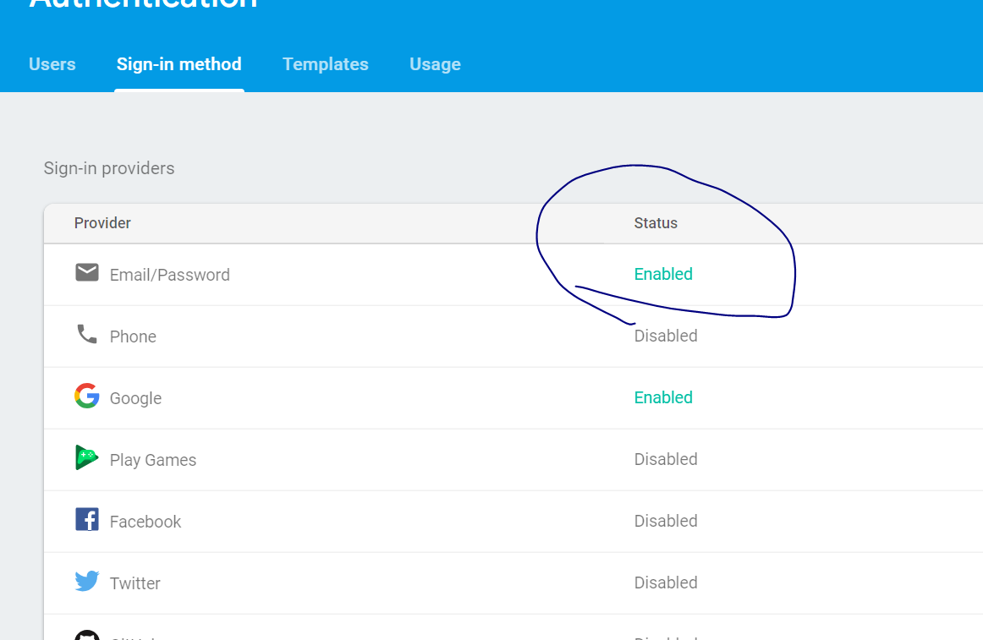
* Make sure the EMAIL/PASSWORD is Enabled, before you proceed, if not will have ERROR
* 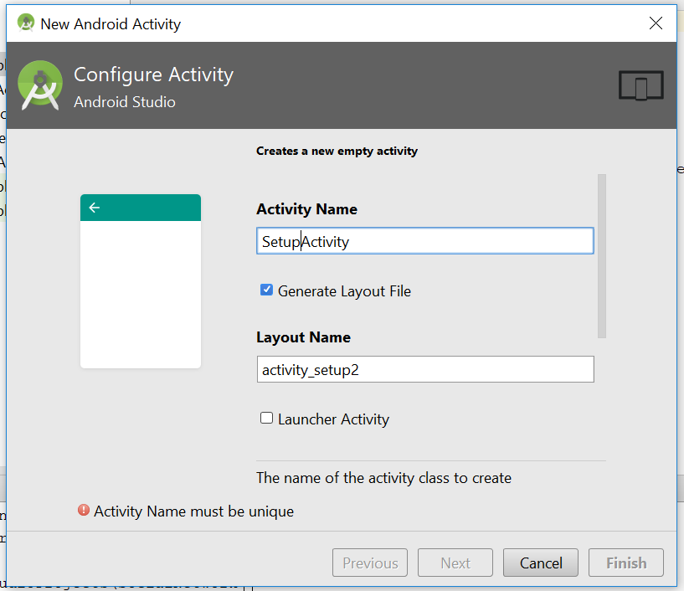
* Now go to Account_setup.xml
* Change the layout to relative layout
* Add this line
* <de.hdodenhof.circleimageview.CircleImageView  
   android:layout_width="200dp"  
   android:layout_height="200dp"  
   android:layout_alignParentTop="true"  
   android:layout_centerHorizontal="true"  
   android:src="@drawable/profile" />
* 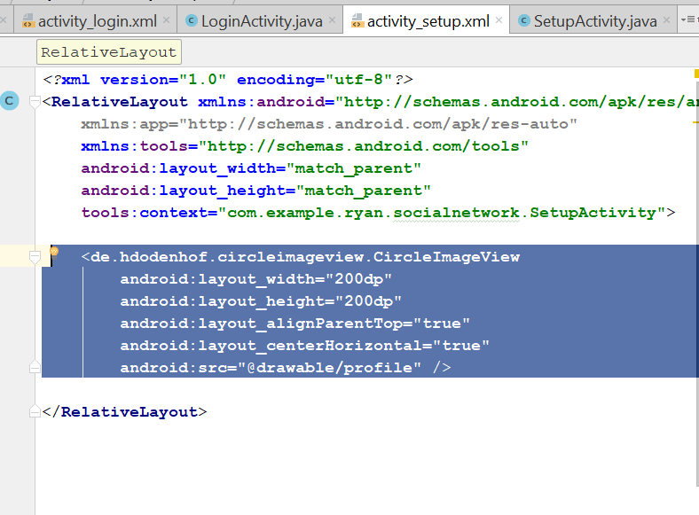
* You see something like this
* 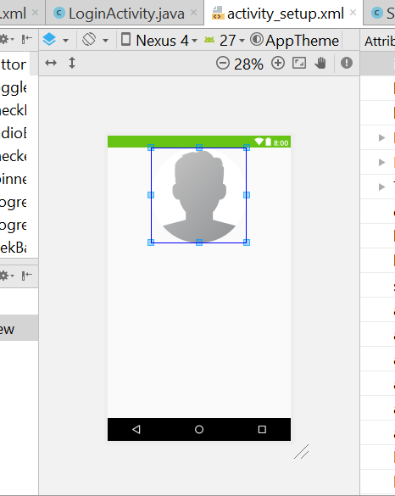
* Add this line here
* android:background="@drawable/register"
* 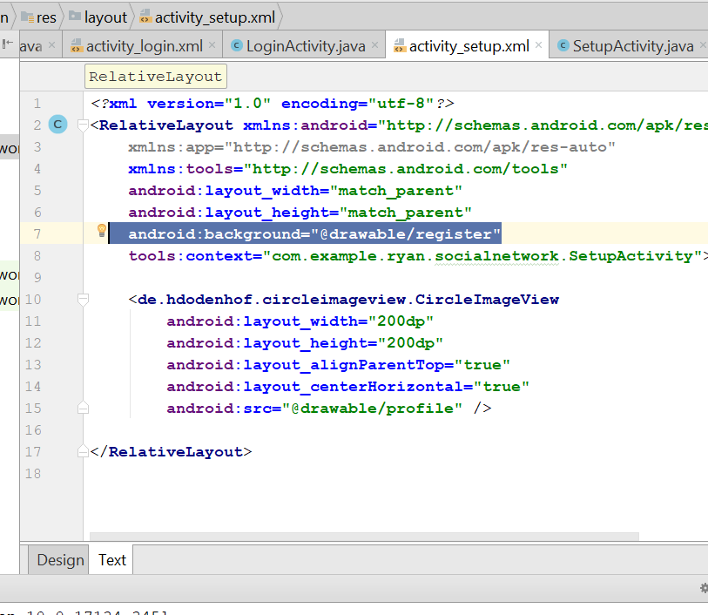
* Now add 3 edit text
* Drag and drop multiline text
* Press this button
* 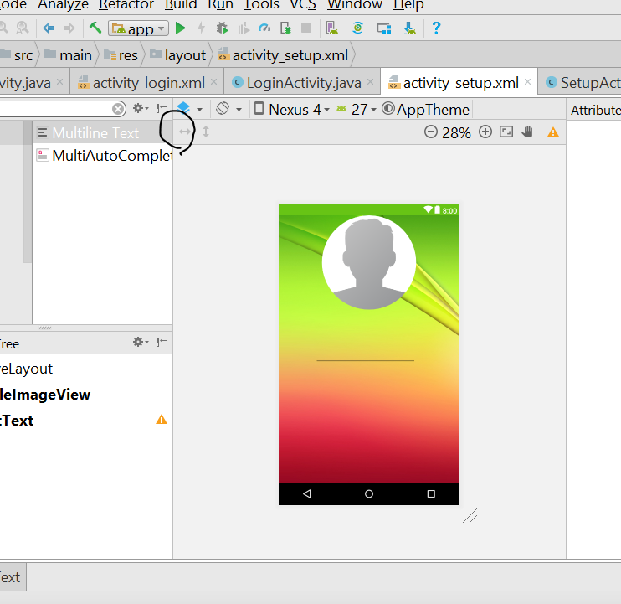
* It will fill the width of the screen
* 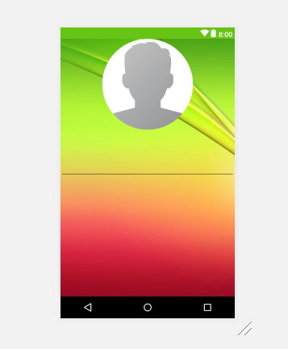
* Add in the hint for each multiline text
* USERNAME, FULL NAME, COUNTRY
* Now drag and drop the button on below
* Now it look like this
* 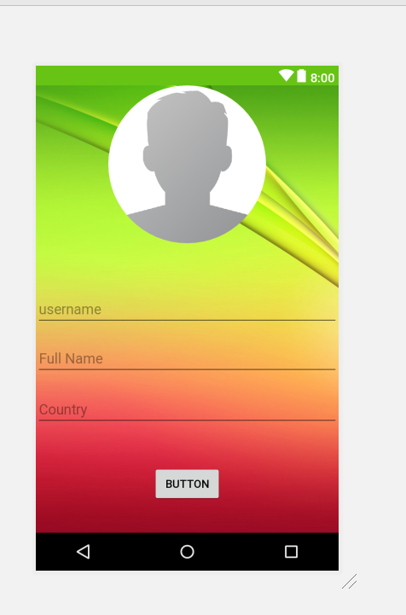
* Add this 3 lines for the first editText
* 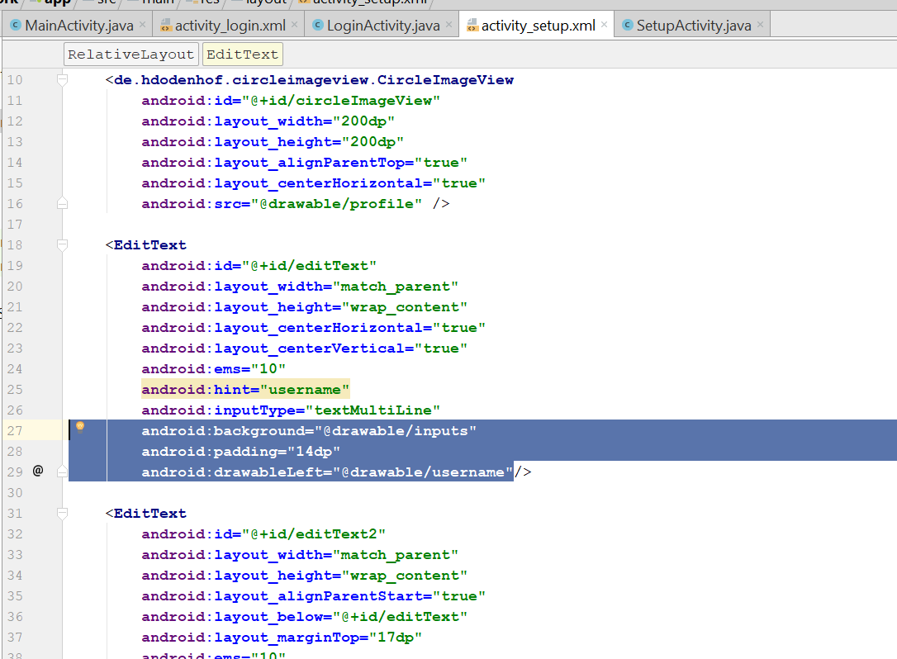
* android:background="@drawable/inputs"  
  android:padding="14dp"  
  android:drawableLeft="@drawable/username"
* copy and paste to the next 2 editText
* change only the drawableLeft icon
* android:drawableLeft="@drawable/name"
* android:drawableLeft="@drawable/country"/
* Copy the the 3 lines to the button
* android:background="@drawable/button"
* 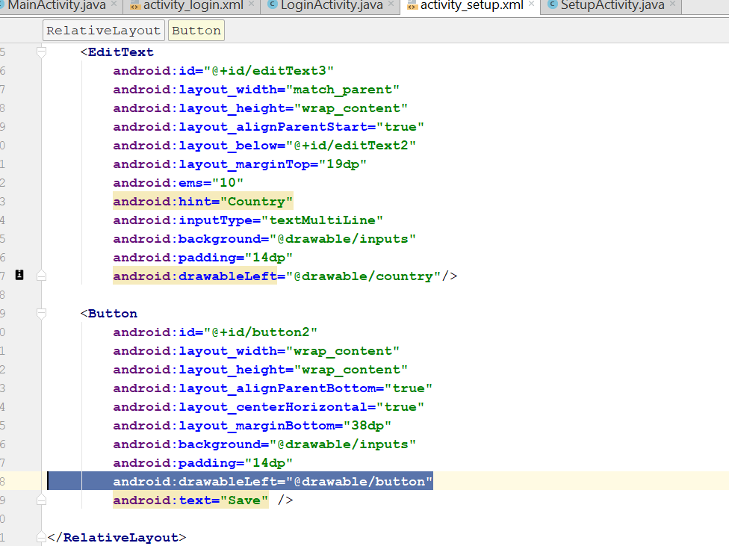
* Now should look like this
* 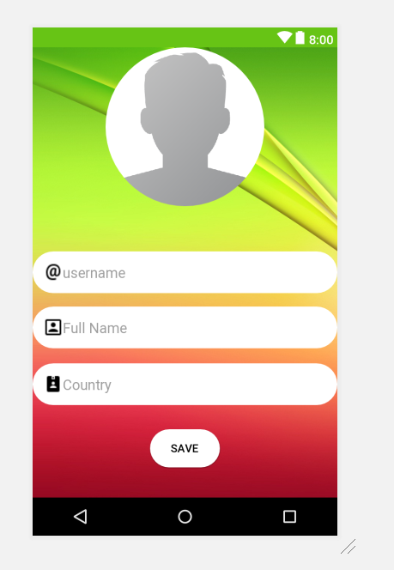
* Now click on the circleView
* From the top margin should be 25dp
* 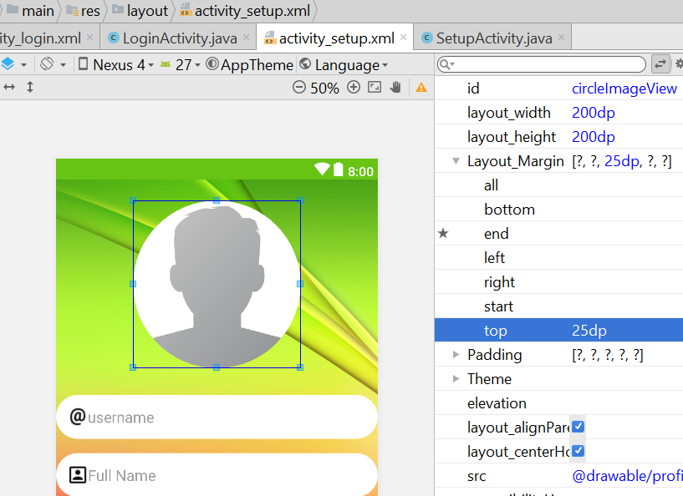
* The id for the username is setup_username
* The id for the circle view is setup_profile_image
* The id for the fullname is setup_full_name
* The id for the username is setup_country_name
* Left and right margin 7dp, from the top margin is 5dp
* Do it for all the editfield
* For the button, width change to 200dp, for the top margin is 8dp. Text size will be 20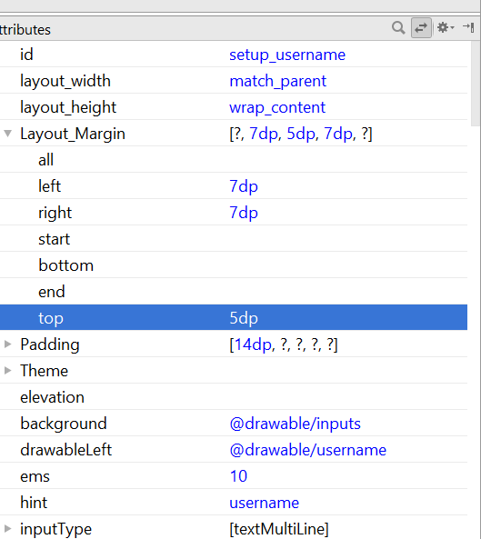
* Textcolour for the button will be background light
* Now it look like that
* 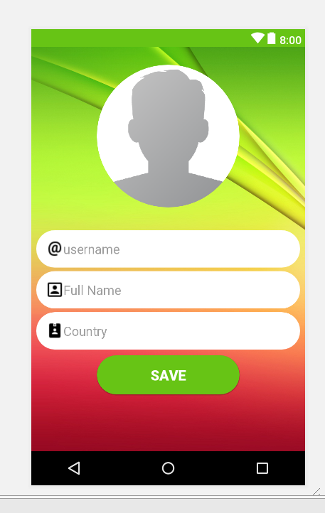
* Now go to SetupActivity.java, add in the following code
* **public class** SetupActivity **extends** AppCompatActivity {  
    
    
   **private** EditText **UserName**, **FullName**, **CountryName**;  
   **private** Button **SaveInformationButton**;  
   **private** CircleImageView **profileImage**;  
    
   @Override  
   **protected void** onCreate(Bundle savedInstanceState) {  
   **super**.onCreate(savedInstanceState);  
   setContentView(R.layout.***activity_setup***);  
    
   **UserName** = (EditText) findViewById(R.id.***setup_username***);  
   **FullName** = (EditText) findViewById(R.id.***setup_full_name***);  
   **CountryName** = (EditText) findViewById(R.id.***setup_country_name***);  
   **SaveInformationButton** = (Button)findViewById(R.id.***setup_information_button***);  
   **profileImage** = (CircleImageView)findViewById(R.id.***setup_profile_image***);  
   }  
  }
* Now go to registerActivity.java
* Add this
* private EditText UserEmail, UserPassword, UserConfirmPassword;  
  private Button CreateAccountButton;
* then in the onCreate()
* add this
* **UserEmail** = (EditText) findViewById(R.id.***register_email***);  
  **UserPassword** = (EditText) findViewById(R.id.***register_password***);  
  **UserConfirmPassword**= (EditText) findViewById(R.id.***register_confirm_password***);  
   **CreateAccountButton** = (Button) findViewById(R.id.***register_create_account***);
* Now go the RegisterActivity.java
* Add this few lines
* **CreateAccountButton**.setOnClickListener(**new** View.OnClickListener() {  
   @Override  
   **public void** onClick(View v) {  
   CreateNewAccount();  
   }  
   });  
  }  
    
  **private void** CreateNewAccount() {  
   String email = **UserEmail**.getText().toString();  
   String password = **UserPassword**.getText().toString();  
   String confirmPassword = **UserConfirmPassword**.getText().toString();  
    
   **if**(TextUtils.*isEmpty*(email))  
   {  
   Toast.*makeText*(**this**, **"Please write your email..."**,Toast.***LENGTH_SHORT***);  
   }  
   **else if**(TextUtils.*isEmpty*(password))  
   {  
   Toast.*makeText*(**this**, **"Please write your password..."**,Toast.***LENGTH_SHORT***);  
   }  
   **else if**(TextUtils.*isEmpty*(confirmPassword))  
   {  
   Toast.*makeText*(**this**, **"Please confirm your password..."**,Toast.***LENGTH_SHORT***);  
   }  
   **else if**(password != confirmPassword)  
   {  
   Toast.*makeText*(**this**, **"Your password do not match with your confirm password..."**,Toast.***LENGTH_SHORT***);  
   }  
  }
* 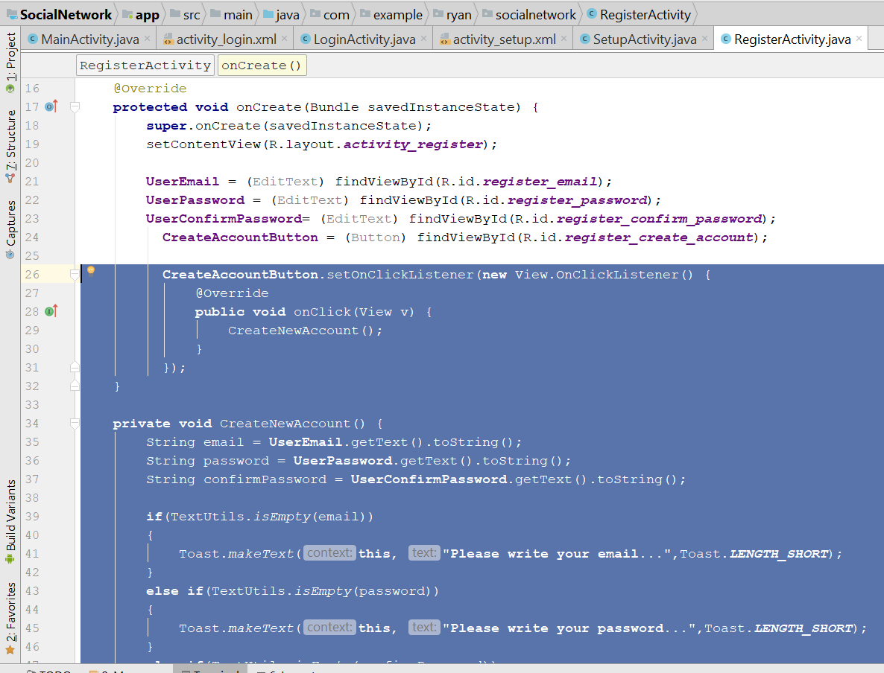
* Then add this two lines on top
* 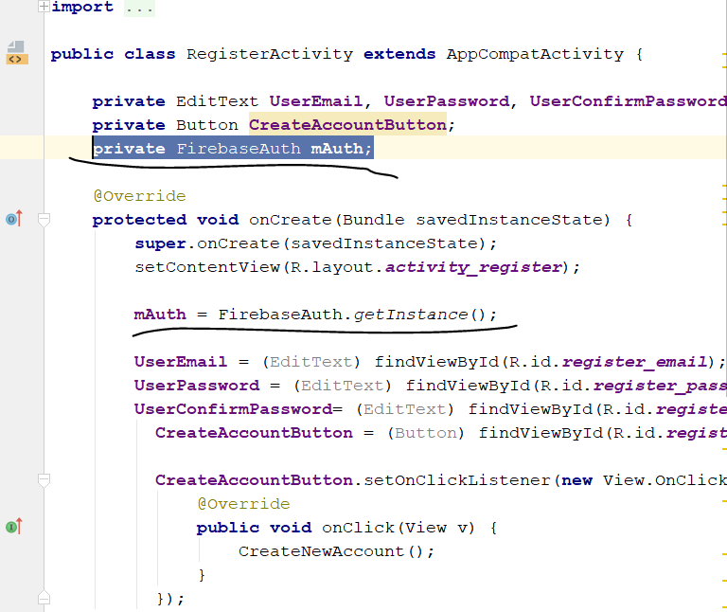
* Then add this
* private ProgressDialog loadingBar;
* add this two lines
* 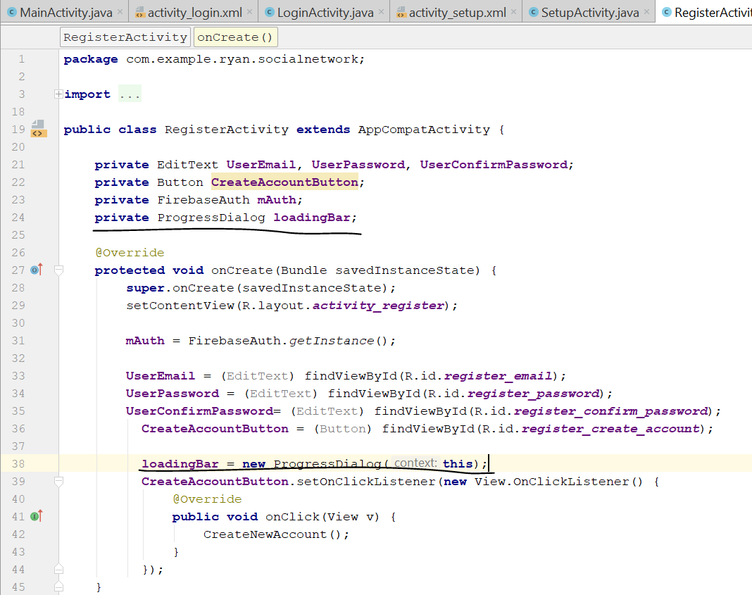
* Add the following code below
* **private void** CreateNewAccount() {  
   String email = **UserEmail**.getText().toString();  
   String password = **UserPassword**.getText().toString();  
   String confirmPassword = **UserConfirmPassword**.getText().toString();  
    
   **if**(TextUtils.*isEmpty*(email))  
   {  
   Toast.*makeText*(**this**, **"Please write your email..."**,Toast.***LENGTH_SHORT***);  
   }  
   **else if**(TextUtils.*isEmpty*(password))  
   {  
   Toast.*makeText*(**this**, **"Please write your password..."**,Toast.***LENGTH_SHORT***);  
   }  
   **else if**(TextUtils.*isEmpty*(confirmPassword))  
   {  
   Toast.*makeText*(**this**, **"Please confirm your password..."**,Toast.***LENGTH_SHORT***);  
   }  
   **else if**(!password .equals( confirmPassword))  
   {  
   Toast.*makeText*(**this**, **"Your password do not match with your confirm password..."**,Toast.***LENGTH_SHORT***);  
   }  
   **else** {  
   **loadingBar**.setTitle(**"Creating New Account"**);  
   **loadingBar**.setMessage(**"Please wait, while we are creating your new Account..."**);  
   **loadingBar**.show();  
   **loadingBar**.setCanceledOnTouchOutside(**true**);  
    
    
   **mAuth**.createUserWithEmailAndPassword(email, password)  
   .addOnCompleteListener(**new** OnCompleteListener<AuthResult>() {  
   @Override  
   **public void** onComplete(@NonNull Task<AuthResult> task) {  
   **if**(task.isSuccessful())  
   {  
   SendUserToSetupActivity();  
   Toast.*makeText*(RegisterActivity.**this**, **"You are authenicated successfully..."**, Toast.***LENGTH_SHORT***).show();  
   **loadingBar**.dismiss();  
   }  
   **else** {  
   String message = task.getException().getMessage();  
   Toast.*makeText*(RegisterActivity.**this**, **"Error occured: "** + message, Toast.***LENGTH_SHORT***).show();  
   **loadingBar**.dismiss();  
   }  
   }  
   });  
   }  
  }  
    
  **private void** SendUserToSetupActivity() {  
   Intent setupIntent = **new** Intent(RegisterActivity.**this**,SetupActivity.**class**);  
   setupIntent.addFlags(Intent.***FLAG_ACTIVITY_NEW_TASK***|Intent.***FLAG_ACTIVITY_CLEAR_TASK***);  
   startActivity(setupIntent);  
   finish();  
  }
* rebuild and run
* Now we do the logout Button
* Go to mainActivity
* You will see this
* 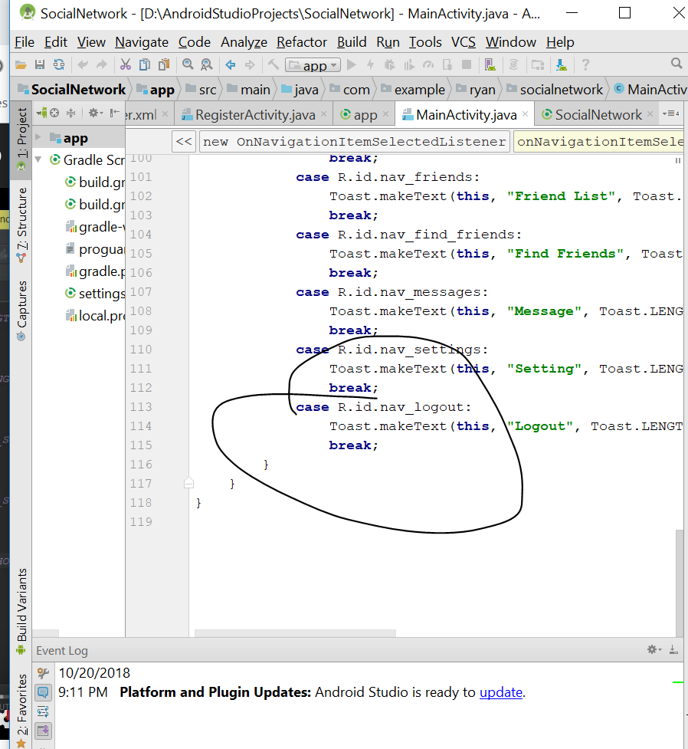
* You will see nav_logout, remove the toast message
* Add this
* SendUserToLoginActivity();
* 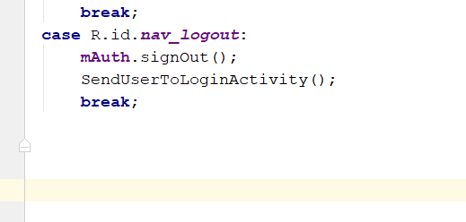
* Rebuild and run
* Now shld be able to log out
* Now we do the login Activity
* Now go to LoginActivity.java
* Go to here
* Declare this
* **private** FirebaseAuth **mAuth**;
* and this in the Oncreate()
* **mAuth** = FirebaseAuth.*getInstance*();
* Declare this
* private ProgressDialog loadingBar;
* and add this in the OnCreate()
* **loadingBar** = **new** ProgressDialog(**this**);
* 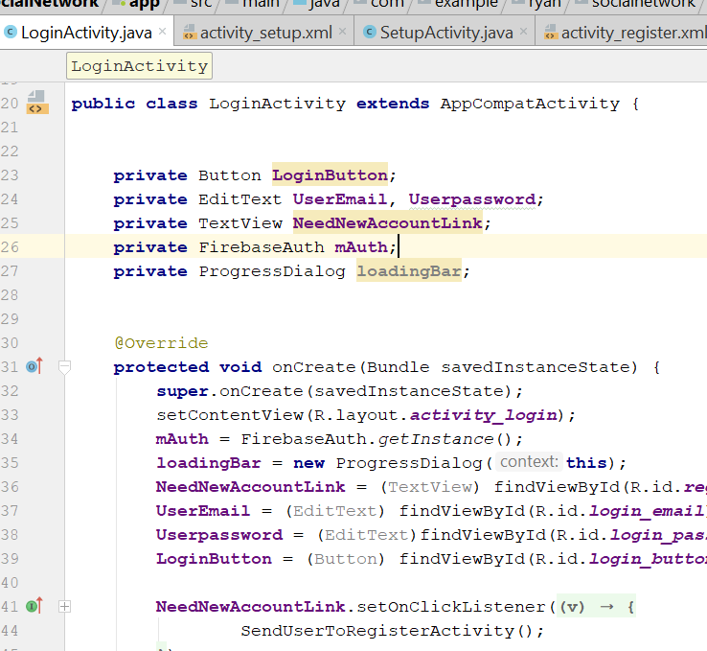
* Add your new code here
* 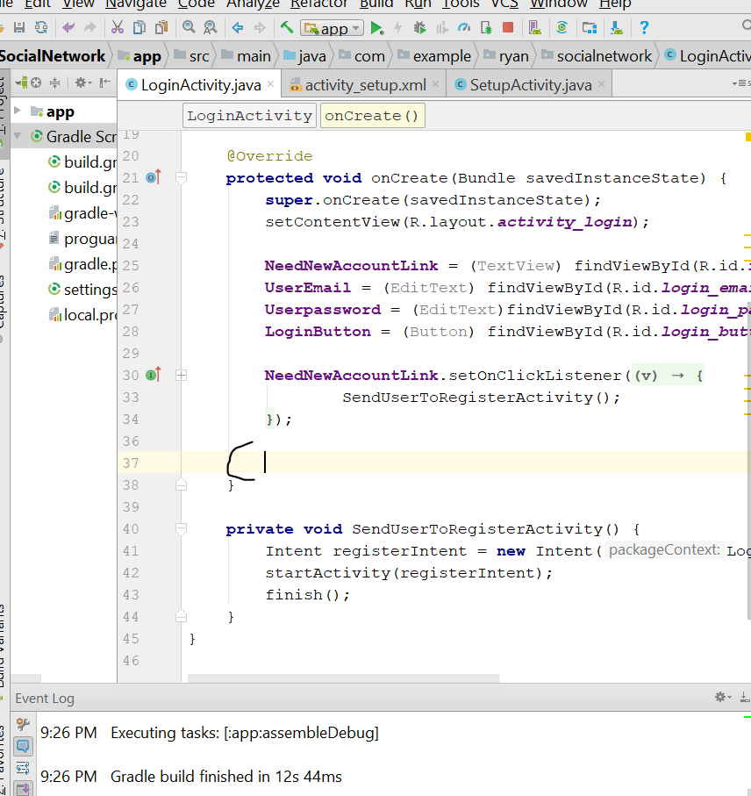
* **LoginButton**.setOnClickListener(**new** View.OnClickListener() {  
   @Override  
   **public void** onClick(View v) {  
   AllowingUserToLogin();  
   }  
   });  
  }  
    
  **private void** AllowingUserToLogin() {  
   String email = **UserEmail**.getText().toString();  
   String password = **Userpassword**.getText().toString();  
    
   **if**(TextUtils.*isEmpty*(email))  
   {  
   Toast.*makeText*(**this**, **"Please write your email..."**, Toast.***LENGTH_SHORT***).show();  
    
   }  
   **else if**(TextUtils.*isEmpty*(password))  
   {  
   Toast.*makeText*(**this**,**"Please write your password.."**, Toast.***LENGTH_SHORT***).show();  
    
   }  
   **else** {  
   **loadingBar**.setTitle(**"Login"**);  
   **loadingBar**.setMessage(**"Please wait, while we are allowing you to login your new Account..."**);  
   **loadingBar**.show();  
   **loadingBar**.setCanceledOnTouchOutside(**true**);  
    
   **mAuth**.signInWithEmailAndPassword(email,password)  
   .addOnCompleteListener(**new** OnCompleteListener<AuthResult>() {  
   @Override  
   **public void** onComplete(@NonNull Task<AuthResult> task) {  
   **if**(task.isSuccessful())  
   {  
   SendUserToMainActivity();  
   Toast.*makeText*(LoginActivity.**this**,**"you are Logged In"**, Toast.***LENGTH_SHORT***).show();  
   **loadingBar**.dismiss();  
   }  
   **else** {  
   String message = task.getException().getMessage();  
   Toast.*makeText*(LoginActivity.**this**,**"error occured: "**+ message, Toast.***LENGTH_SHORT***).show();  
   **loadingBar**.dismiss();  
   }  
   }  
   });  
   }  
  }  
    
  **private void** SendUserToMainActivity() {  
    
   Intent mainIntent = **new** Intent(LoginActivity.**this**, MainActivity.**class**);  
   mainIntent.addFlags(Intent.***FLAG_ACTIVITY_NEW_TASK***|Intent.***FLAG_ACTIVITY_CLEAR_TASK***);  
   startActivity(mainIntent);  
   finish();  
  }  
    
  **private void** SendUserToRegisterActivity() {  
   Intent registerIntent = **new** Intent(LoginActivity.**this**, RegisterActivity.**class**);  
   startActivity(registerIntent);  
   finish();  
  }
* 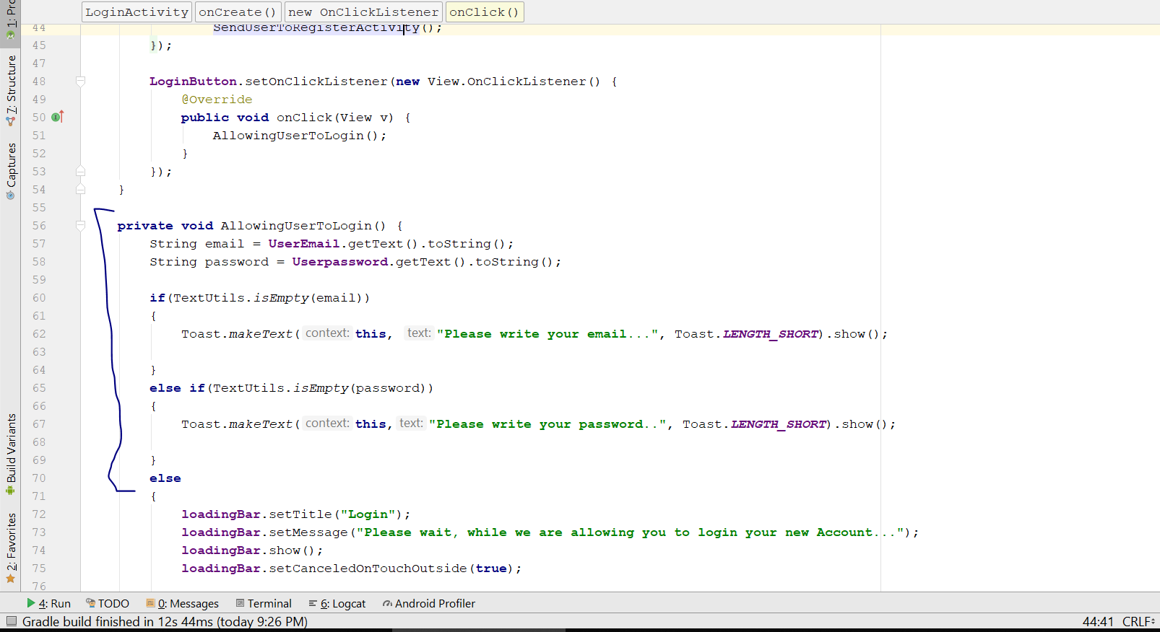
* Rebuild and Run
* You should be able to login now
* Go to Firebase> Go to database > Rules
* Change to "rules": { ".read": true, ".write": false}
* 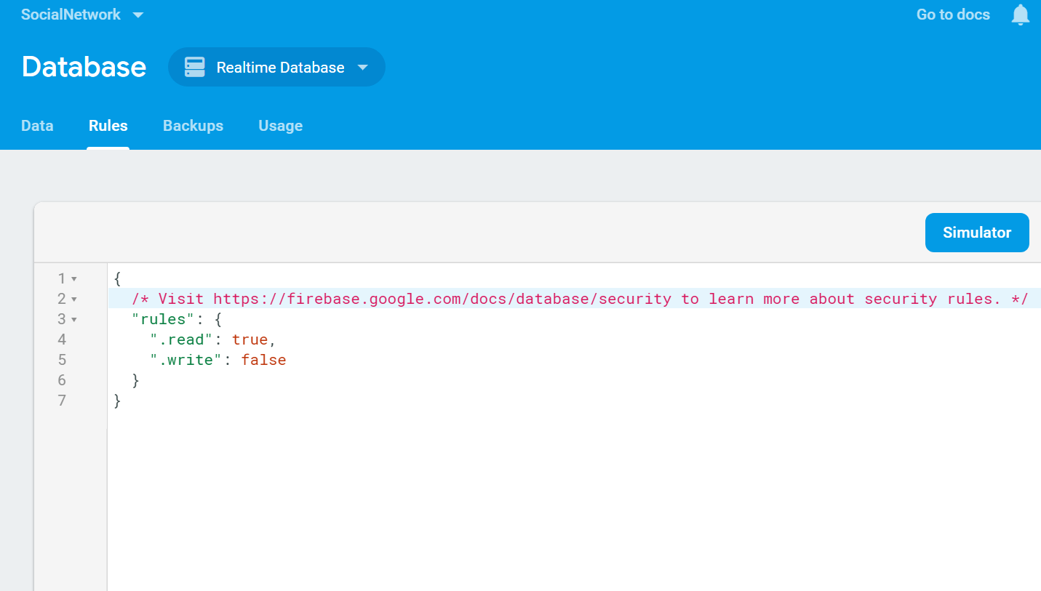
* Go to MainActivity.java
* Go to the OnStart()
* Change the code inside to this
* FirebaseUser currentUser = **mAuth**.getCurrentUser();  
  **if**(currentUser == **null**)  
  {  
   SendUserToLoginActivity();  
  }  
  **else**{  
   CheckUserExistence();  
  }
* 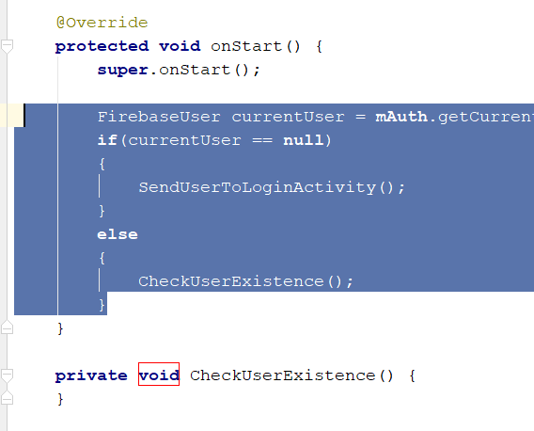
* Add this one top
* **private** DatabaseReference **UsersRef**;
* add this in onCreate();
* **UsersRef** = FirebaseDatabase.*getInstance*().getReference().child(**"Users"**);
* After the onStart(), add this code
* **private void** CheckUserExistence() {  
   **final** String current_user_id = **mAuth**.getCurrentUser().getUid();  
    
   **UsersRef**.addValueEventListener(**new** ValueEventListener() {  
   @Override  
   **public void** onDataChange(DataSnapshot dataSnapshot) {  
   **if**(!dataSnapshot.hasChild(current_user_id))  
   {  
   SendUserToSetupActivity();  
   }  
   }  
    
   @Override  
   **public void** onCancelled(DatabaseError databaseError) {  
    
   }  
   });  
    
  }  
    
  **private void** SendUserToSetupActivity() {  
   Intent SetupIntent = **new** Intent(MainActivity.**this**,SetupActivity.**class**);  
   SetupIntent.addFlags(Intent.***FLAG_ACTIVITY_NEW_TASK***|Intent.***FLAG_ACTIVITY_CLEAR_TASK***);  
   startActivity(SetupIntent);  
   finish();  
  }  
    
  **private void** SendUserToLoginActivity() {  
   Intent loginIntent = **new** Intent(MainActivity.**this**,LoginActivity.**class**);  
   loginIntent.addFlags(Intent.***FLAG_ACTIVITY_NEW_TASK***|Intent.***FLAG_ACTIVITY_CLEAR_TASK***);  
   startActivity(loginIntent);  
   finish();  
  }
* rebuild and run, you should see the app redirect user to the setup activity page if the user is wrong
* now go to loginActivity.java
* add this method
* @Override  
  **protected void** onStart() {  
   **super**.onStart();  
   FirebaseUser currentUser = **mAuth**.getCurrentUser();  
   **if**(currentUser != **null**)  
   {  
   SendUserToMainActivity();  
   }  
  }
* Rebuild and run
* Now go to registerActivity.java
* Add this code
* **protected void** onStart() {  
   **super**.onStart();  
   FirebaseUser currentUser = **mAuth**.getCurrentUser();  
   **if**(currentUser != **null**)  
   {  
   SendUserToMainActivity();  
   }  
  }  
    
  **private void** SendUserToMainActivity() {  
    
   Intent mainIntent = **new** Intent(RegisterActivity.**this**, MainActivity.**class**);  
   mainIntent.addFlags(Intent.***FLAG_ACTIVITY_NEW_TASK***|Intent.***FLAG_ACTIVITY_CLEAR_TASK***);  
   startActivity(mainIntent);  
   finish();  
  }

# Save user Information

* First make sure your rules in the database everything change to true
* 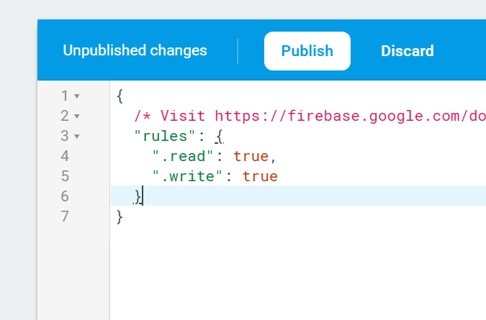
* Now go to SetupActivity.java
* Create this code on top
* **private** FirebaseAuth **mAuth**;  
  **private** DatabaseReference **UserRef**;
* String currentUserID;
* private ProgressDialog loadingBar;
* then in the onCreate() method
* **mAuth** = FirebaseAuth.*getInstance*();  
  **UserRef** = FirebaseDatabase.*getInstance*().getReference().child(**"Users"**).child(**currentUserID**);  
  **currentUserID** = **mAuth**.getCurrentUser().getUid();
* **loadingBar** = **new** ProgressDialog(**this**);
* Add this code below the profileimage
* **SaveInformationButton**.setOnClickListener(**new** View.OnClickListener() {  
   @Override  
   **public void** onClick(View v) {  
   SaveAccountSetupInformation();  
   }  
  });
* 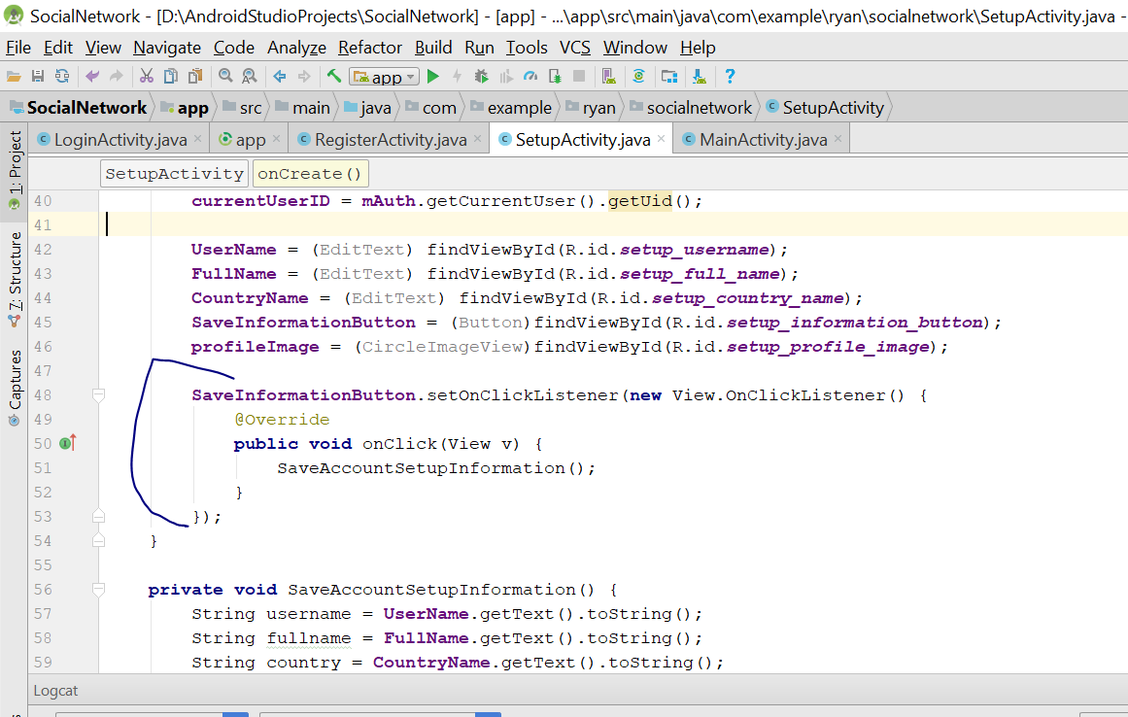
* Then add this code outside onCreate()
* **private void** SaveAccountSetupInformation() {  
   String username = **UserName**.getText().toString();  
   String fullname = **FullName**.getText().toString();  
   String country = **CountryName**.getText().toString();  
    
   **if** (TextUtils.*isEmpty*(username)) {  
   Toast.*makeText*(**this**, **"Please write your username..."**, Toast.***LENGTH_SHORT***).show();  
   } **else if** (TextUtils.*isEmpty*(fullname)) {  
   Toast.*makeText*(**this**, **"Please write your full name..."**, Toast.***LENGTH_SHORT***).show();  
    
   } **else if** (TextUtils.*isEmpty*(country)) {  
   Toast.*makeText*(**this**, **"Please write your country..."**, Toast.***LENGTH_SHORT***).show();  
   } **else** {  
    
   **loadingBar**.setTitle(**"Saving Information"**);  
   **loadingBar**.setMessage(**"Please wait, while we are creating your new Account..."**);  
   **loadingBar**.show();  
   **loadingBar**.setCanceledOnTouchOutside(**true**);  
    
   HashMap userMap = **new** HashMap();  
   userMap.put(**"username"**, username);  
   userMap.put(**"fullname"**, fullname);  
   userMap.put(**"country"**, country);  
   userMap.put(**"status"**, **"Hey here, I am using social Network, develop by Ryan"**);  
   userMap.put(**"gender"**, **"none"**);  
   userMap.put(**"dob"**, **""**);  
   userMap.put(**"relationshipstatus"**, **"none"**);  
   **UserRef**.updateChildren(userMap).addOnCompleteListener(**new** OnCompleteListener() {  
   @Override  
   **public void** onComplete(@NonNull Task task) {  
   **if** (task.isSuccessful()) {  
   SendUserToMainActivity();  
   Toast.*makeText*(SetupActivity.**this**, **"your Account is created Successfully"**, Toast.***LENGTH_LONG***).show();  
   **loadingBar**.dismiss();  
    
   } **else** {  
   String message = task.getException().getMessage();  
   Toast.*makeText*(SetupActivity.**this**, **"Error Occured: "** + message, Toast.***LENGTH_SHORT***).show();  
   **loadingBar**.dismiss();  
   }  
   }  
   });  
    
   }  
  }  
    
  **private void** SendUserToMainActivity() {  
   Intent mainIntent = **new** Intent(SetupActivity.**this**, MainActivity.**class**);  
   mainIntent.addFlags(Intent.***FLAG_ACTIVITY_NEW_TASK***|Intent.***FLAG_ACTIVITY_CLEAR_TASK***);  
   startActivity(mainIntent);  
   finish();  
  }
* Now go to android manifest
* Add this line
* <uses-permission android:name="android.permission.INTERNET"></uses-permission>
* 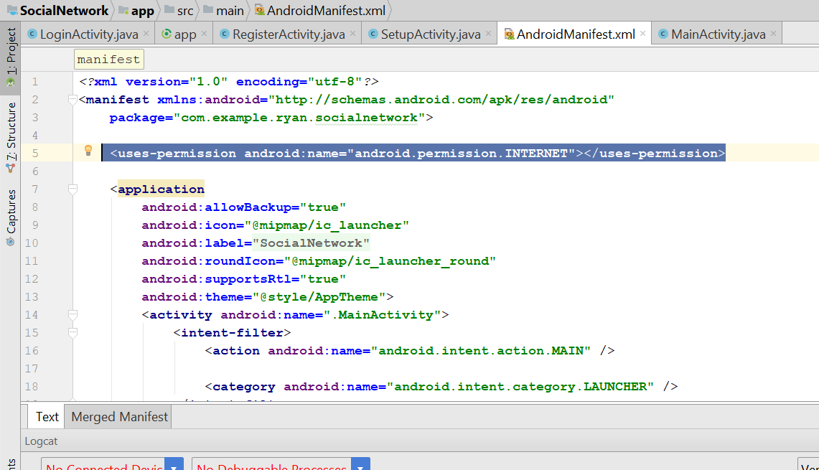
* Rebuild and run
* You should see this in the database
* 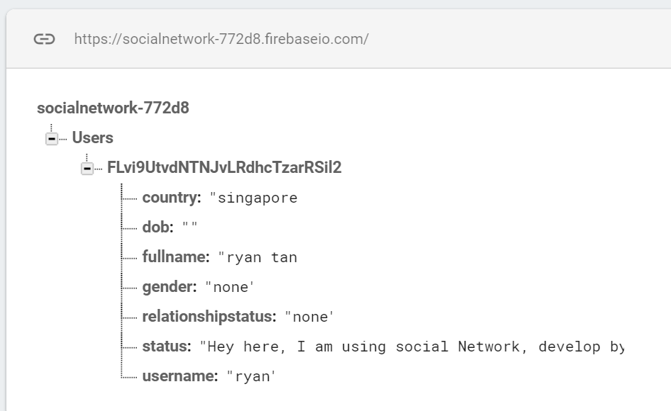

# Profile Image

* Go to SetupActivity.java
* Declare this on top
* final static int *Gallery_Pick* = 1;
* 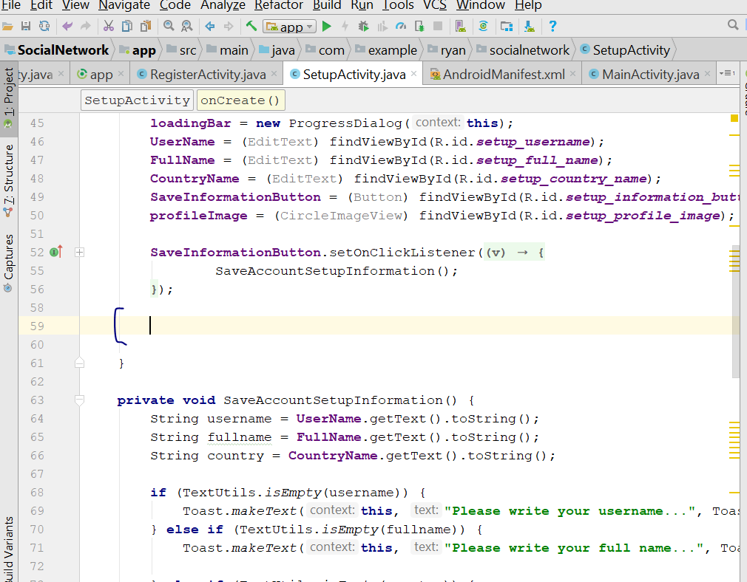
* Write your code here, after the SaveInformatiobutton.setOnClickListener
* **profileImage**.setOnClickListener(**new** View.OnClickListener() {  
   @Override  
   **public void** onClick(View v) {  
   Intent galleryIntent = **new** Intent();  
   galleryIntent.setAction(Intent.***ACTION_GET_CONTENT***);  
   galleryIntent.setType((**"image/*"**));  
   startActivityForResult(galleryIntent,***Gallery_Pick***);  
   }  
  });
* rebuild and run, when u create a new user, you should see the option to select image when u click on the profile pic
* go and get the library from here
* <https://github.com/ArthurHub/Android-Image-Cropper>
* 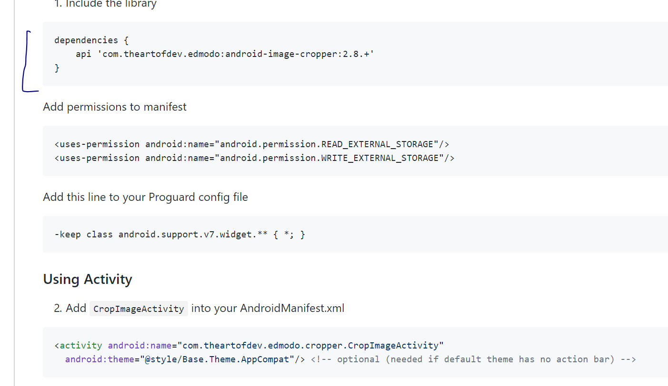
* Copy the library API
* Then go to app build.gradle
* Add this line below
* implementation 'com.theartofdev.edmodo:android-image-cropper:2.6.+'
* 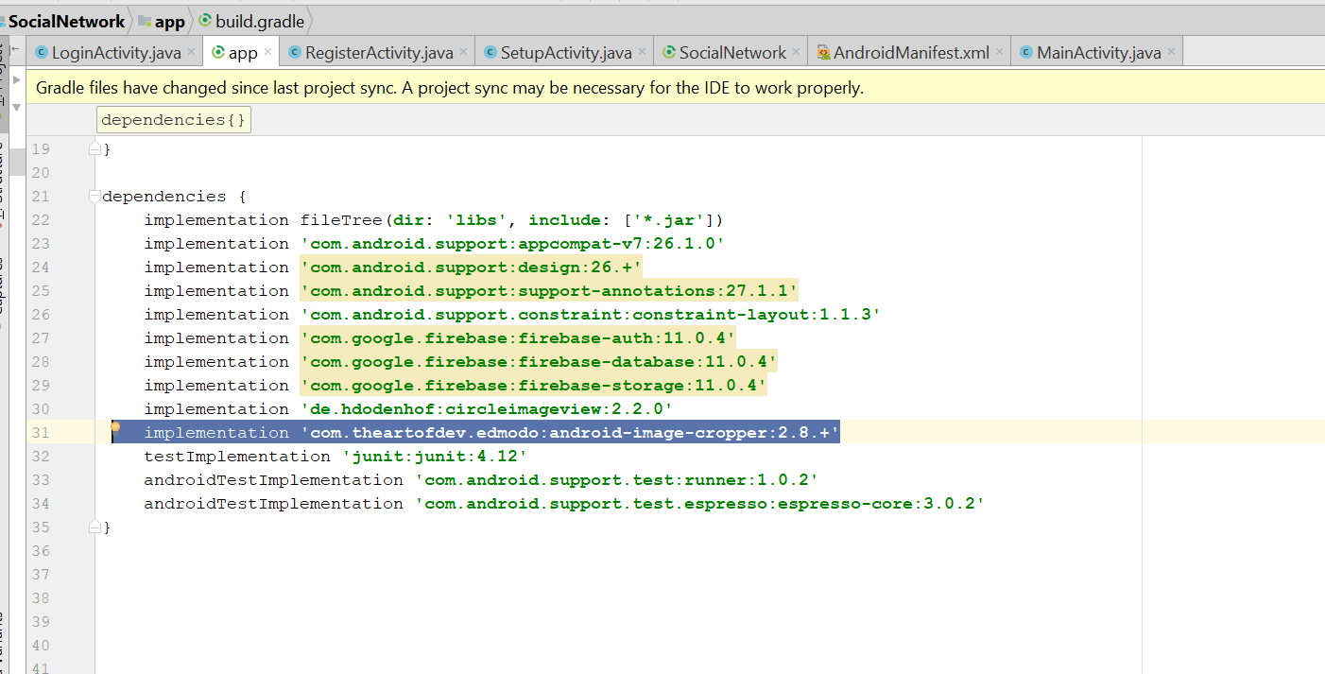
* Sync now
* Now it should show build okay
* Add the permission
* 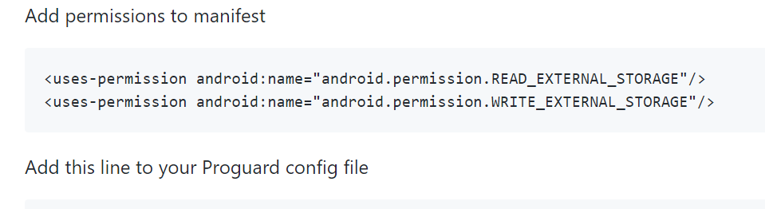
* Paste this code in the android Manifest file
* <uses-permission android:name="android.permission.READ_EXTERNAL_STORAGE"/>  
  <uses-permission android:name="android.permission.WRITE_EXTERNAL_STORAGE"/>
* Copy this line
* 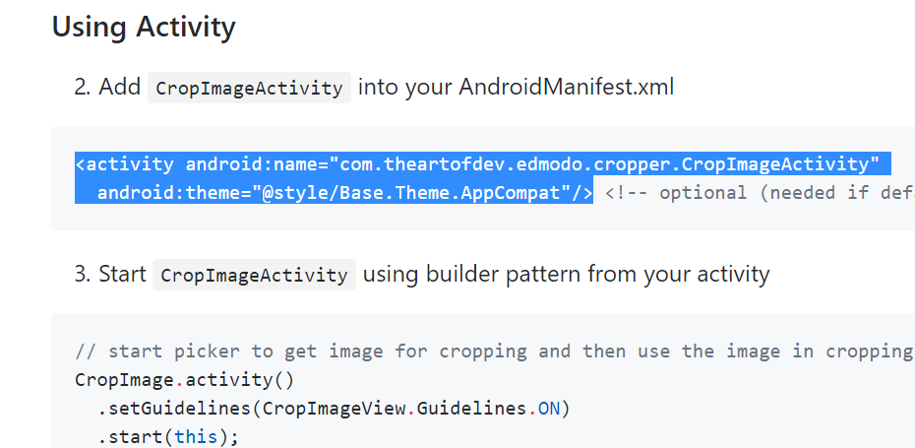
* <activity android:name="com.theartofdev.edmodo.cropper.CropImageActivity"
* android:theme="@style/Base.Theme.AppCompat"/>
* Paste in the Android Manifest
* 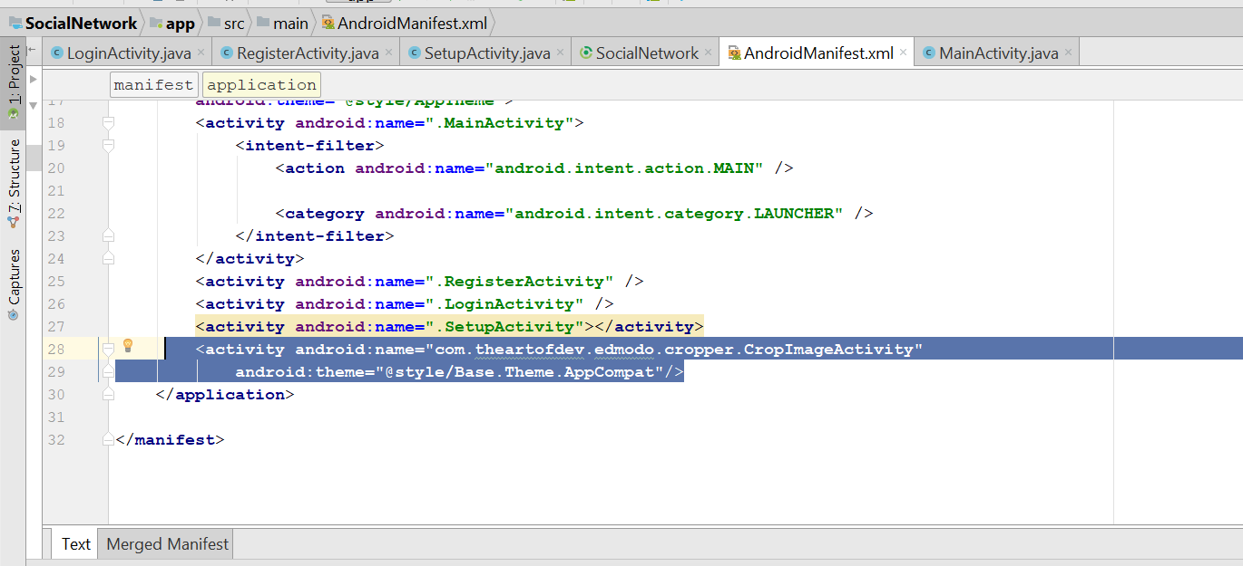
* In the setupActivity.java
* Add the following code
* @Override  
  **protected void** onActivityResult(**int** requestCode, **int** resultCode, Intent data) {  
   **super**.onActivityResult(requestCode, resultCode, data);  
   **if**(requestCode==***Gallery_Pick*** && resultCode==***RESULT_OK*** && data!=**null**)  
   {  
   Uri ImageUri = data.getData();  
   CropImage.*activity*().setGuidelines(CropImageView.Guidelines.***ON***)  
   .setAspectRatio(1,1)  
   .start(**this**);  
   }  
    
   **if**(requestCode==CropImage.***CROP_IMAGE_ACTIVITY_REQUEST_CODE***)  
   {  
   CropImage.ActivityResult result = CropImage.*getActivityResult*(data);  
   **if**(requestCode == ***RESULT_OK***)  
   {  
   Uri resultUri = result.getUri();  
   }  
    
   }  
    
  }
* 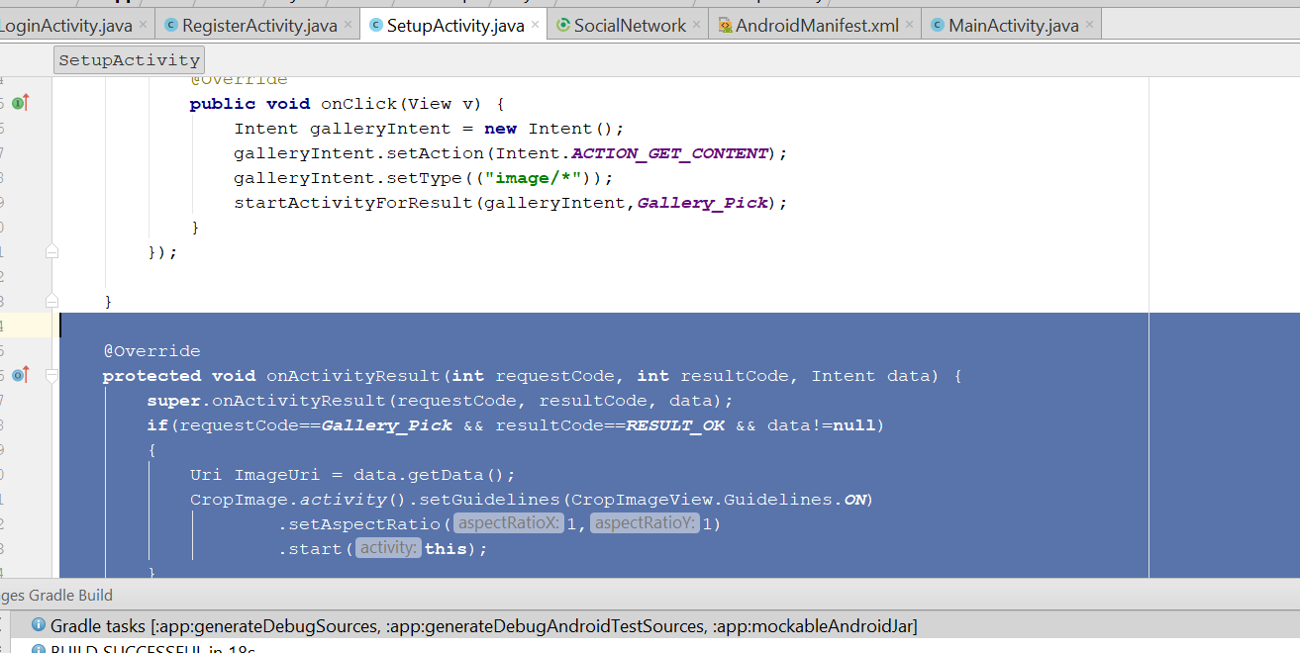
* Rebuild & Run
* Error Encounter:
* Error:Execution failed for task ':app:transformDexArchiveWithExternalLibsDexMergerForDebug'. > java.lang.RuntimeException: com.android.builder.dexing.DexArchiveMergerException: Unable to merge dex
* Solution: check the gradle, make sure the version is 11.2.0
* Add this line
* implementation 'com.google.android.gms:play-services:11.2.0'
* implementation 'com.android.support:multidex:1.0.2'
* Now you should be able to run successfully
* Now you should able to crop the image successfully with the crop image lib
* Back to the SetupActivity.java, add this line
* private StorageReference UserProfileImageRef;
* On the onCreate(), add this line
* **UserProfileImageRef** = FirebaseStorage.*getInstance*().getReference().child(**"profile Images"**);
* Change the protected void onActivityResult
* **protected void** onActivityResult(**int** requestCode, **int** resultCode, Intent data) {  
   **super**.onActivityResult(requestCode, resultCode, data);  
   **if**(requestCode==***Gallery_Pick*** && resultCode==***RESULT_OK*** && data!=**null**)  
   {  
    
   Uri ImageUri = data.getData();  
   CropImage.*activity*().setGuidelines(CropImageView.Guidelines.***ON***)  
   .setAspectRatio(1,1)  
   .start(**this**);  
   }  
    
   **if**(requestCode==CropImage.***CROP_IMAGE_ACTIVITY_REQUEST_CODE***)  
   {  
   **loadingBar**.setTitle(**"Profile Image"**);  
   **loadingBar**.setMessage(**"Please wait, while we are updating your profile image..."**);  
   **loadingBar**.show();  
   **loadingBar**.setCanceledOnTouchOutside(**true**);  
   CropImage.ActivityResult result = CropImage.*getActivityResult*(data);  
   **if**(resultCode == ***RESULT_OK***)  
   {  
   Uri resultUri = result.getUri();  
   StorageReference filePath = **UserProfileImageRef**.child(**currentUserID** + **".jpg"**);  
   filePath.putFile(resultUri).addOnCompleteListener(**new** OnCompleteListener<UploadTask.TaskSnapshot>() {  
   @Override  
   **public void** onComplete(@NonNull Task<UploadTask.TaskSnapshot> task) {  
   **if**(task.isSuccessful())  
   {  
   Toast.*makeText*(SetupActivity.**this**,**"Profile Image stored successfully to Firebase storage..."**, Toast.***LENGTH_SHORT***).show();  
   **final** String downloadUrl = task.getResult().getDownloadUrl().toString();  
   **UserRef**.child(**"profileimage"**).setValue(downloadUrl)  
   .addOnCompleteListener(**new** OnCompleteListener<Void>() {  
   @Override  
   **public void** onComplete(@NonNull Task<Void> task) {  
   **if**(task.isSuccessful())  
   {  
   Intent selfIntent = **new** Intent(SetupActivity.**this**, SetupActivity.**class**);  
   startActivity(selfIntent);  
   Toast.*makeText*(SetupActivity.**this**,**"Profile Image stored to Firebase Database Successfully.."**,Toast.***LENGTH_SHORT***).show();  
   **loadingBar**.dismiss();  
   }  
   **else** {  
   String message = task.getException().getMessage();  
   Toast.*makeText*(SetupActivity.**this**,**"Error Occurred :"** + message,Toast.***LENGTH_SHORT***).show();  
   **loadingBar**.dismiss();  
   }  
   }  
   });  
   }  
   }  
   });  
    
   }  
   **else** {  
   Toast.*makeText*(**this**,**"Error occured: Images cannot be cropped. Try again."**,Toast.***LENGTH_SHORT***).show();  
   **loadingBar**.dismiss();  
   }  
    
   }  
    
  }
* Now go to firebase > storage > get started
* 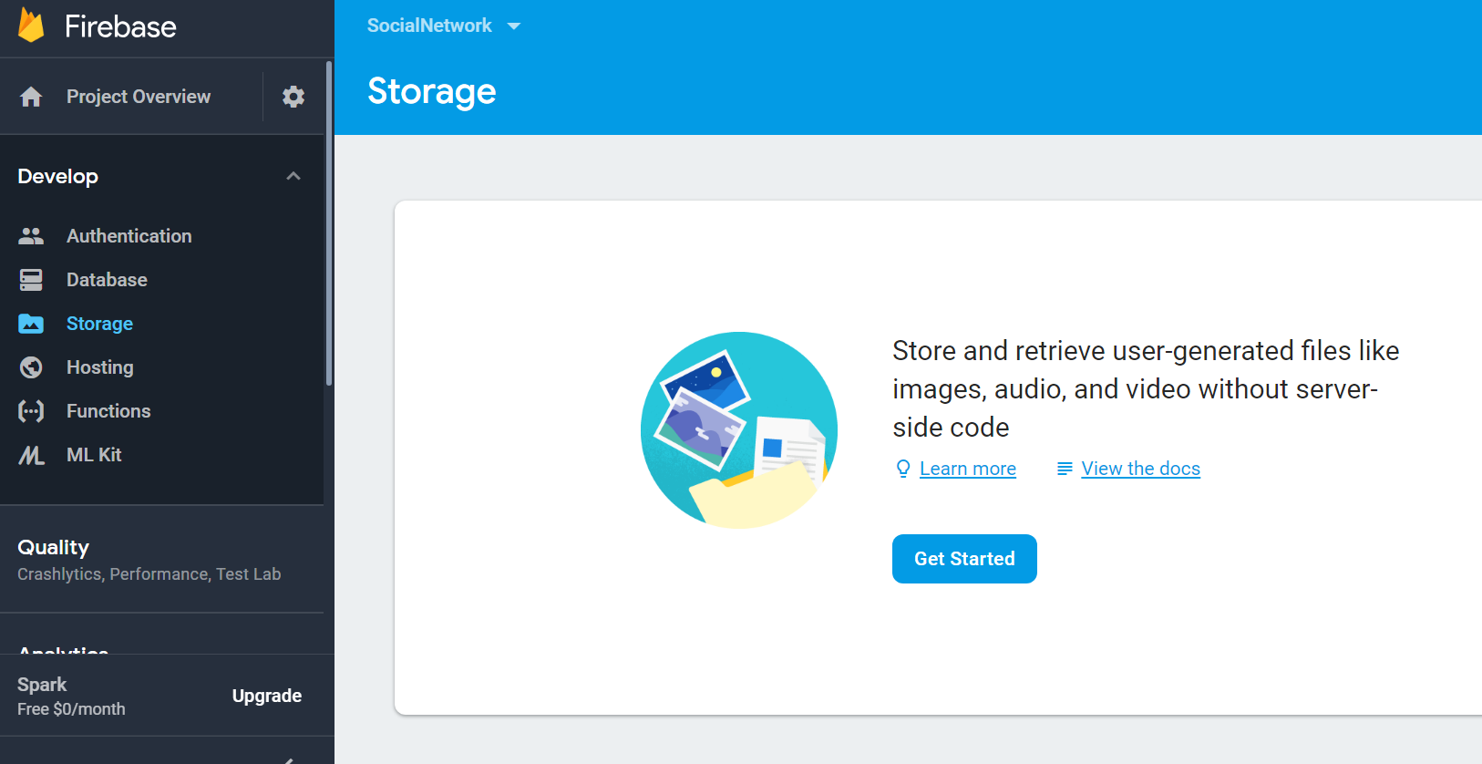
* Rebuild and run
* You should be able to see this after cropping your image and save
* 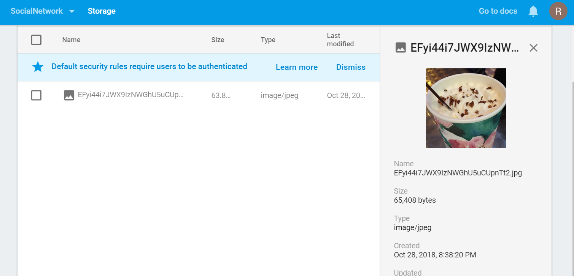
* Now go to setupActivity.java
* Go to <http://square.github.io/picasso/>
* Copy the gradle
* 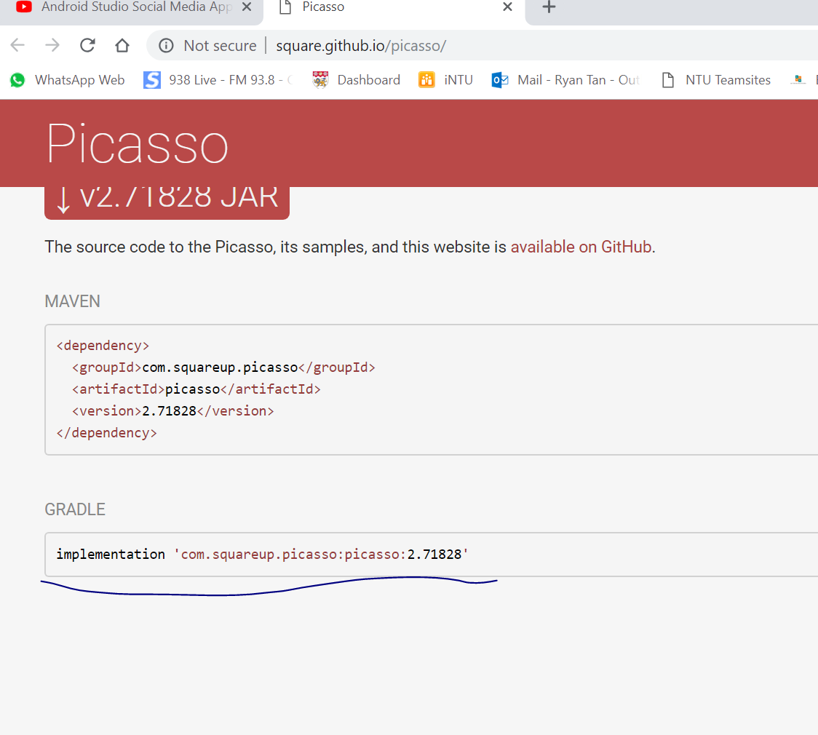
* Paste it on the build.gradle and sync now
* implementation 'com.squareup.picasso:picasso:2.71828'
* add this code
* **UserRef**.addValueEventListener(**new** ValueEventListener() {  
   @Override  
   **public void** onDataChange(DataSnapshot dataSnapshot) {  
   **if**(dataSnapshot.exists())  
   {  
   String image = dataSnapshot.child(**"profileimage"**).getValue().toString();  
   Picasso.*get*().load(image).placeholder(R.drawable.***profile***).into(**profileImage**);  
   }  
   }  
    
   @Override  
   **public void** onCancelled(DatabaseError databaseError) {  
    
   }  
  });
* After the this line
* 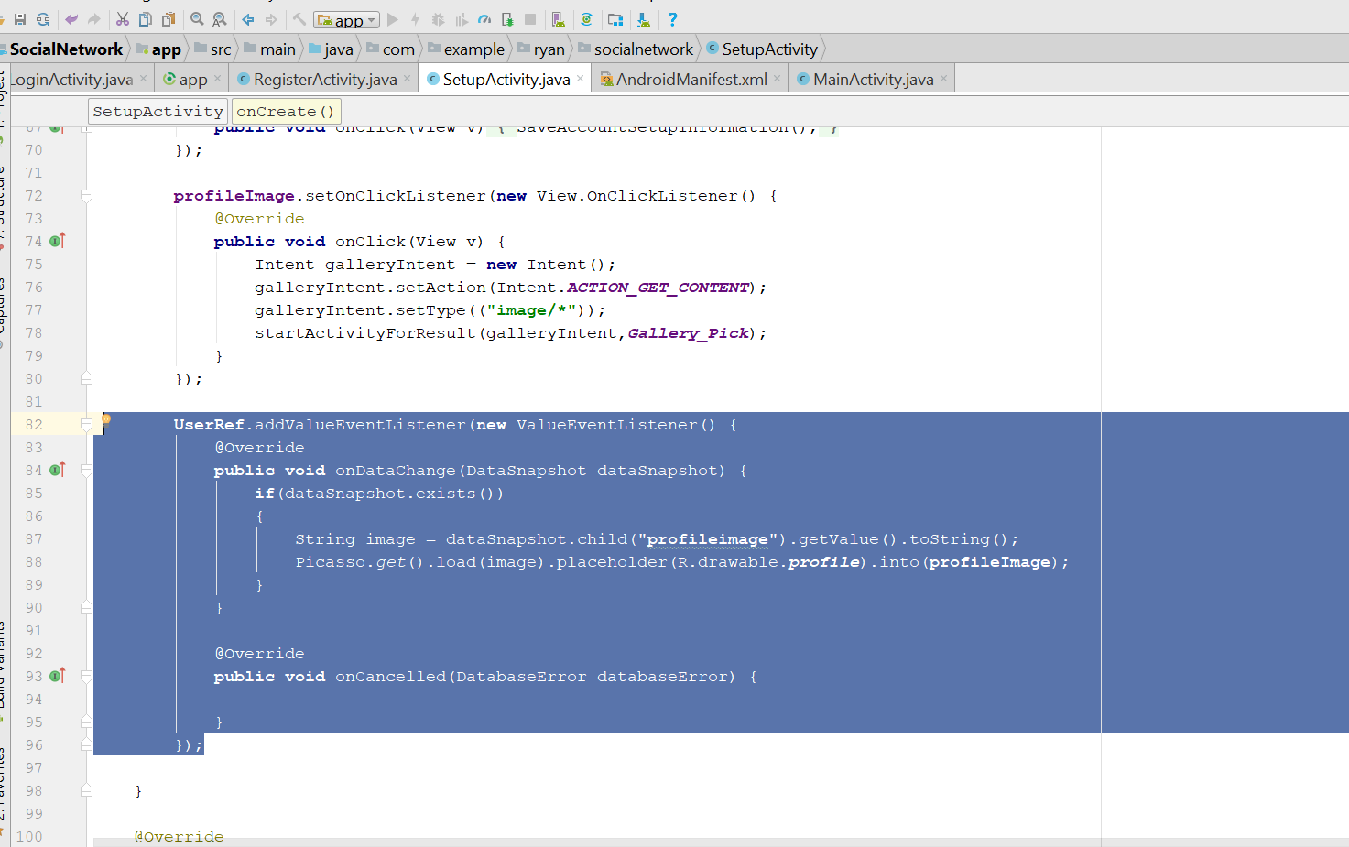
* Rebuild and run
* Image shld be able to display when u crop a image at new user

# Navigation header image

* Now we have to do the navigation image header
* Now go to Mainactivity.java
* Add this on top
* private TextView NavProfileUsername;
* String currentUserID;
* in the onCreate() method
* add this codes
* **NavProfileImage** = (CircleImageView) navView.findViewById(R.id.***nav_profile_image***);  
  **NavProfileUsername** = (TextView) navView.findViewById(R.id.***nav_user_full_name***);
* After mAuth
* Add this line
* 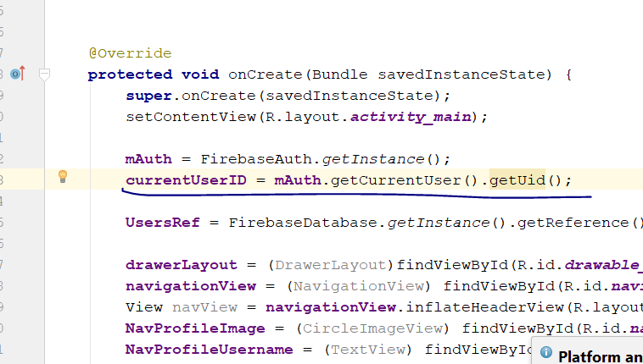
* Add this line after the NavProfileUsername
* **UsersRef**.child(**currentUserID**).addValueEventListener(**new** ValueEventListener() {  
   @Override  
   **public void** onDataChange(DataSnapshot dataSnapshot) {  
   **if**(dataSnapshot.exists())  
   {  
   String fullname = dataSnapshot.child(**"fullname"**).getValue()  
   .toString();  
   String image = dataSnapshot.child(**"profileimage"**).getValue()  
   .toString();  
    
   **NavProfileUsername**.setText(fullname);  
   Picasso.*get*().load(image).placeholder(R.drawable.***profile***).into(**NavProfileImage**);  
    
   }  
   }  
    
   @Override  
   **public void** onCancelled(DatabaseError databaseError) {  
    
   }  
  });
* 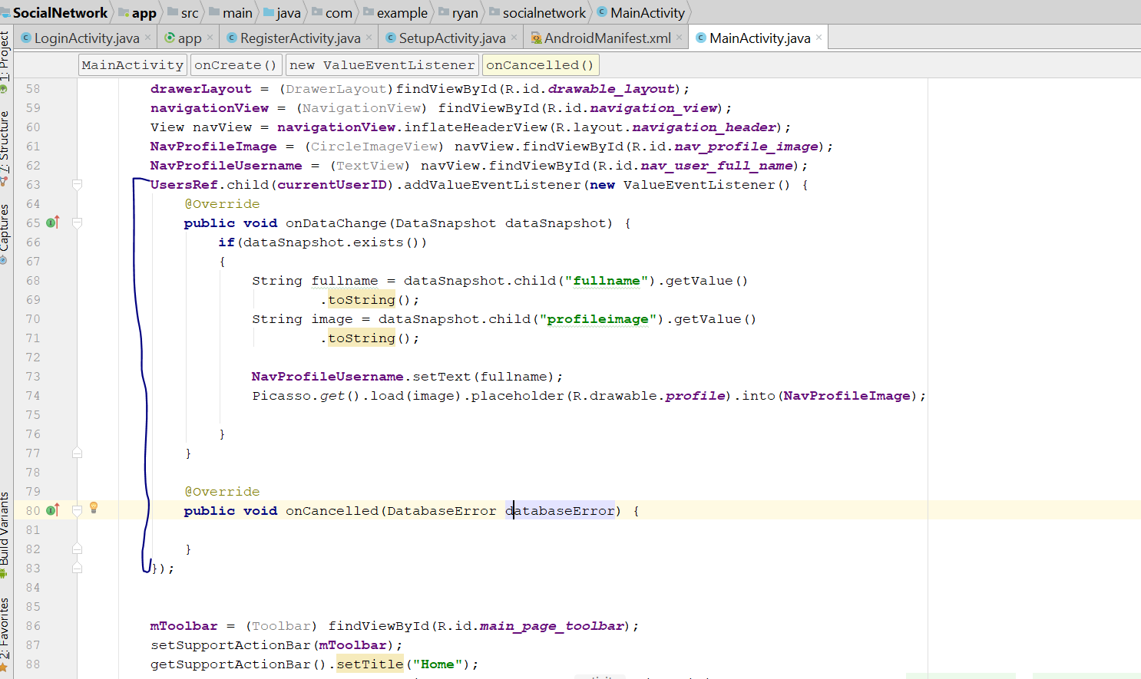
* Rebuild and run, you should see the image on the side

# Add validation

* Go to the mainActiivity.java
* In the Oncreate method, change the the onDataChanged() to this
* **public void** onDataChange(DataSnapshot dataSnapshot) {  
   **if**(dataSnapshot.exists())  
   {  
    
   **if**(dataSnapshot.hasChild(**"fullname"**))  
   {  
   String fullname = dataSnapshot.child(**"fullname"**).getValue().toString();  
   **NavProfileUsername**.setText(fullname);  
   }  
   **if**(dataSnapshot.hasChild(**"profileimage"**)){  
   String image = dataSnapshot.child(**"profileimage"**).getValue().toString();  
    
    
   Picasso.*get*().load(image).placeholder(R.drawable.***profile***).into(**NavProfileImage**);  
   }  
   **else** {  
   Toast.*makeText*(MainActivity.**this**,**"Profile Name do not exist.."**,Toast.***LENGTH_SHORT***).show();  
   }  
    
    
    
    
    
   }  
  }
* Now go to setupActivity.java
* Change the onDataChanged to this
* **public void** onDataChange(DataSnapshot dataSnapshot) {  
   **if**(dataSnapshot.exists())  
   {  
   **if**(dataSnapshot.hasChild(**"profileimage"**)) {  
   String image = dataSnapshot.child(**"profileimage"**).getValue().toString();  
   Picasso.*get*().load(image).placeholder(R.drawable.***profile***).into(**profileImage**);  
   }  
   **else** {  
   Toast.*makeText*(SetupActivity.**this**,**"Please select profile image first."**,Toast.***LENGTH_SHORT***).show();;  
   }  
   }  
  }
* 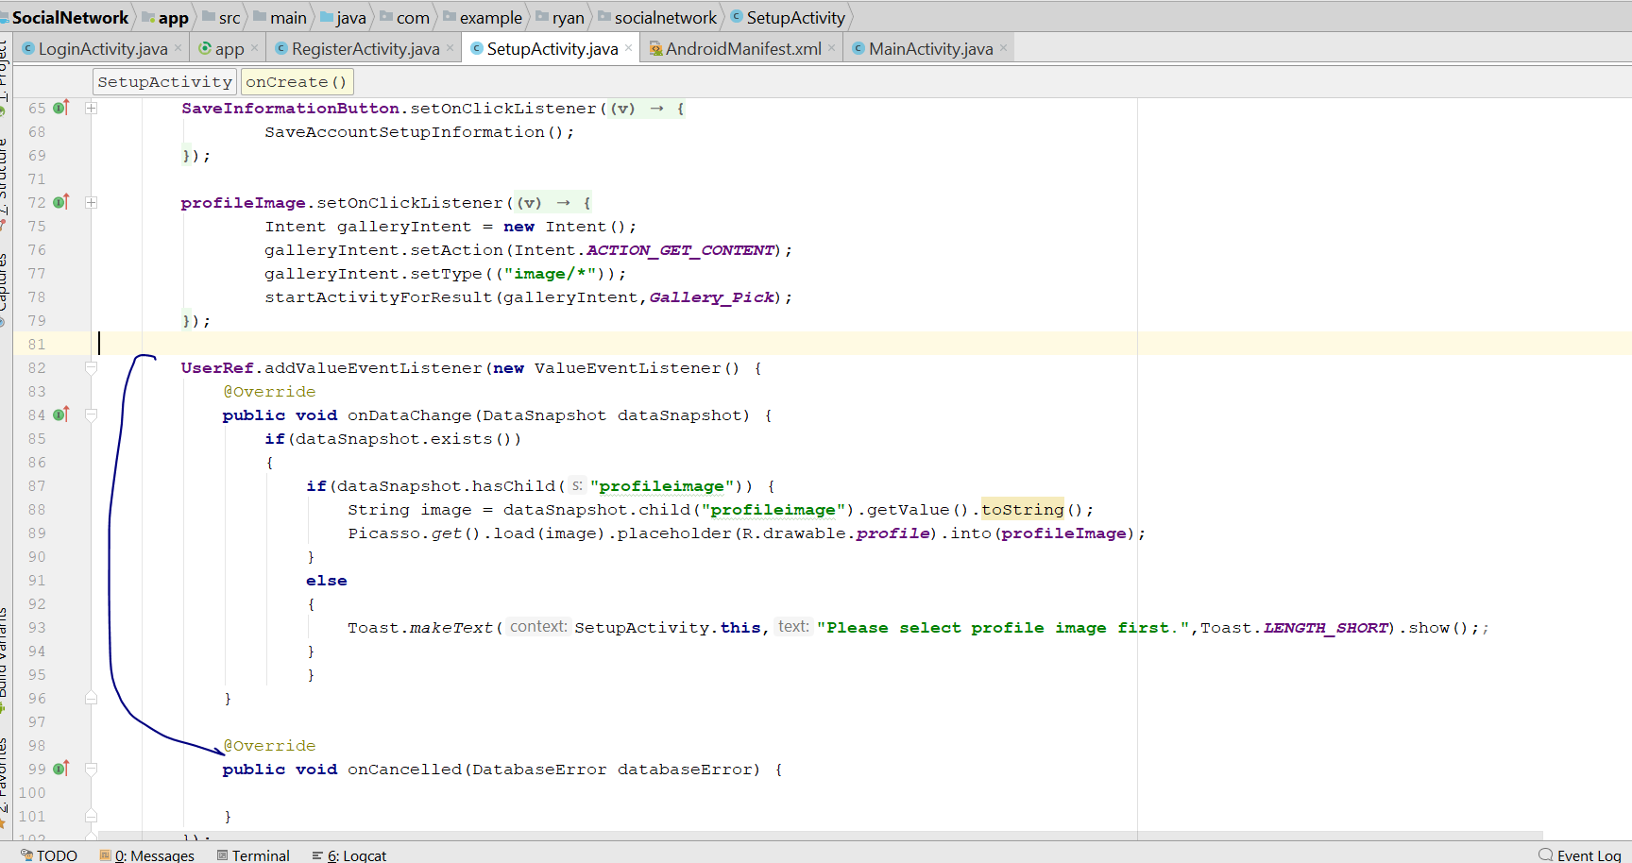
* Now go to android Manifest
* Cut the Intent -filter from MainActivity
* 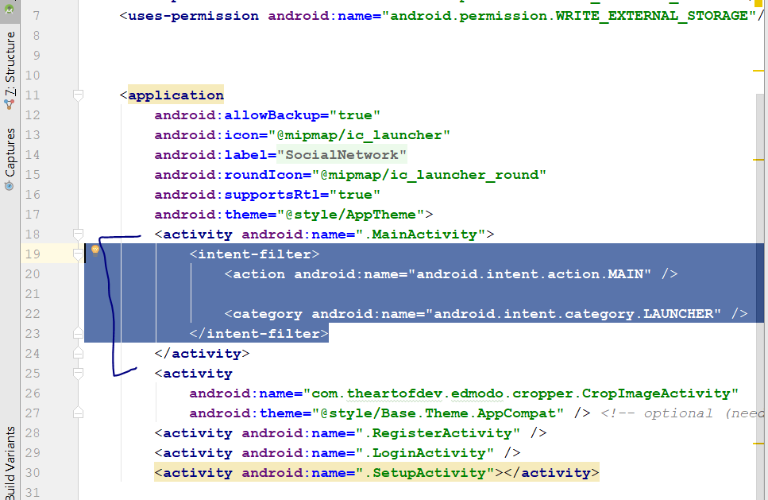
* Cut this, the past in the LoginActivity, like this
* 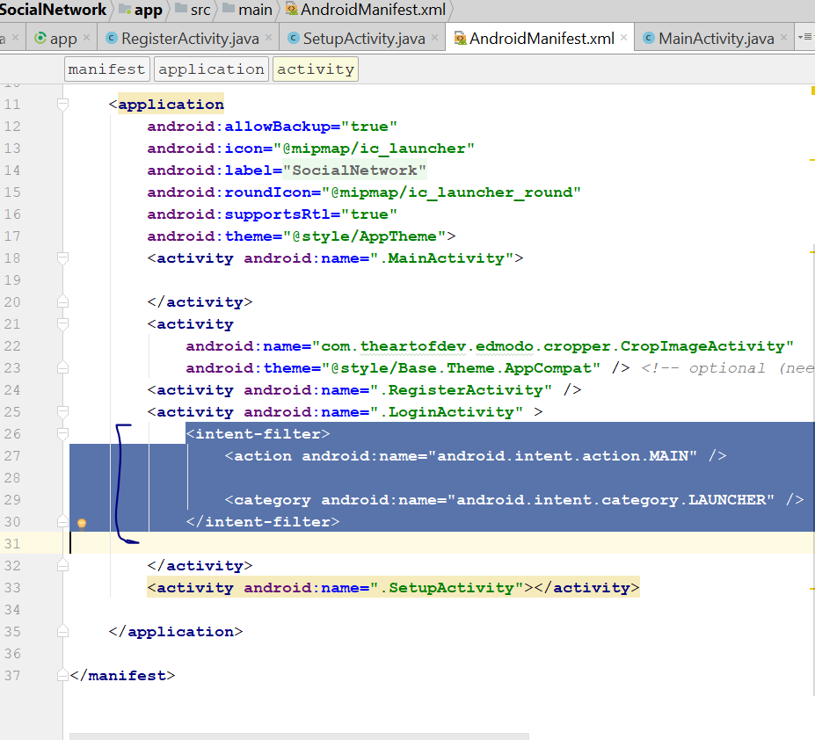
* Paste it here
* Rebuild and run, if you logout, you should start in Login Activity, and if you nvr logout, you will be in MainActivity, even if your restart.

# Add new post

* Create a button on the top Right corner
* Go to Activity_main.xml
* Add your new code here
* 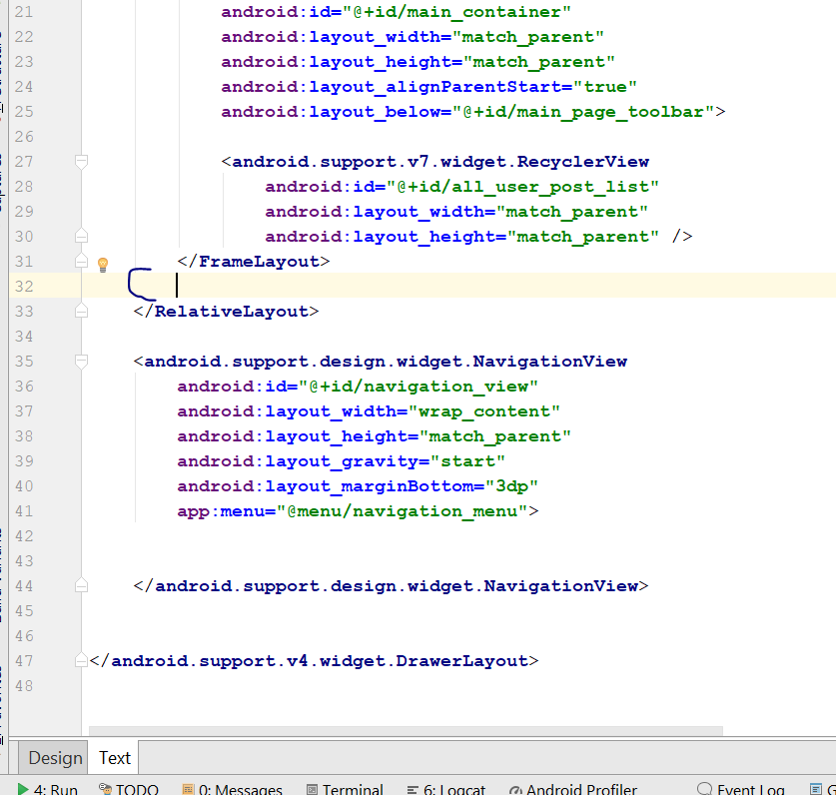
* <ImageButton  
   android:id="@+id/add_new_post_button"  
   android:layout_width="48dp"  
   android:layout_height="48dp"  
   android:layout_above="@id/main_container"  
   android:layout_alignParentEnd="true"  
   android:src="@drawable/add_post_high"  
   android:scaleType="centerCrop"  
   android:layout_marginBottom="4dp"  
   android:layout_marginRight="12dp"  
   android:background="@color/colorPrimaryDark"  
   android:baselineAlignBottom="false"  
   android:focusableInTouchMode="false"  
   />
* 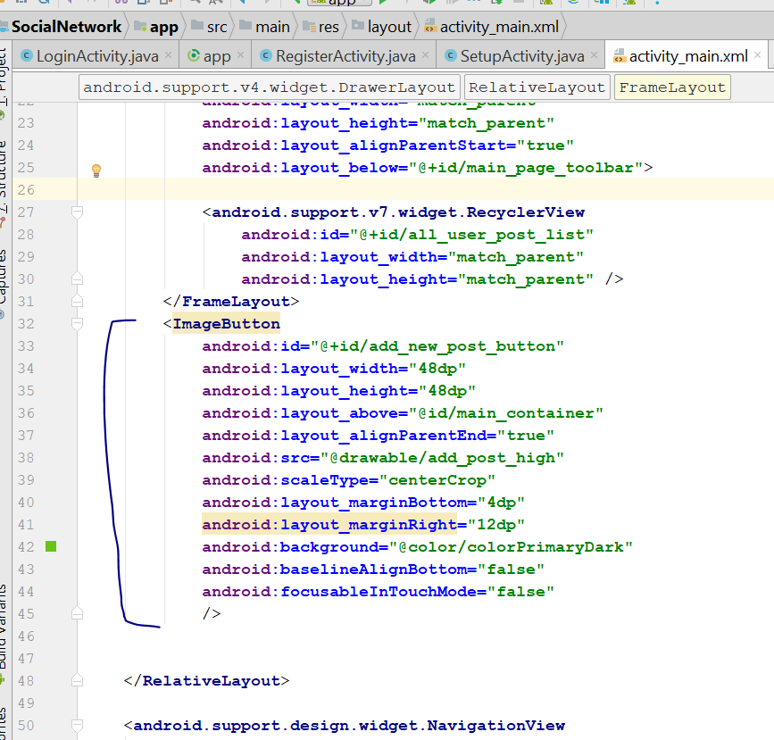
* If u do everything correctly, now should look this
* 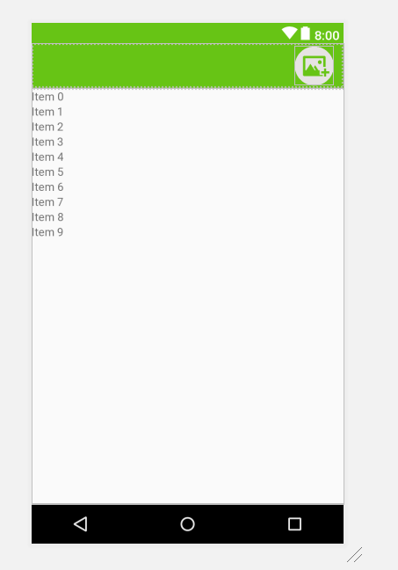
* Now go to MainActivity.java
* Add this
* private ImageButton AddNewPostButton;
* Then in the onCreate(), add this line
* **AddNewPostButton** = (ImageButton) findViewById(R.id.***add_new_post_button***);
* **AddNewPostButton**.setOnClickListener(**new** View.OnClickListener() {  
   @Override  
   **public void** onClick(View v) {  
     
   }  
  });
* Now create new Activity
* Create empty Activity> PostActivity
* 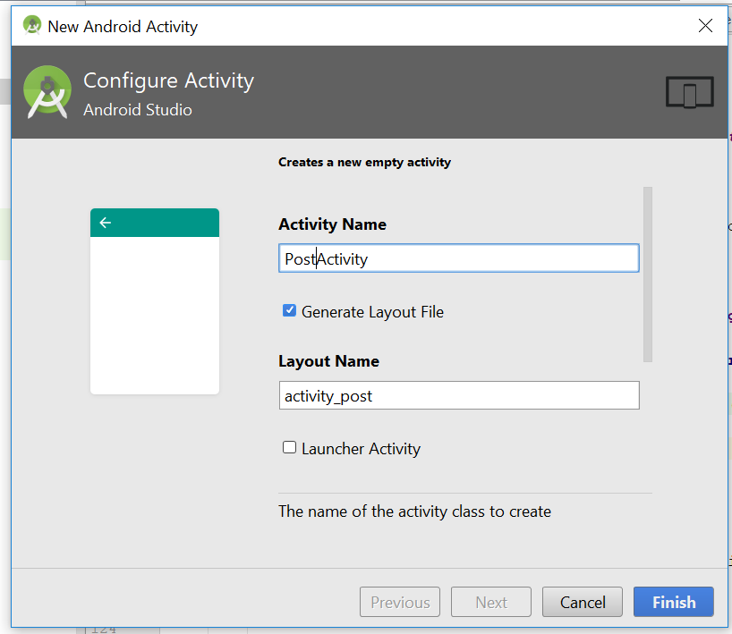
* Add this line on MainActivity
* SendUserToPostActivity();
* 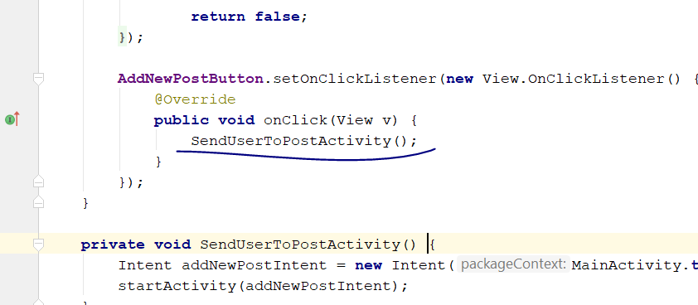
* Then add this method
* **private void** SendUserToPostActivity() {  
   Intent addNewPostIntent = **new** Intent(MainActivity.**this**, PostActivity.**class**);  
   startActivity(addNewPostIntent);  
  }
* In the UserMenuSelector Method, add this
* **case** R.id.***nav_post***:  
   SendUserToPostActivity();  
   **break**;
* 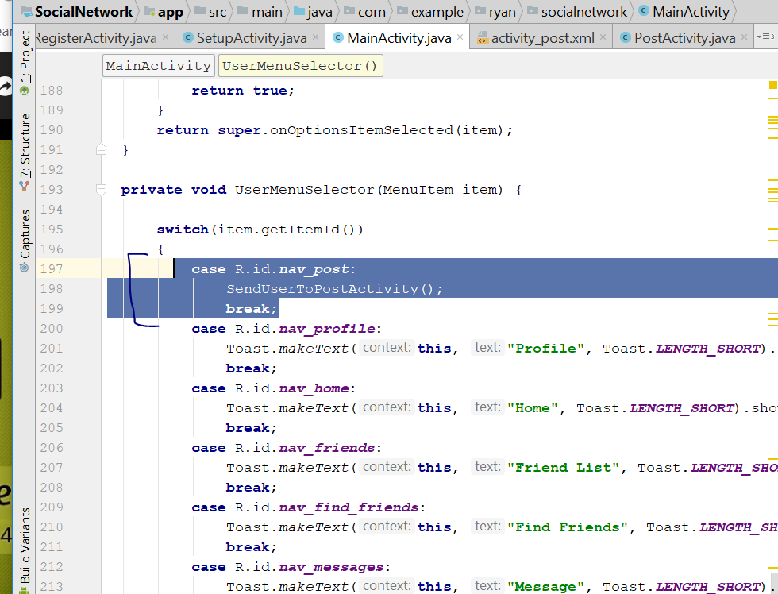
* Rebuild and run, if you tap on add new post, should bring you to the PostActivity
* Now go to activity_post.xml, change to relative_layout
* 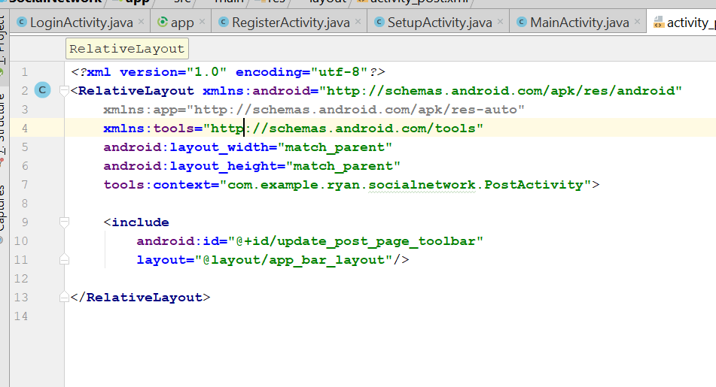
* Add this code
* <include  
    
   android:id="@+id/update_post_page_toolbar"  
   layout="@layout/app_bar_layout"/>
* 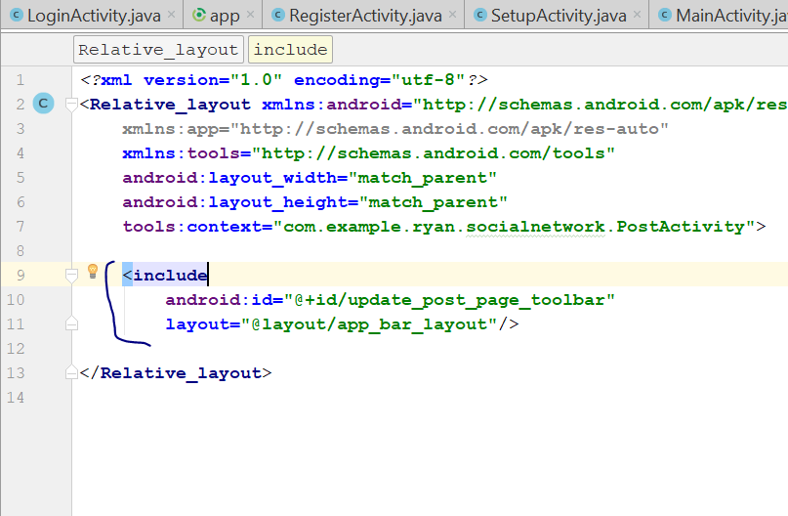
* Go to PostActivity.java
* Add this code
* **private** Toolbar **mToolbar**;  
    
  @Override  
  **protected void** onCreate(Bundle savedInstanceState) {  
   **super**.onCreate(savedInstanceState);  
   setContentView(R.layout.***activity_post***);  
    
   **mToolbar** = (Toolbar) findViewById(R.id.***update_post_page_toolbar***);  
   setSupportActionBar(**mToolbar**);  
   getSupportActionBar().setDisplayHomeAsUpEnabled(**true**);  
   getSupportActionBar().setDisplayShowHomeEnabled(**true**);  
   getSupportActionBar().setTitle(**"Update Post"**);  
  }  
    
  @Override  
  **public boolean** onOptionsItemSelected(MenuItem item) {  
    
   **int** id = item.getItemId();  
   **if**(id== android.R.id.***home***)  
   {  
   SendUserToMainActivity();  
   }  
   **return super**.onOptionsItemSelected(item);  
  }  
    
  **private void** SendUserToMainActivity(){  
   Intent mainIntent = **new** Intent(PostActivity.**this**, MainActivity.**class**);  
   startActivity(mainIntent);  
  }
* 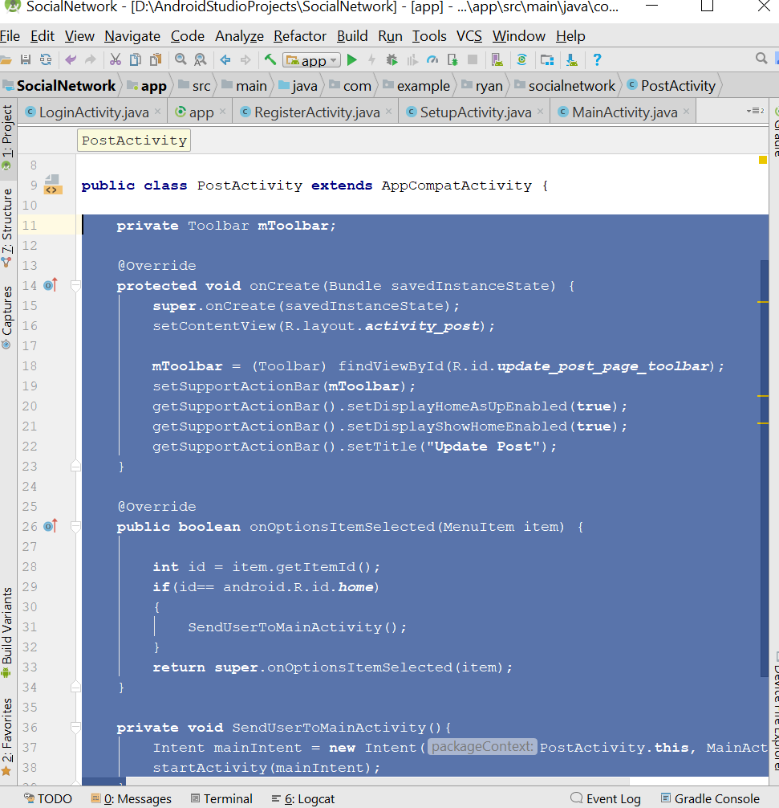
* Now go to activity_post.xml
* Drag and drop an image button
* You will see things like this
* 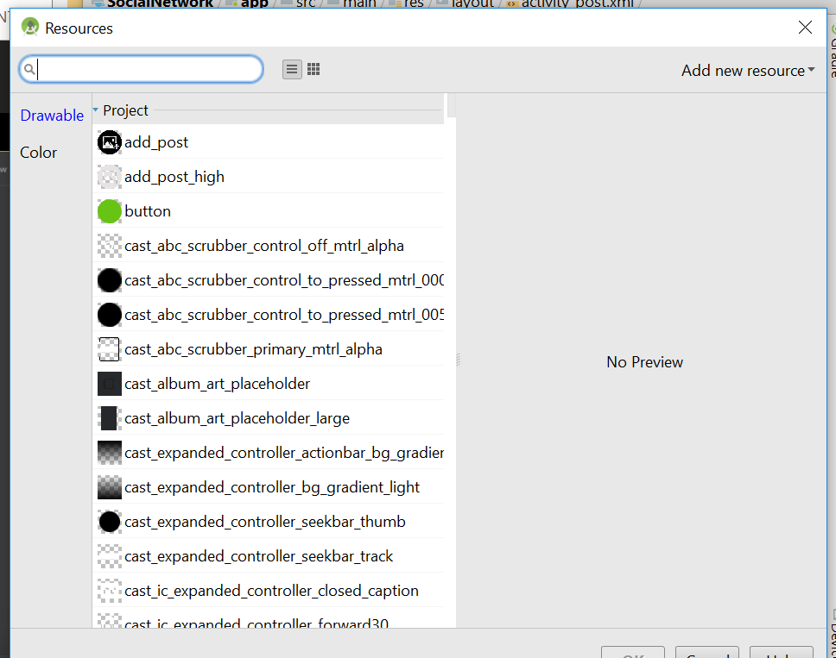
* Choose the image “Select_image”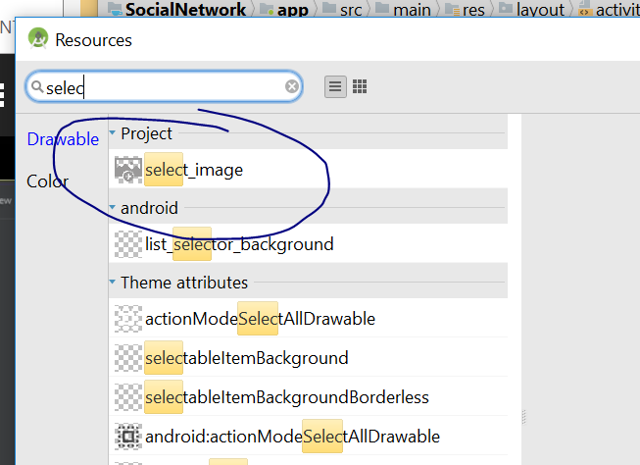
* Now go to attribute, select scaletype > centercrop
* 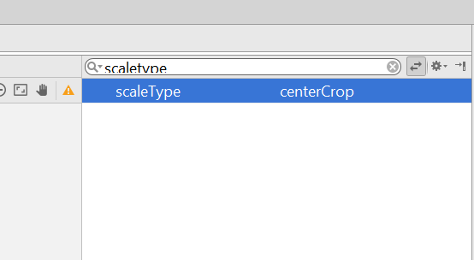
* With will be match parent, height will be 300dp
* Now it should look like this
* 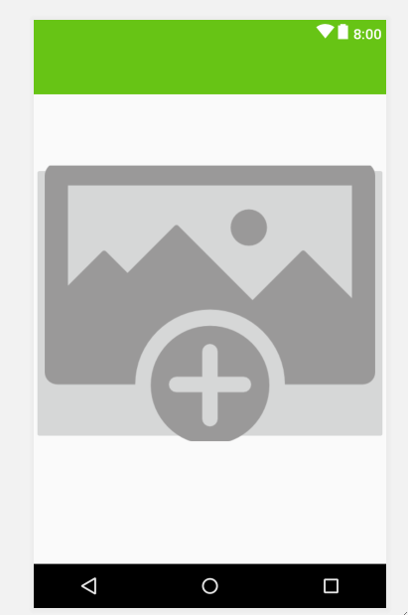
* Now we need to drag a multiline text
* Click on this
* 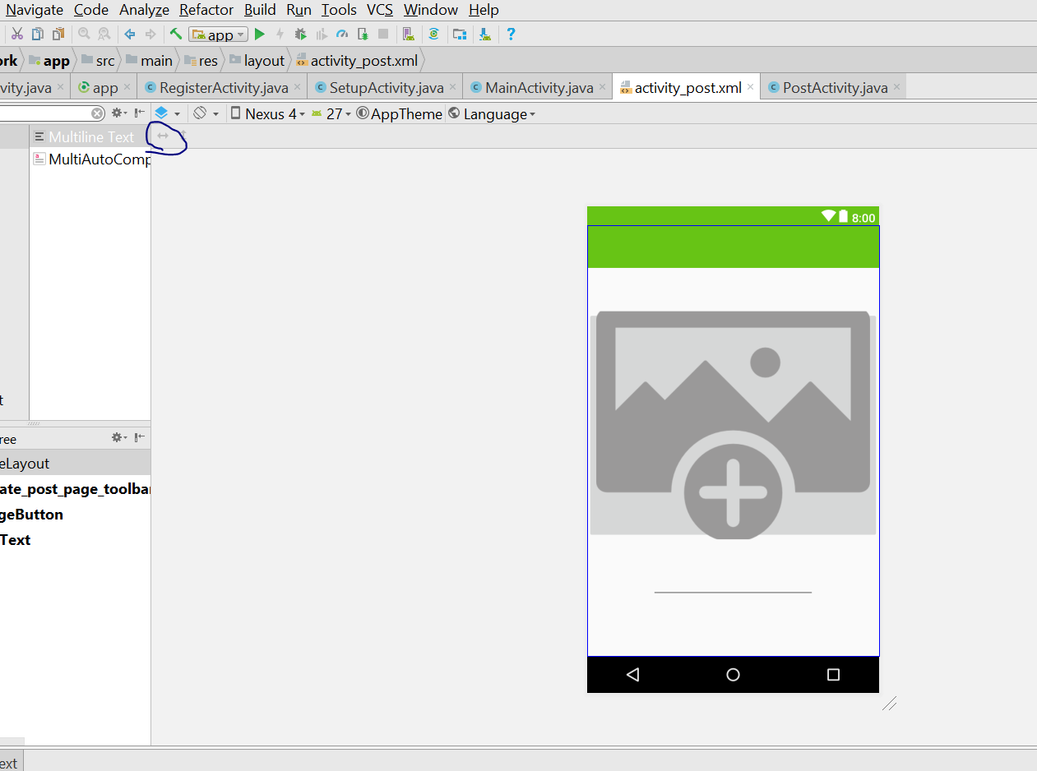
* Now it look like this
* 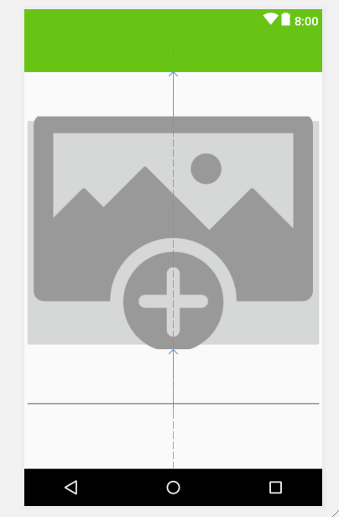
* Now drag and drop a button into the layout
* Then change the text to “Update Post”
* 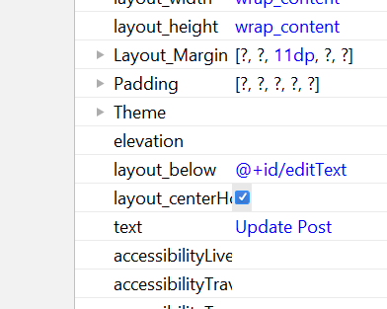
* 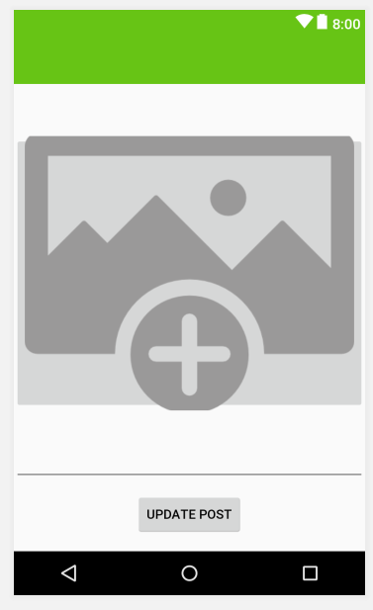
* Add a hint to the EditText, something about your image here
* Now it look like this
* 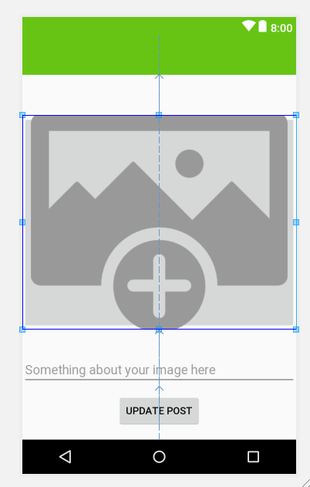
* Now go to the XML, add this
* android:background="@drawable/login"
* 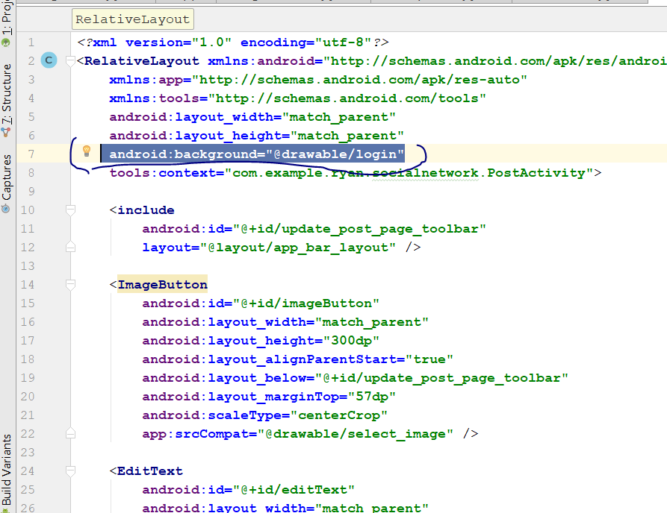
* Now should look like this
* 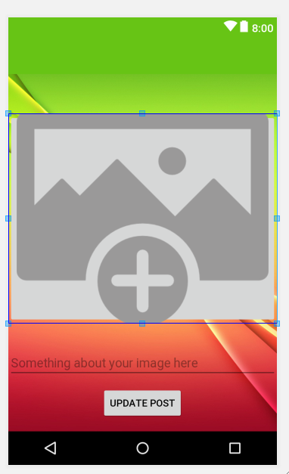
* Add this for EditText in the XML
* android:background="@drawable/inputs"
* Add this for button
* android:background="@drawable/button"
* Now should look like this
* 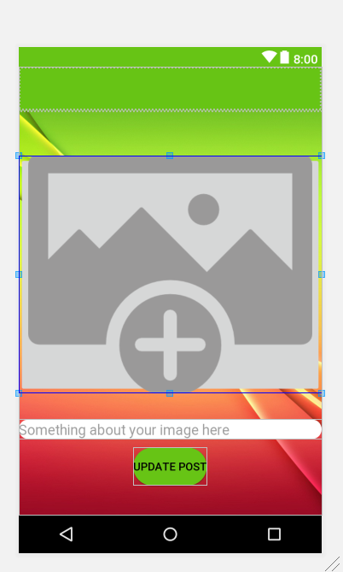
* EditText Padding change to 15dp
* 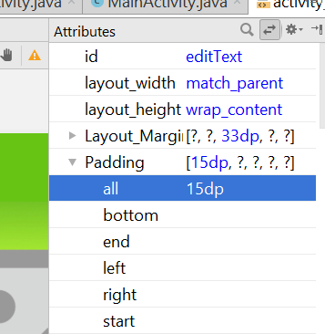
* Button padding change to 10dp
* 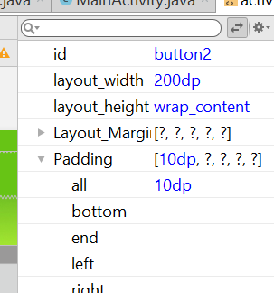
* Width change to 200dp for the button
* TextSize change to 18sp
* Textcolour select Background light
* 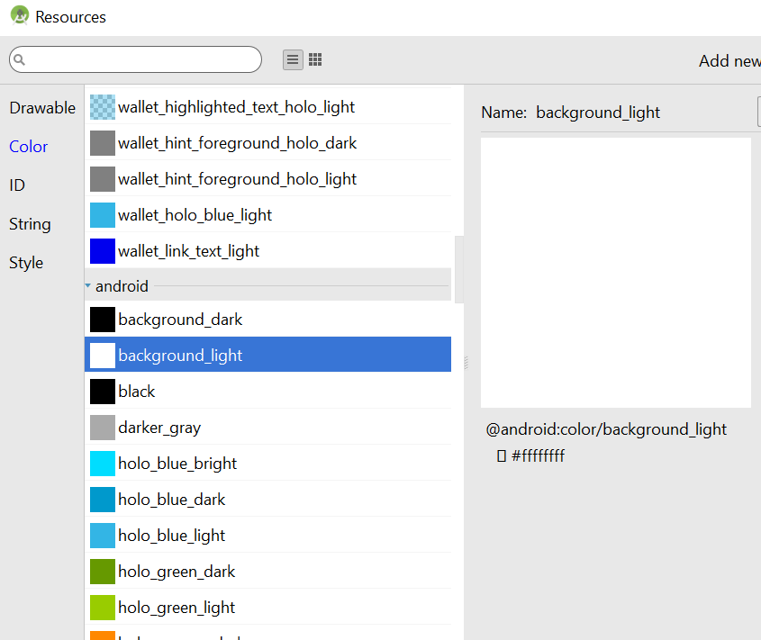
* Now select imagebutton, select the Scaletype
* Change to fitcenter
* 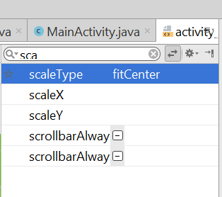
* For the imageButton layout from the top should be 20dp
* 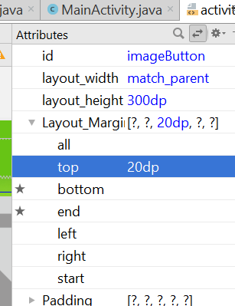
* For the Edittext should be 1dp from the top
* For the Button should be 5 dp from the top
* For the id of the imagebutton should be **select_post_image**
* For the id of the editText should be **post_description**
* For the id of the editText should be **update_post_button**
* Now go to PostActivity.java
* Add this
* private ImageButton SelectPostImage;  
  private Button UpdatePostButton;  
  private EditText PostDescription;
* In the OnCreate()
* **SelectPostImage** = (ImageButton) findViewById(R.id.***select_post_image***);  
  **UpdatePostButton** = (Button) findViewById(R.id.***update_post_button***);  
  **PostDescription** = (EditText) findViewById(R.id.***post_description***);
* Add this
* **SelectPostImage**.setOnClickListener(**new** View.OnClickListener() {  
   @Override  
   **public void** onClick(View v) {  
   OpenGallery();  
   }  
  });
* Create new OpenGallery method
* 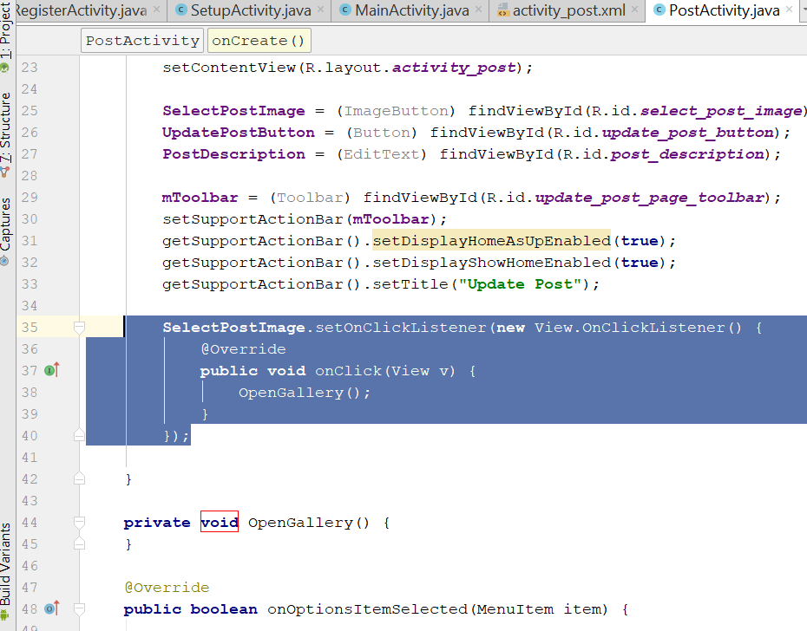
* Copy this line, inside the method
* Intent galleryIntent = **new** Intent();  
  galleryIntent.setAction(Intent.***ACTION_GET_CONTENT***);  
  galleryIntent.setType((**"image/*"**));  
  startActivityForResult(galleryIntent,***Gallery_Pick***);
* Into the OpenGallery()
* 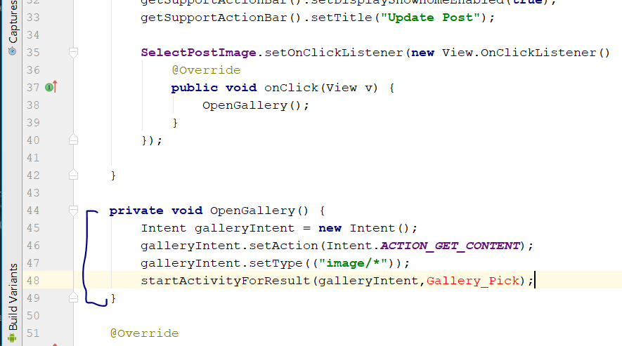
* Add this line on the top
* private static final int *Gallery_Pick* = 1;
* Rebuild and Run
* Now declare this variable,
* private Uri ImageUri;
* On the PostActivity.java
* Add this line
* **protected void** onActivityResult(**int** requestCode, **int** resultCode, Intent data) {  
   **super**.onActivityResult(requestCode, resultCode, data);  
   **if**(requestCode==***Gallery_Pick*** && resultCode== ***RESULT_OK*** && data != **null**)  
   {  
   **ImageUri** = data.getData();  
   **SelectPostImage**.setImageURI(**ImageUri**);  
   }  
  }
* 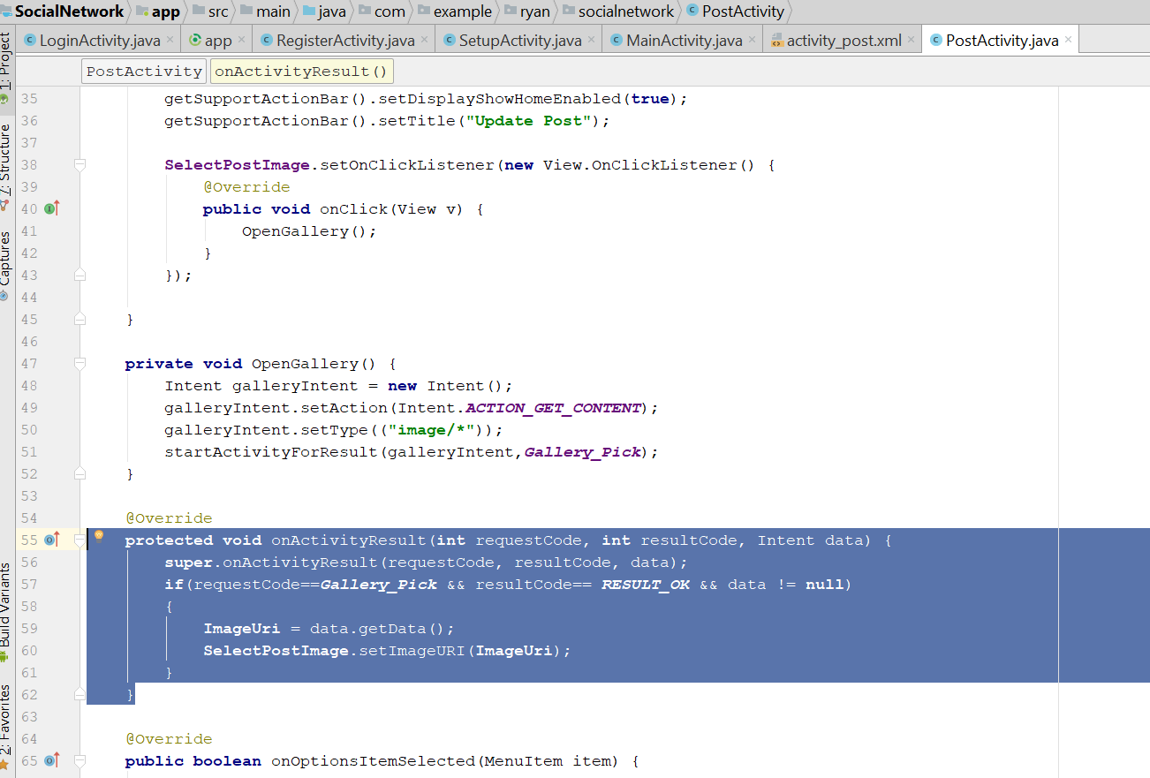
* Rebuild and Run
* The image shld appear in the button that u select
* Add the following code in OnCreate()
* **UpdatePostButton**.setOnClickListener(**new** View.OnClickListener() {  
   @Override  
   **public void** onClick(View v) {  
   validatePostInfo();  
   }  
  });
* 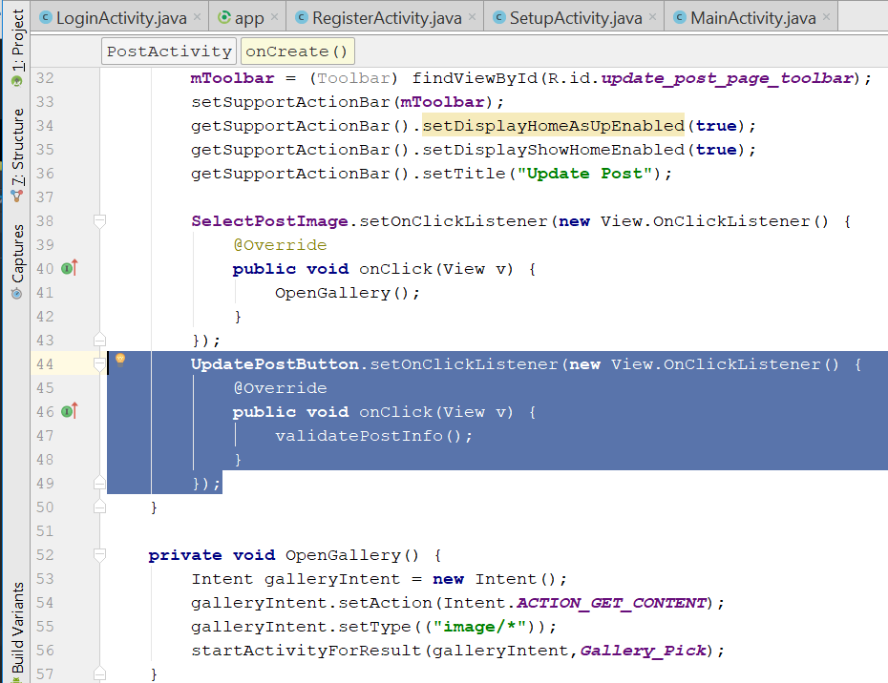
* Create the Method validatePostInfo()
* Add this line on top
* private String Description;
* **private void** validatePostInfo() {  
   **Description** = **PostDescription**.getText().toString();  
   **if**(**ImageUri** == **null**)  
   {  
   Toast.*makeText*(**this**,**"Please select post image..."**, Toast.***LENGTH_SHORT***).show();  
   }  
   **else if**(TextUtils.*isEmpty*(**Description**))  
   {  
   Toast.*makeText*(**this**,**"Please say something about your image..."**, Toast.***LENGTH_SHORT***).show();  
   }  
   **else** {  
   StoringImageToFirebaseStorage();  
   }  
  }
* 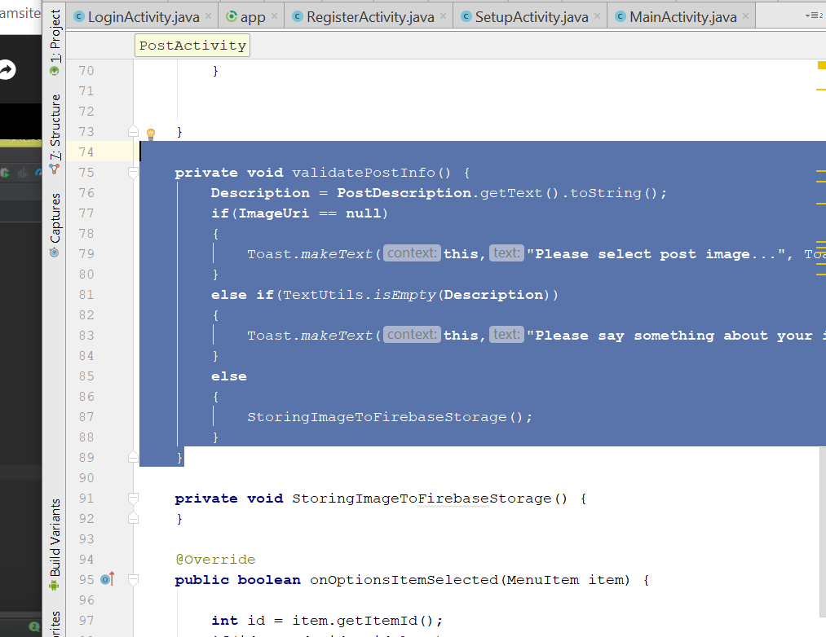
* Create the method, StoringImageToFirebaseStorage()
* Create this variable on top
* private StorageReference PostImageReference;
* add this in onCreate()
* PostImageReference = FirebaseStorage.*getInstance*().getReference();
* Declare this on top
* private String saveCurrentDate, saveCurrentTime, postRandomName;
* add this for the StoringImageToFirebaseStorage()
* **private void** StoringImageToFirebaseStorage() {  
   Calendar calFordDate = Calendar.*getInstance*();  
   SimpleDateFormat currentDate = **new** SimpleDateFormat(**"dd-MMM-yyyy"**);  
   **saveCurrentDate** = currentDate.format(calFordDate.getTime());  
    
   Calendar calFordTime = Calendar.*getInstance*();  
   SimpleDateFormat currentTime = **new** SimpleDateFormat(**"HH:mm"**);  
   **saveCurrentTime** = currentTime.format(calFordDate.getTime());  
    
   **postRandomName** = **saveCurrentDate** + **saveCurrentTime**;  
    
   StorageReference filepath = **PostImageReference**.child(**"Post Images"**)  
   .child(**ImageUri**.getLastPathSegment()+**postRandomName**+ **".jpg"**);  
    
   filepath.putFile(**ImageUri**).addOnCompleteListener(**new** OnCompleteListener<UploadTask.TaskSnapshot>() {  
   @Override  
   **public void** onComplete(@NonNull Task<UploadTask.TaskSnapshot> task) {  
   **if**(task.isSuccessful())  
   {  
   Toast.*makeText*(PostActivity.**this**, **"image uploaded successfully to Storage"**, Toast.***LENGTH_SHORT***).show();  
   }  
   **else** {  
   String message = task.getException().getMessage();  
   Toast.*makeText*(PostActivity.**this**, **"Error Occured:"** + message, Toast.***LENGTH_SHORT***).show();  
   }  
   }  
   });  
  }
* rebuild and Run now
* adding a image will store it in the firebase
* 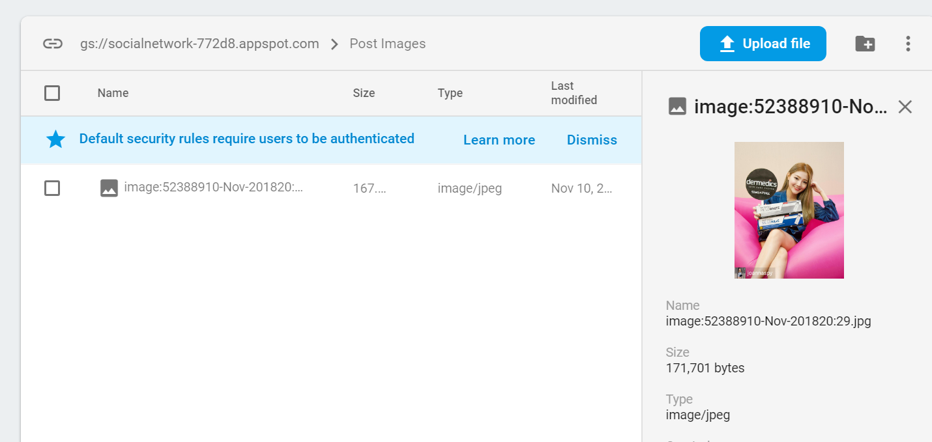
* Declare the variable on top
* private String downloadUrl;
* private DatabaseReference usersRef, PostRef;
* **private** FirebaseAuth **mAuth**;
* private String downloadUrl, current_user_id;
* private ProgressDialog loadingBar;
* in the onCreate()
* **usersRef** = FirebaseDatabase.*getInstance*().getReference().child(**"Users"**);
* **mAuth** = FirebaseAuth.*getInstance*();
* **current_user_id** = **mAuth**.getCurrentUser().getUid();
* **PostRef** = FirebaseDatabase.*getInstance*().getReference().child(**"Posts"**);
* **loadingBar** = **new** ProgressDialog(**this**);
* Add this line
* 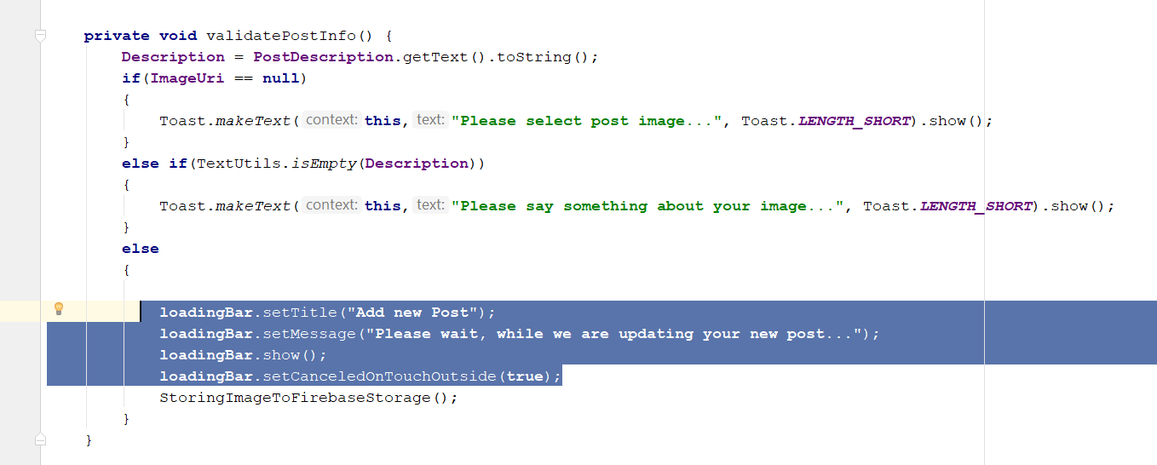
* loadingBar.setTitle("Add new Post");  
  loadingBar.setMessage("Please wait, while we are updating your new post...");  
  loadingBar.show();  
  loadingBar.setCanceledOnTouchOutside(true);
* Add this two lines here
* **downloadUrl** = task.getResult().getDownloadUrl().toString();  
  SavingPostInformationToDatabase();
* 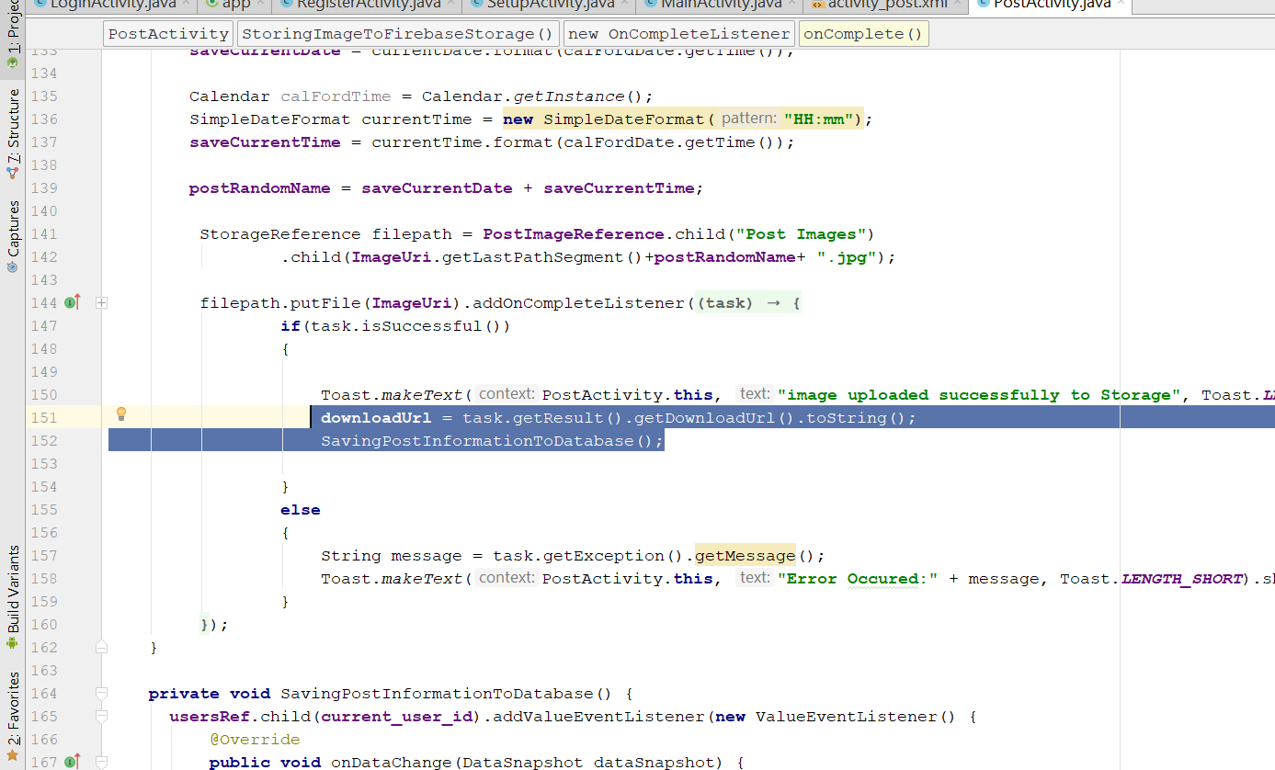
* Create a new method, SavingPostInformationToDatabase()
* **private void** SavingPostInformationToDatabase() {  
   **usersRef**.child(**current_user_id**).addValueEventListener(**new** ValueEventListener() {  
   @Override  
   **public void** onDataChange(DataSnapshot dataSnapshot) {  
   **if**(dataSnapshot.exists())  
   {  
   String userFullName = dataSnapshot.child(**"fullname"**).getValue().toString();  
   String userProfileImage = dataSnapshot.child(**"profileImage"**).getValue().toString();  
   HashMap postsmap = **new** HashMap();  
   postsmap.put(**"uid"**,**current_user_id**);  
   postsmap.put(**"date"**,**saveCurrentDate**);  
   postsmap.put(**"time"**,**saveCurrentTime**);  
   postsmap.put(**"description"**,**Description**);  
   postsmap.put(**"postimage"**,**downloadUrl**);  
   postsmap.put(**"profileimage"**,userProfileImage);  
   postsmap.put(**"fullname"**,userFullName);  
    
   **PostRef**.child(**current_user_id**+**postRandomName**).updateChildren(postsmap)  
   .addOnCompleteListener(**new** OnCompleteListener() {  
   @Override  
   **public void** onComplete(@NonNull Task task) {  
   **if**(task.isSuccessful())  
   {  
   SendUserToMainActivity();  
   Toast.*makeText*(PostActivity.**this**, **"New Post is updated successfully"**, Toast.***LENGTH_SHORT*** ).show();  
   **loadingBar**.dismiss();  
   }  
   **else** {  
   Toast.*makeText*(PostActivity.**this**, **"Error occured while updating"**, Toast.***LENGTH_SHORT*** ).show();  
   **loadingBar**.dismiss();  
   }  
   }  
   });  
    
   }  
   }  
    
   @Override  
   **public void** onCancelled(DatabaseError databaseError) {  
    
   }  
   });  
  }
* rebuild and run, the new post shld update the database
* you should see this
* 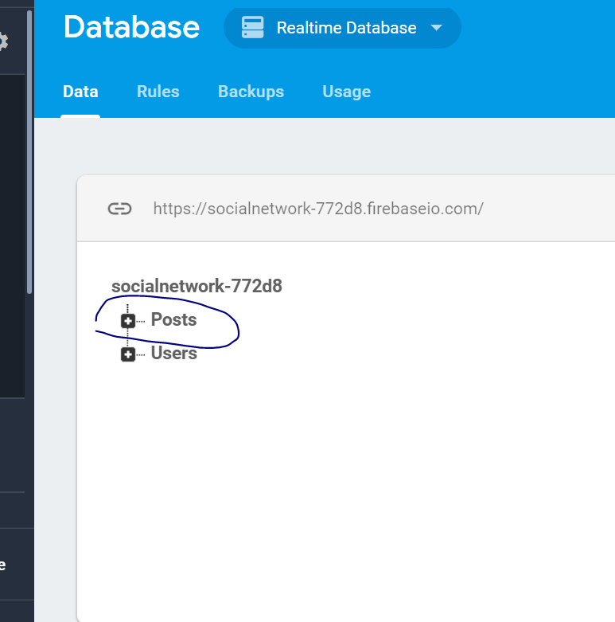

# Display User Post

* Go to Res>layout> Create new Layout Resource file
* Name it as all_post_layout
* 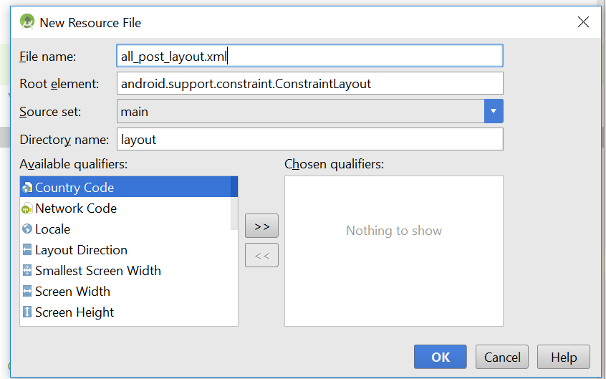
* Now change the layout to relative layout
* 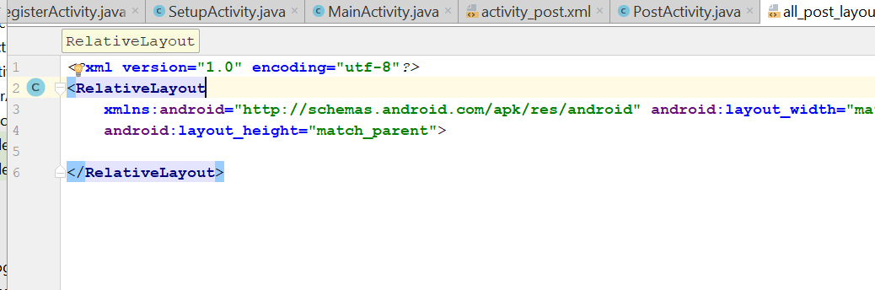
* android:layout_height="wrap_content"
* The whole code look like this
* *<?*xml version="1.0" encoding="utf-8"*?>*<RelativeLayout  
   xmlns:android="http://schemas.android.com/apk/res/android"  
   android:layout_width="match_parent"  
   android:layout_height="wrap_content">  
    
  <LinearLayout  
   android:layout_width="match_parent"  
   android:layout_height="wrap_content"  
   android:orientation="vertical"  
   android:layout_marginBottom="3dp"  
   android:layout_marginLeft="10dp"  
   android:layout_marginRight="10dp"  
   android:layout_marginTop="10dp"  
    
   >  
    
   <LinearLayout  
   android:layout_width="match_parent"  
   android:layout_height="wrap_content"  
   android:layout_marginTop="1dp"  
   android:padding="5dp"  
   android:orientation="horizontal"  
   >  
    
   <de.hdodenhof.circleimageview.CircleImageView  
   android:id="@+id/post_profile_image"  
   android:layout_width="60dp"  
   android:layout_height="60dp"  
   android:src="@drawable/profile"  
   android:scaleType="centerCrop"  
   android:layout_marginLeft="4dp"  
   />  
    
   <LinearLayout  
   android:layout_width="match_parent"  
   android:layout_height="wrap_content"  
   android:orientation="vertical">  
   <TextView  
   android:id="@+id/post_user_name"  
   android:layout_width="match_parent"  
   android:layout_height="wrap_content"  
   android:text="user_name"  
   android:layout_marginTop="8dp"  
   android:layout_marginLeft="5dp"  
   android:textAlignment="textStart"  
   android:textSize="16dp"  
   android:textStyle="bold"  
   android:textColor="@android:color/black"/>  
   <LinearLayout  
   android:layout_width="match_parent"  
   android:layout_height="wrap_content"  
   android:orientation="horizontal"  
   android:layout_marginLeft="5dp"  
   android:padding="2dp"  
   >  
   <TextView  
   android:id="@+id/text"  
   android:layout_width="wrap_content"  
   android:layout_height="wrap_content"  
   android:text="has been updated a post"  
   android:textColor="@android:color/darker_gray"  
   android:textSize="13sp"  
   android:textStyle="bold"  
    
   />  
   <TextView  
   android:id="@+id/post_date"  
   android:layout_width="wrap_content"  
   android:layout_height="wrap_content"  
   android:text="Date"  
   android:textColor="@android:color/black"  
   android:textSize="13sp"  
    
    
   />  
   <TextView  
   android:id="@+id/post_time"  
   android:layout_width="wrap_content"  
   android:layout_height="wrap_content"  
   android:text="Time"  
   android:textColor="@android:color/black"  
   android:textSize="13sp"  
    
    
   />  
   </LinearLayout>  
    
   </LinearLayout>  
    
    
    
   </LinearLayout>  
    
   <TextView  
   android:id="@+id/post_description"  
   android:layout_width="match_parent"  
   android:layout_height="wrap_content"  
   android:text="Post_description...."  
   android:layout_marginLeft="3dp"  
   android:layout_marginRight="3dp"  
   android:padding="3dp"  
   android:textSize="14dp"  
   android:textColor="@android:color/black"  
   />  
   <ImageView  
   android:id="@+id/post_image"  
   android:layout_width="match_parent"  
   android:layout_height="200dp"  
   android:layout_margin="3dp"  
   android:adjustViewBounds="true"  
   android:scaleType="centerCrop"/>  
    
  </LinearLayout>  
    
  </RelativeLayout>
* Your code should look like this
* 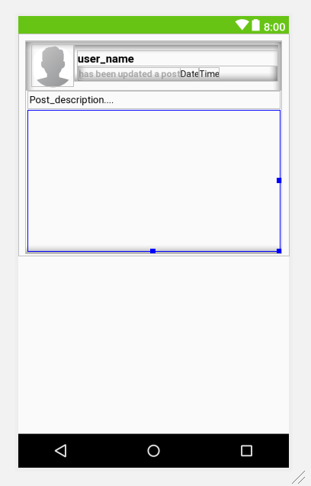
* Go to main_activity.java
* Cast the recycle view in the Oncreate Method
* Add this in oneCreate()
* **postList** = (RecyclerView) findViewById(R.id.***all_user_post_list***);  
  **postList**.setHasFixedSize(**true**);  
   LinearLayoutManager linearLayoutManager = **new** LinearLayoutManager(**this**);  
   linearLayoutManager.setReverseLayout(**true**);  
   linearLayoutManager.setStackFromEnd(**true**);  
   **postList**.setLayoutManager(linearLayoutManager);
* 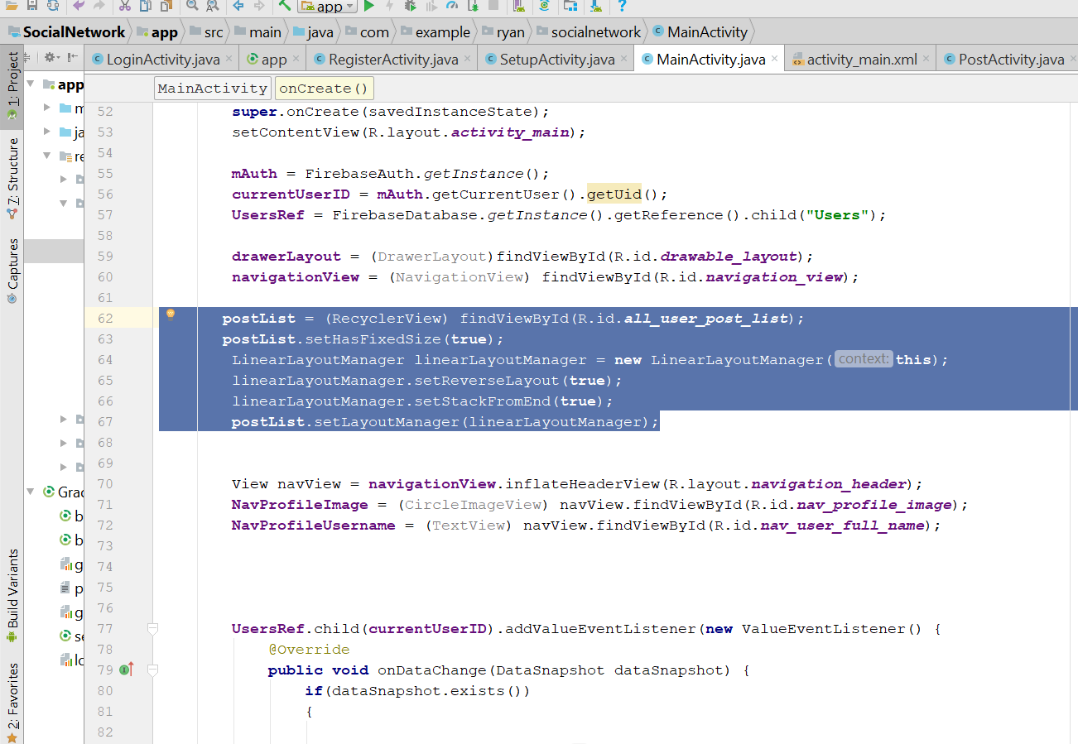
* Now add a new code here
* 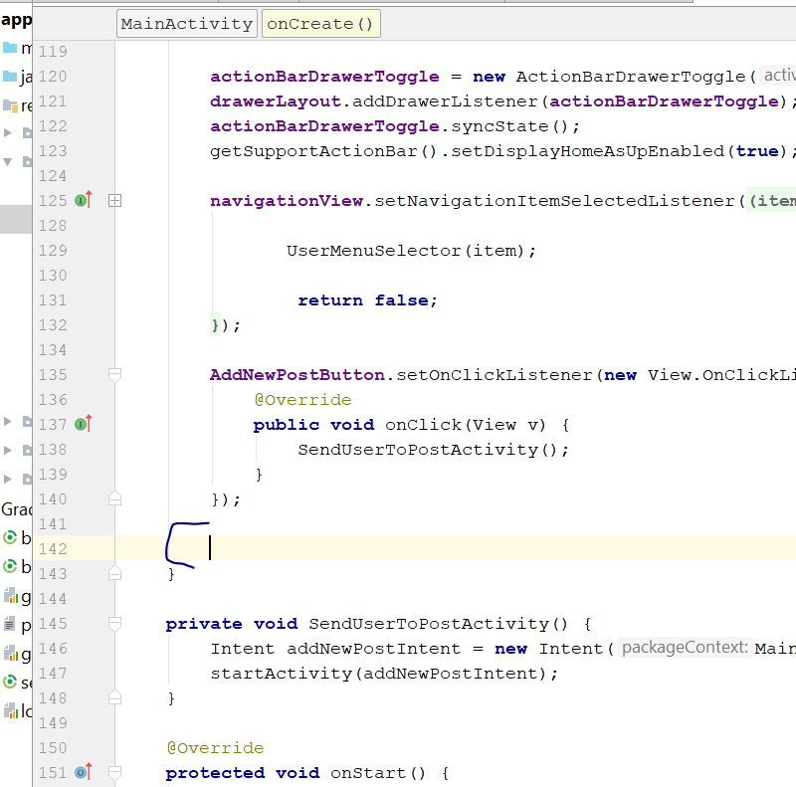
* Write this
* DisplayAllUserPosts();
* Create this method
* Then go to this URL
* <https://github.com/firebase/FirebaseUI-Android>
* Copy this line
* 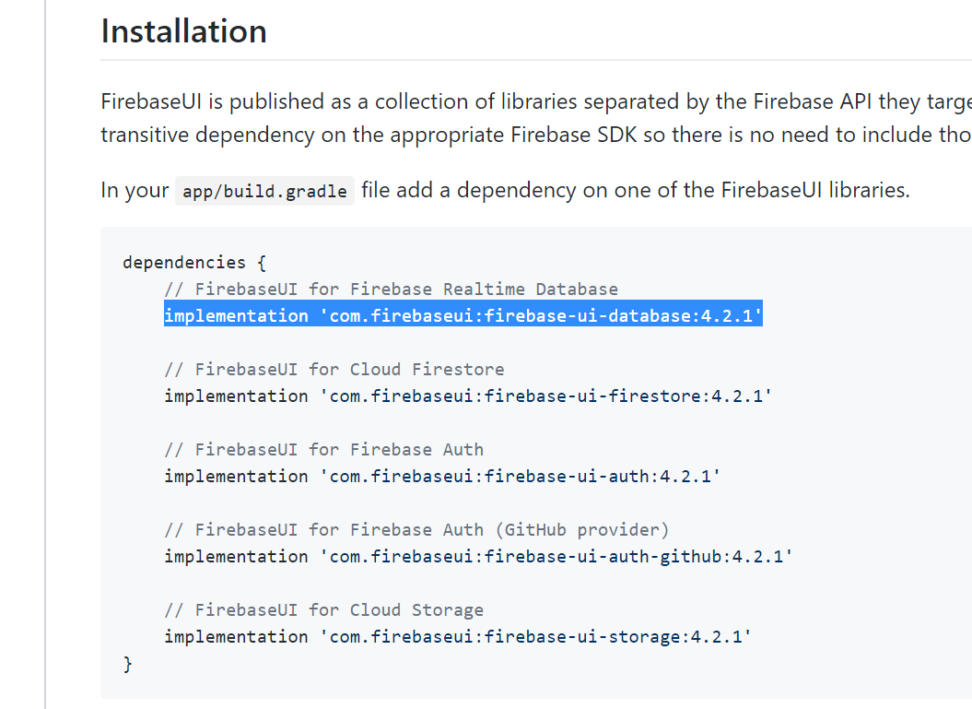
* implementation 'com.firebaseui:firebase-ui-database:4.2.1'
* paste it to the gradle.app
* change ur library accordingly to the firebase version
* Change to this
* implementation 'com.firebaseui:firebase-ui-database:2.1.1'

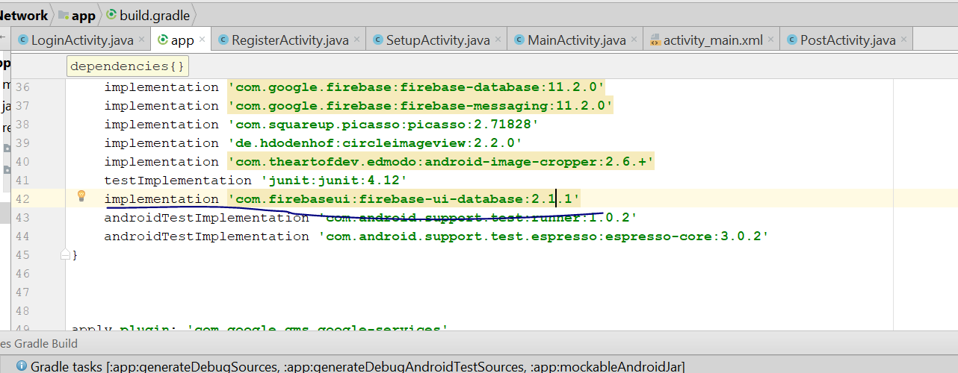

* now sync it
* create a new class call posts
* 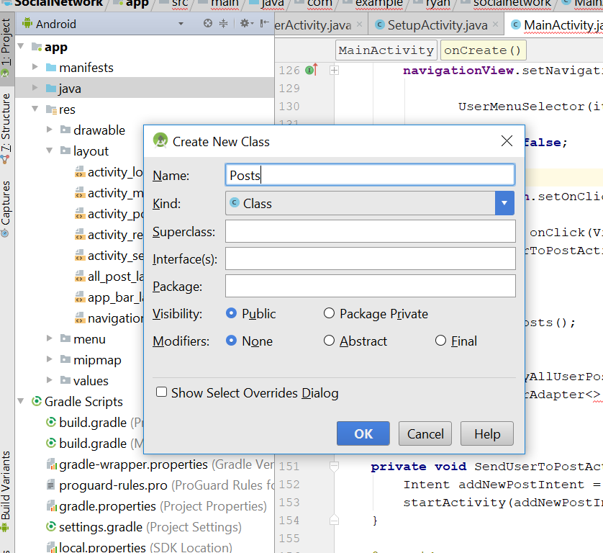
* The code for this Code class is like that
* */**  
   * Created by Ryan on 11/17/2018.  
   */***public class** Posts {  
   **public** String **uid**, **time**, **date**, **postimage**, description, **profileimage**, **fullname**;  
    
   **public** Posts()  
   {  
     
   }  
    
   **public** Posts(String uid, String time, String date, String postimage, String description, String profileimage, String fullname) {  
    
   **this**.**uid** = uid;  
   **this**.**time** = time;  
   **this**.**date** = date;  
   **this**.**postimage** = postimage;  
   **this**.description = description;  
   **this**.**profileimage** = profileimage;  
   **this**.**fullname** = fullname;  
   }  
    
   **public** String getUid() {  
   **return uid**;  
   }  
    
   **public void** setUid(String uid) {  
   **this**.**uid** = uid;  
   }  
    
   **public** String getTime() {  
   **return time**;  
   }  
    
   **public void** setTime(String time) {  
   **this**.**time** = time;  
   }  
    
   **public** String getDate() {  
   **return date**;  
   }  
    
   **public void** setDate(String date) {  
   **this**.**date** = date;  
   }  
    
   **public** String getPostimage() {  
   **return postimage**;  
   }  
    
   **public void** setPostimage(String postimage) {  
   **this**.**postimage** = postimage;  
   }  
    
   **public** String getDescription() {  
   **return** description;  
   }  
    
   **public void** setDescription(String description) {  
   **this**.description = description;  
   }  
    
   **public** String getProfileimage() {  
   **return profileimage**;  
   }  
    
   **public void** setProfileimage(String profileimage) {  
   **this**.**profileimage** = profileimage;  
   }  
    
   **public** String getFullname() {  
   **return fullname**;  
   }  
    
   **public void** setFullname(String fullname) {  
   **this**.**fullname** = fullname;  
   }  
  }
* Now go to Mainactivity.java
* Add this method
* **public static class** PostsViewHolder **extends** RecyclerView.ViewHolder  
  {  
   View **mView**;  
   **public** PostsViewHolder(View itemView)  
   {  
   **super**(itemView);  
   **mView** = itemView;  
   }  
  }
* Declare this extra on top
* private DatabaseReference UsersRef, PostsRef;
* On the onCreate(), write this
* PostsRef = FirebaseDatabase.*getInstance*().getReference().child(**"Posts"**);
* Go to the method = DisplayAllUserPosts()
* Add the following code
* **private void** DisplayAllUserPosts() {  
   FirebaseRecyclerAdapter<Posts,PostsViewHolder> firebaseRecyclerAdapter =  
   **new** FirebaseRecyclerAdapter<Posts, PostsViewHolder>(  
   Posts.**class**,  
   R.layout.***all_post_layout***,  
   PostsViewHolder.**class**,  
   **PostsRef** ) {  
   @Override  
   **protected void** populateViewHolder(PostsViewHolder viewHolder, Posts model, **int** position) {  
    
   viewHolder.setFullname(model.getFullname());  
   viewHolder.setTime(model.getTime());  
   viewHolder.setDate(model.getDate());  
   viewHolder.setDescription(model.getDescription());  
   viewHolder.setProfileimage(getApplicationContext(), model.getProfileimage());  
   viewHolder.setPostimage(getApplicationContext(), model.getPostimage());  
   }  
   };  
    
   **postList**.setAdapter(firebaseRecyclerAdapter);  
    
  }
* 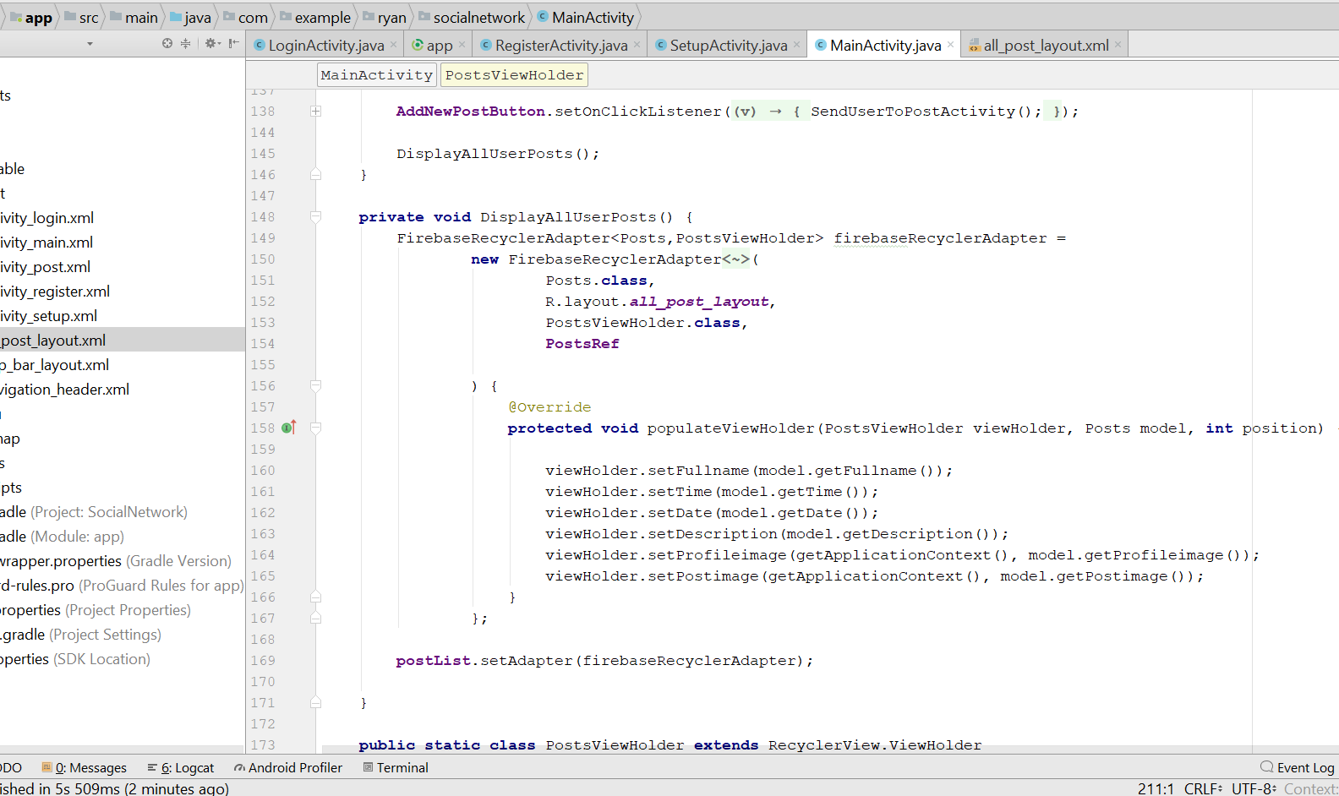
* Then add this
* **public static class** PostsViewHolder **extends** RecyclerView.ViewHolder  
  {  
   View **mView**;  
   **public** PostsViewHolder(View itemView)  
   {  
   **super**(itemView);  
   **mView** = itemView;  
   }  
   **public void** setFullname(String fullname)  
   {  
   TextView username = (TextView) **mView**.findViewById(R.id.***post_user_name***);  
   username.setText(fullname);  
   }  
   **public void** setProfileimage(Context ctx, String profileimage)  
   {  
   CircleImageView image = (CircleImageView) **mView**.findViewById(R.id.***post_profile_image***);  
   Picasso.*get*().load(profileimage).into(image);  
   }  
   **public void** setTime(String time)  
   {  
   TextView PostTime = (TextView) **mView**.findViewById(R.id.***post_time***);  
   PostTime.setText(**" "** +time);  
   }  
   **public void** setDate(String date)  
   {  
   TextView PostDate = (TextView) **mView**.findViewById(R.id.***post_date***);  
   PostDate.setText(**" "**+date);  
   }  
   **public void** setDescription(String description)  
   {  
   TextView PostDescription = (TextView) **mView**.findViewById(R.id.***post_description***);  
   PostDescription.setText(description);  
   }  
   **public void** setPostimage(Context ctx,String postimage)  
   {  
   ImageView PostImage = (ImageView) **mView**.findViewById(R.id.***post_image***);  
   Picasso.*get*().load(postimage).into(PostImage);  
   }  
    
  }
* Rebuild and Run
* You should see the post you posted just now
* Now go to all_post_layout.xml
* Go drawable> create new Resource file, call it post_border.xml
* 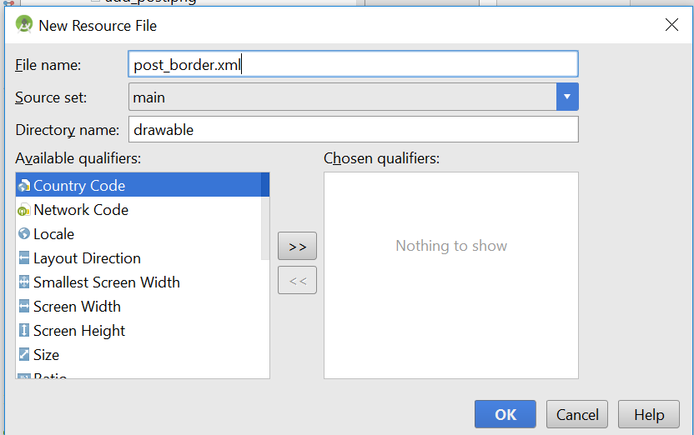
* You should see this
* 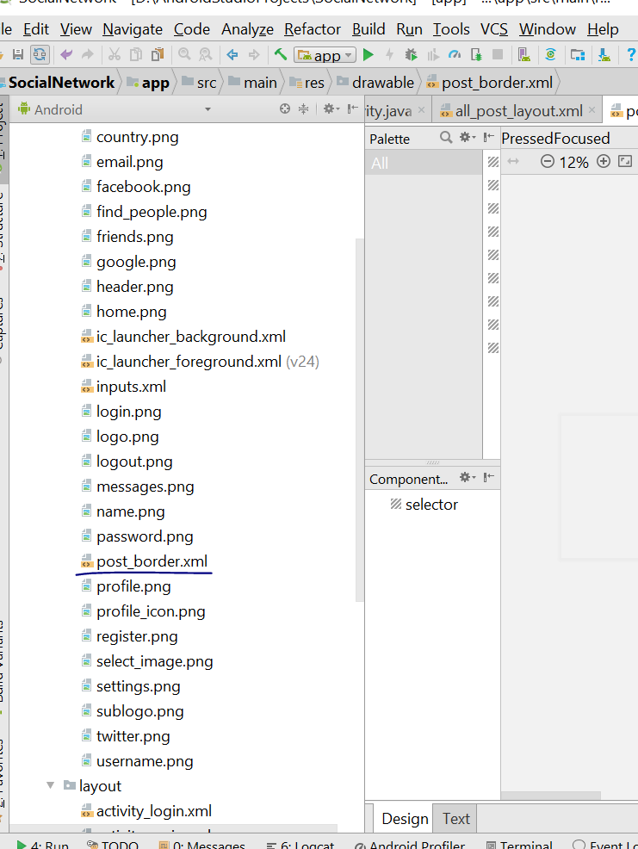
* Change the SELECTOR to SHAPE
* 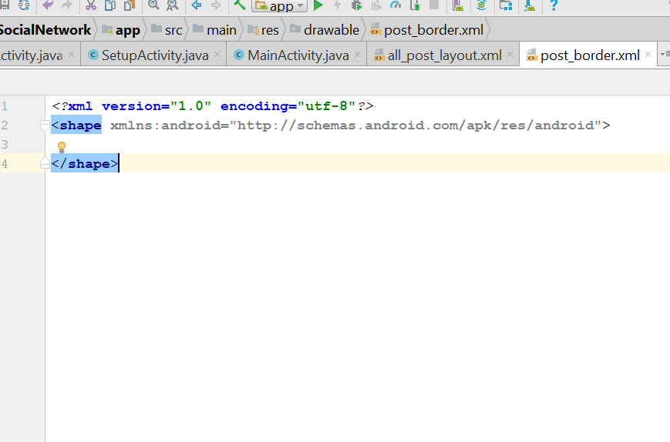
* Add this inside
* <stroke  
   android:width="3dp"  
   android:color="@color/colorPrimaryDark">  
    
  </stroke>
* Now look like this
* 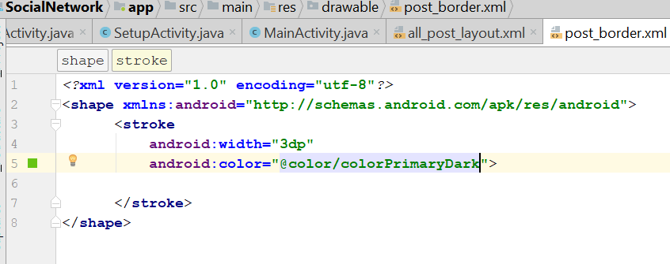
* Now go to all_post_layout.xml
* Add this to the LinearLayout
* 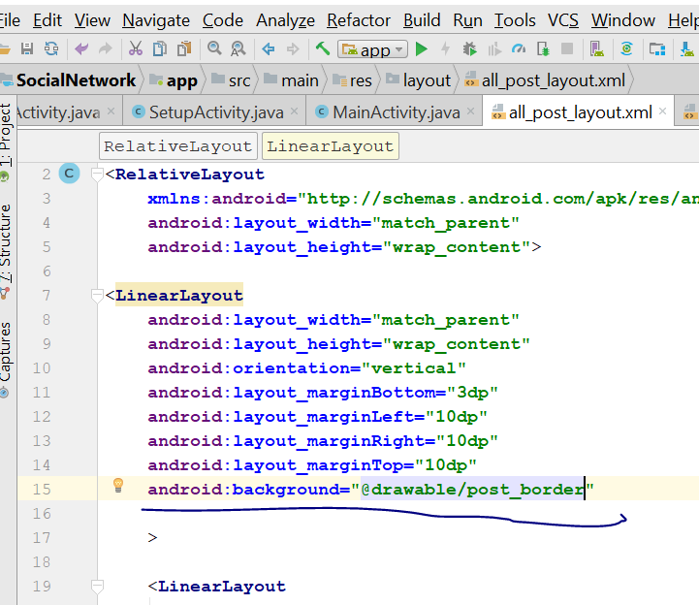
* Now should look like this
* 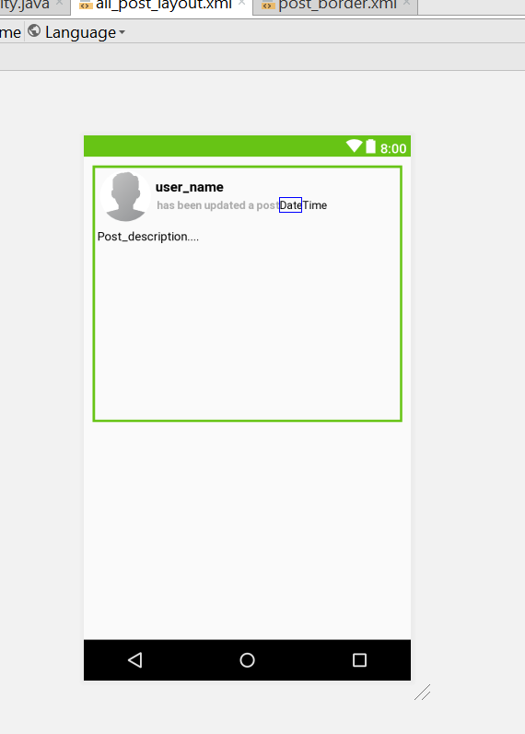
* Rebuild and run

# Login Google Account

* Now go to LoginActivity.java
* Add this
* private ImageView googleSignInButton;
* Add this in the onCreate()
* googleSignInButton = (ImageView) findViewById(R.id.*google_signin_button*);
* Now go this URL : <https://firebase.google.com/docs/auth/android/google-signin>
* You will see this
* 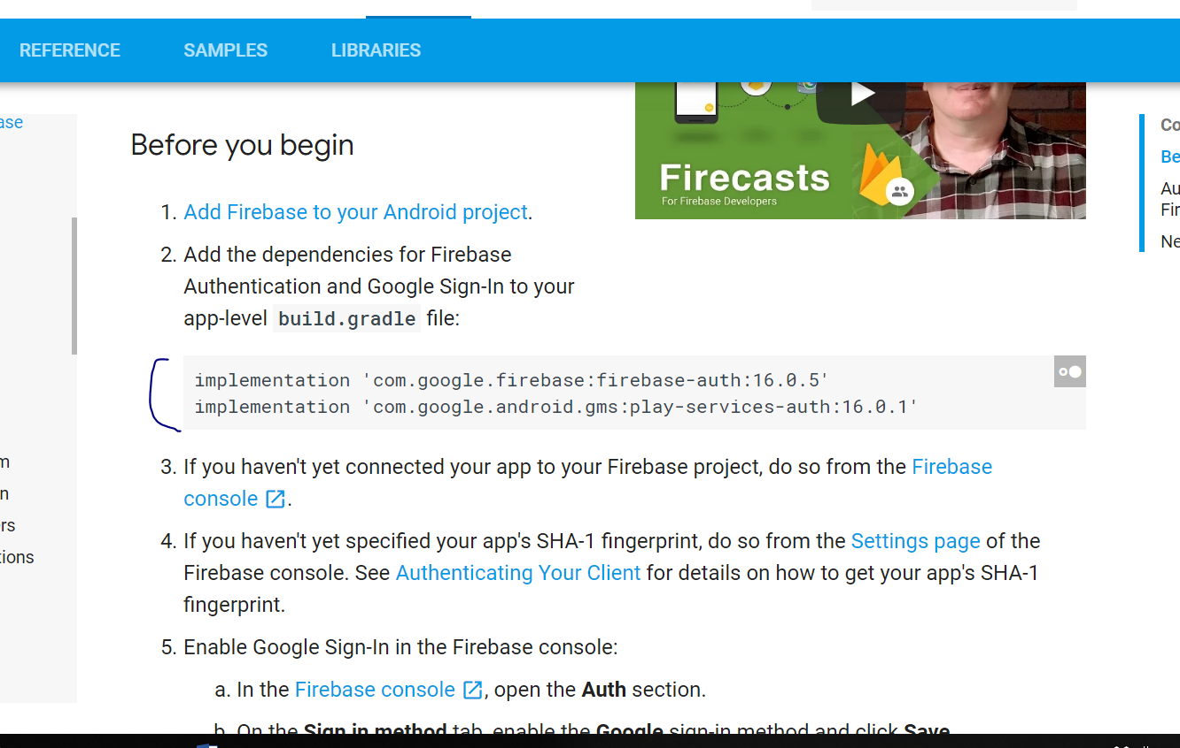
* Add this line to the gradle
* implementation 'com.google.android.gms:play-services-auth:11.2.0'
* sync now
* Add this lines on the onCreate()
* *// Configure Google Sign In*GoogleSignInOptions gso = **new** GoogleSignInOptions.Builder(GoogleSignInOptions.***DEFAULT_SIGN_IN***)  
   .requestIdToken(getString(R.string.***default_web_client_id***))  
   .requestEmail()  
   .build();
* 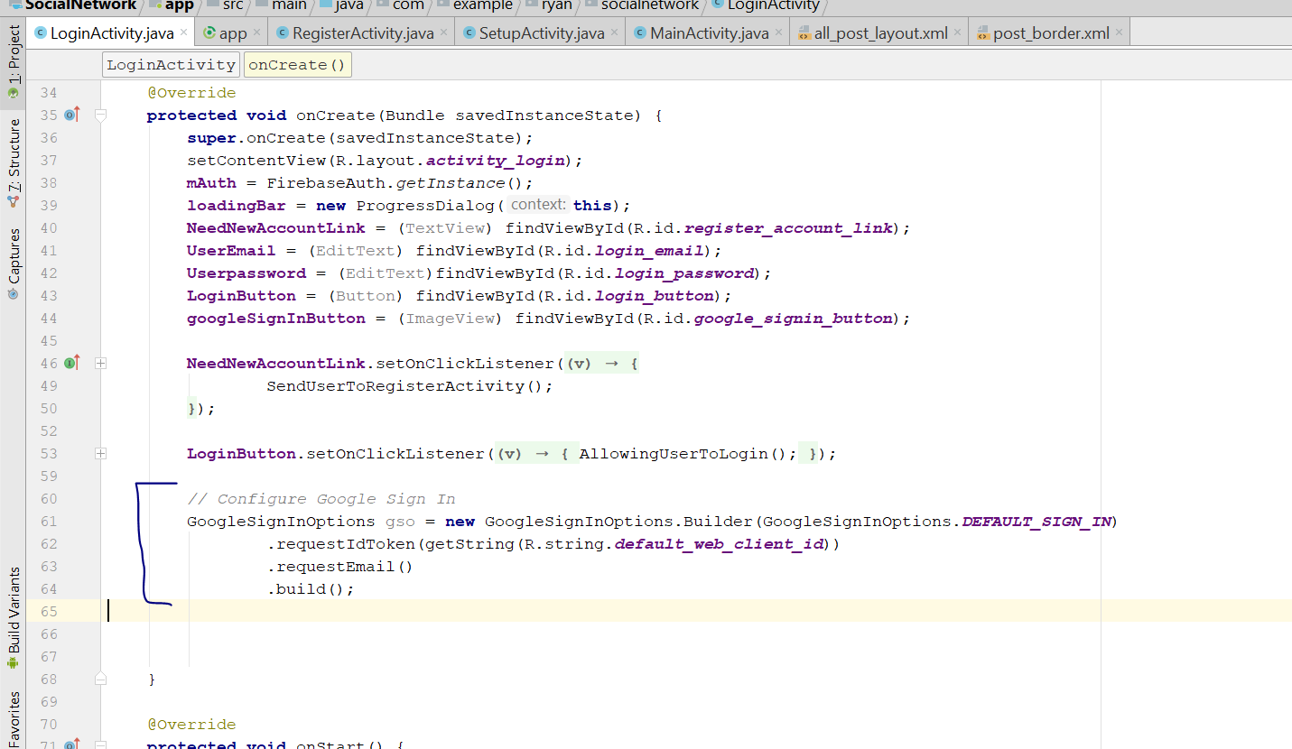
* Now declare this two variable on top
* private static final int *RC_SIGN_IN* = 1;  
  private GoogleApiClient mGoogleSigninClient;
* Then paste this method in the class
* **private void** signIn() {  
   Intent signInIntent = Auth.***GoogleSignInApi***.getSignInIntent(**mGoogleSigninClient**);  
   startActivityForResult(signInIntent, ***RC_SIGN_IN***);  
  }
* 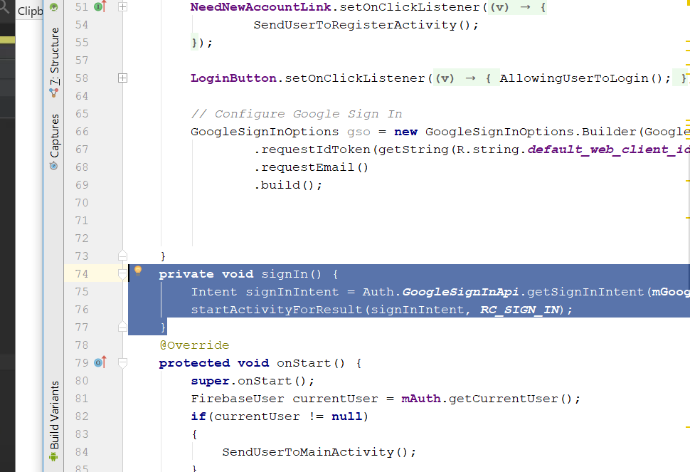
* Now declare this on top
* private static final String *TAG* = "LoginActivity";
* Add this to the onCreate()
* **mGoogleSigninClient** = **new** GoogleApiClient.Builder(**this**)  
   .enableAutoManage(**this**, **new** GoogleApiClient.OnConnectionFailedListener() {  
   @Override  
   **public void** onConnectionFailed(@NonNull ConnectionResult connectionResult) {  
   Toast.*makeText*(LoginActivity.**this**, **"Connection to Google Sign In failed..."**, Toast.***LENGTH_SHORT***).show();  
   }  
   })  
   .addApi(Auth.***GOOGLE_SIGN_IN_API***,gso)  
   .build();  
    
  **googleSignInButton**.setOnClickListener(**new** View.OnClickListener() {  
   @Override  
   **public void** onClick(View v) {  
   signIn();  
   }  
  });
* 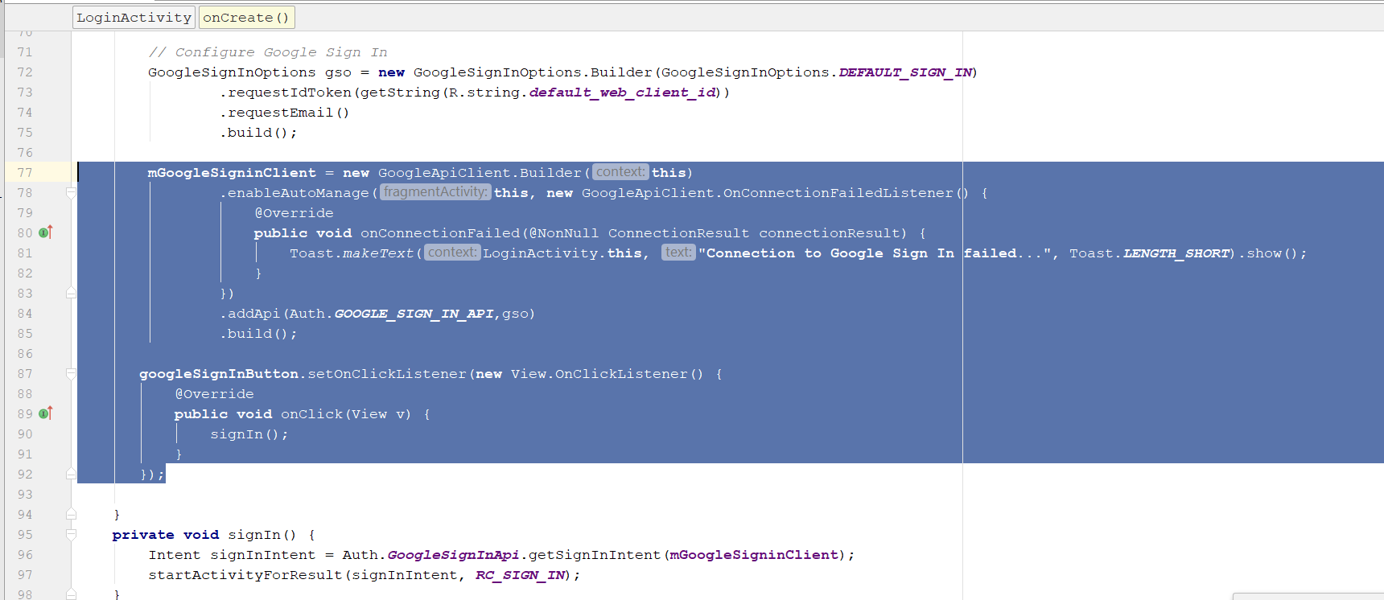
* Then add this method
* **private void** SendUserToLoginActivity() {  
    
   Intent mainIntent = **new** Intent(LoginActivity.**this**, LoginActivity.**class**);  
   mainIntent.addFlags(Intent.***FLAG_ACTIVITY_NEW_TASK***|Intent.***FLAG_ACTIVITY_CLEAR_TASK***);  
   startActivity(mainIntent);  
   finish();  
  }
* Add those code
* **private void** signIn() {  
   Intent signInIntent = Auth.***GoogleSignInApi***.getSignInIntent(**mGoogleSigninClient**);  
   startActivityForResult(signInIntent, ***RC_SIGN_IN***);  
  }  
    
  **public void** onActivityResult(**int** requestCode, **int** resultCode, Intent data) {  
   **super**.onActivityResult(requestCode, resultCode, data);  
    
   **if** (requestCode == ***RC_SIGN_IN***) {  
    
   **loadingBar**.setTitle(**"Google Sign In"**);  
   **loadingBar**.setMessage(**"Please wait, while we are allowing you to login your Google Account..."**);  
   **loadingBar**.show();  
   **loadingBar**.setCanceledOnTouchOutside(**true**);  
   GoogleSignInResult result = Auth.***GoogleSignInApi***.getSignInResultFromIntent(data);  
   **if**(result.isSuccess())  
   {  
   GoogleSignInAccount account = result.getSignInAccount();  
   firebaseAuthWithGoogle(account);  
   Toast.*makeText*(**this**, **"Please wait, we are getting your result..."**, Toast.***LENGTH_SHORT***).show();  
   }  
   **else** {  
   Toast.*makeText*(**this**, **"Can't get Auth Result..."**, Toast.***LENGTH_SHORT***).show();  
   **loadingBar**.dismiss();  
   }  
    
    
   }  
  }  
  **private void** firebaseAuthWithGoogle(GoogleSignInAccount acct) {  
   Log.*d*(***TAG***, **"firebaseAuthWithGoogle:"** + acct.getId());  
    
   AuthCredential credential = GoogleAuthProvider.*getCredential*(acct.getIdToken(), **null**);  
   **mAuth**.signInWithCredential(credential)  
   .addOnCompleteListener(**this**, **new** OnCompleteListener<AuthResult>() {  
   @Override  
   **public void** onComplete(@NonNull Task<AuthResult> task) {  
   **if** (task.isSuccessful()) {  
   Log.*d*(***TAG***, **"signInWithCredential:success"**);  
   SendUserToMainActivity();  
   **loadingBar**.dismiss();  
    
   } **else** {  
   Log.*w*(***TAG***, **"signInWithCredential:failure"**, task.getException());  
   String message = task.getException().toString();  
   SendUserToLoginActivity();  
   Toast.*makeText*(LoginActivity.**this**, **"Not Authenticated: "**+ message, Toast.***LENGTH_SHORT***).show();  
   **loadingBar**.dismiss();  
   }  
    
   *// ...* }  
   });  
  }
* Now go to Firebase website
* Click on this
* 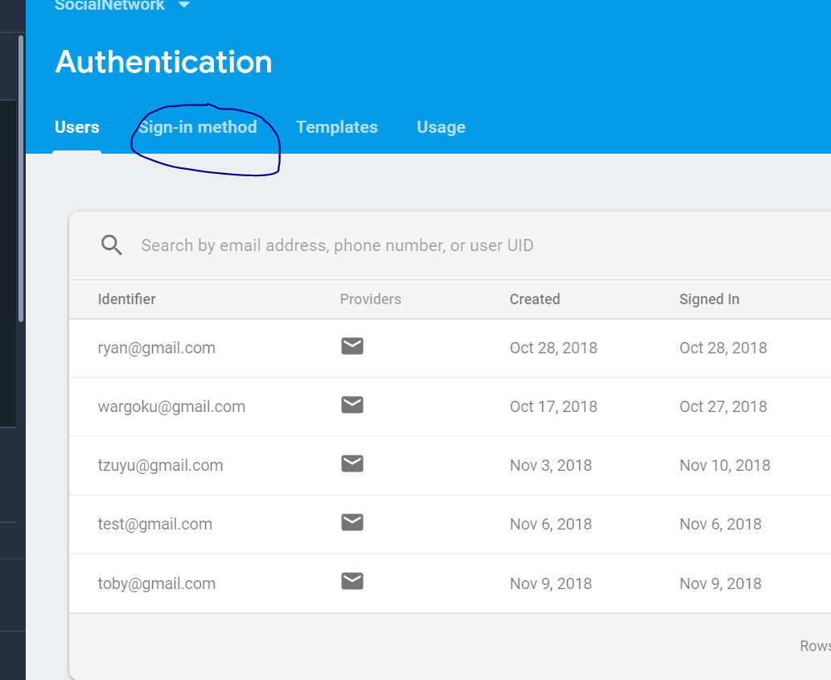
* Enabled the Google sign in
* 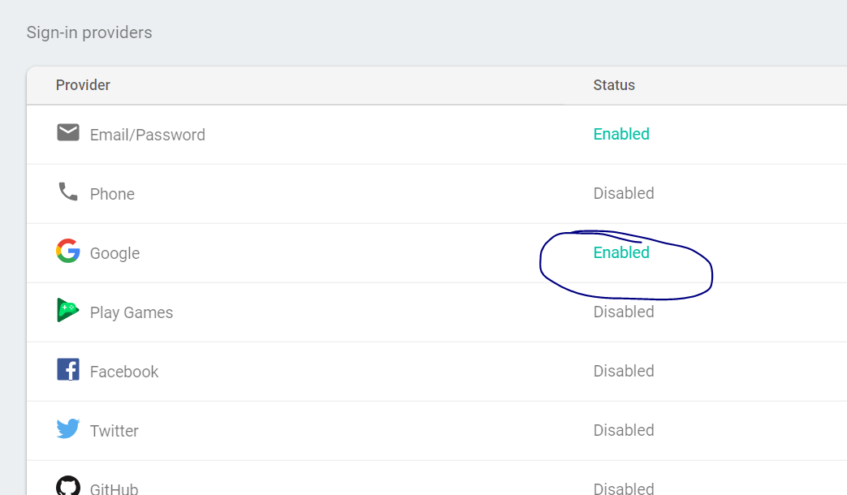
* Rebuild and run
* You shld be able to create a account by Google sign in
* You should see this
* 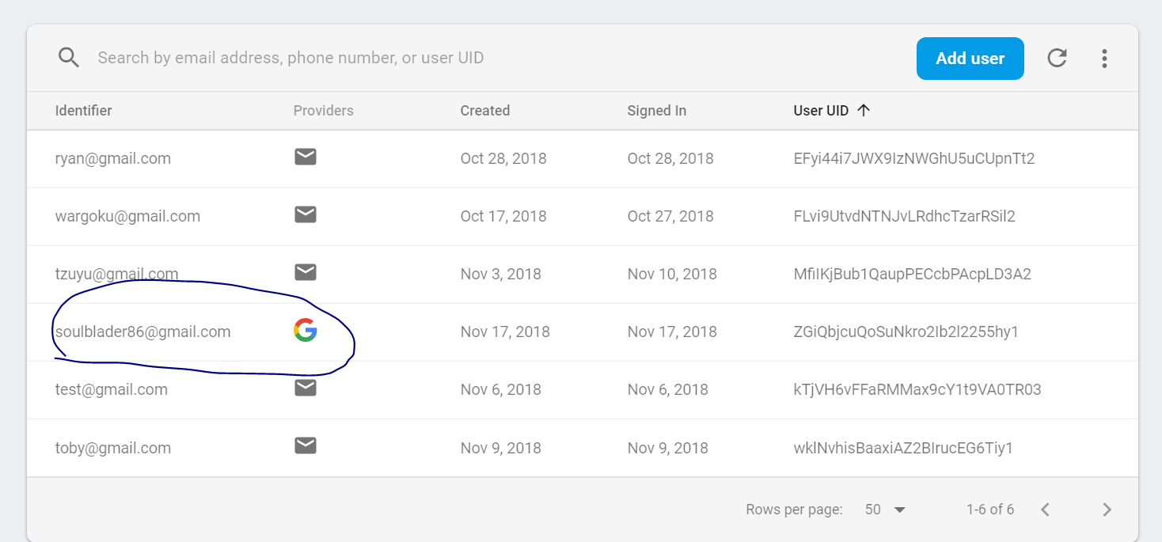

# Delete and Edit Post

* Create a new Activity
* Call it ClickPostActivity.java
* 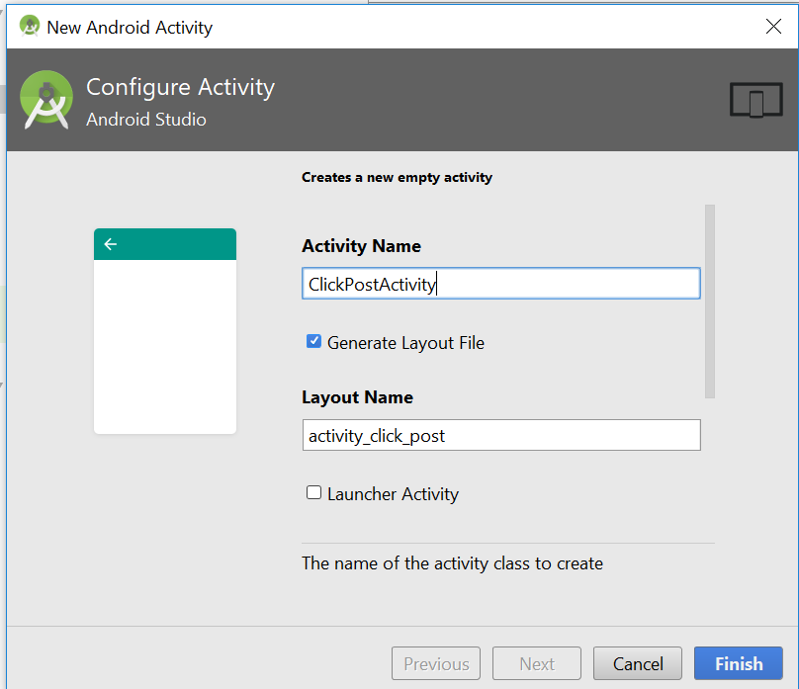
* Now go to activity_click_post.xml, the layout file
* Change the layout to relative layout
* Drag and drop an imageView here
* 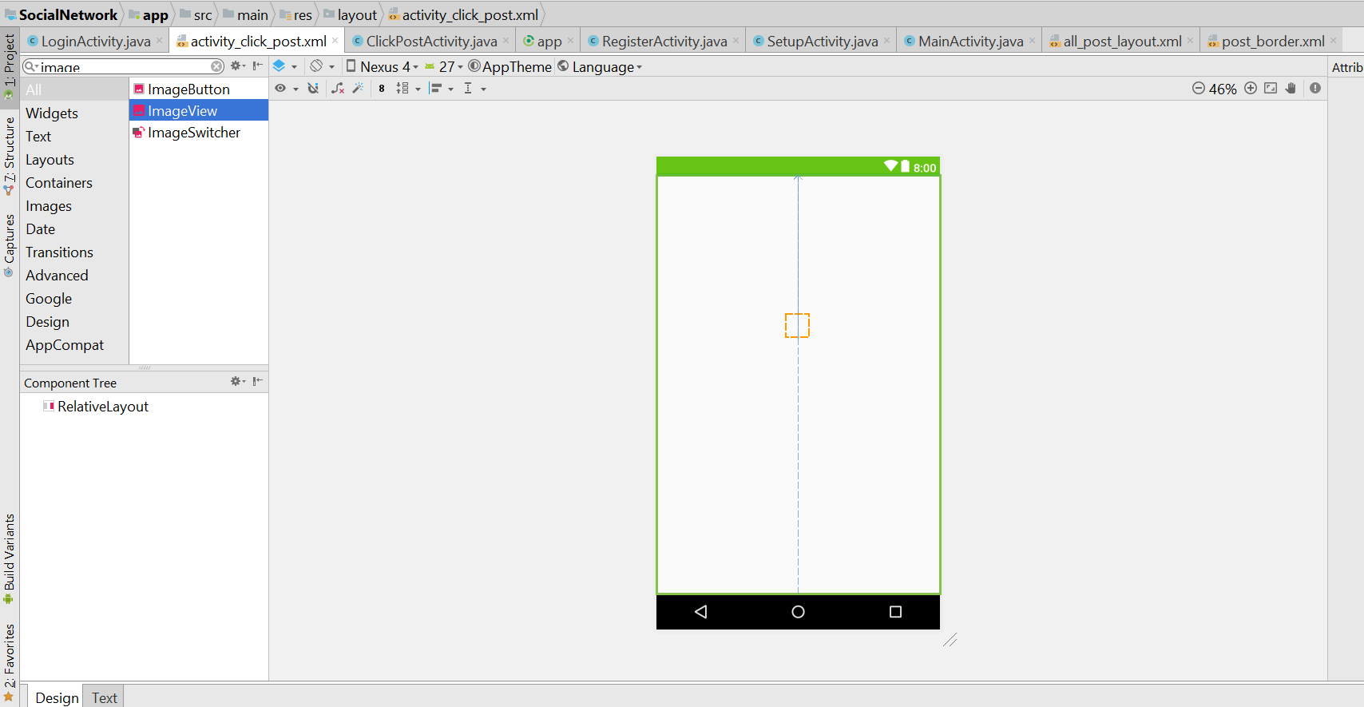
* Then u will see this
* 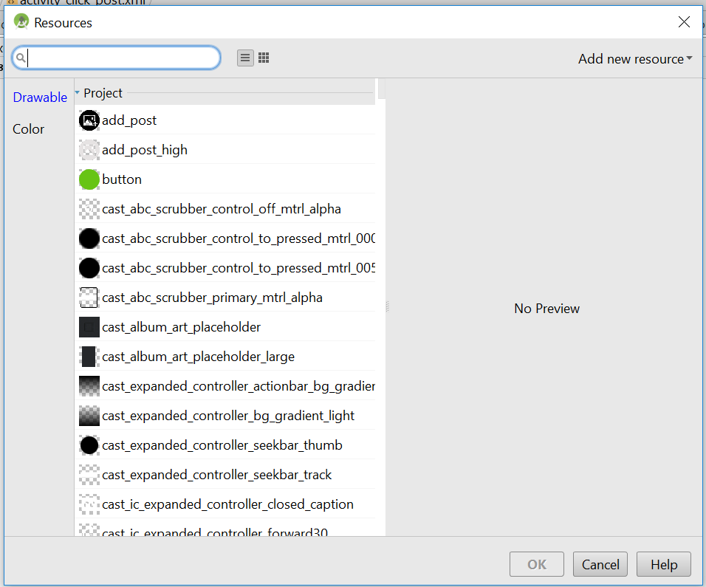
* Type SELECT_IMAGE
* 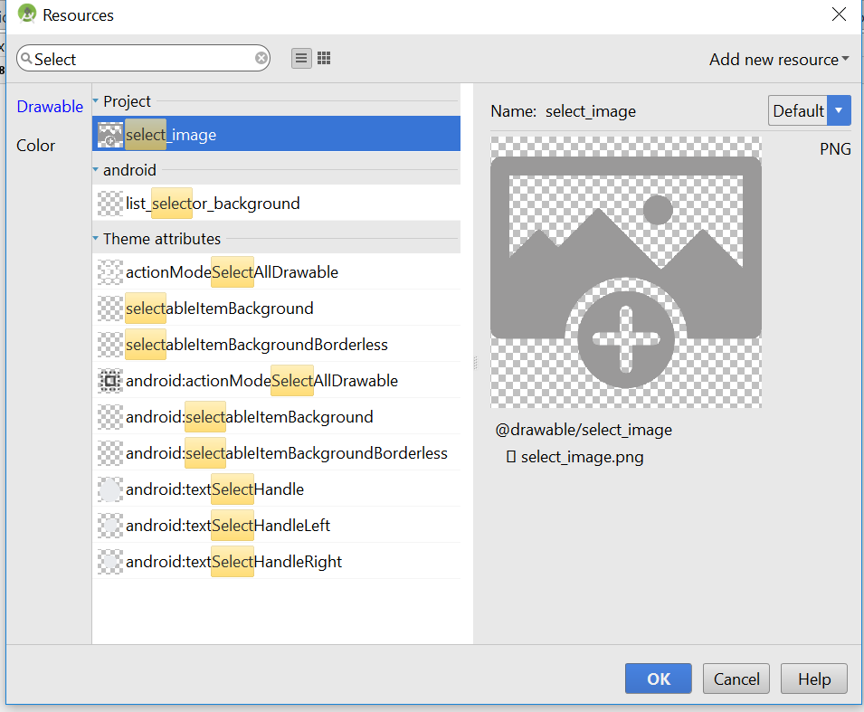
* Choose this image
* Move the image to the top, like this
* 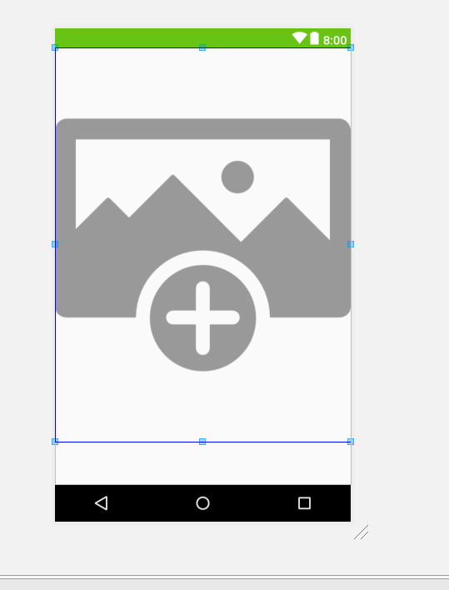
* Change the layout height to 300dp
* And change the margin to 10dp
* 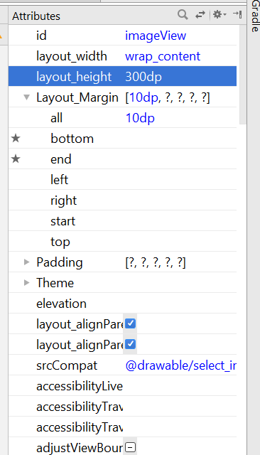
* Drag and drop a textview below
* Now it look like this
* 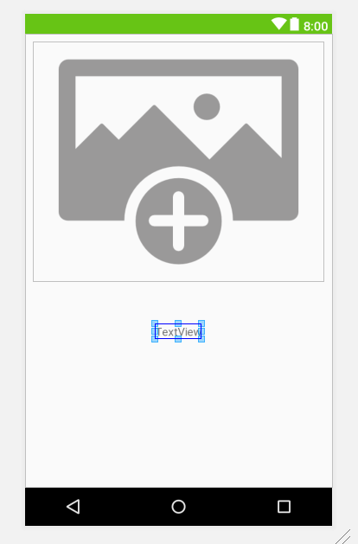
* textView width change to match parent
* Text change to “Post Description…”
* Now drag and drop two button, and all width change to Match_parent
* Now shld look like this
* 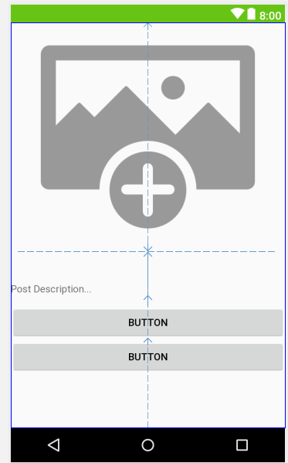
* Change the name of the button and shift it bottom
* The Text change to Delete Post and Edit Post
* The bottom margin change to 2dp
* 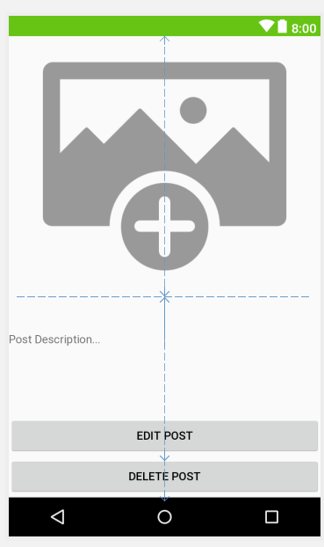
* Now select the TextView, layout_margin, left is 10dp, right is 10dp
* Textsize change to 16sp
* For the two button, change the layout_margin to this value, left and right
* 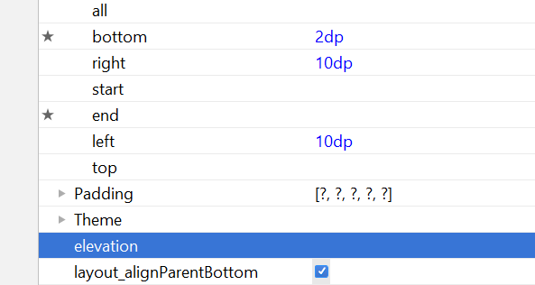
* Now shld look like this

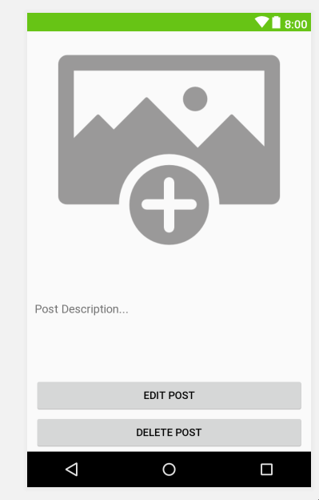

* Now go the TEXT
* Add this line
* android:background="@drawable/register"
* 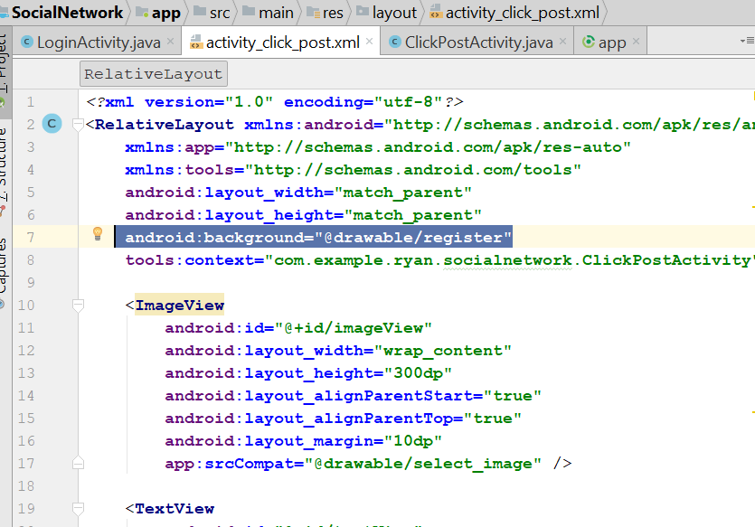
* The background will change
* Now change the background of each button
* android:background="@drawable/button"
* 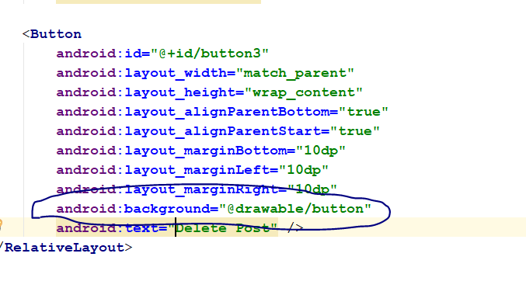
* Now change the button layout margin of each button to 10dp
* 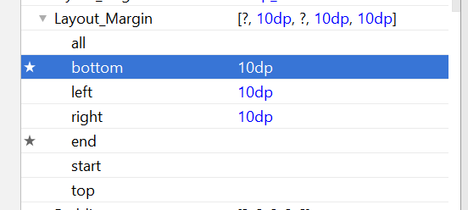
* Now shld look like this
* 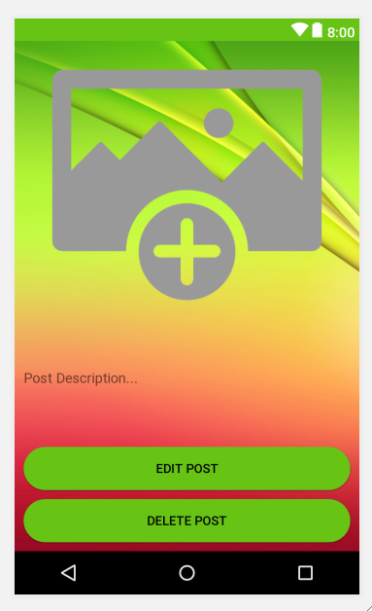
* For the TextView, change to bold and change text colour to background light colour
* 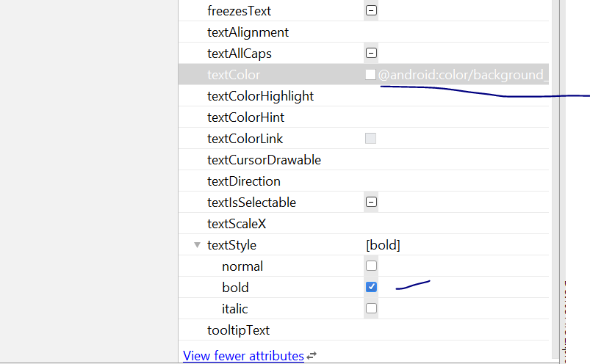
* Change the button colour too , change to background light
* Change button text size to 18sp
* 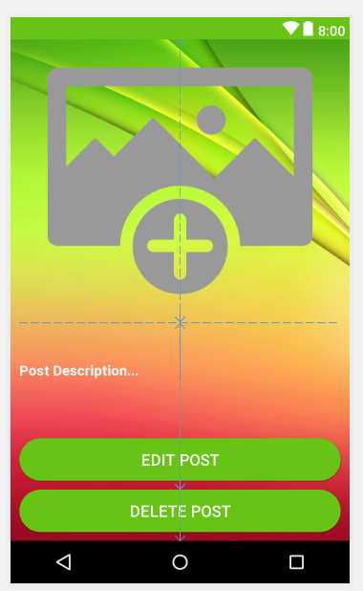
* Padding of the text, change to 13dp
* 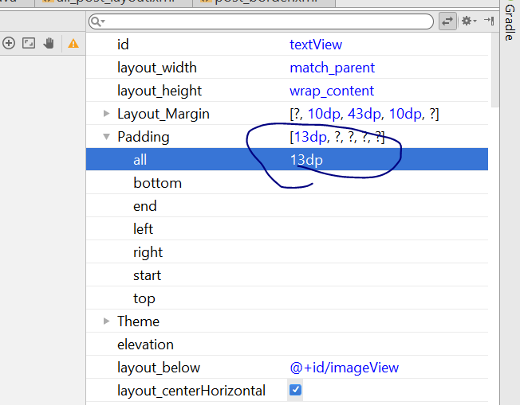
* Id of the imageView -> post_image
* Id of the TextView -> post_description
* Id of the Delete Button -> delete_post_button
* Id of the Edit Button -> edit_post_button
* Now go the clickpostActivity.java
* Add the following code
* 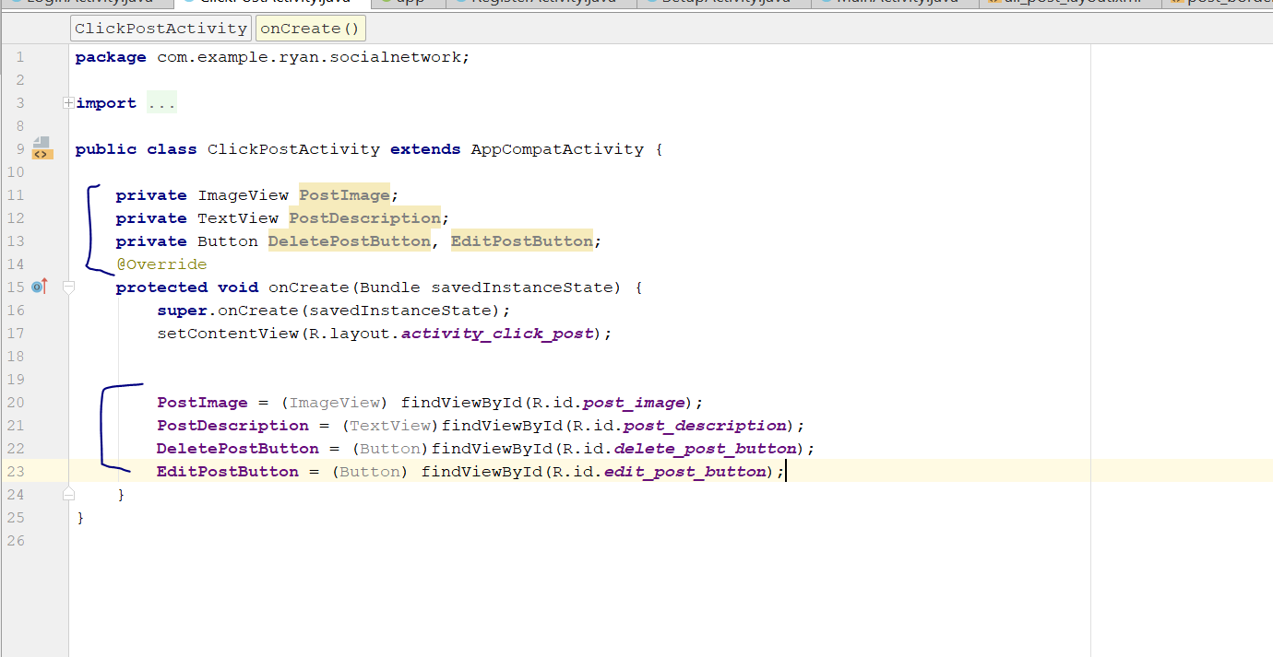
* **public class** ClickPostActivity **extends** AppCompatActivity {  
    
   **private** ImageView **PostImage**;  
   **private** TextView **PostDescription**;  
   **private** Button **DeletePostButton**, **EditPostButton**;  
   @Override  
   **protected void** onCreate(Bundle savedInstanceState) {  
   **super**.onCreate(savedInstanceState);  
   setContentView(R.layout.***activity_click_post***);  
    
    
   **PostImage** = (ImageView) findViewById(R.id.***post_image***);  
   **PostDescription** = (TextView)findViewById(R.id.***post_description***);  
   **DeletePostButton** = (Button)findViewById(R.id.***delete_post_button***);  
   **EditPostButton** = (Button) findViewById(R.id.***edit_post_button***);  
   }  
  }
* Save the project
* Now go to activity_click_post.xml, then change the text “post Description” colour.
* Change the colour to black
* 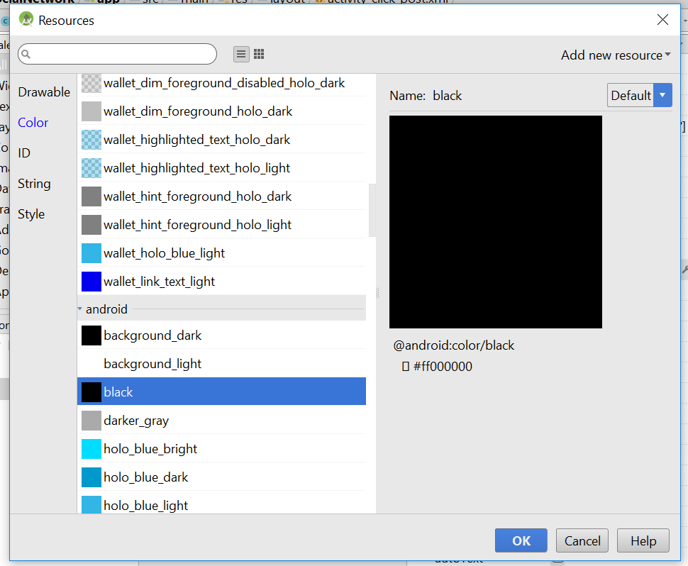
* Now should look like this
* 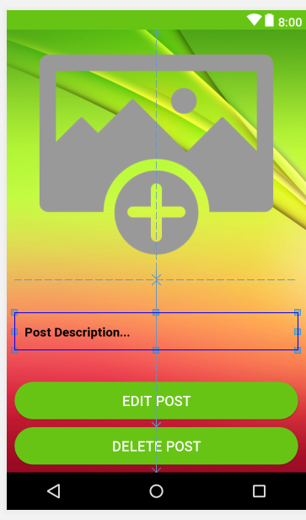
* For the image, scaletype change to centerInside
* 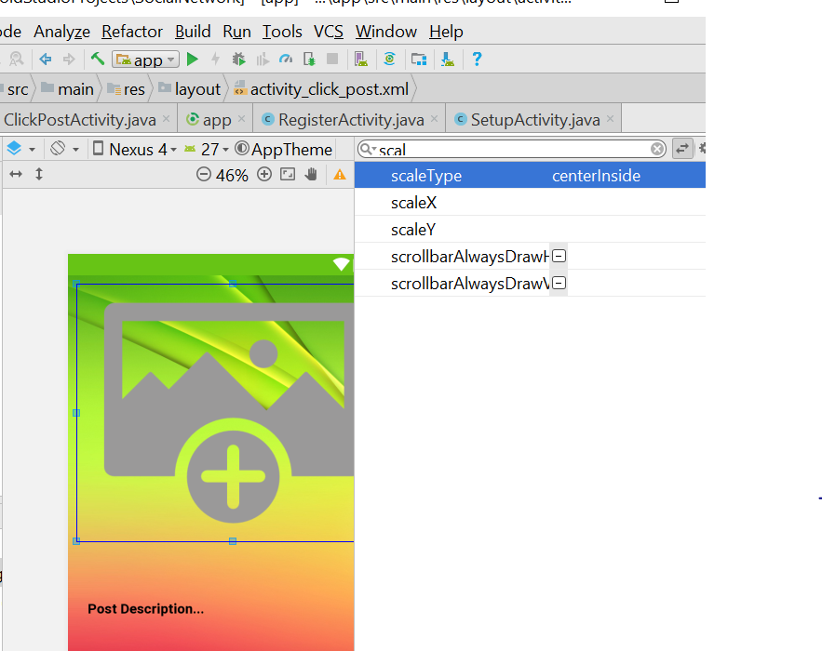
* Layout margin top of Post Description, should be 0
* 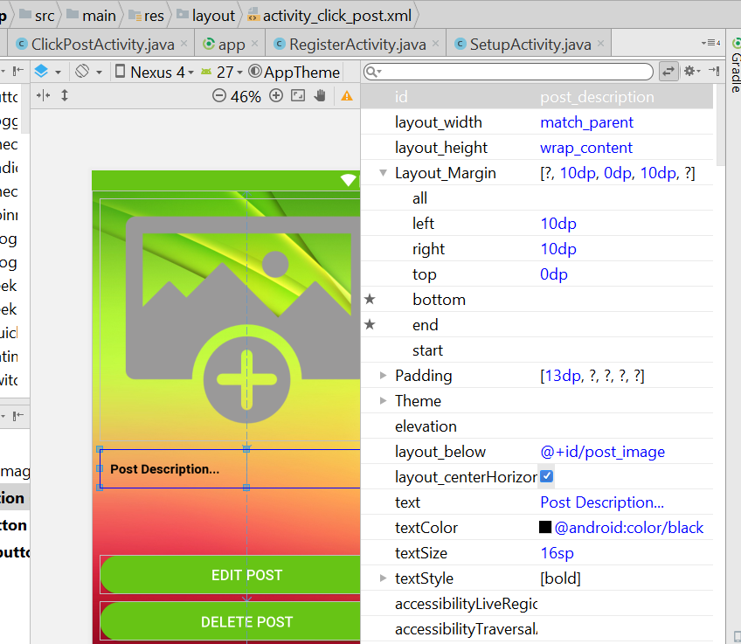
* Padding will be 8dp
* 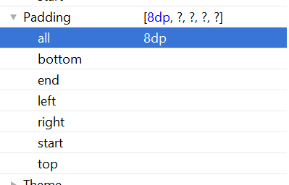
* Now change the id of the each item in the xml
* Go to the TEXT view
* Change id, post_image to “click_post_image”
* Change id, post_description to “click_post_description”
* 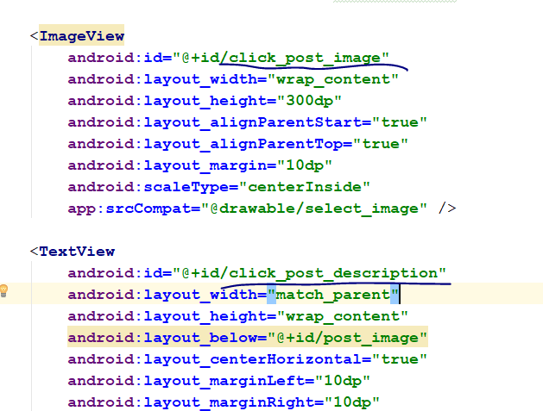
* Save the project
* Now you shld see something like this
* 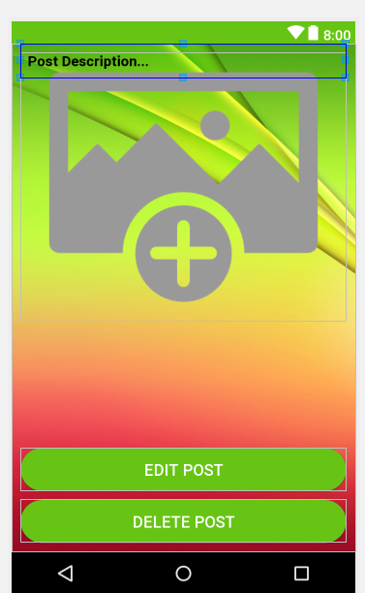
* Shift the post_description down
* The layout margin of the post description: from the left and right should be 5dp, see below
* 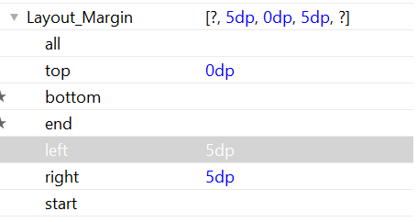
* Now we shall go the mainactivity.java
* Now go to the method : DisplayAllUserPosts()
* Go to here
* 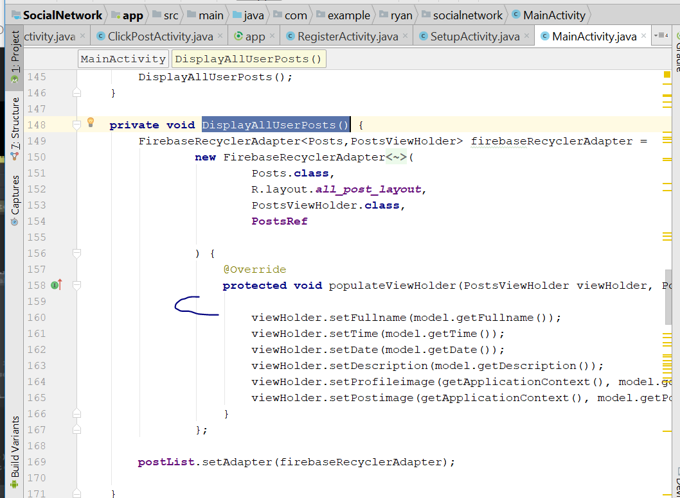
* Add this
* **final** String PostKey = getRef(position).getKey();
* and add this below
* viewHolder.**mView**.setOnClickListener(**new** View.OnClickListener() {  
   @Override  
   **public void** onClick(View v) {  
   Intent clickPostIntent = **new** Intent(MainActivity.**this**, ClickPostActivity.**class**);  
   clickPostIntent.putExtra(**"PostKey"**,PostKey);  
   startActivity(clickPostIntent);  
   }  
  });
* 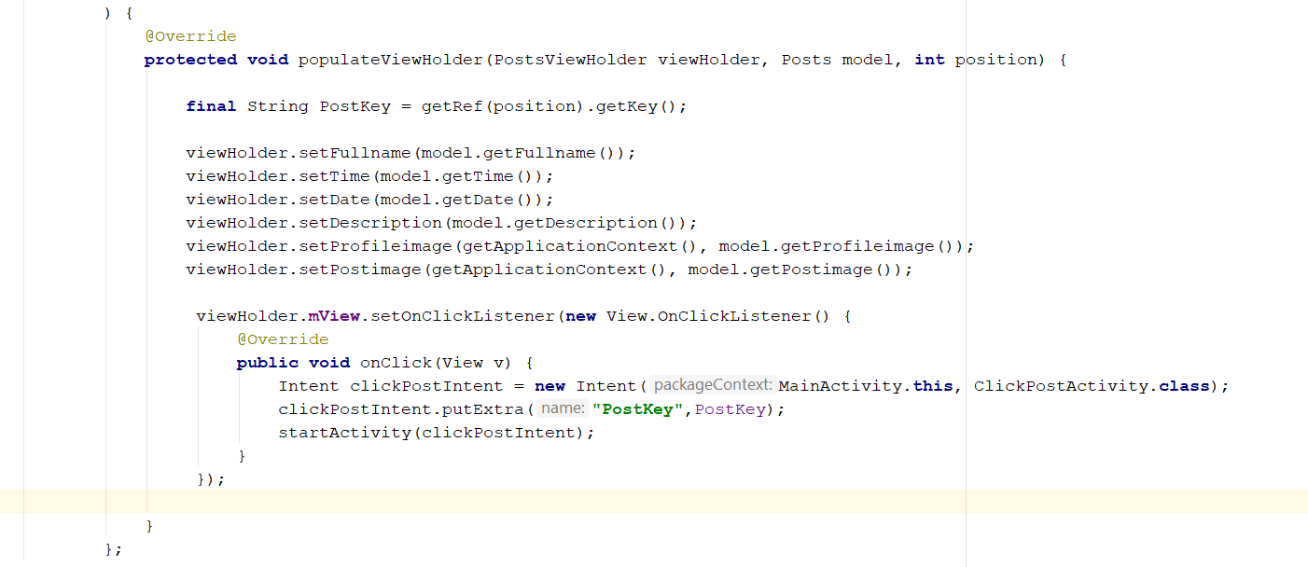
* Now go to the ClickPostActivity.java
* Add this variable on the top
* private Button DeletePostButton, EditPostButton;  
    
  private DatabaseReference ClickPostRef;
* In the onCreate()
* Add this
* **PostKey** = getIntent().getExtras().get(**"PostKey"**).toString();  
  **ClickPostRef** = FirebaseDatabase.*getInstance*().getReference().child(**"Posts"**).child(**PostKey**);
* **ClickPostRef**.addValueEventListener(**new** ValueEventListener() {  
   @Override  
   **public void** onDataChange(DataSnapshot dataSnapshot) {  
   String description = dataSnapshot.child(**"description"**).getValue().toString();  
   String image = dataSnapshot.child(**"postimage"**).getValue().toString();  
    
   **PostDescription**.setText(description);  
    
   Picasso.*get*().load(image).into(**PostImage**);  
   }  
    
   @Override  
   **public void** onCancelled(DatabaseError databaseError) {  
    
   }  
  });
* 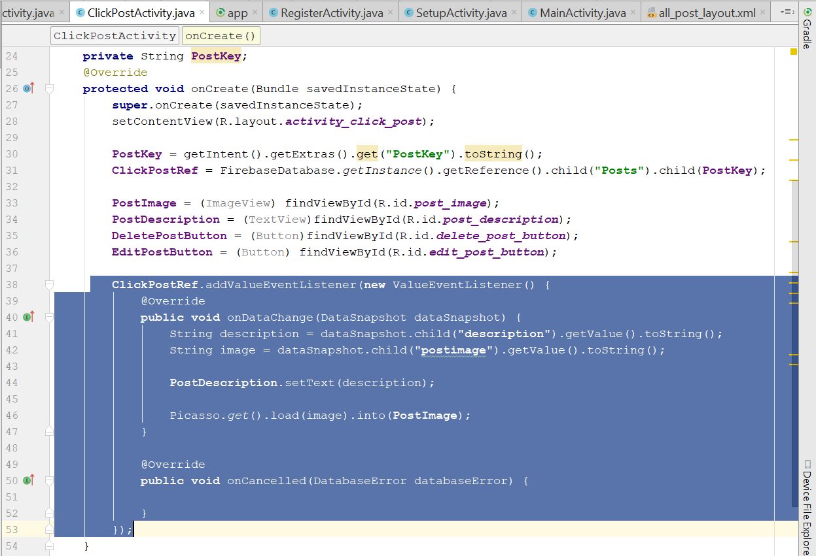
* Change this two line, to click_post_image
* 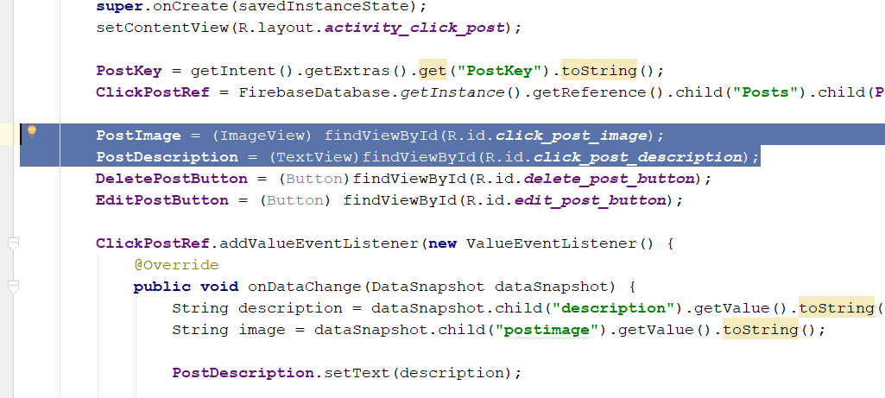
* Rebuild and Run
* When u tap the image, you bring to the click post activity screen
* Now we add some validation for the user, only allow them to edit their own post only
* Now go to CLickPostActvity.java
* Add this
* **private** FirebaseAuth **mAuth**;
* private String PostKey, currentUserID;
* in the OnCreate()
* **mAuth** = FirebaseAuth.*getInstance*();  
  **currentUserID** = **mAuth**.getCurrentUser().getUid();
* DeletePostButton.setVisibility(View.*INVISIBLE*);  
  EditPostButton.setVisibility(View.*INVISIBLE*);
* Now add a new code in ClickPostRef.addValueEventListener
* 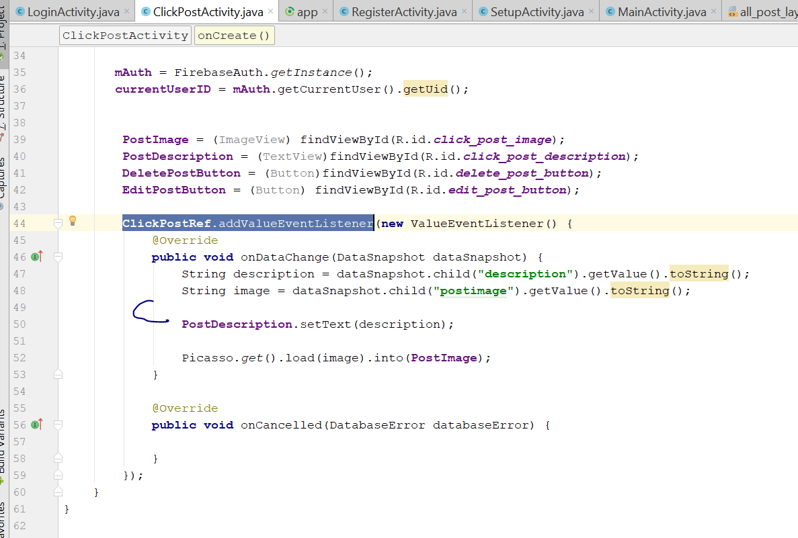
* Change the code into like that
* **ClickPostRef**.addValueEventListener(**new** ValueEventListener() {  
   @Override  
   **public void** onDataChange(DataSnapshot dataSnapshot) {  
   **description** = dataSnapshot.child(**"description"**).getValue().toString();  
   **image** = dataSnapshot.child(**"postimage"**).getValue().toString();  
   **databaseUserID** = dataSnapshot.child(**"uid"**).getValue().toString();  
   **PostDescription**.setText(**description**);  
    
   Picasso.*get*().load(**image**).into(**PostImage**);  
    
   **if**(**currentUserID**.equals(**databaseUserID**))  
   {  
   **DeletePostButton**.setVisibility(View.***VISIBLE***);  
   **EditPostButton**.setVisibility(View.***VISIBLE***);  
   }  
   }
* 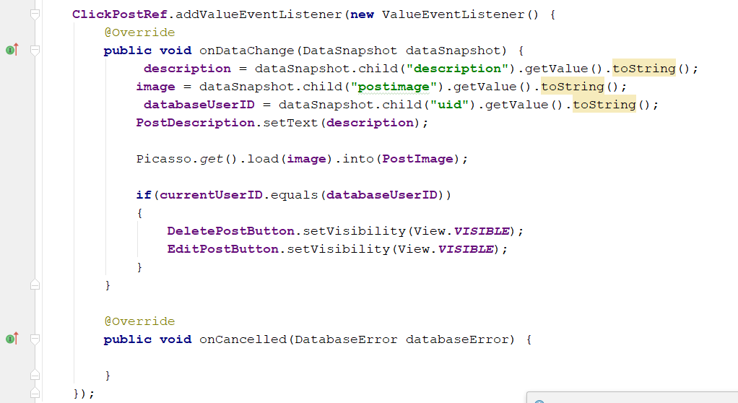
* Go to activity_click_post.xml, change the imageView layout_width to Match parent
* 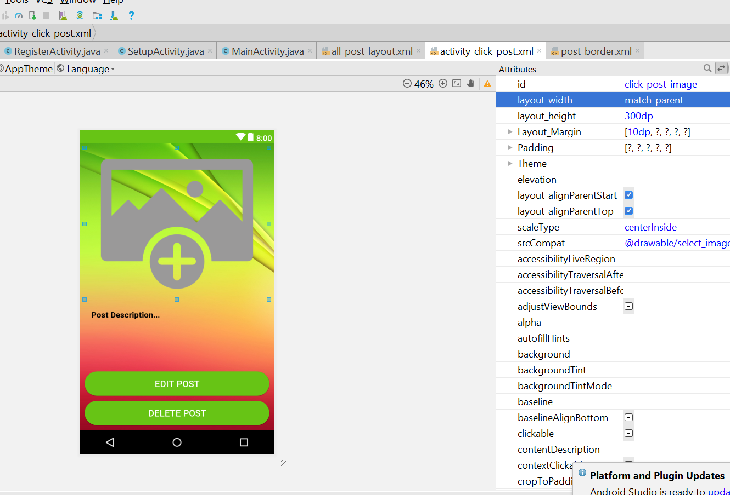
* Now to text View
* Add this line
* 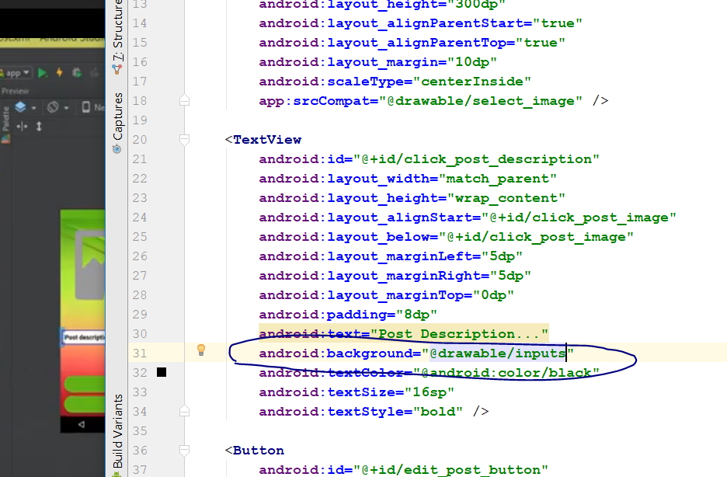
* android:background="@drawable/inputs"
* padding all change to 15dp
* Margin left and right change to 10 dp
* 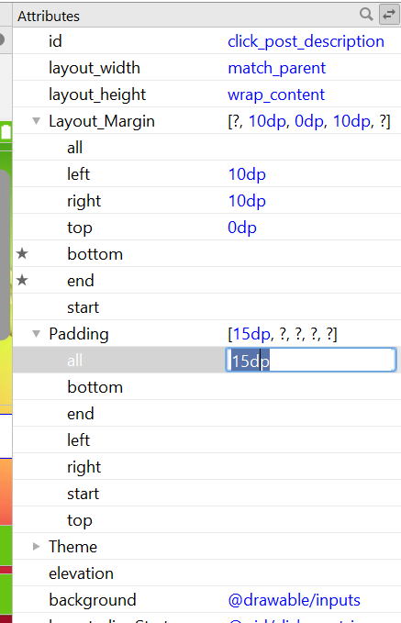
* Rebuild and run
* If you click on people post, button will disappear
* Now we do delete post
* Now go to ClickPostActivity.java
* Add the following code in the onCreate()
* **DeletePostButton**.setOnClickListener(**new** View.OnClickListener() {  
   @Override  
   **public void** onClick(View v) {  
   DeleteCurrentPost();  
   }  
  });
* Then add the following code outside onCreate
* **private void** DeleteCurrentPost() {  
    
   **ClickPostRef**.removeValue();  
   SendUserToMainActivity();  
   Toast.*makeText*(**this**, **"Post has been deleted."**, Toast.***LENGTH_SHORT***).show();  
    
  }  
  **private void** SendUserToMainActivity() {  
    
   Intent mainIntent = **new** Intent(ClickPostActivity.**this**, MainActivity.**class**);  
   mainIntent.addFlags(Intent.***FLAG_ACTIVITY_NEW_TASK***|Intent.***FLAG_ACTIVITY_CLEAR_TASK***);  
   startActivity(mainIntent);  
   finish();  
  }
* 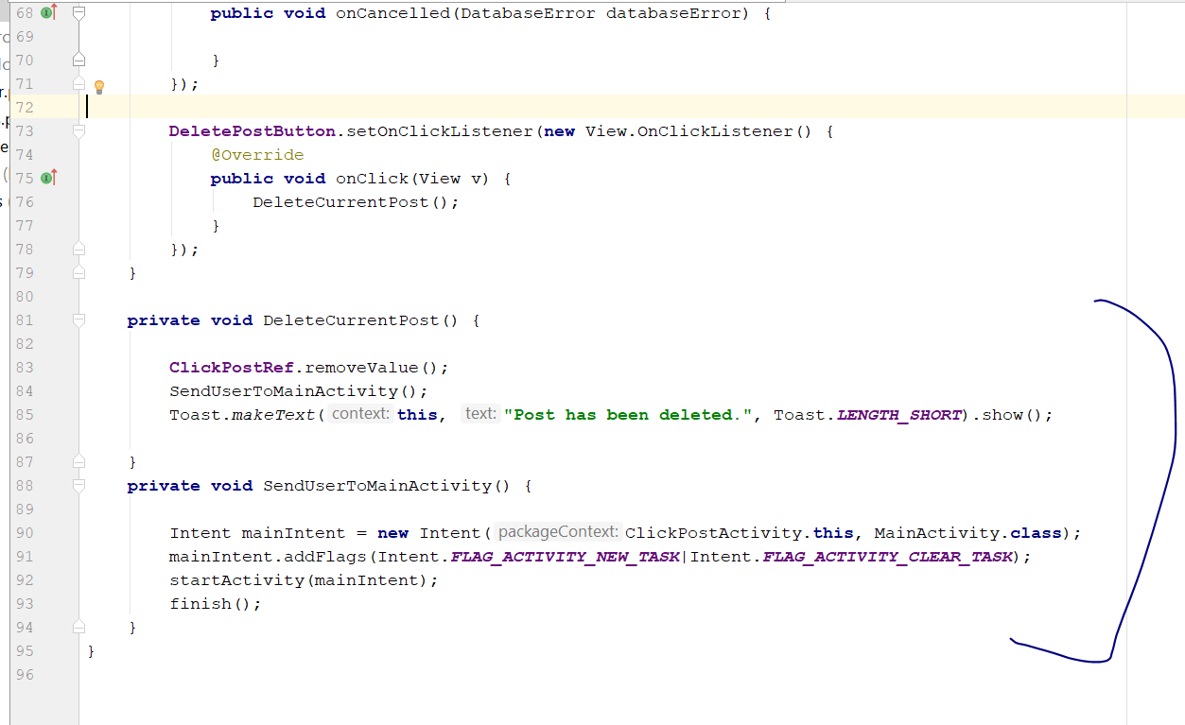
* Add the following validation in the onDataChange
* 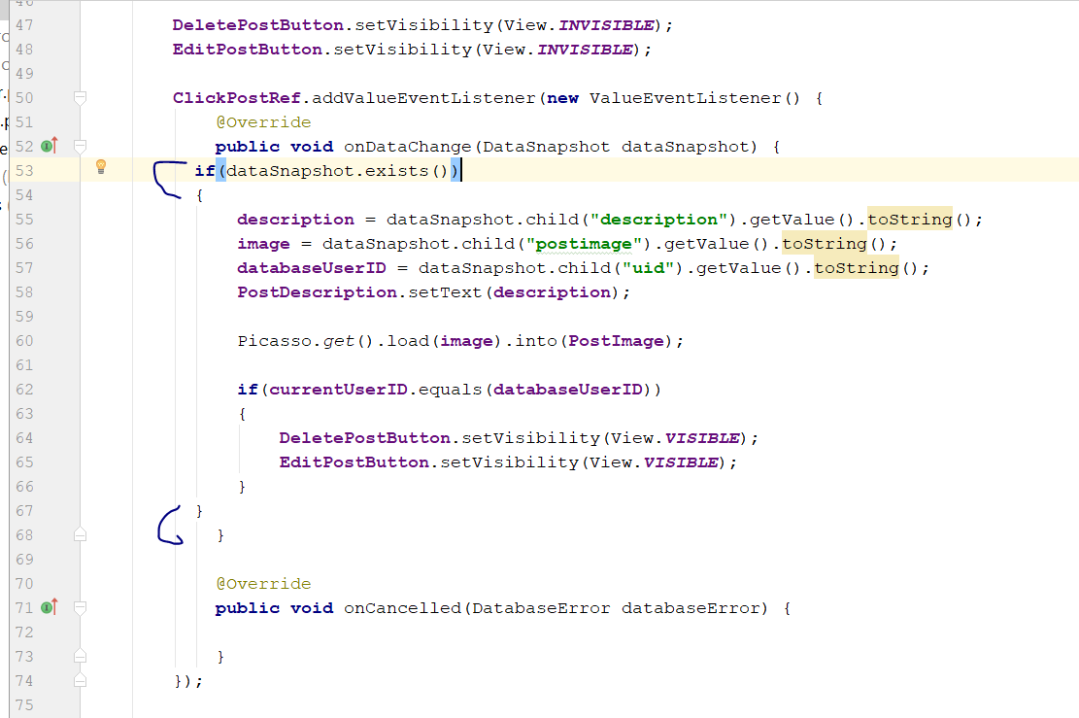
* Rebuild and Run
* After you delete your post, it should disappear
* Now go to activity_click_post.xml
* Click on click_post_image
* 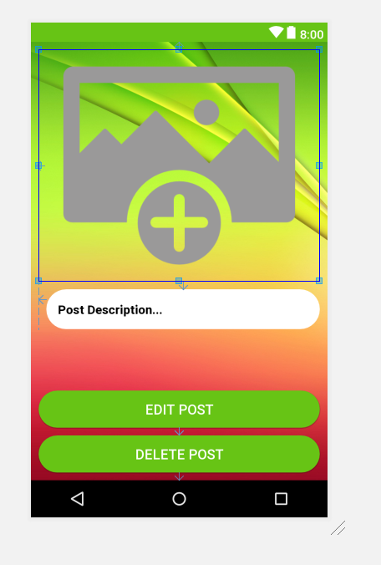
* Change the scaleType to None
* 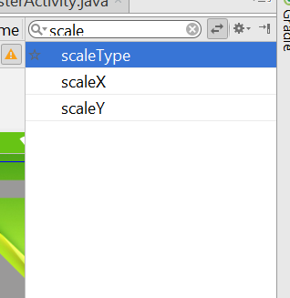
* Rebuild and Run, now image shld be fit better in the screen
* Now we do edit post
* Go to ClickPostActivity.java
* Add this new Method
* **private void** EditCurrentPost(String description) {  
    
   AlertDialog.Builder builder = **new** AlertDialog.Builder(ClickPostActivity.**this**);  
   builder.setTitle(**"Edit Post:"**);  
    
   **final** EditText inputField = **new** EditText(ClickPostActivity.**this**);  
   inputField.setText(description);  
   builder.setView(inputField);  
   builder.setPositiveButton(**"Update"**, **new** DialogInterface.OnClickListener() {  
   @Override  
   **public void** onClick(DialogInterface dialog, **int** which) {  
   **ClickPostRef**.child(**"description"**).setValue(inputField.getText().toString());  
   Toast.*makeText*(ClickPostActivity.**this**, **"Post Updated successfully"**, Toast.***LENGTH_SHORT***).show();  
    
   }  
   });  
    
   builder.setNegativeButton(**"Cancel"**, **new** DialogInterface.OnClickListener() {  
   @Override  
   **public void** onClick(DialogInterface dialog, **int** which) {  
   dialog.cancel();  
   }  
   });  
   Dialog dialog = builder.create();  
   dialog.show();  
   dialog.getWindow().setBackgroundDrawableResource(android.R.color.***holo_green_dark***);  
    
  }
* 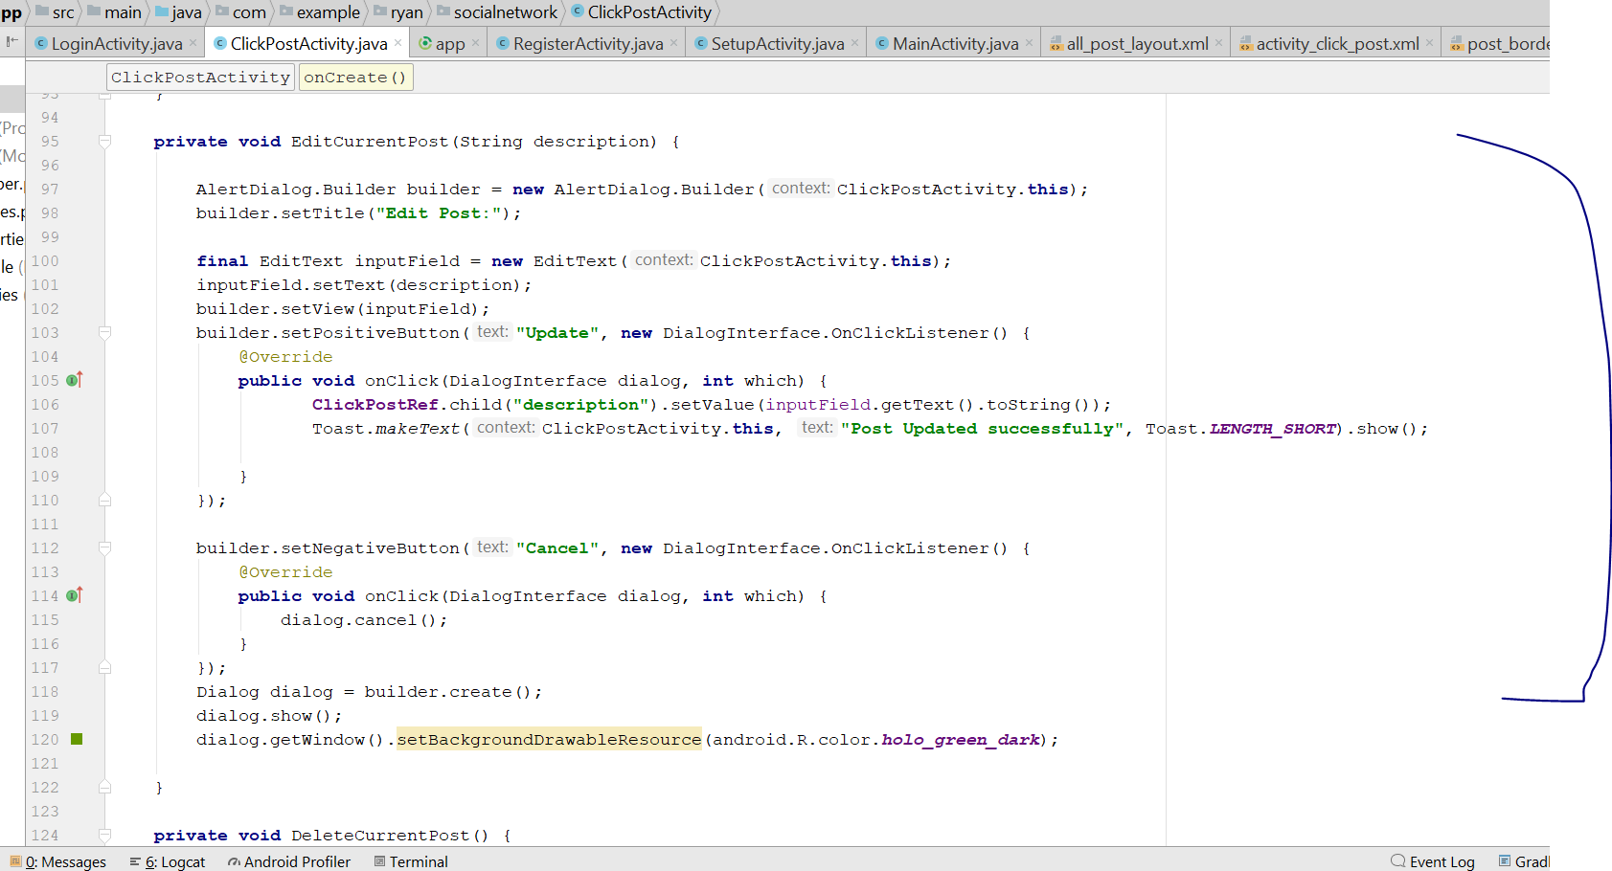
* Then add the following code, inside onDataChange
* **EditPostButton**.setOnClickListener(**new** View.OnClickListener() {  
   @Override  
   **public void** onClick(View v) {  
   EditCurrentPost(**description**);  
   }  
  });
* 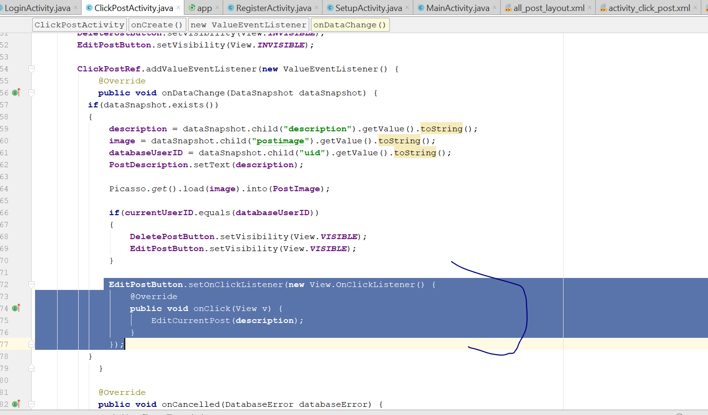
* Rebuild and Run
* When you click on edit button, you shld see a edit dialog box appear

# Create Setting Activity

* Create a empty Activity
* Call it SettingActivity
* 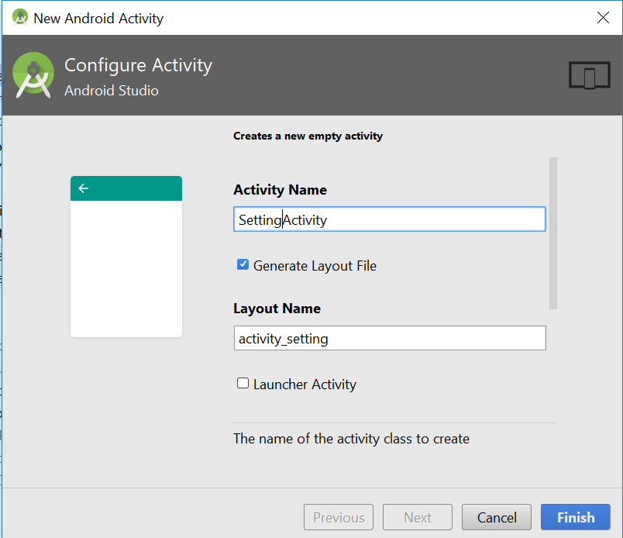
* Click finish
* Go to Activity_setting.xml
* Change the layout to relativeLayout
* Add this in the XML background
* android:background="@drawable/register"
* 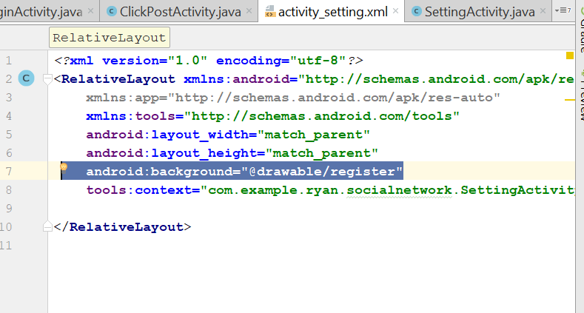
* Add this line inside the layout
* <include android:id="@+id/setting_toolbar"  
   layout="@layout/app_bar_layout"/>
* 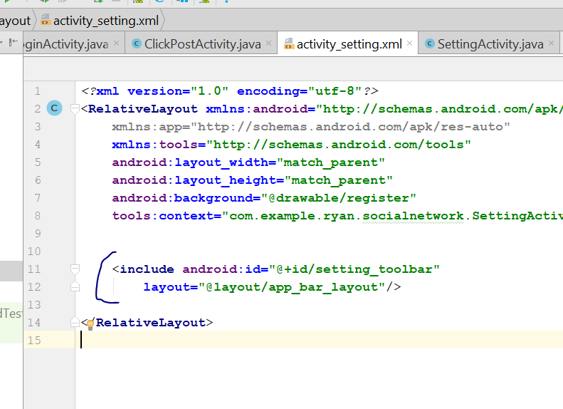
* Now drag and drop a scrollview into the centre
* 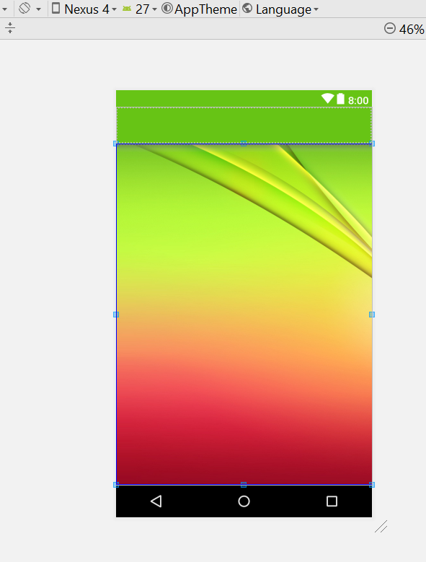
* Shift the position to under the appbar
* Go to Text, remove the linear layout in the scrollView, and change it to RelativeLayout
* Inside the relative layout, add in the following code
* <RelativeLayout  
   android:layout_width="match_parent"  
   android:layout_height="wrap_content"  
   >  
   <de.hdodenhof.circleimageview.CircleImageView  
   android:id="@+id/setting_profile_image"  
   android:layout_width="250dp"  
   android:layout_height="250dp"  
   android:layout_alignParentTop="true"  
   android:layout_centerHorizontal="true"  
   android:layout_marginTop="10dp"  
   android:src="@drawable/profile"/>  
   <EditText  
   android:id="@+id/settings_status"  
   android:layout_width="match_parent"  
   android:layout_height="wrap_content"  
   android:layout_below="@+id/setting_profile_image"  
   android:layout_marginLeft="40dp"  
   android:layout_marginRight="40dp"  
   android:background="@drawable/inputs"  
   android:layout_marginTop="4dp"  
   android:hint="profile status"  
   android:padding="30dp"  
   android:textColor="@android:color/background_dark"  
   android:textSize="20sp"  
   android:textStyle="bold"  
   />  
   <EditText  
   android:id="@+id/settings_username"  
   android:layout_width="match_parent"  
   android:layout_height="wrap_content"  
   android:layout_below="@+id/settings_status"  
   android:layout_marginLeft="10dp"  
   android:layout_marginRight="10dp"  
   android:background="@drawable/inputs"  
   android:layout_marginTop="30dp"  
   android:hint="username"  
   android:padding="12dp"  
   android:textColor="@android:color/background_dark"  
   android:textSize="20sp"  
   android:textStyle="bold"  
   />  
   <EditText  
   android:id="@+id/settings_profile_full_name"  
   android:layout_width="match_parent"  
   android:layout_height="wrap_content"  
   android:layout_below="@+id/settings_username"  
   android:layout_marginLeft="10dp"  
   android:layout_marginRight="10dp"  
   android:background="@drawable/inputs"  
   android:layout_marginTop="6dp"  
   android:hint="profile name"  
   android:padding="12dp"  
   android:textColor="@android:color/background_dark"  
   android:textSize="20sp"  
   android:textStyle="bold"  
   />  
    
   <EditText  
   android:id="@+id/settings_country"  
   android:layout_width="match_parent"  
   android:layout_height="wrap_content"  
   android:layout_below="@+id/settings_profile_full_name"  
   android:layout_marginLeft="10dp"  
   android:layout_marginRight="10dp"  
   android:background="@drawable/inputs"  
   android:layout_marginTop="6dp"  
   android:hint="country"  
   android:padding="12dp"  
   android:textColor="@android:color/background_dark"  
   android:textSize="20sp"  
   android:textStyle="bold"  
   />  
   <EditText  
   android:id="@+id/settings_dob"  
   android:layout_width="match_parent"  
   android:layout_height="wrap_content"  
   android:layout_below="@+id/settings_country"  
   android:layout_marginLeft="10dp"  
   android:layout_marginRight="10dp"  
   android:background="@drawable/inputs"  
   android:layout_marginTop="6dp"  
   android:hint="Date of Birth"  
   android:padding="12dp"  
   android:textColor="@android:color/background_dark"  
   android:textSize="20sp"  
   android:textStyle="bold"  
   />  
   <EditText  
   android:id="@+id/settings_gender"  
   android:layout_width="match_parent"  
   android:layout_height="wrap_content"  
   android:layout_below="@+id/settings_dob"  
   android:layout_marginLeft="10dp"  
   android:layout_marginRight="10dp"  
   android:background="@drawable/inputs"  
   android:layout_marginTop="6dp"  
   android:hint="Gender"  
   android:padding="12dp"  
   android:textColor="@android:color/background_dark"  
   android:textSize="20sp"  
   android:textStyle="bold"  
   />  
   <EditText  
   android:id="@+id/settings_relationship_status"  
   android:layout_width="match_parent"  
   android:layout_height="wrap_content"  
   android:layout_below="@+id/settings_gender"  
   android:layout_marginLeft="10dp"  
   android:layout_marginRight="10dp"  
   android:background="@drawable/inputs"  
   android:layout_marginTop="6dp"  
   android:hint="Relationship Status"  
   android:padding="12dp"  
   android:textColor="@android:color/background_dark"  
   android:textSize="20sp"  
   android:textStyle="bold"  
   />  
    
   <Button  
   android:id="@+id/update_account_settings_buttons"  
   android:layout_width="match_parent"  
   android:layout_height="60dp"  
   android:layout_below="@+id/settings_relationship_status"  
   android:text="Update Account Settings"  
   android:layout_margin="20dp"  
   android:background="@drawable/button"  
   android:textColor="@color/colorAccent"  
   android:textSize="20sp"  
   android:textStyle="bold"  
   android:textAllCaps="false"  
   />
* 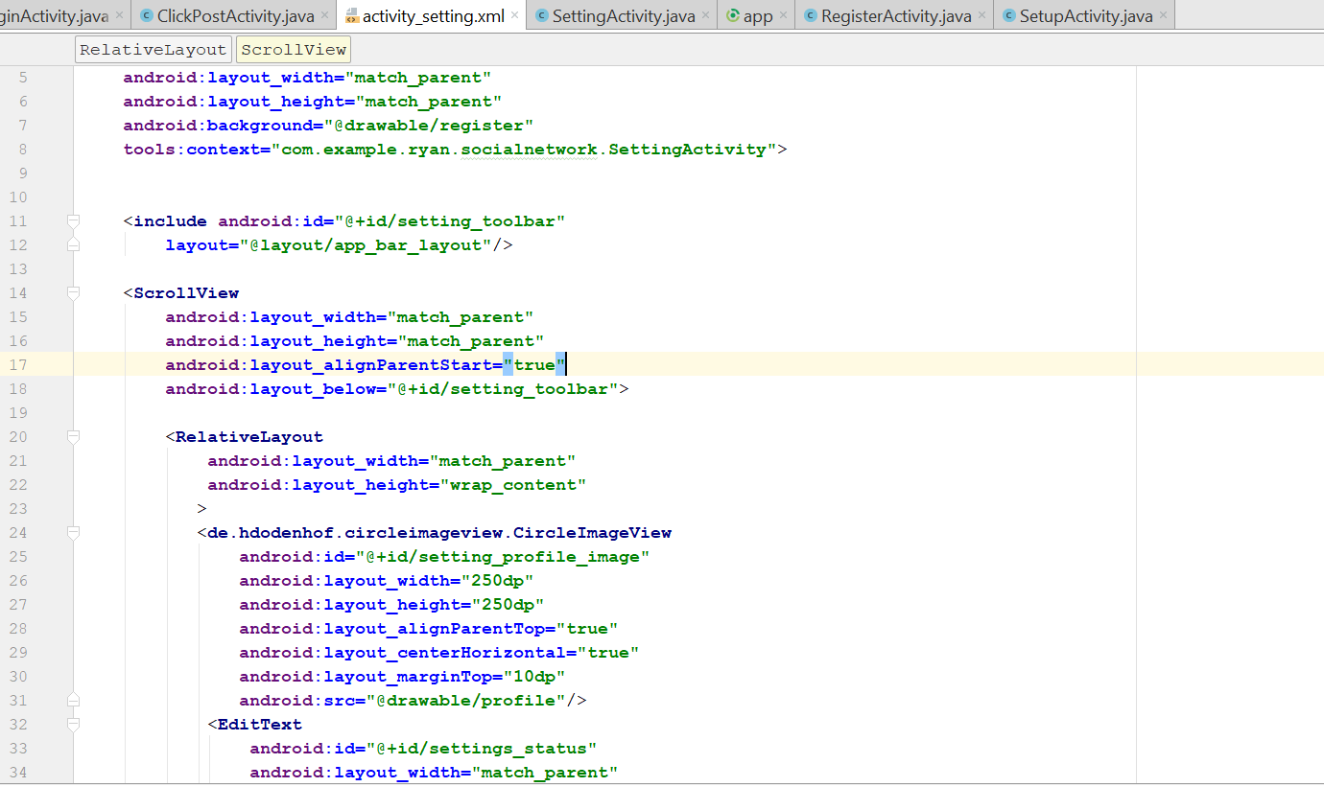
* The entire code for the layout will be
* *<?*xml version="1.0" encoding="utf-8"*?>*<RelativeLayout xmlns:android="http://schemas.android.com/apk/res/android"  
   xmlns:app="http://schemas.android.com/apk/res-auto"  
   xmlns:tools="http://schemas.android.com/tools"  
   android:layout_width="match_parent"  
   android:layout_height="match_parent"  
   android:background="@drawable/register"  
   tools:context="com.example.ryan.socialnetwork.SettingActivity">  
    
    
   <include android:id="@+id/setting_toolbar"  
   layout="@layout/app_bar_layout"/>  
    
   <ScrollView  
   android:layout_width="match_parent"  
   android:layout_height="match_parent"  
   android:layout_alignParentStart="true"  
   android:layout_below="@+id/setting_toolbar">  
    
   <RelativeLayout  
   android:layout_width="match_parent"  
   android:layout_height="wrap_content"  
   >  
   <de.hdodenhof.circleimageview.CircleImageView  
   android:id="@+id/setting_profile_image"  
   android:layout_width="250dp"  
   android:layout_height="250dp"  
   android:layout_alignParentTop="true"  
   android:layout_centerHorizontal="true"  
   android:layout_marginTop="10dp"  
   android:src="@drawable/profile"/>  
   <EditText  
   android:id="@+id/settings_status"  
   android:layout_width="match_parent"  
   android:layout_height="wrap_content"  
   android:layout_below="@+id/setting_profile_image"  
   android:layout_marginLeft="40dp"  
   android:layout_marginRight="40dp"  
   android:background="@drawable/inputs"  
   android:layout_marginTop="4dp"  
   android:hint="profile status"  
   android:padding="30dp"  
   android:textColor="@android:color/background_dark"  
   android:textSize="20sp"  
   android:textStyle="bold"  
   />  
   <EditText  
   android:id="@+id/settings_username"  
   android:layout_width="match_parent"  
   android:layout_height="wrap_content"  
   android:layout_below="@+id/settings_status"  
   android:layout_marginLeft="10dp"  
   android:layout_marginRight="10dp"  
   android:background="@drawable/inputs"  
   android:layout_marginTop="30dp"  
   android:hint="username"  
   android:padding="12dp"  
   android:textColor="@android:color/background_dark"  
   android:textSize="20sp"  
   android:textStyle="bold"  
   />  
   <EditText  
   android:id="@+id/settings_profile_full_name"  
   android:layout_width="match_parent"  
   android:layout_height="wrap_content"  
   android:layout_below="@+id/settings_username"  
   android:layout_marginLeft="10dp"  
   android:layout_marginRight="10dp"  
   android:background="@drawable/inputs"  
   android:layout_marginTop="6dp"  
   android:hint="profile name"  
   android:padding="12dp"  
   android:textColor="@android:color/background_dark"  
   android:textSize="20sp"  
   android:textStyle="bold"  
   />  
    
   <EditText  
   android:id="@+id/settings_country"  
   android:layout_width="match_parent"  
   android:layout_height="wrap_content"  
   android:layout_below="@+id/settings_profile_full_name"  
   android:layout_marginLeft="10dp"  
   android:layout_marginRight="10dp"  
   android:background="@drawable/inputs"  
   android:layout_marginTop="6dp"  
   android:hint="country"  
   android:padding="12dp"  
   android:textColor="@android:color/background_dark"  
   android:textSize="20sp"  
   android:textStyle="bold"  
   />  
   <EditText  
   android:id="@+id/settings_dob"  
   android:layout_width="match_parent"  
   android:layout_height="wrap_content"  
   android:layout_below="@+id/settings_country"  
   android:layout_marginLeft="10dp"  
   android:layout_marginRight="10dp"  
   android:background="@drawable/inputs"  
   android:layout_marginTop="6dp"  
   android:hint="Date of Birth"  
   android:padding="12dp"  
   android:textColor="@android:color/background_dark"  
   android:textSize="20sp"  
   android:textStyle="bold"  
   />  
   <EditText  
   android:id="@+id/settings_gender"  
   android:layout_width="match_parent"  
   android:layout_height="wrap_content"  
   android:layout_below="@+id/settings_dob"  
   android:layout_marginLeft="10dp"  
   android:layout_marginRight="10dp"  
   android:background="@drawable/inputs"  
   android:layout_marginTop="6dp"  
   android:hint="Gender"  
   android:padding="12dp"  
   android:textColor="@android:color/background_dark"  
   android:textSize="20sp"  
   android:textStyle="bold"  
   />  
   <EditText  
   android:id="@+id/settings_relationship_status"  
   android:layout_width="match_parent"  
   android:layout_height="wrap_content"  
   android:layout_below="@+id/settings_gender"  
   android:layout_marginLeft="10dp"  
   android:layout_marginRight="10dp"  
   android:background="@drawable/inputs"  
   android:layout_marginTop="6dp"  
   android:hint="Relationship Status"  
   android:padding="12dp"  
   android:textColor="@android:color/background_dark"  
   android:textSize="20sp"  
   android:textStyle="bold"  
   />  
    
   <Button  
   android:id="@+id/update_account_settings_buttons"  
   android:layout_width="match_parent"  
   android:layout_height="60dp"  
   android:layout_below="@+id/settings_relationship_status"  
   android:text="Update Account Settings"  
   android:layout_margin="20dp"  
   android:background="@drawable/button"  
   android:textColor="@color/colorAccent"  
   android:textSize="20sp"  
   android:textStyle="bold"  
   android:textAllCaps="false"  
   />  
   </RelativeLayout>  
   </ScrollView>  
    
  </RelativeLayout>
* It should look like this
* 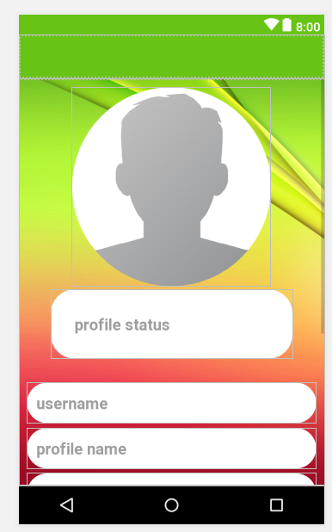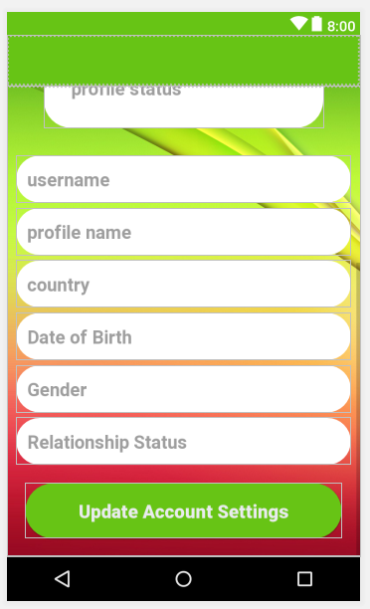
* Now go to the SettingActivity.java
* Declare this variable
* private Toolbar mToolbar;
* In the onCreate()
* Add the following code
* **mToolbar** = (Toolbar) findViewById(R.id.***setting_toolbar***);  
  setSupportActionBar(**mToolbar**);  
  getSupportActionBar().setTitle(**"Account Settings"**);  
  getSupportActionBar().setDisplayShowHomeEnabled(**true**);
* Now go to the Android Manifest
* Add this
* <activity android:name=".SettingActivity"  
   android:parentActivityName=".MainActivity"  
    
   ></activity>
* 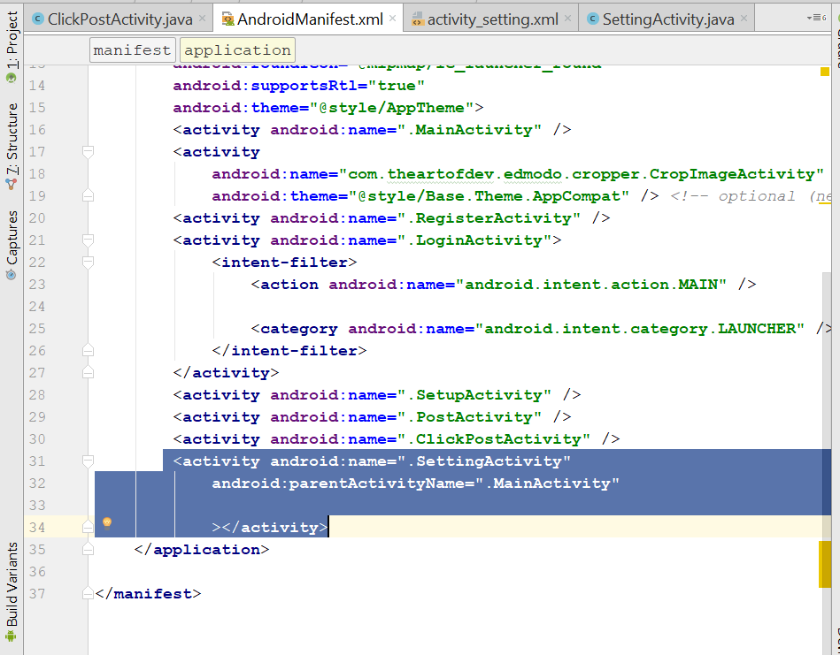
* Now go to MainActivity.java
* Add this new method
* **private void** SendUserToSettingActivity() {  
   Intent loginIntent = **new** Intent(MainActivity.**this**,SettingActivity.**class**);  
   startActivity(loginIntent);  
    
  }
* Go to UserMenuSelector
* 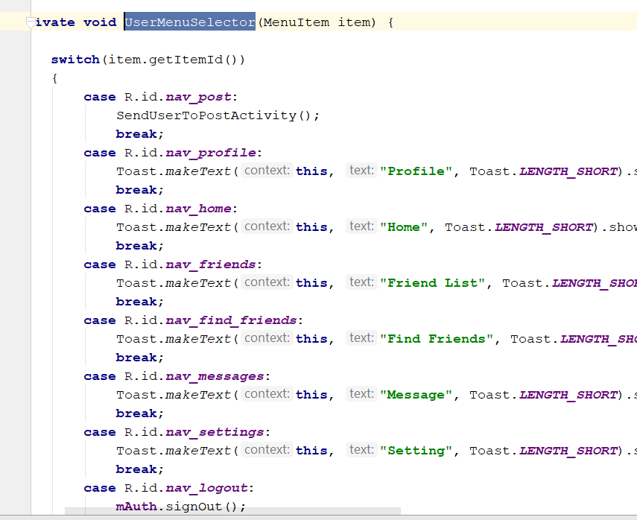
* Change the nav_setting option
* Add this
* SendUserToSettingActivity();
* 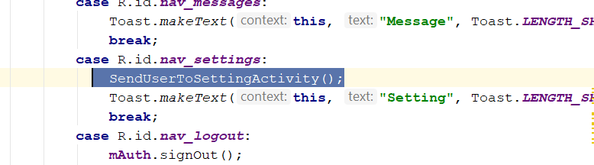
* Rebuild and Run, the button shld be working
* Now go to SettingActivity.java
* Declare those variable
* private Toolbar mToolbar;  
  private EditText userName, userProfName, userStatus, userCountry, userGender, userRelation, userDOB;  
  private Button UpdateAccountSettingsButton;  
  private CircleImageView userProfleimage;  
  private DatabaseReference SettinguserRef;  
  private FirebaseAuth mAuth;  
  private String currentUserId;
* In the onCreate, add the following code
* **super**.onCreate(savedInstanceState);  
  setContentView(R.layout.***activity_setting***);  
    
  **mAuth** = FirebaseAuth.*getInstance*();  
  **currentUserId** = **mAuth**.getCurrentUser().getUid();  
  **SettinguserRef** = FirebaseDatabase.*getInstance*().getReference().child(**"Users"**).child(**currentUserId**);  
    
    
  **mToolbar** = (Toolbar) findViewById(R.id.***setting_toolbar***);  
  setSupportActionBar(**mToolbar**);  
  getSupportActionBar().setTitle(**"Account Settings"**);  
  getSupportActionBar().setDisplayShowHomeEnabled(**true**);  
    
  **userName** = (EditText) findViewById(R.id.***settings_username***);  
  **userProfName** = (EditText) findViewById(R.id.***settings_profile_full_name***);  
  **userStatus** = (EditText) findViewById(R.id.***settings_status***);  
  **userCountry** = (EditText) findViewById(R.id.***settings_country***);  
  **userGender** = (EditText) findViewById(R.id.***settings_gender***);  
  **userRelation** = (EditText) findViewById(R.id.***settings_relationship_status***);  
  **userDOB** = (EditText) findViewById(R.id.***settings_dob***);  
    
  **userProfleimage** = (CircleImageView)findViewById(R.id.***setting_profile_image***);  
    
  **UpdateAccountSettingsButton** = (Button) findViewById(R.id.***update_account_settings_buttons***);  
    
  **SettinguserRef**.addValueEventListener(**new** ValueEventListener() {  
   @Override  
   **public void** onDataChange(DataSnapshot dataSnapshot) {  
   **if**(dataSnapshot.exists())  
   {  
   String myProfileImage = dataSnapshot.child(**"profileimage"**).getValue().toString();  
   String myUserName = dataSnapshot.child(**"username"**).getValue().toString();  
   String myProfileName = dataSnapshot.child(**"fullname"**).getValue().toString();  
   String myProfileStatus = dataSnapshot.child(**"status"**).getValue().toString();  
   String myDOB = dataSnapshot.child(**"dob"**).getValue().toString();  
   String myCountry = dataSnapshot.child(**"country"**).getValue().toString();  
   String myGender = dataSnapshot.child(**"gender"**).getValue().toString();  
   String myRelationStatus = dataSnapshot.child(**"relationshipstatus"**).getValue().toString();  
   Picasso.*get*().load(myProfileImage).placeholder(R.drawable.***profile***).into(**userProfleimage**);  
   **userName**.setText(myUserName);  
   **userProfName**.setText(myProfileName);  
   **userStatus**.setText(myProfileStatus);  
   **userDOB**.setText(myDOB);  
   **userCountry**.setText(myCountry);  
   **userGender**.setText(myGender);  
   **userRelation**.setText(myRelationStatus);  
    
   }  
   }  
    
   @Override  
   **public void** onCancelled(DatabaseError databaseError) {  
    
   }  
  });
* 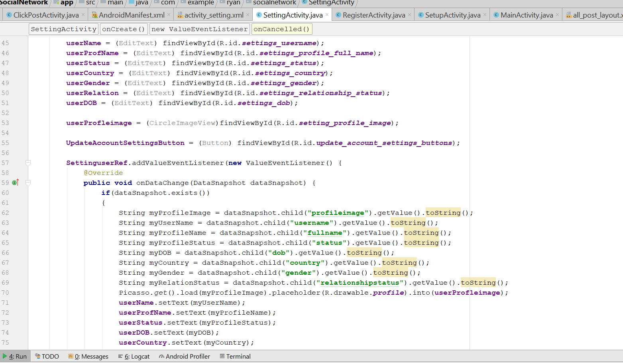
* Rebuild and Run, now when u click on setting should bring u to setting page

# Create Profile Activity

* Create a new Activity – profile Activity
* 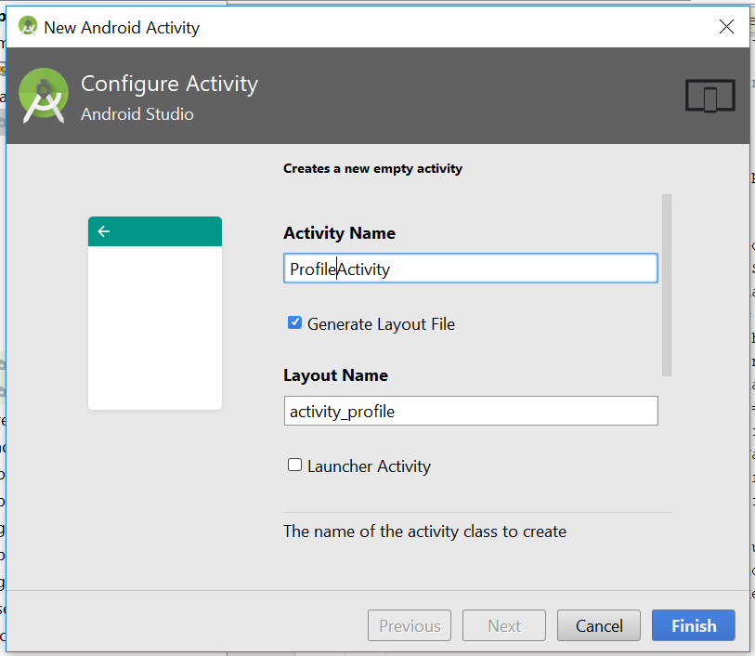
* Now go to activity_profile.xml, change the layout to RelativeLayout
* You will see something like this
* 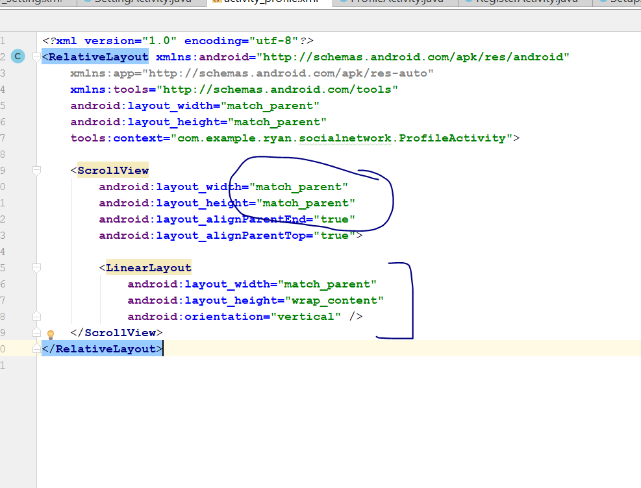
* Make sure the ScrollView LayoutWidth is match parent
* And Change the inner LinearLayout to Relative_layout
* Change to this
* <RelativeLayout  
   android:layout_width="match_parent"  
   android:layout_height="wrap_content"  
   >  
    
  </RelativeLayout>
* Now go to the values> color.xml
* Add a new color
* Add this
* <color name="colorProfile">#3B4041</color>
* 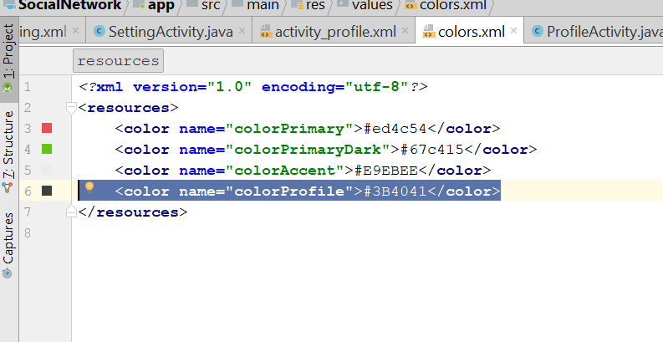
* Now go back to the activity_profile.xml, add this line
* android:background="@color/colorProfile"
* 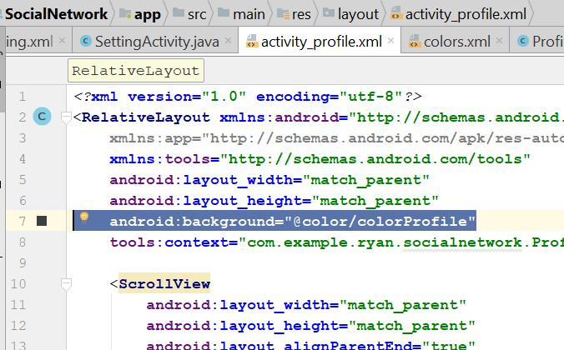
* Ad the following code inside the inner Relative layout
* <de.hdodenhof.circleimageview.CircleImageView  
   android:id="@+id/my_profile_pic"  
   android:layout_width="300dp"  
   android:layout_height="300dp"  
   android:layout_alignParentTop="true"  
   android:layout_centerHorizontal="true"  
   android:layout_marginTop="15dp"  
   android:src="@drawable/profile" />  
    
  <TextView  
   android:id="@+id/my_profile_full_name"  
   android:layout_width="match_parent"  
   android:layout_height="wrap_content"  
   android:layout_below="@+id/my_profile_pic"  
   android:layout_marginTop="5dp"  
   android:text="Profile Name"  
   android:textAlignment="center"  
   android:textAllCaps="false"  
   android:textColor="@android:color/background_light"  
   android:textSize="20sp"  
   android:textStyle="bold" />  
    
  <TextView  
   android:id="@+id/my_username"  
   android:layout_width="match_parent"  
   android:layout_height="wrap_content"  
   android:layout_below="@+id/my_profile_full_name"  
   android:text="user name"  
   android:textAlignment="center"  
   android:textAllCaps="false"  
   android:textColor="@android:color/background_light"  
   android:textSize="18sp" />  
    
  <TextView  
   android:id="@+id/my_profile_status"  
   android:layout_width="match_parent"  
   android:layout_height="wrap_content"  
   android:layout_below="@+id/my_username"  
   android:layout_marginTop="5dp"  
   android:text="hey there, I am using social app, developed by Ryan"  
   android:textAlignment="center"  
   android:textAllCaps="false"  
   android:textColor="@android:color/darker_gray"  
   android:textSize="22sp" />  
    
  <TextView  
   android:id="@+id/my_country"  
   android:layout_width="match_parent"  
   android:layout_height="wrap_content"  
   android:layout_below="@+id/my_profile_status"  
   android:layout_marginTop="60dp"  
   android:text="Country"  
   android:textAlignment="center"  
   android:textAllCaps="false"  
   android:textColor="@color/colorAccent"  
   android:textSize="18sp" />  
    
  <TextView  
   android:id="@+id/my_dob"  
   android:layout_width="match_parent"  
   android:layout_height="wrap_content"  
   android:layout_below="@+id/my_country"  
   android:layout_marginTop="2dp"  
   android:text="Date of Birth"  
   android:textAlignment="center"  
   android:textAllCaps="false"  
   android:textColor="@color/colorAccent"  
   android:textSize="18sp" />  
    
  <TextView  
   android:id="@+id/my_gender"  
   android:layout_width="match_parent"  
   android:layout_height="wrap_content"  
   android:layout_below="@+id/my_dob"  
   android:layout_marginTop="2dp"  
   android:text="Gender"  
   android:textAlignment="center"  
   android:textAllCaps="false"  
   android:textColor="@color/colorAccent"  
   android:textSize="18sp" />  
    
  <TextView  
   android:id="@+id/my_relationship_status"  
   android:layout_width="match_parent"  
   android:layout_height="wrap_content"  
   android:layout_below="@+id/my_gender"  
   android:layout_marginTop="2dp"  
   android:text="Relationship status"  
   android:textAlignment="center"  
   android:textAllCaps="false"  
   android:textColor="@color/colorAccent"  
   android:textSize="18sp" />
* It shld look something like this
* 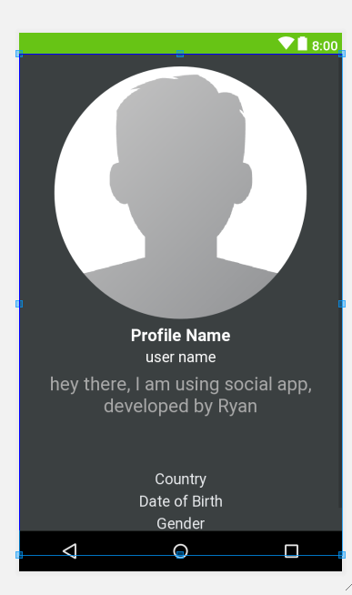
* Now go to profile Activity.java
* Declare this on top
* private TextView userName, userProfName, userStatus, userCountry, userGender, userRelation, userDOB;  
  private CircleImageView userProfileImage;
* Then in the OnCreate(), you add this
* **userName** = (TextView) findViewById(R.id.my_username);  
  **userProfName** = (TextView) findViewById(R.id.my_profile_full_name);  
  **userStatus** = (TextView) findViewById(R.id.my_profile_status);  
  **userCountry** = (TextView) findViewById(R.id.my_country);  
  **userGender** = (TextView) findViewById(R.id.my_gender);  
  **userRelation** = (TextView) findViewById(R.id.my_relationship_status);  
  **userDOB** = (TextView) findViewById(R.id.my_dob);  
  **userProfileImage** = (CircleImageView)findViewById(R.id.my_profile_pic);
* Now declare this on the top
* private DatabaseReference profileUserRef;  
  private FirebaseAuth mAuth;  
  private String currentUserID;
* In the onCreate(), add this
* **profileUserRef**.addValueEventListener(**new** ValueEventListener() {  
   @Override  
   **public void** onDataChange(DataSnapshot dataSnapshot) {  
   **if**(dataSnapshot.exists())  
   {  
   String myProfileImage = dataSnapshot.child(**"profileimage"**).getValue().toString();  
   String myUserName = dataSnapshot.child(**"username"**).getValue().toString();  
   String myProfileName = dataSnapshot.child(**"fullname"**).getValue().toString();  
   String myProfileStatus = dataSnapshot.child(**"status"**).getValue().toString();  
   String myDOB = dataSnapshot.child(**"dob"**).getValue().toString();  
   String myCountry = dataSnapshot.child(**"country"**).getValue().toString();  
   String myGender = dataSnapshot.child(**"gender"**).getValue().toString();  
   String myRelationStatus = dataSnapshot.child(**"relationshipstatus"**).getValue().toString();  
    
    
   Picasso.*get*().load(myProfileImage).placeholder(R.drawable.***profile***).into(**userProfileImage**);  
   **userName**.setText(**"@"**+myUserName);  
   **userProfName**.setText(myProfileName);  
   **userStatus**.setText(myProfileStatus);  
   **userDOB**.setText(**"DOB: "**+myDOB);  
   **userCountry**.setText(**"Country: "**+myCountry);  
   **userGender**.setText(**"Gender: "**+myGender);  
   **userRelation**.setText(**"Relationship: "**+myRelationStatus);  
   }  
   }  
    
   @Override  
   **public void** onCancelled(DatabaseError databaseError) {  
    
   }  
  });
* 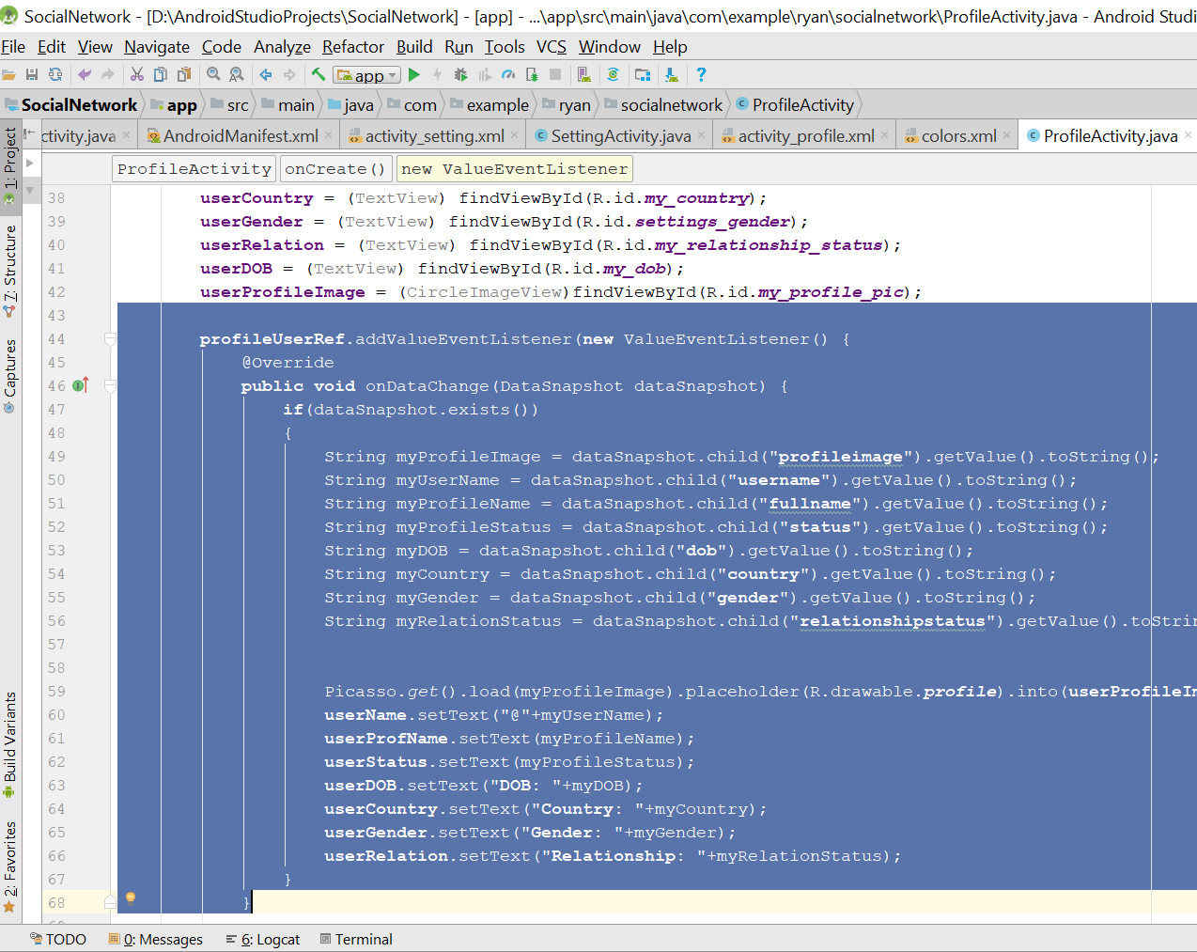
* Now go to the MainActivity.java
* Add this code
* **private void** SendUserToProfileActivity() {  
   Intent loginIntent = **new** Intent(MainActivity.**this**,ProfileActivity.**class**);  
   startActivity(loginIntent);  
    
  }
* 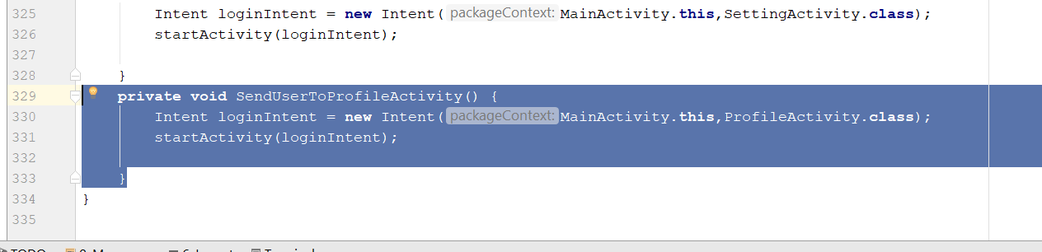
* Add the new code here
* 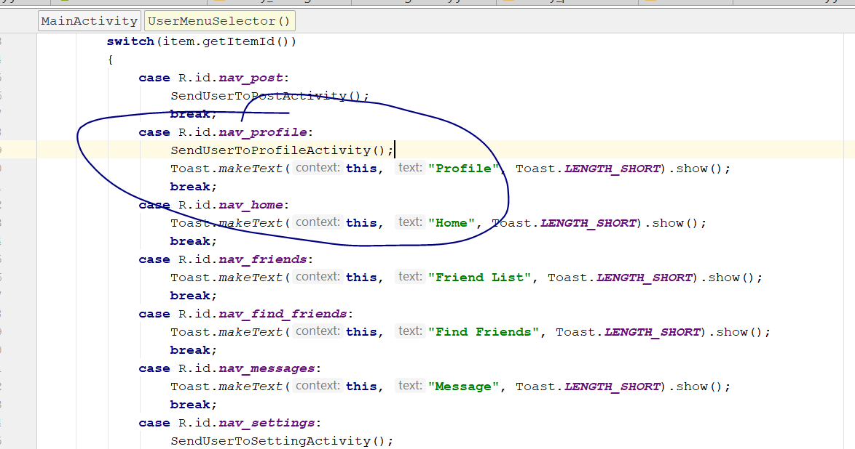
* Rebuild and run
* Profle page should be working

# Create Find Friend Activity

* Create a new Activity, call FindFriendsActivity
* 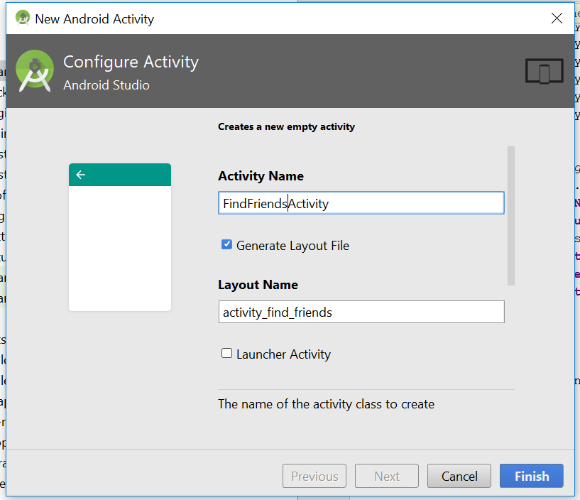
* Click finish
* Now go activity_find_friends.xml
* Change the layout to relative layout
* Add this line here
* android:background="@color/colorProfile"
* 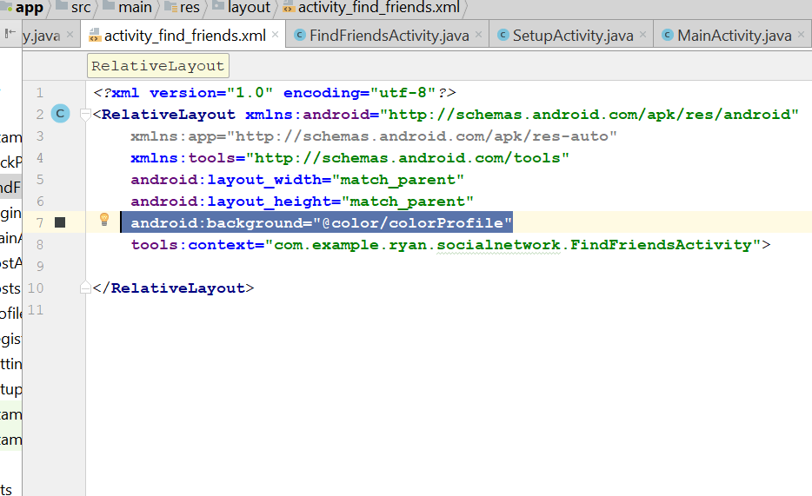
* Now you add this in the layout
* <include  
   android:id="@+id/find_friends_appbar_layout"  
   layout="@layout/app_bar_layout"  
    
   >
* 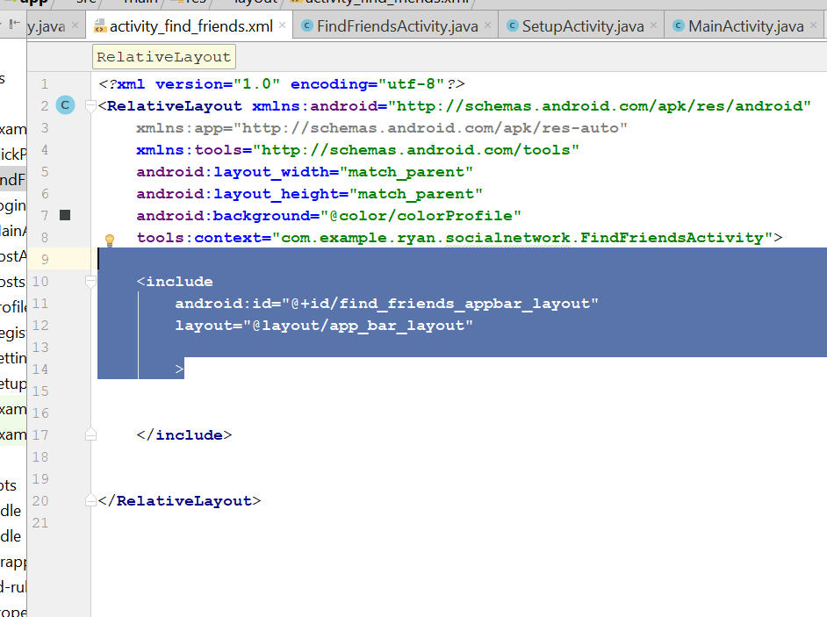
* Now go to androidManifest, go to this code
* <activity android:name=".FindFriendsActivity"  
     
     
   ></activity>
* Add in the parentActivity
* <activity android:name=".FindFriendsActivity"  
   android:parentActivityName=".MainActivity"  
    
   ></activity>
* 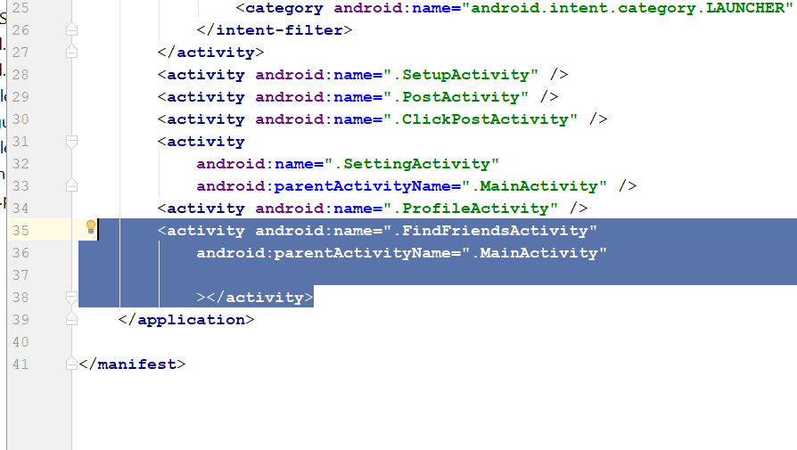
* Now go back to the activity_find_friends.xml
* Download this png file, search from this link and put in the drawable folder
* https://drive.google.com/file/d/16NcjWlvyCwmxWX0_JtFZ78XRhE4BBZpy/view
* Add a new relative layout after the include, and add this
* <RelativeLayout  
   android:id="@+id/myLayout"  
   android:layout_width="match_parent"  
   android:layout_height="wrap_content"  
   android:layout_marginTop="15dp"  
   android:layout_below="@+id/find_friends_appbar_layout"  
   >  
    
   <TextView  
   android:id="@+id/simpleTextID"  
   android:layout_width="match_parent"  
   android:layout_height="wrap_content"  
   android:layout_alignParentEnd="true"  
   android:layout_marginLeft="20dp"  
   android:text="Search for people and Friends from school and University"  
   android:textColor="@android:color/background_light"  
   android:textSize="18sp"  
   android:textStyle="bold"  
   />  
   <EditText  
   android:id="@+id/search_box_input"  
   android:layout_width="280dp"  
   android:layout_height="70dp"  
   android:layout_below="@id/simpleTextID"  
   android:layout_alignParentStart="true"  
   android:layout_marginLeft="21dp"  
   android:layout_marginTop="10dp"  
   android:background="@drawable/inputs"  
   android:ems="10"  
   android:hint="search here..."  
   android:inputType="textMultiLine"  
   android:padding="10dp"  
   android:textColor="@color/colorProfile"  
   android:textColorHint="@color/colorProfile"  
    
   />  
   <ImageButton  
   android:id="@+id/search_people_friends_button"  
   android:layout_width="70dp"  
   android:layout_height="70dp"  
   android:layout_marginTop="10dp"  
   android:layout_below="@id/simpleTextID"  
   android:layout_toEndOf="@+id/search_box_input"  
   android:background="@drawable/inputs"  
   android:src="@drawable/search"  
   />  
    
    
    
  </RelativeLayout>
* After you are done, add a new code after this relative layout
* 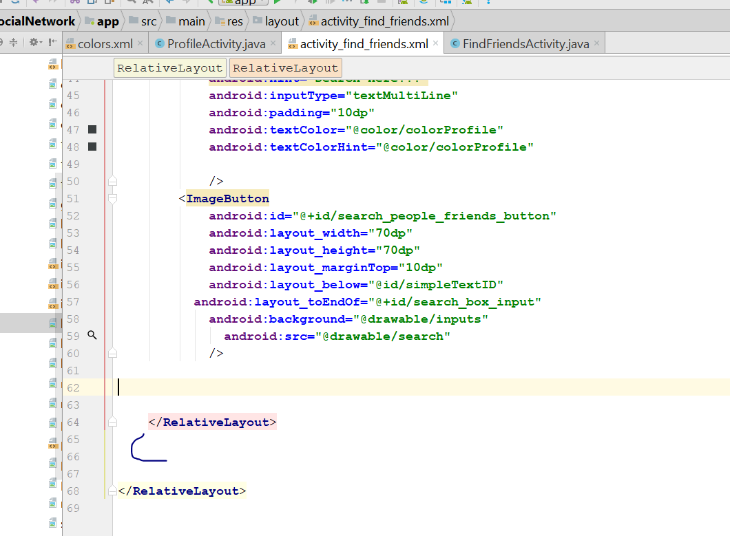
* Add this code, the recycleView
* <android.support.v7.widget.RecyclerView  
   android:layout_width="match_parent"  
   android:layout_height="match_parent"  
   android:layout_alignParentStart="true"  
   android:layout_below="@+id/myLayout"  
   android:layout_margin="10dp"  
   android:id="@+id/search_result_list"  
    
    
   >
* 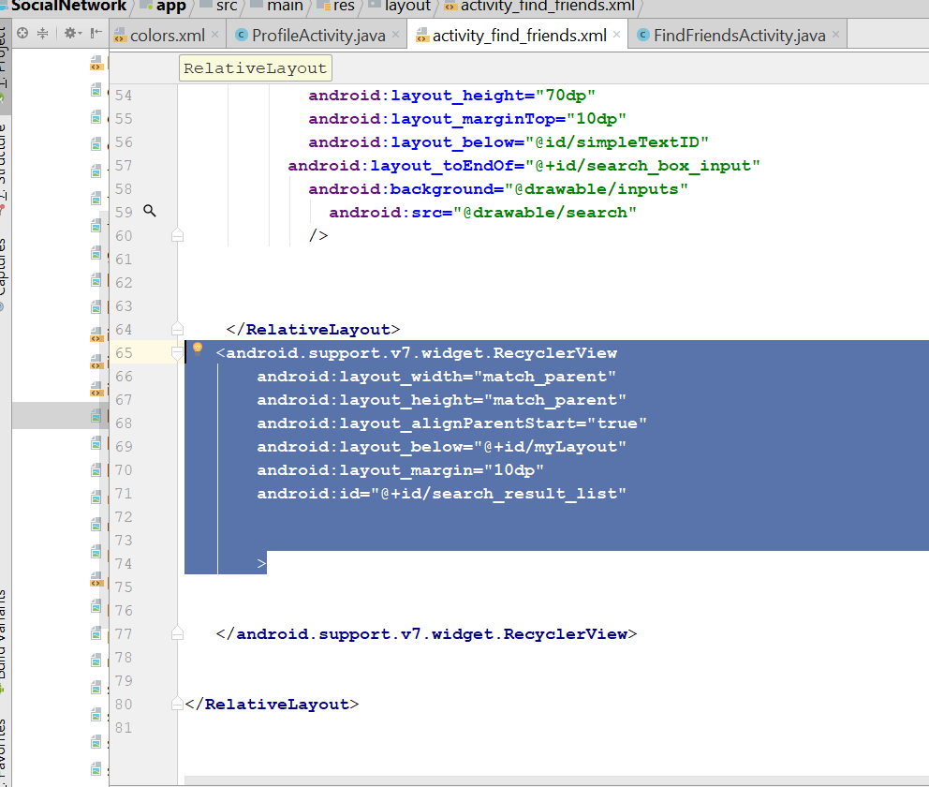
* Right now, after all those code, your design view, should look like this
* 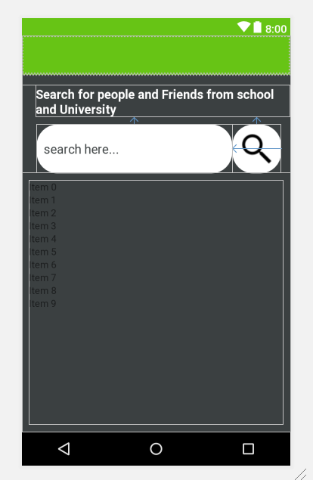
* Go to layout>new>layout_resource_file
* Call it : all_users_display_layout
* 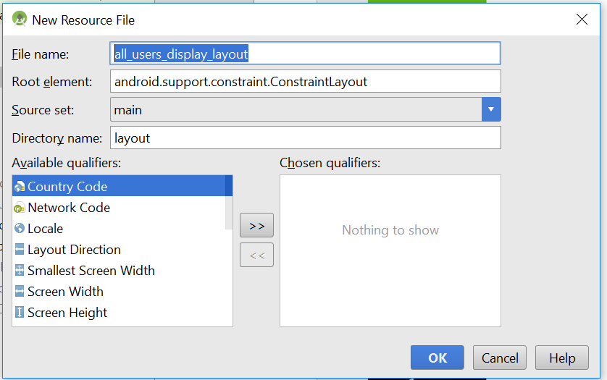
* Click okay
* Go to all_user_display_layout, change the constraint layout to Linear layout
* android:layout_height="wrap_content"  
  android:layout_margin="10dp"
* It should look like this
* 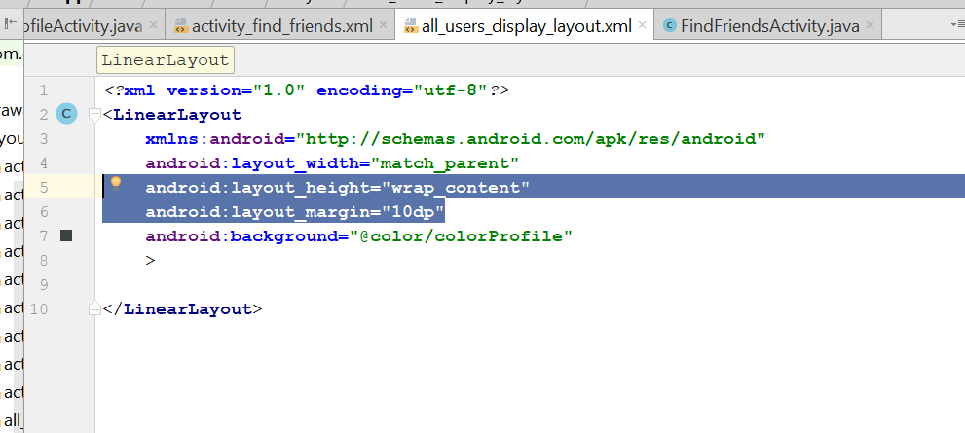
* Inside the linear layout, add in new code
* <de.hdodenhof.circleimageview.CircleImageView  
   android:id="@+id/all_user_profile_image"  
   android:layout_width="85dp"  
   android:layout_height="85dp"  
   android:layout_marginLeft="10dp"  
   android:src="@drawable/profile"/>  
    
  <LinearLayout  
   android:layout_width="match_parent"  
   android:layout_height="wrap_content"  
   android:orientation="vertical"  
   android:layout_margin="5dp"  
   >  
   <TextView  
   android:id="@+id/all_user_profile_full_name"  
   android:layout_width="match_parent"  
   android:layout_height="wrap_content"  
   android:text="user full name"  
   android:textAlignment="textStart"  
   android:textColor="@android:color/background_light"  
   android:textSize="18sp"  
   android:textStyle="bold"  
   />  
   <TextView  
   android:id="@+id/all_user_status"  
   android:layout_width="match_parent"  
   android:layout_height="wrap_content"  
   android:text="status"  
   android:textAlignment="textStart"  
   android:textColor="@android:color/background_light"  
   android:textSize="16sp"  
    
   />  
    
  </LinearLayout>
* 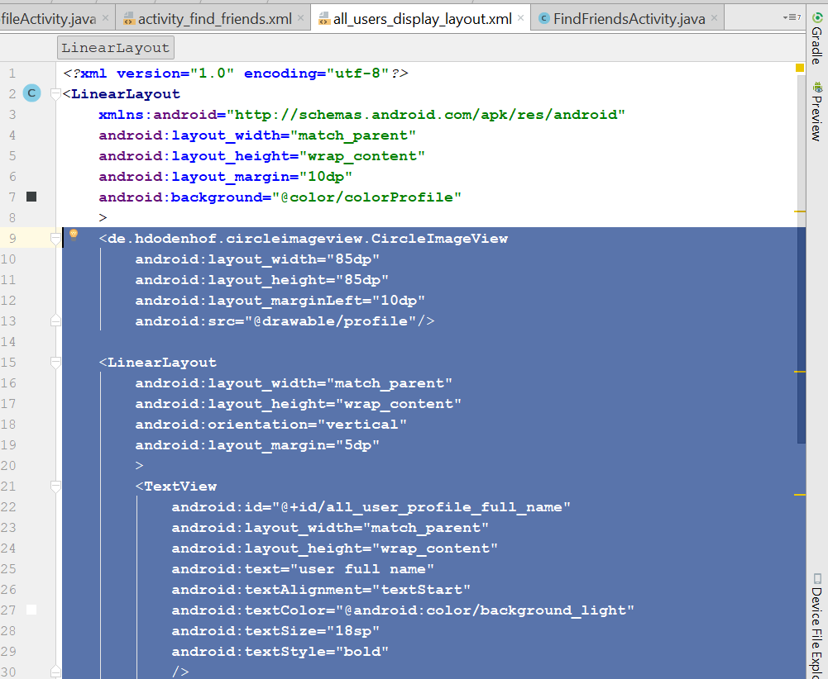
* You design view, should look something like this
* 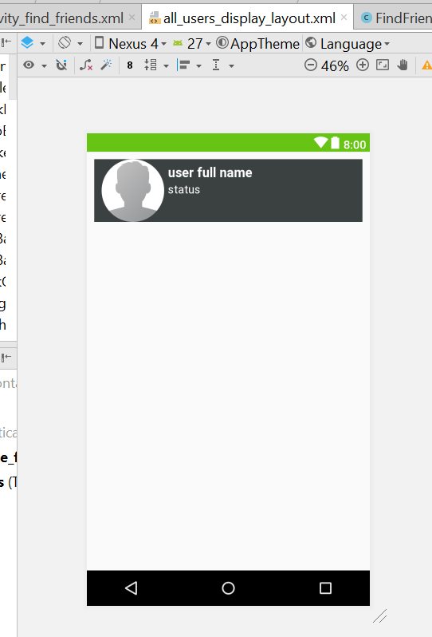
* For the findFriendsActivity.java, change the whole code to this
* **package** com.example.ryan.socialnetwork;  
    
  **import** android.support.v7.app.AppCompatActivity;  
  **import** android.os.Bundle;  
  **import** android.support.v7.widget.Toolbar;  
    
  **public class** FindFriendsActivity **extends** AppCompatActivity {  
    
   **private** Toolbar **mToolbar**;  
    
   @Override  
   **protected void** onCreate(Bundle savedInstanceState) {  
   **super**.onCreate(savedInstanceState);  
   setContentView(R.layout.***activity_find_friends***);  
    
   **mToolbar** = (Toolbar) findViewById(R.id.***find_friends_appbar_layout***);  
   setSupportActionBar(**mToolbar**);  
   getSupportActionBar().setDisplayHomeAsUpEnabled(**true**);  
   getSupportActionBar().setTitle(**"Update Post"**);  
   }  
  }
* Now go to MainActivity.java
* Add this code
* **private void** SendUserToFindFriendsActivity() {  
   Intent loginIntent = **new** Intent(MainActivity.**this**,FindFriendsActivity.**class**);  
   startActivity(loginIntent);  
    
  }
* 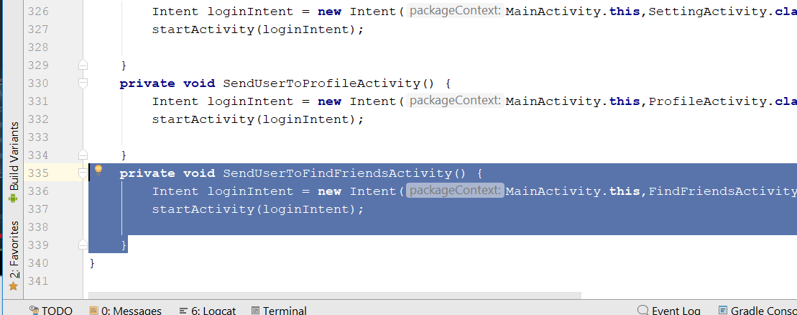
* Call this method here
* 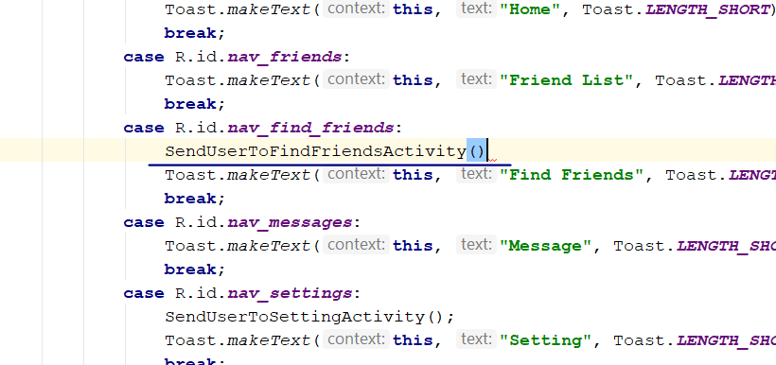
* Rebuild and Run
* Now you should be to see FindFriendActivity, when u tap on find friend button
* Now create a new Module Class, create a new Java class
* Call it FindFriends
* 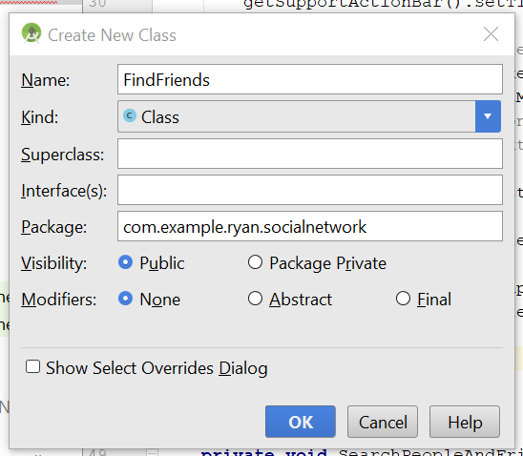
* This is the code for the java class

**public class** FindFriends {  
  
 **public** String **profileimage**, **fullname**, **status**;  
 **public** FindFriends(){}  
  
  
 **public** String getProfileimage() {  
 **return profileimage**;  
 }  
  
 **public void** setProfileimage(String profileimage) {  
 **this**.**profileimage** = profileimage;  
 }  
  
 **public** String getFullname() {  
 **return fullname**;  
 }  
  
 **public void** setFullname(String fullname) {  
 **this**.**fullname** = fullname;  
 }  
  
 **public** String getStatus() {  
 **return status**;  
 }  
  
 **public void** setStatus(String status) {  
 **this**.**status** = status;  
 }  
  
 **public** FindFriends(String profileimage, String fullname, String status) {  
 **this**.**profileimage** = profileimage;  
 **this**.**fullname** = fullname;  
 **this**.**status** = status;  
 }  
}

* }
* Now go to the FindFriendActivity.java
* Declare those object
* private ImageButton SearchButton;  
  private EditText SearchInputText;  
  private RecyclerView SearchResultList;  
  private DatabaseReference allUsersDatabaseRef;
* in the OnCreate(), add the following
* **SearchResultList** = (RecyclerView) findViewById(R.id.***search_result_list***);  
  **SearchResultList**.setHasFixedSize(**true**);  
  **SearchResultList**.setLayoutManager(**new** LinearLayoutManager(**this**));  
  **SearchButton** = (ImageButton) findViewById(R.id.***search_people_friends_button***);  
  **SearchInputText** = (EditText) findViewById(R.id.***search_box_input***);  
    
  **SearchButton**.setOnClickListener(**new** View.OnClickListener() {  
   @Override  
   **public void** onClick(View v) {  
    
   String searchboxInput = **SearchInputText**.getText().toString();  
   SearchPeopleAndFriends(searchboxInput);  
   }  
  });
* 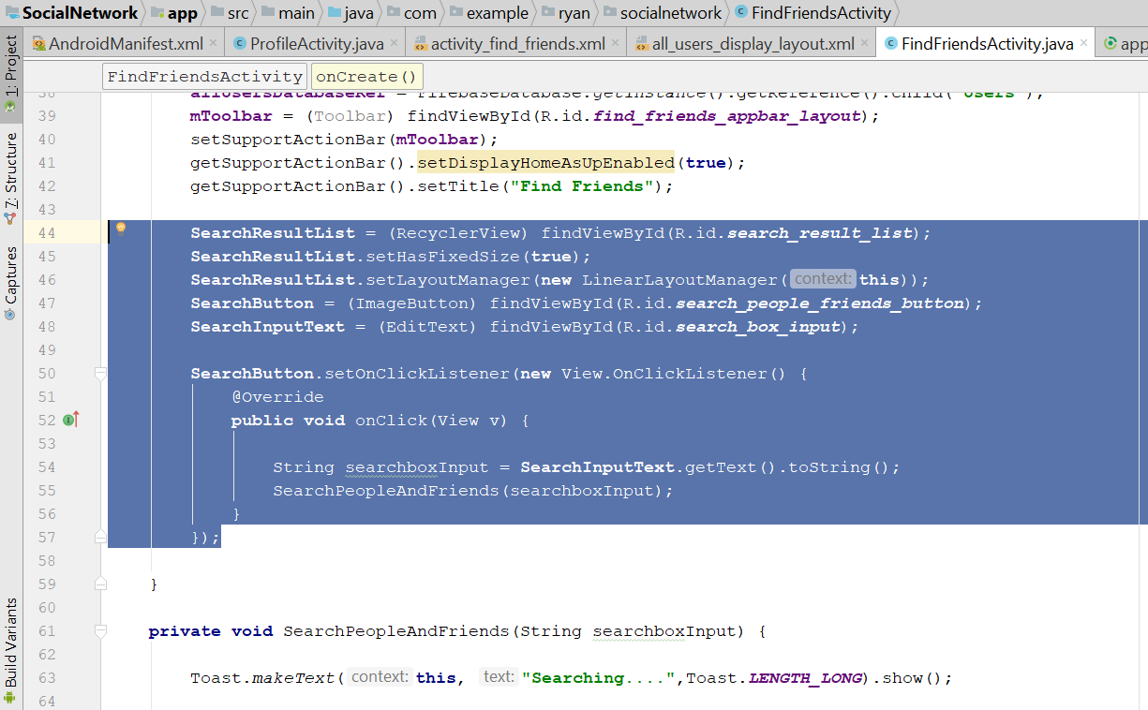
* Add those method, outside the onCreate()
* **private void** SearchPeopleAndFriends(String searchboxInput) {  
    
   Toast.*makeText*(**this**, **"Searching...."**,Toast.***LENGTH_LONG***).show();  
    
   Query searchPeopleandFriendsQuery = **allUsersDatabaseRef**.orderByChild(**"fullname"**)  
   .startAt(searchboxInput).endAt(searchboxInput+**"\uf8ff"**);  
    
    
    
   FirebaseRecyclerAdapter<FindFriends, FindFriendsViewHolder> firebaseRecyclerAdapter  
   = **new** FirebaseRecyclerAdapter<FindFriends, FindFriendsViewHolder>(  
    
   FindFriends.**class**,  
   R.layout.***all_users_display_layout***,  
   FindFriendsViewHolder.**class**,  
   searchPeopleandFriendsQuery  
    
   )  
   {  
   @Override  
   **protected void** populateViewHolder(FindFriendsViewHolder viewHolder, FindFriends model, **int** position) {  
   viewHolder.setFullName(model.getFullname());  
   viewHolder.setStatus(model.getStatus());  
   viewHolder.setProfileImage(getApplicationContext(),model.getProfileimage());  
   }  
   };  
    
   **SearchResultList**.setAdapter(firebaseRecyclerAdapter);  
    
  }  
    
  **public static class** FindFriendsViewHolder **extends** RecyclerView.ViewHolder  
  {  
   View **mView**;  
    
   **public** FindFriendsViewHolder(View itemView) {  
   **super**(itemView);  
   **mView** = itemView;  
   }  
    
   **public void** setProfileImage(Context ctx,String profileImage) {  
    
   CircleImageView myImage = (CircleImageView) **mView**.findViewById(R.id.***all_user_profile_image***);  
   Picasso.*get*().load(profileImage).placeholder(R.drawable.***profile***).into(myImage);  
    
   }  
   **public void** setFullName(String fullname){  
   TextView myName = (TextView) **mView**.findViewById(R.id.***all_user_profile_full_name***);  
   myName.setText(fullname);  
   }  
   **public void** setStatus(String status){  
   TextView myStatus = (TextView) **mView**.findViewById(R.id.***all_user_status***);  
   myStatus.setText(status);  
   }  
    
  }
* 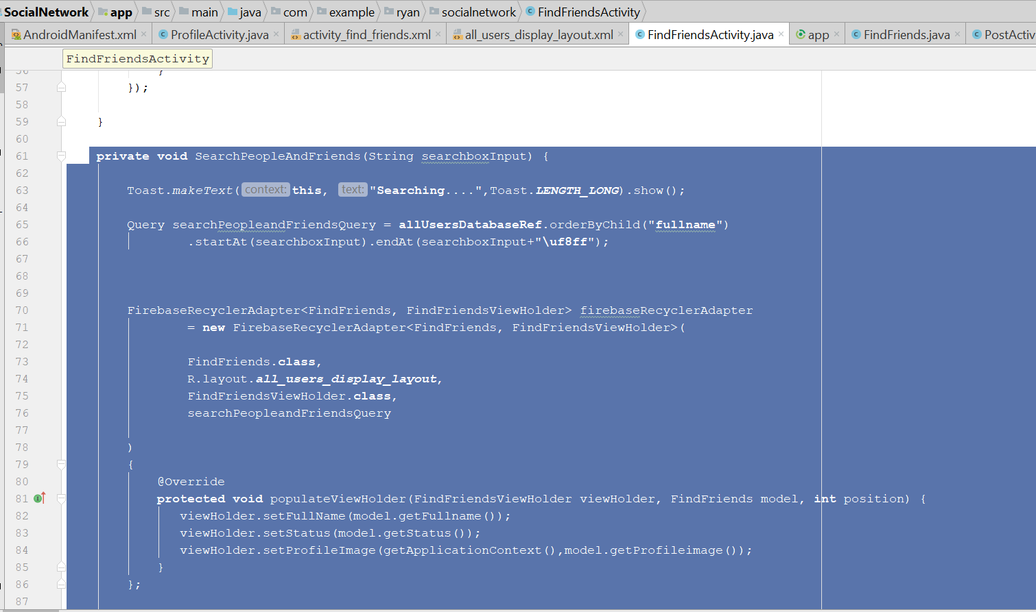
* Rebuild and run, the search should work.

# Like Post function

* First, download the 3 icon from here
* <https://drive.google.com/drive/folders/1lSwMWNSWPUXpPHjttgLrG84c8UWs2fiq>
* 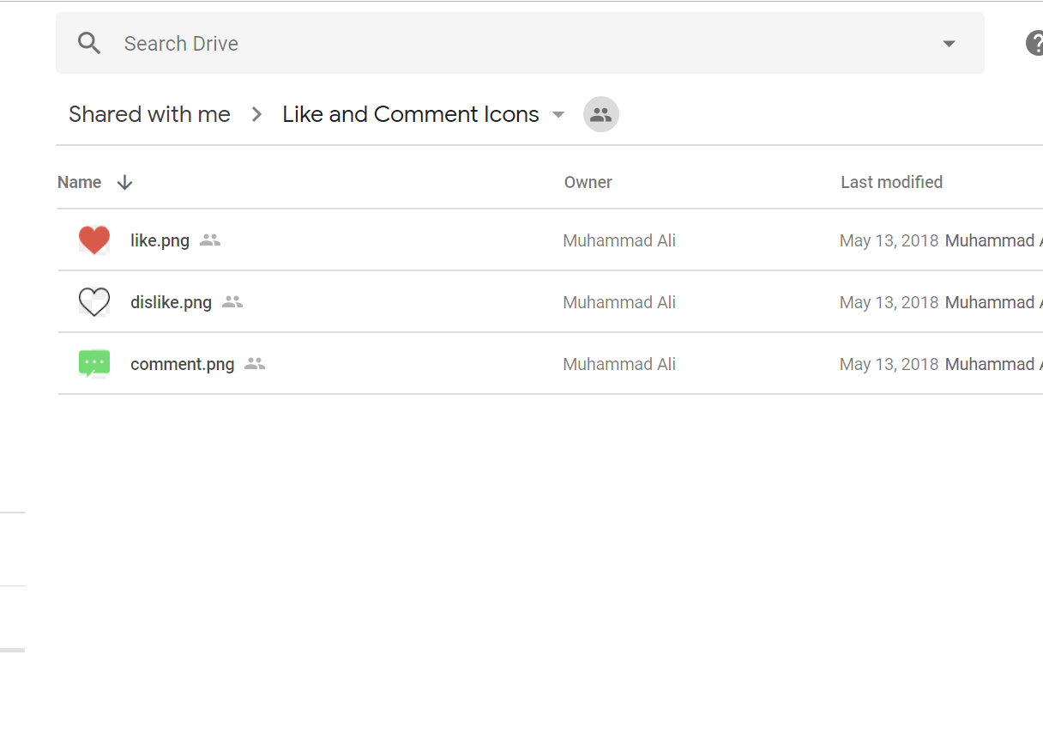
* Import this 3 icon into drawable folder
* Now go to value> colour.xml
* Add this line
* <color name="mainBackground">#D7D7D7</color>
* 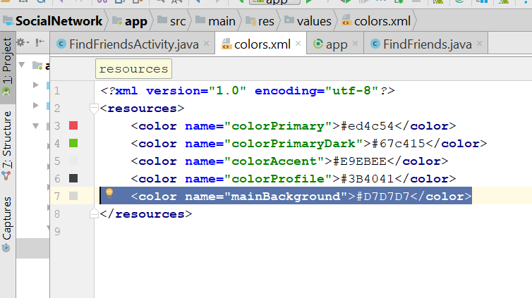
* Now go to activity_main.xml
* Add this line
* android:background="@color/mainBackground"
* 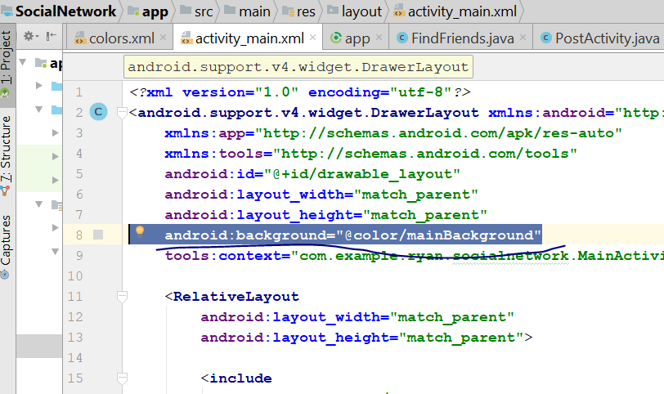
* Now go to all_post_layout.xml
* Add this again
* android:background="@color/mainBackground"
* 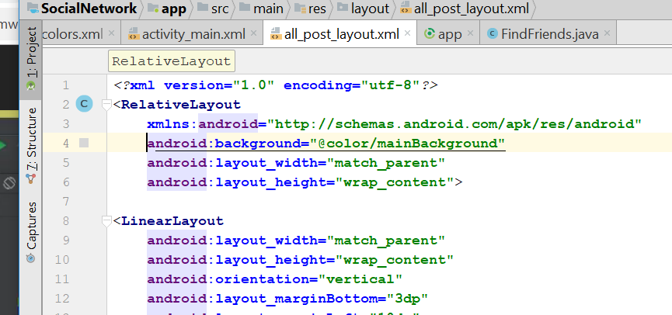
* After the imageView of the id post_image, add this
* <LinearLayout  
   android:layout_width="match_parent"  
   android:layout_height="wrap_content"  
   android:orientation="horizontal"  
   android:layout_marginLeft="10dp"  
   android:layout_marginRight="10dp"  
    
   >  
   <ImageButton  
   android:id="@+id/like_button"  
   android:layout_width="wrap_content"  
   android:layout_height="wrap_content"  
   android:src="@drawable/dislike"/>  
   <TextView  
   android:id="@+id/display_no_of_likes"  
   android:layout_width="wrap_content"  
   android:layout_height="wrap_content"  
   android:text="0 likes"  
   android:padding="15dp"  
   android:textColor="@android:color/black"  
   android:textSize="14sp"  
   android:textStyle="bold"  
   />  
   <ImageButton  
   android:id="@+id/comment_button"  
   android:layout_width="wrap_content"  
   android:layout_height="wrap_content"  
   android:src="@drawable/comment"  
   android:layout_marginLeft="150dp"/>  
    
    
  </LinearLayout>
* 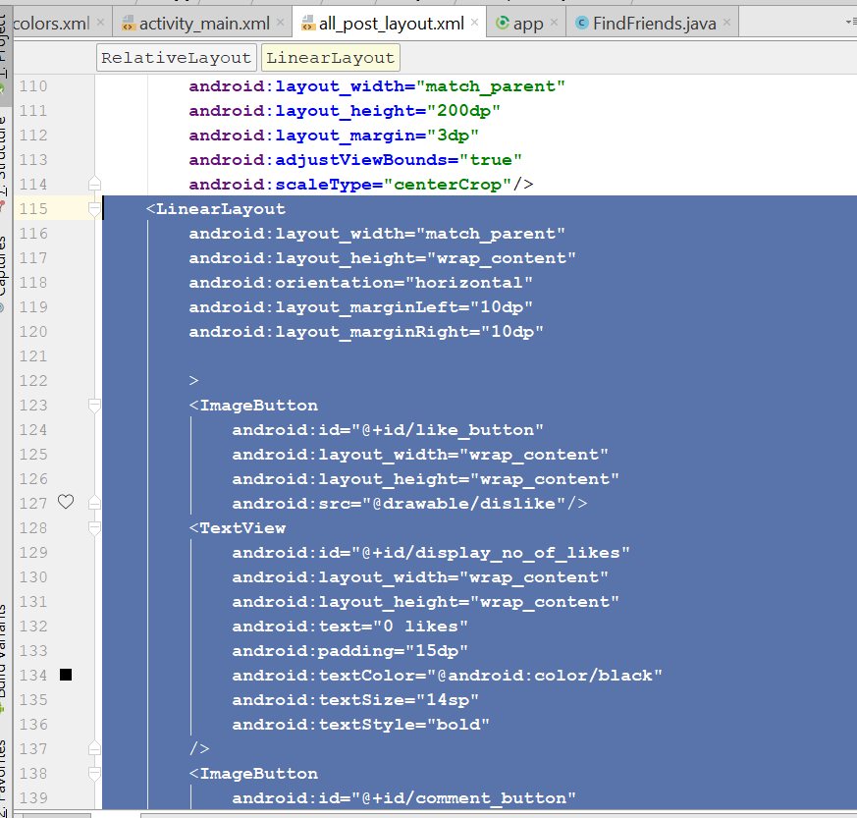
* You shld get something like this for the design view
* 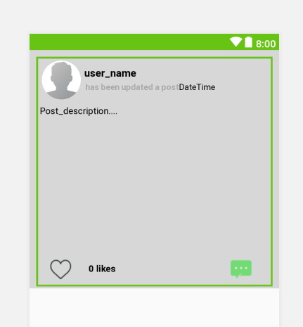
* Now go to MainActivity.java
* Go to public static class PostsViewHolder
* Add the following lines
* ImageButton LikePostButton, CommentPostButton;  
  TextView DisplayNoOfLikes;
* 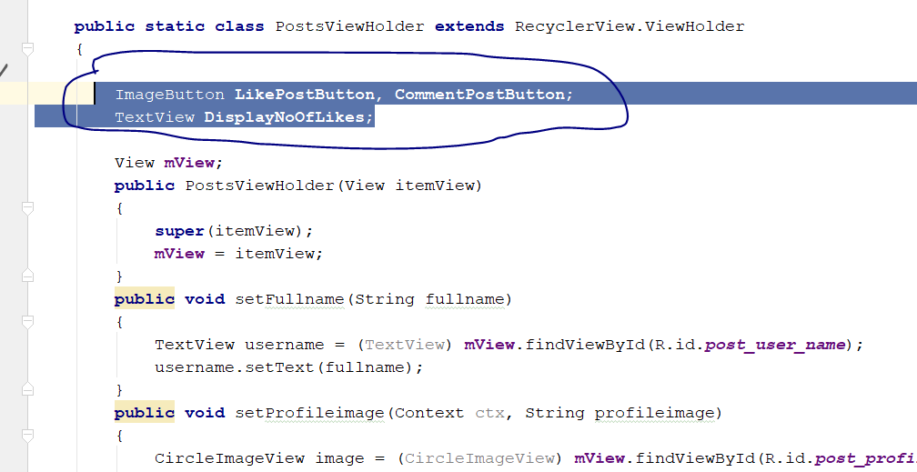
* Inside the constructor, add this
* LikePostButton = (ImageButton)mView.findViewById(R.id.*like_button*);  
  CommentPostButton = (ImageButton)mView.findViewById(R.id.*comment_button*);  
  DisplayNoOfLikes = (TextView)mView.findViewById(R.id.*display_no_of_likes*);
* 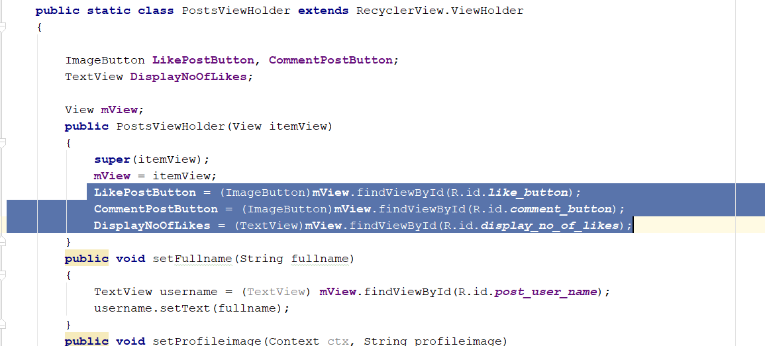
* Rebuild and Run, you shld see the button on each post
* Now go to MainActivity.java
* Add new variable
* private DatabaseReference UsersRef, PostsRef, LikesRef;
* Boolean LikeChecker = false;
* in the OnCreate() add this,
* **LikesRef** = FirebaseDatabase.*getInstance*().getReference().child(**"Likes"**);
* Now go to private void DisplayAllUserPosts()
* Add your new code here
* 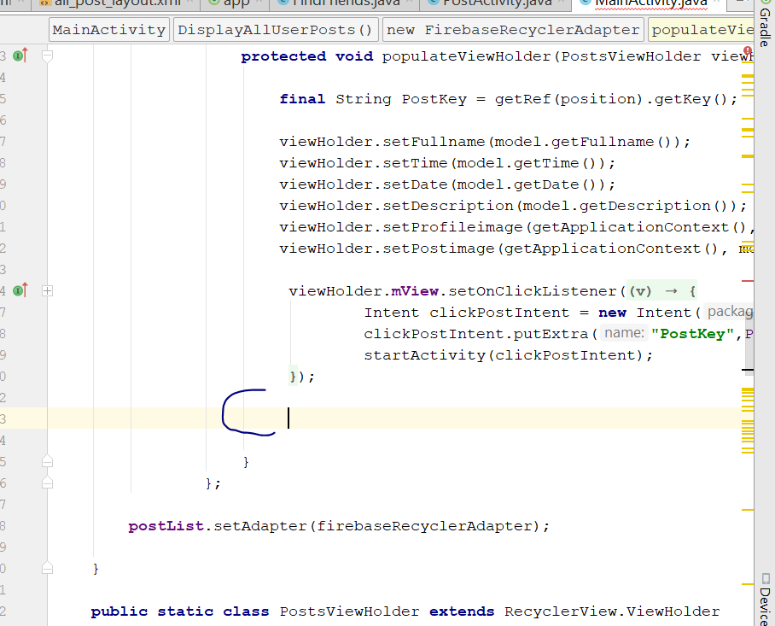
* viewHolder.**LikePostButton**.setOnClickListener(**new** View.OnClickListener() {  
   @Override  
   **public void** onClick(View v) {  
   **LikeChecker** = **true**;  
   **LikesRef**.addValueEventListener(**new** ValueEventListener() {  
   @Override  
   **public void** onDataChange(DataSnapshot dataSnapshot) {  
   **if**(dataSnapshot.child(PostKey).hasChild(**currentUserID**))  
   {  
   **LikesRef**.child(PostKey).child(**currentUserID**).removeValue();  
   **LikeChecker** = **false**;  
   }  
   **else** {  
   **LikesRef**.child(PostKey).child(**currentUserID**).setValue(**true**);  
   **LikeChecker** = **false**;  
   }  
   }  
    
   @Override  
   **public void** onCancelled(DatabaseError databaseError) {  
    
   }  
   });  
   }  
  });
* 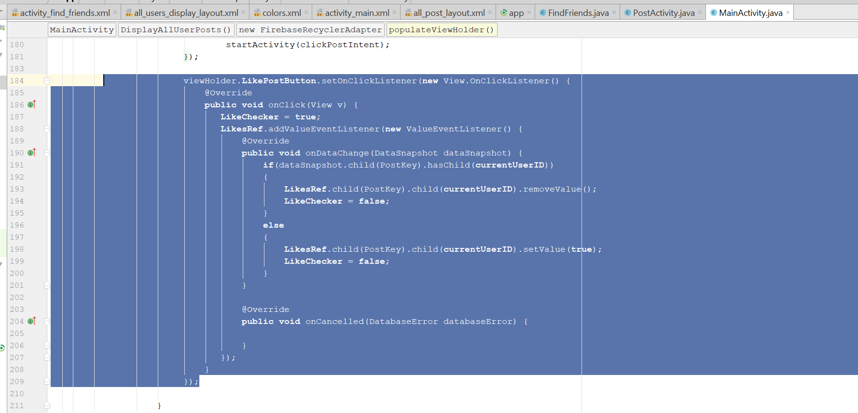
* Now go to the class: PostViewHolder
* Add this two variable
* String **currentUserId**;  
  DatabaseReference **LikesRef**;
* In the constructor, add this
* **LikesRef** = FirebaseDatabase.*getInstance*().getReference().child(**"Likes"**);  
  **currentUserId** = FirebaseAuth.*getInstance*().getCurrentUser().getUid();
* 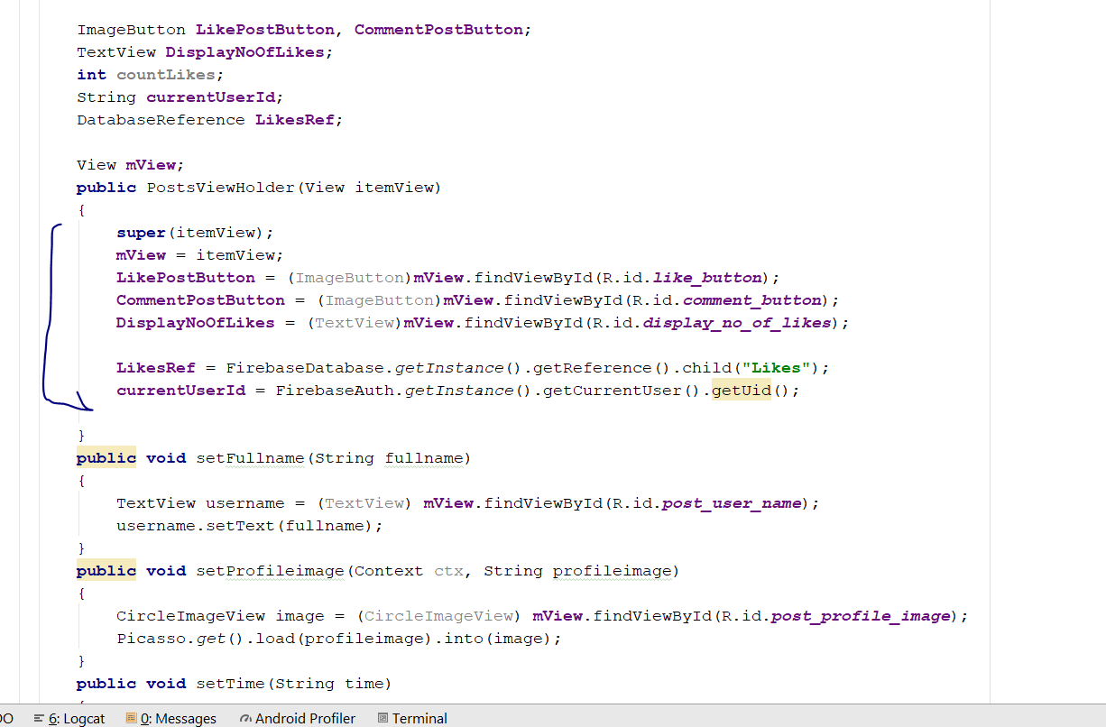
* Now go to the private void DisplayAllUserPosts()
* Add this line here
* viewHolder.setLikeButtonStatus(PostKey);
* 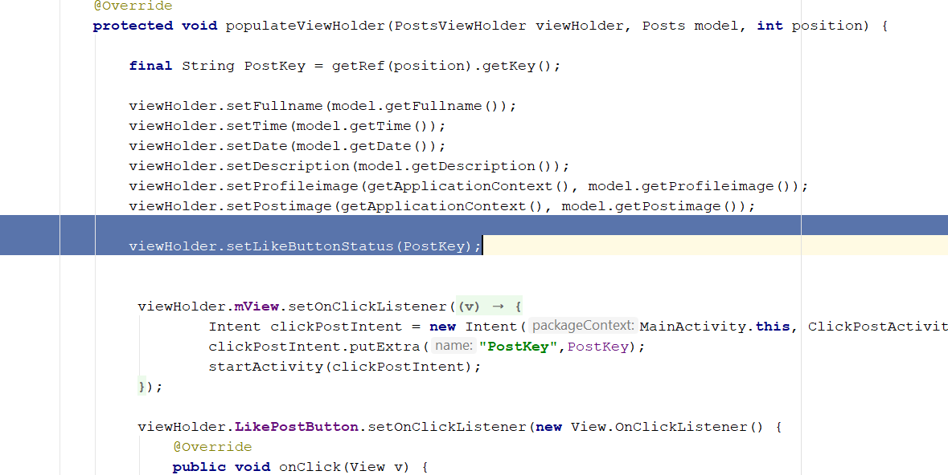
* Create a new method in the populateViewholder class
* **public void** setLikeButtonStatus(**final** String PostKey)  
  {  
   **LikesRef**.addValueEventListener(**new** ValueEventListener() {  
   @Override  
   **public void** onDataChange(DataSnapshot dataSnapshot) {  
   **if**(dataSnapshot.child(PostKey).hasChild(**currentUserId**))  
   {  
   **countLikes** = (**int**) dataSnapshot.child(PostKey).getChildrenCount();  
   **LikePostButton**.setImageResource(R.drawable.***like***);  
   **DisplayNoOfLikes**.setText(Integer.*toString*(**countLikes**)+ **" Likes"**);  
   }  
   **else**  
   {  
   **countLikes** = (**int**) dataSnapshot.child(PostKey).getChildrenCount();  
   **LikePostButton**.setImageResource(R.drawable.***dislike***);  
   **DisplayNoOfLikes**.setText(Integer.*toString*(**countLikes**)+**" Likes"**);  
   }  
   }  
    
   @Override  
   **public void** onCancelled(DatabaseError databaseError) {  
    
   }  
   });  
  }
* add it here
* 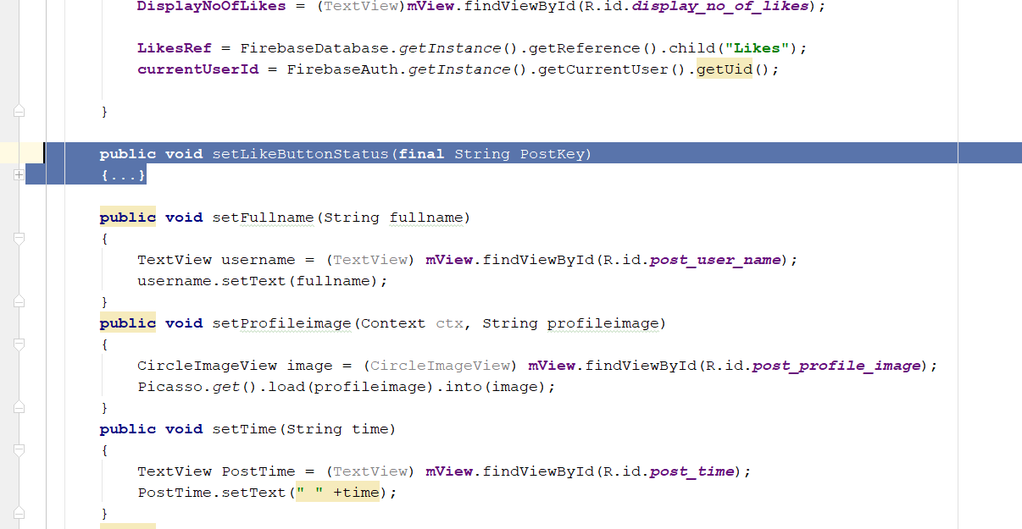
* Now go to the private void DisplayAllUserPosts()
* Add this after likePost Button onClick(), if LikeChecker.equals (true)
* 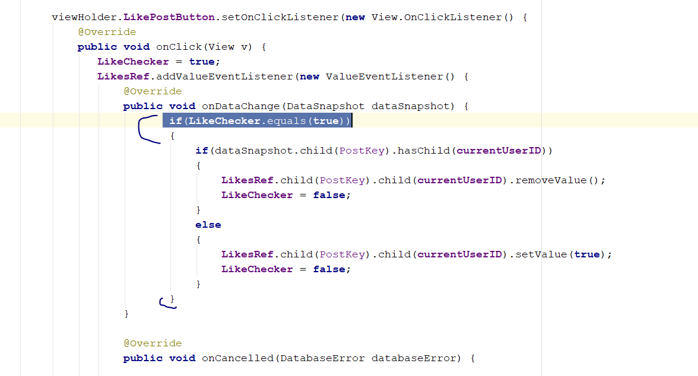
* Rebuild and run, now when u like a post
* Likes child should be appear in the firebase
* 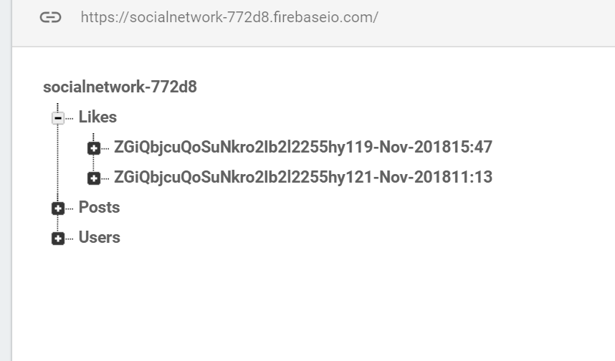

# Comment Post Function

* Go to this link and download the send_comment icon, and put it on the drawable folder
* https://drive.google.com/file/d/1kwj0Hbf0wJlLBIMWbS4WWE35vVtDHmf-/view
* Create new> empty Activity
* Call it commentActivity
* 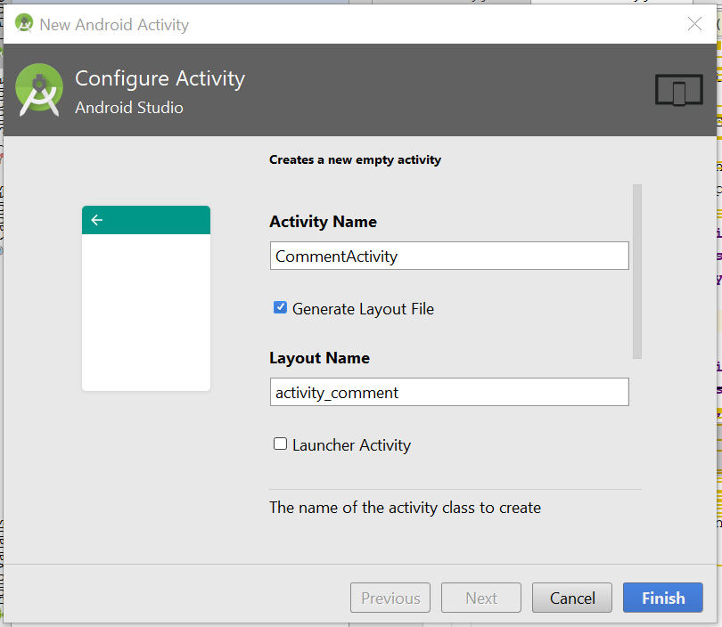
* Now go to activity_comment.xml, change to RelativeLayout
* 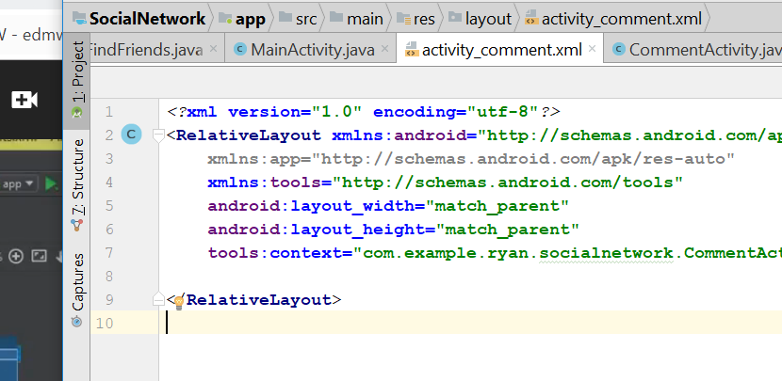
* Drag and drop a TextView, the width make it match parent
* 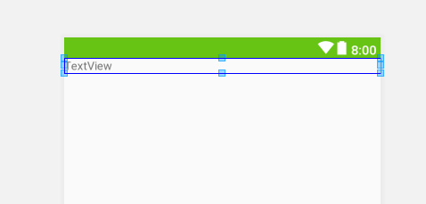
* Text Change to Comments
* Relative Layout_margin = 5dp
* This one
* 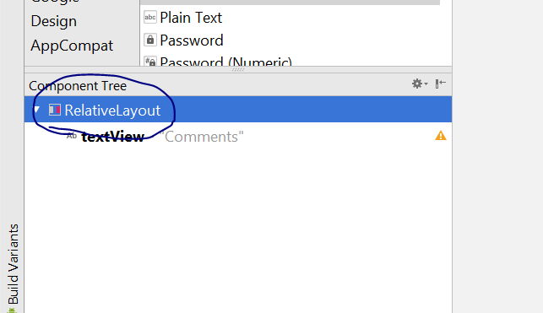
* 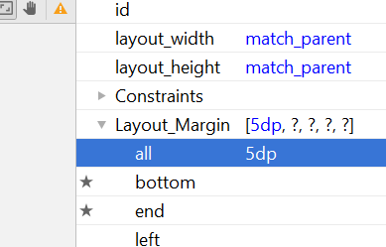
* Now go to Text, and add the few property of the the TextView
* android:text="Comments"  
  android:textSize="24sp"  
  android:textStyle="bold"  
  android:textColor="@android:color/black"
* 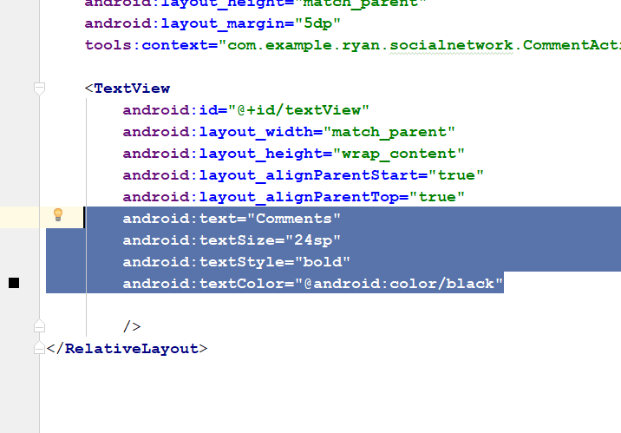
* 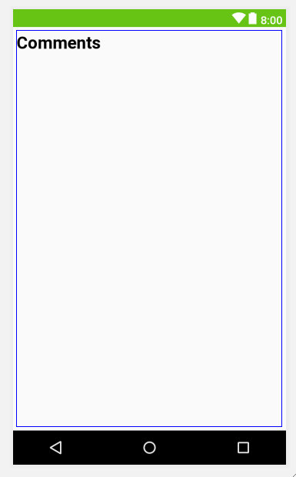
* It should look like this
* Now, drag and drop a recycle View and drag to the centre
* 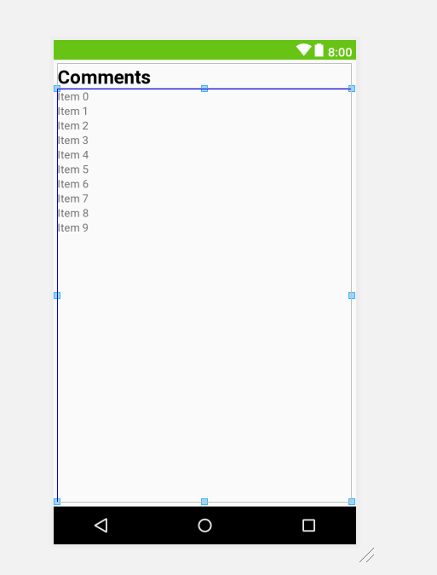
* For the recyleView, the layout_margin should be 5dp
* Now go the TEXT
* RecycleView id : **comments_list**
* Type those code, after RecycleView
* <EditText  
   android:id="@+id/comment_input"  
   android:layout_width="match_parent"  
   android:layout_height="wrap_content"  
   android:layout_alignParentStart="true"  
   android:layout_alignParentBottom="true"  
   android:layout_marginRight="55dp"  
   android:background="@drawable/inputs"  
   android:padding="15dp"  
   android:hint="Write a comment here..."  
   android:inputType="textMultiLine"  
   />  
    
  <ImageButton  
   android:id="@+id/post_comment_btn"  
   android:layout_width="wrap_content"  
   android:layout_height="wrap_content"  
   android:layout_alignBottom="@+id/comment_input"  
   android:layout_alignParentEnd="true"  
   android:padding="15dp"  
   android:src="@drawable/post_comment"  
    
   />
* Now look like this
* 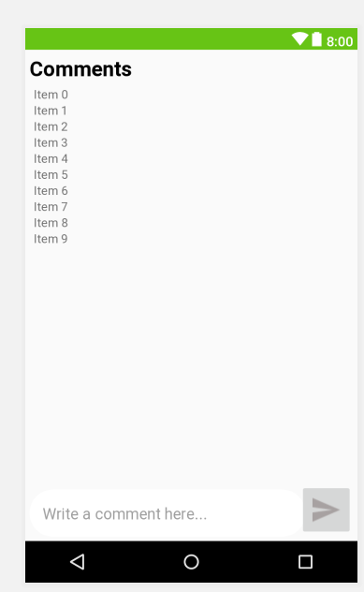
* Now go to CommentActivity.java
* The code shld be like that
* **package** com.example.ryan.socialnetwork;  
    
  **import** android.support.v7.app.AppCompatActivity;  
  **import** android.os.Bundle;  
  **import** android.support.v7.widget.LinearLayoutManager;  
  **import** android.support.v7.widget.RecyclerView;  
  **import** android.widget.EditText;  
  **import** android.widget.ImageButton;  
    
  **public class** CommentActivity **extends** AppCompatActivity {  
    
    
   **private** ImageButton **PostCommentButton**;  
   **private** EditText **CommentInputText**;  
   **private** RecyclerView **CommentsList**;  
   **private** String **Post_Key**;  
    
   @Override  
   **protected void** onCreate(Bundle savedInstanceState) {  
   **super**.onCreate(savedInstanceState);  
   setContentView(R.layout.***activity_comment***);  
    
    
   **Post_Key** = getIntent().getExtras().get(**"PostKey"**).toString();  
   **CommentsList**= (RecyclerView)findViewById(R.id.***comments_list***);  
   **CommentsList**.setHasFixedSize(**true**);  
   LinearLayoutManager linearLayoutManager = **new** LinearLayoutManager(**this**);  
   linearLayoutManager.setReverseLayout(**true**);  
   linearLayoutManager.setStackFromEnd(**true**);  
   **CommentsList**.setLayoutManager(linearLayoutManager);  
    
   **CommentInputText** = (EditText) findViewById(R.id.***comment_input***);  
   **PostCommentButton** = (ImageButton)findViewById(R.id.***post_comment_btn***);  
   }  
  }
* Now go to MainActivity.java
* Go to DisplayAllUserPosts()
* Add this code
* viewHolder.**CommentPostButton**.setOnClickListener(**new** View.OnClickListener() {  
   @Override  
   **public void** onClick(View v) {  
   Intent commentsIntent = **new** Intent(MainActivity.**this**, CommentActivity.**class**);  
   commentsIntent.putExtra(**"PostKey"**,PostKey);  
   startActivity(commentsIntent);  
   }  
  });
* 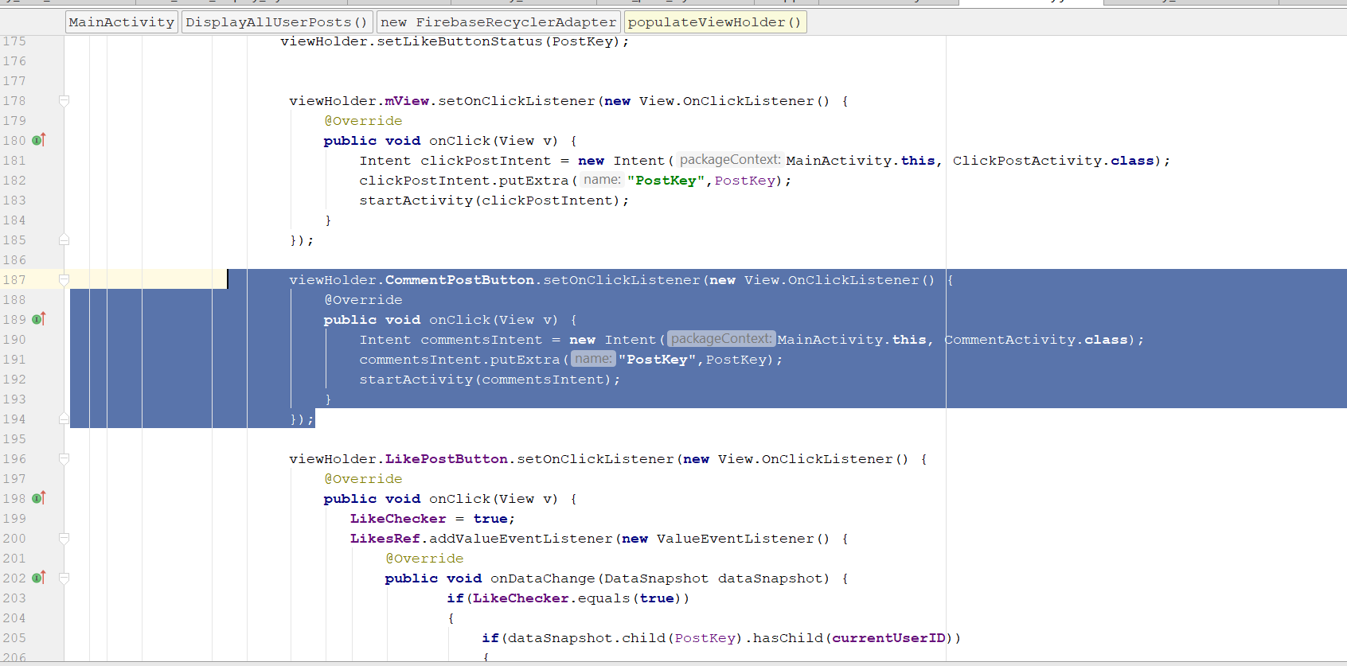
* Go to activity_comment.xml
* Add a android background
* android:background="@color/mainBackground"
* 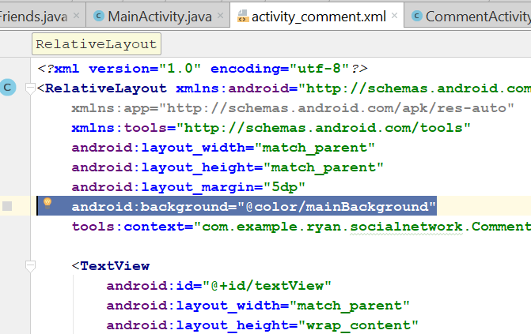
* Rebuild and run, now when u click the comment button, it will bring you to the page
* Now go to commentActivity.java
* Declare this variable
* private String current_user_id;  
  private DatabaseReference UsersRef, PostsRef;  
  private FirebaseAuth mAuth;
* 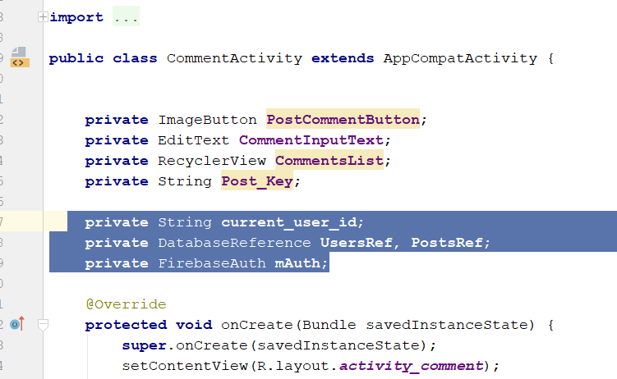
* In the onCreate()
* Add this
* **UsersRef** = FirebaseDatabase.*getInstance*().getReference().child(**"Users"**);  
  **mAuth** = FirebaseAuth.*getInstance*();  
  **current_user_id** = **mAuth**.getCurrentUser().getUid();  
  **Post_Key** = getIntent().getExtras().get(**"PostKey"**).toString();  
  **PostsRef** = FirebaseDatabase.*getInstance*().getReference().child(**"Posts"**).child(**Post_Key**).child(**"Comments"**);
* After the Post Comment button, add this lines
* **PostCommentButton**.setOnClickListener(**new** View.OnClickListener() {  
   @Override  
   **public void** onClick(View v) {  
   **UsersRef**.child(**current_user_id**).addValueEventListener(**new** ValueEventListener() {  
   @Override  
   **public void** onDataChange(DataSnapshot dataSnapshot) {  
   **if**(dataSnapshot.exists())  
   {  
   String userName = dataSnapshot.child(**"username"**).getValue().toString();  
   ValidateComment(userName);  
   **CommentInputText**.setText(**""**);  
   }  
   }  
    
   @Override  
   **public void** onCancelled(DatabaseError databaseError) {  
    
   }  
   });  
   }  
  });
* 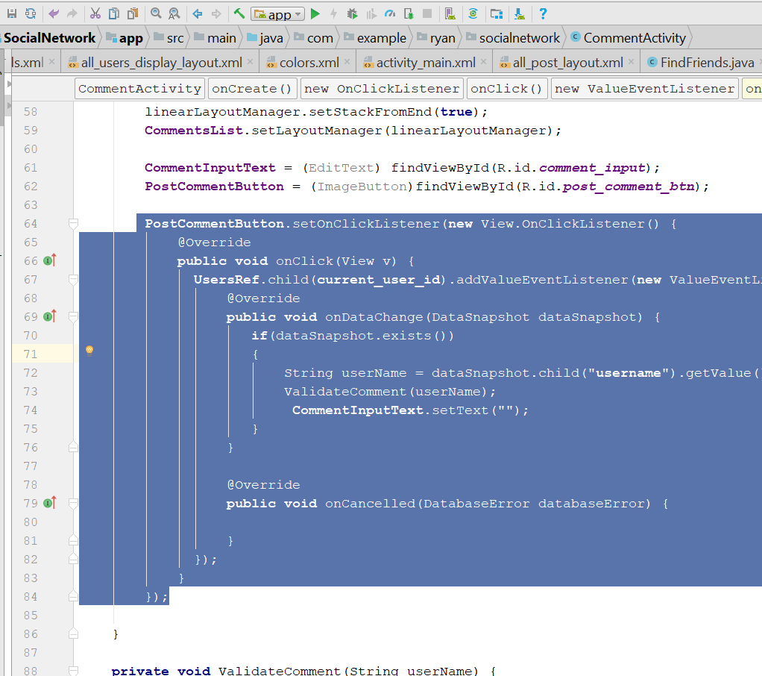
* Add a new method in the class
* **private void** ValidateComment(String userName) {  
    
   String commentText = **CommentInputText**.getText().toString();  
   **if**(TextUtils.*isEmpty*(commentText))  
   {  
   Toast.*makeText*(**this**, **"please write text to comment..."**, Toast.***LENGTH_SHORT***).show();  
   }  
   **else** {  
   Calendar calFordDate = Calendar.*getInstance*();  
   SimpleDateFormat currentDate = **new** SimpleDateFormat(**"dd-MMM-yyyy"**);  
   **final** String saveCurrentDate = currentDate.format(calFordDate.getTime());  
    
   Calendar calFordTime = Calendar.*getInstance*();  
   SimpleDateFormat currentTime = **new** SimpleDateFormat(**"HH:mm"**);  
   **final** String saveCurrentTime = currentTime.format(calFordDate.getTime());  
    
   **final** String RandomKey = **current_user_id**+ saveCurrentDate + saveCurrentTime;  
    
   HashMap commentsMap = **new** HashMap();  
   commentsMap.put(**"uid"**, **current_user_id**);  
   commentsMap.put(**"comment"**, commentText);  
   commentsMap.put(**"date"**, saveCurrentDate);  
   commentsMap.put(**"time"**, saveCurrentTime);  
   commentsMap.put(**"username"**, userName);  
    
   **PostsRef**.child(RandomKey).updateChildren(commentsMap)  
   .addOnCompleteListener(**new** OnCompleteListener() {  
   @Override  
   **public void** onComplete(@NonNull Task task)  
    
   {  
   **if**(task.isSuccessful())  
   {  
   Toast.*makeText*(CommentActivity.**this**, **"You have commented successfully..."**, Toast.***LENGTH_SHORT***).show();  
   }  
   **else** {  
   Toast.*makeText*(CommentActivity.**this**, **"Error Occured, try again..."**, Toast.***LENGTH_SHORT***).show();  
    
   }  
   }  
   });  
   }  
  }
* rebuild and Run, you should be able to comment
* Now click new>layout resource file
* Call it all_comments_layout, click okay
* 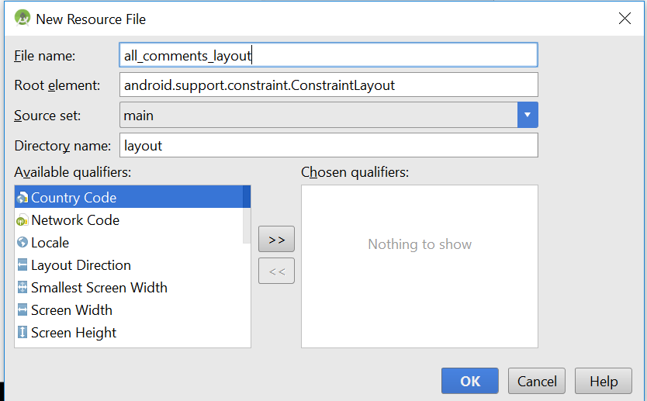
* Change to Relative_layout
* Change the layout_height to wrap content
* The whole code for the xml should be this
* *<?*xml version="1.0" encoding="utf-8"*?>*<RelativeLayout  
   xmlns:android="http://schemas.android.com/apk/res/android"  
   android:layout_width="match_parent"  
   android:layout_height="wrap_content"  
   >  
    
   <LinearLayout  
   android:layout_width="match_parent"  
   android:layout_height="wrap_content"  
   android:orientation="vertical"  
   android:background="@drawable/post_border"  
   >  
   <LinearLayout  
   android:layout_width="match_parent"  
   android:layout_height="wrap_content"  
   android:layout_margin="10dp"  
   android:orientation="horizontal"  
   >  
   <TextView  
   android:id="@+id/comment_username"  
   android:layout_width="wrap_content"  
   android:layout_height="wrap_content"  
   android:text="username"  
   android:textColor="@android:color/black"  
   android:textSize="16sp"  
   android:textStyle="bold"  
   />  
   <TextView  
   android:id="@+id/simple_text"  
   android:layout_width="wrap_content"  
   android:layout_height="wrap_content"  
   android:text="commented on"  
   android:textColor="@android:color/darker_gray"  
   android:textSize="14sp"  
   android:textStyle="bold"  
   />  
   <TextView  
   android:id="@+id/comment_date"  
   android:layout_width="wrap_content"  
   android:layout_height="wrap_content"  
   android:text="Date:"  
   android:textSize="14sp"  
   android:textStyle="bold"  
   />  
    
   </LinearLayout>  
   <LinearLayout  
   android:layout_width="match_parent"  
   android:layout_height="wrap_content"  
   android:orientation="vertical"  
   android:layout_margin="10dp"  
   >  
   <TextView  
   android:id="@+id/comment_text"  
   android:layout_width="wrap_content"  
   android:layout_height="wrap_content"  
   android:text="Comment text will display here"  
   android:textSize="16sp"  
   android:textStyle="bold"  
   />  
   <TextView  
   android:id="@+id/comment_time"  
   android:layout_width="match_parent"  
   android:layout_height="wrap_content"  
   android:text="Time:"  
   android:textAlignment="viewEnd"  
   android:textSize="14sp"  
   android:textStyle="bold"  
   />  
    
    
    
    
   </LinearLayout>  
    
   </LinearLayout>  
    
  </RelativeLayout>
* You should see this
* 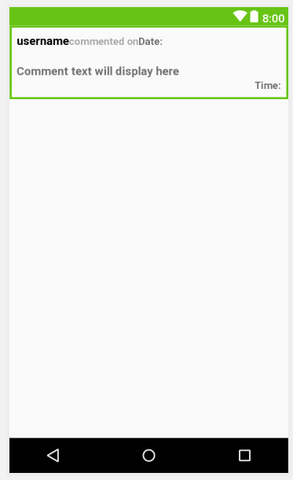
* Next step, create new Java class
* The java class call “Comments.java”
* This is the code for the Comments.java
* **package** com.example.ryan.socialnetwork;  
    
  */**  
   * Created by Ryan on 12/25/2018.  
   */***public class** Comments  
  {  
   **public** String **comment**, **date**, **time**, **username**;  
    
   **public** Comments(String comment, String date, String time, String username) {  
   **this**.**comment** = comment;  
   **this**.**date** = date;  
   **this**.**time** = time;  
   **this**.**username** = username;  
   }  
    
   **public** Comments()  
   {  
    
   }  
    
   **public** String getComment() {  
   **return comment**;  
   }  
    
   **public void** setComment(String comment) {  
   **this**.**comment** = comment;  
   }  
    
   **public** String getDate() {  
   **return date**;  
   }  
    
   **public void** setDate(String date) {  
   **this**.**date** = date;  
   }  
    
   **public** String getTime() {  
   **return time**;  
   }  
    
   **public void** setTime(String time) {  
   **this**.**time** = time;  
   }  
    
   **public** String getUsername() {  
   **return username**;  
   }  
    
   **public void** setUsername(String username) {  
   **this**.**username** = username;  
   }  
  }
* Now create the static class
* Go to the CommentActivity.java
* Write your new code here
* 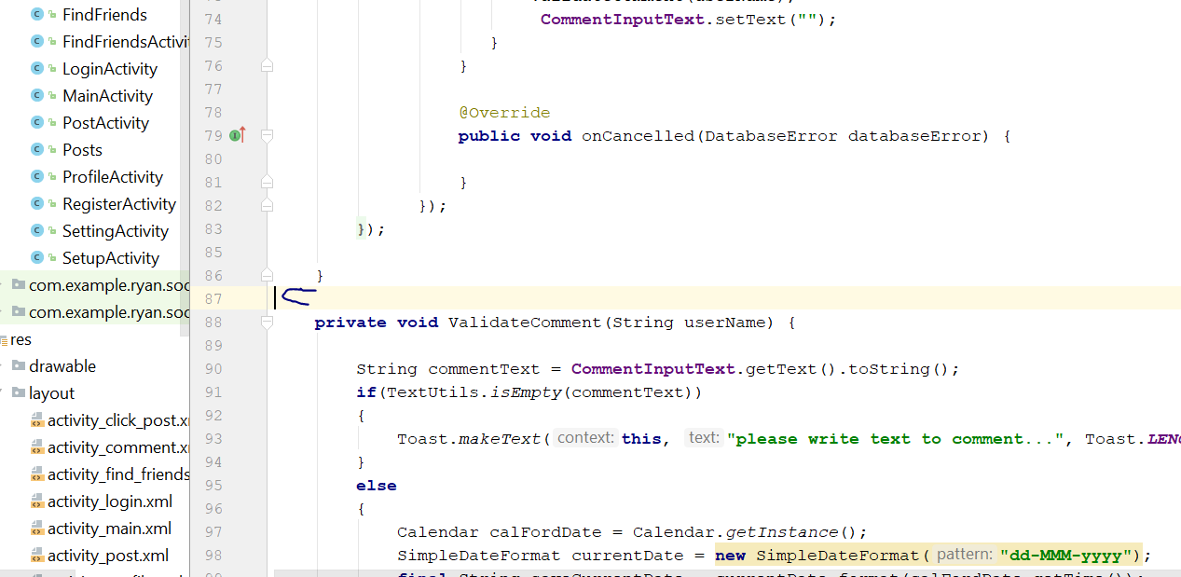
* Add those code
* @Override  
  **protected void** onStart() {  
   **super**.onStart();  
   FirebaseRecyclerAdapter<Comments,CommentsViewHolder> firebaseRecyclerAdapter  
   = **new** FirebaseRecyclerAdapter<Comments, CommentsViewHolder>  
   (  
   Comments.**class**,  
   R.layout.***all_comments_layout***,  
   CommentsViewHolder.**class**,  
   **PostsRef** ) {  
   @Override  
   **protected void** populateViewHolder(CommentsViewHolder viewHolder, Comments model, **int** position) {  
   viewHolder.setUsername(model.getUsername());  
   viewHolder.setComment(model.getComment());  
   viewHolder.setDate(model.getDate());  
   viewHolder.setTime(model.getTime());  
   }  
   };  
   **CommentsList**.setAdapter(firebaseRecyclerAdapter);  
  }  
    
  **public static class** CommentsViewHolder **extends** RecyclerView.ViewHolder  
  {  
   View **mView**;  
   **public** CommentsViewHolder(View itemView)  
   {  
   **super**(itemView);  
   **mView** = itemView;  
   }  
   **public void** setUsername(String username)  
   {  
   TextView myuserName = (TextView) **mView**.findViewById(R.id.***comment_username***);  
   myuserName.setText(**"@"**+username+**" "**);  
   }  
   **public void** setComment(String comment)  
   {  
   TextView myComment = (TextView) **mView**.findViewById(R.id.***comment_text***);  
   myComment.setText(comment);  
   }  
   **public void** setDate(String date)  
   {  
   TextView myDate = (TextView) **mView**.findViewById(R.id.***comment_date***);  
   myDate.setText(**" Date: "**+date);  
   }  
   **public void** setTime(String time)  
   {  
   TextView myTime = (TextView) **mView**.findViewById(R.id.***comment_time***);  
   myTime.setText(**" Time: "**+time);  
   }  
  }
* Rebuild and run, now all the comment shld be able to retrieve

# Forget password Activity

* Go to Activity_login.xml
* Add those code
* <TextView  
   android:id="@+id/forget_password_link"  
   android:layout_width="match_parent"  
   android:layout_height="wrap_content"  
   android:layout_alignParentBottom="true"  
   android:layout_alignParentStart="true"  
   android:text="Forget Password?"  
   android:textAlignment="center"  
   android:textColor="@android:color/black"  
   android:textStyle="bold"  
   />
* 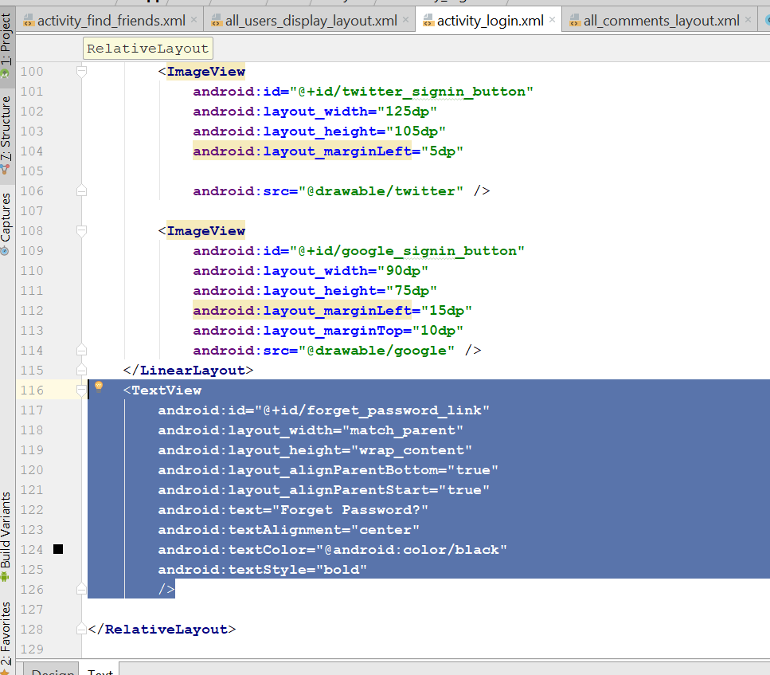
* 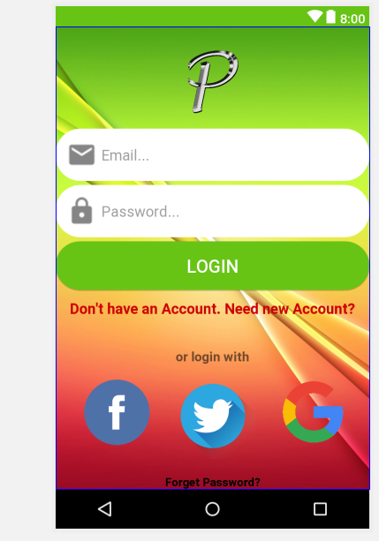
* Now create empty activity>ResetPasswordActivity
* 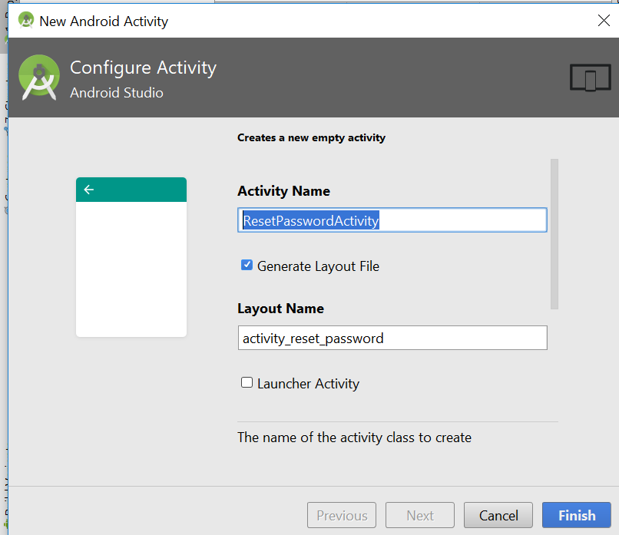
* Click finish
* Now go to loginActivity.java
* Add this new link
* 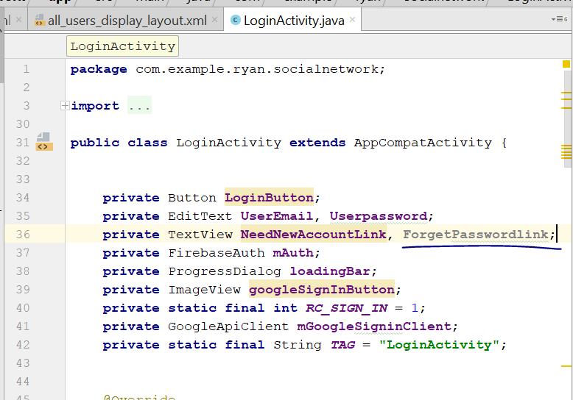
* Add this to the OnCreate()
* ForgetPasswordlink = (TextView) findViewById(R.id.*forget_password_link*);
* **ForgetPasswordlink**.setOnClickListener(**new** View.OnClickListener() {  
   @Override  
   **public void** onClick(View v) {  
   startActivity(**new** Intent(LoginActivity.**this**,ResetPasswordActivity.**class**));  
     
   }  
  });
* Now go to activity_reset_password.xml
* Change the code to this
* *<?*xml version="1.0" encoding="utf-8"*?>*<RelativeLayout xmlns:android="http://schemas.android.com/apk/res/android"  
   xmlns:app="http://schemas.android.com/apk/res-auto"  
   xmlns:tools="http://schemas.android.com/tools"  
   android:background="@drawable/login"  
   android:layout_width="match_parent"  
   android:layout_height="match_parent"  
   tools:context="com.example.ryan.socialnetwork.ResetPasswordActivity">  
    
   <include  
   android:id="@+id/forget_password_toolbar"  
   layout="@layout/app_bar_layout"></include>  
    
    
    
  </RelativeLayout>
* Drag and drop a textView in the centre of the layout
* Layout_width =match_parent
* Look like this
* 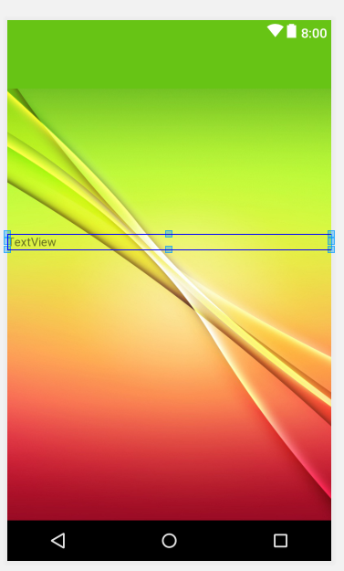
* Change some of the attribute of the TextView
* Text = We will mail you a link after when you provide email and click on send button. Please click on that link to reset your password.
* Text size change to 20sp
* 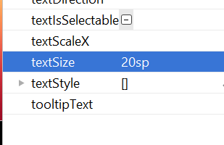
* 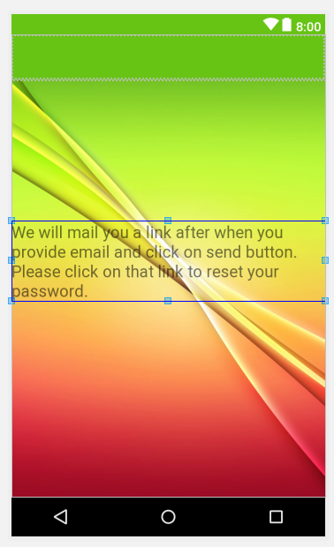
* textAlignment = center
* textstyle should be bold
* text colour change to background dark
* 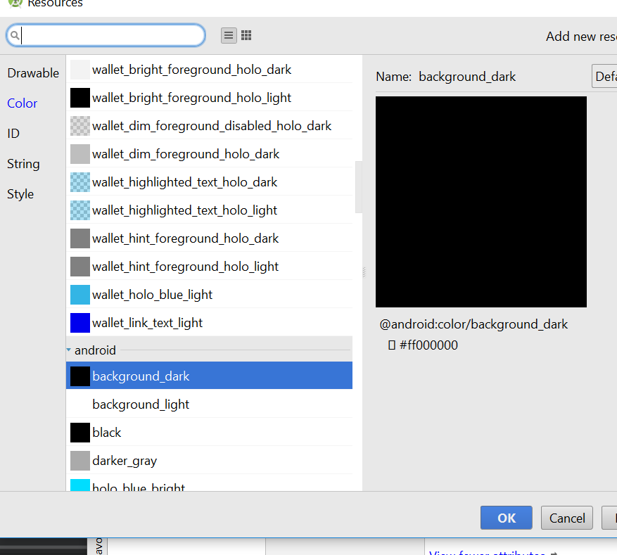
* Margin from the top is 100dp
* 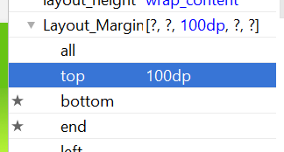
* Now should look like this
* 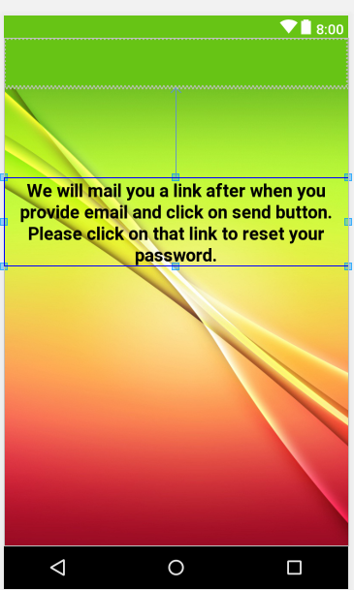
* Drag and drop a email text to the layout
* 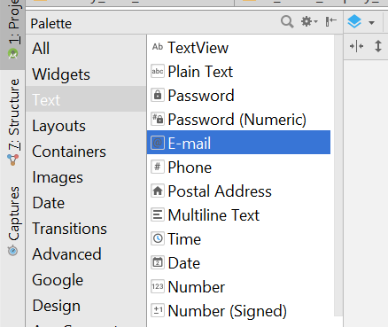
* Make it match_parent for the width
* 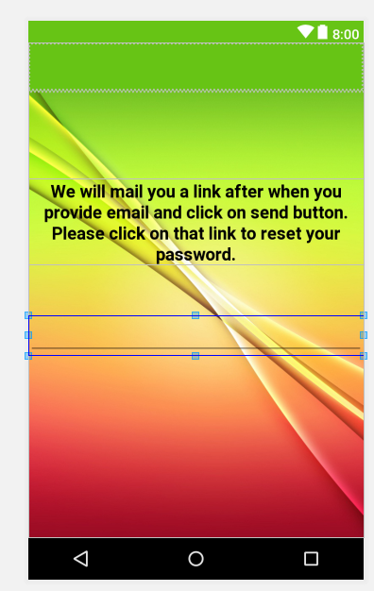
* Change the property of the email text to this
* <EditText  
   android:id="@+id/editText"  
   android:layout_width="match_parent"  
   android:layout_height="wrap_content"  
   android:layout_alignParentStart="true"  
   android:layout_below="@+id/textView3"  
   android:layout_marginTop="15dp"  
   android:layout_marginLeft="15dp"  
   android:layout_marginRight="15dp"  
   android:ems="10"  
   android:padding="15dp"  
   android:background="@drawable/inputs"  
   android:hint="write your email here"  
   android:inputType="textEmailAddress" />
* You should see something like this
* 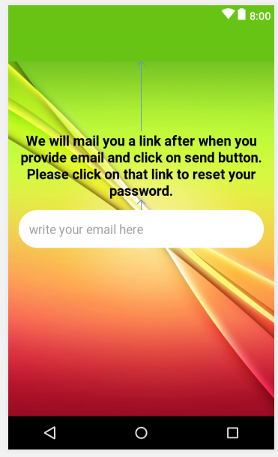
* Now add a button
* This is the new property for textView and button
* <EditText  
   android:id="@+id/reset_password_EMAIL"  
   android:layout_width="match_parent"  
   android:layout_height="wrap_content"  
   android:layout_alignParentStart="true"  
   android:layout_below="@+id/textView3"  
   android:layout_marginTop="15dp"  
   android:layout_marginLeft="15dp"  
   android:layout_marginRight="15dp"  
   android:ems="10"  
   android:padding="15dp"  
   android:background="@drawable/inputs"  
   android:hint="write your email here"  
   android:inputType="textEmailAddress" />  
    
  <Button  
   android:id="@+id/reset_password_email_button"  
   android:layout_width="match_parent"  
   android:layout_height="wrap_content"  
   android:layout_below="@+id/reset_password_EMAIL"  
   android:layout_centerHorizontal="true"  
   android:layout_marginTop="10dp"  
   android:layout_marginLeft="60dp"  
   android:layout_marginRight="60dp"  
   android:textColor="@android:color/background_light"  
   android:textStyle="bold"  
   android:textSize="20dp"  
   android:background="@drawable/button"  
   android:text="Send Email" />
* 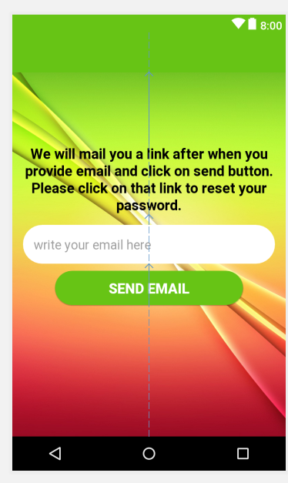
* Now go to resetPasswordActivity.java
* Import this
* **import** android.support.v7.widget.Toolbar;
* declare those variable
* private Toolbar mToolbar;  
  private Button ResetPasswordSendEmailButton;  
  private EditText ResetEmailInput;
* in the onCreate(), add this
* **mToolbar** = (Toolbar) findViewById(R.id.***forget_password_toolbar***);  
   setSupportActionBar(**mToolbar**);  
   getSupportActionBar().setDisplayShowHomeEnabled(**true**);  
   getSupportActionBar().setTitle(**"Reset Password"**);  
    
    
    
  **ResetPasswordSendEmailButton** = (Button) findViewById(R.id.***reset_password_email_button***);  
  **ResetEmailInput** = (EditText) findViewById(R.id.***reset_password_EMAIL***);
* Now go to android manifest
* Add this line to “ResetPasswordActivity”
* android:parentActivityName=".MainActivity
* 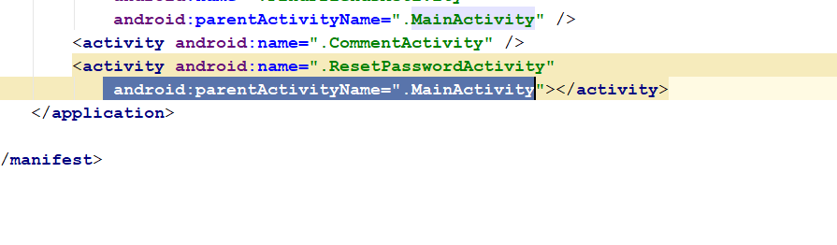
* Rebuild and run, when you click on the link, it should bring u to the ResetPassword Activity
* Go to firebase, check on Authentication
* 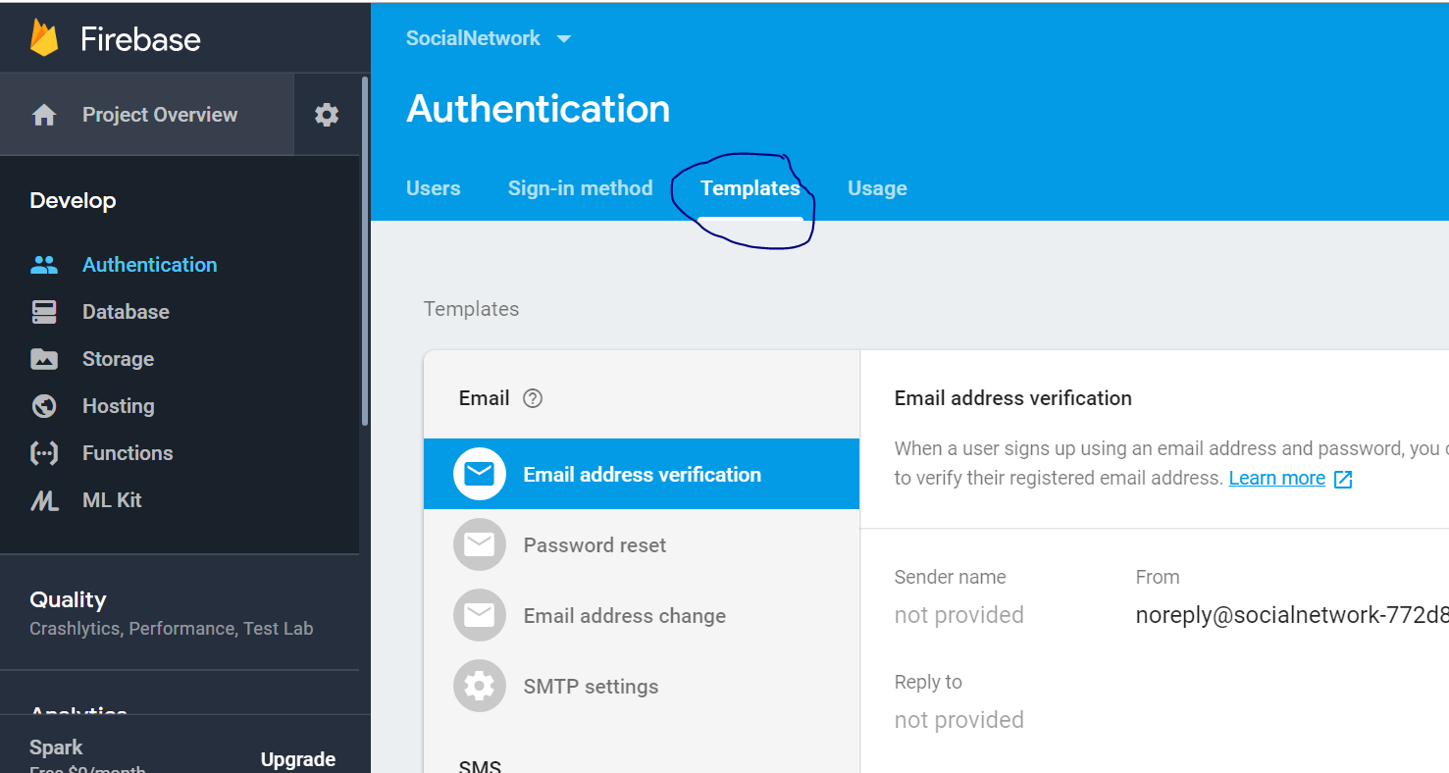
* Click on password reset
* 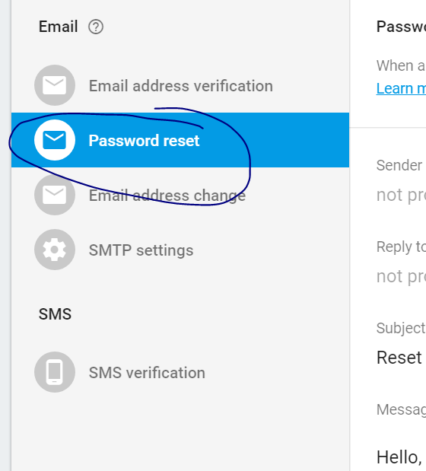
* 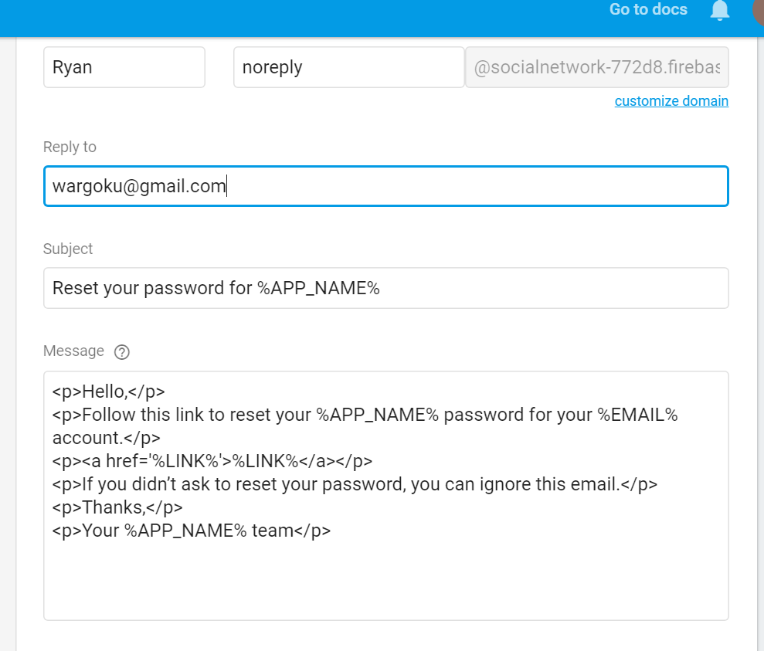
* Click save
* In the ResetPasswordActivity.java
* Declare this
* **private** FirebaseAuth **mAuth**;
* In the onCreate() method
* Add this line
* **mAuth** = FirebaseAuth.*getInstance*();
* **ResetPasswordSendEmailButton**.setOnClickListener(**new** View.OnClickListener() {  
   @Override  
   **public void** onClick(View v) {  
   **final** String userEmail = **ResetEmailInput**.getText().toString();  
   **if**(TextUtils.*isEmpty*(userEmail))  
   {  
   Toast.*makeText*(ResetPasswordActivity.**this**,**"Please write your valid email address first..."**, Toast.***LENGTH_SHORT***).show();  
    
   }  
   **else** {  
   **mAuth**.sendPasswordResetEmail(userEmail).addOnCompleteListener(**new** OnCompleteListener<Void>() {  
   @Override  
   **public void** onComplete(@NonNull Task<Void> task) {  
   **if**(task.isSuccessful())  
   {  
   Toast.*makeText*(ResetPasswordActivity.**this**, **"Please check your email account if you want to reset your password"**, Toast.***LENGTH_SHORT***).show();  
   startActivity(**new** Intent(ResetPasswordActivity.**this**,LoginActivity.**class**));  
     
   }  
   **else** {  
   String message = task.getException().getMessage();  
   Toast.*makeText*(ResetPasswordActivity.**this**, **"Error Occured: "**+ userEmail, Toast.***LENGTH_SHORT***).show();  
   }  
   }  
   });  
   }  
   }  
  });
* 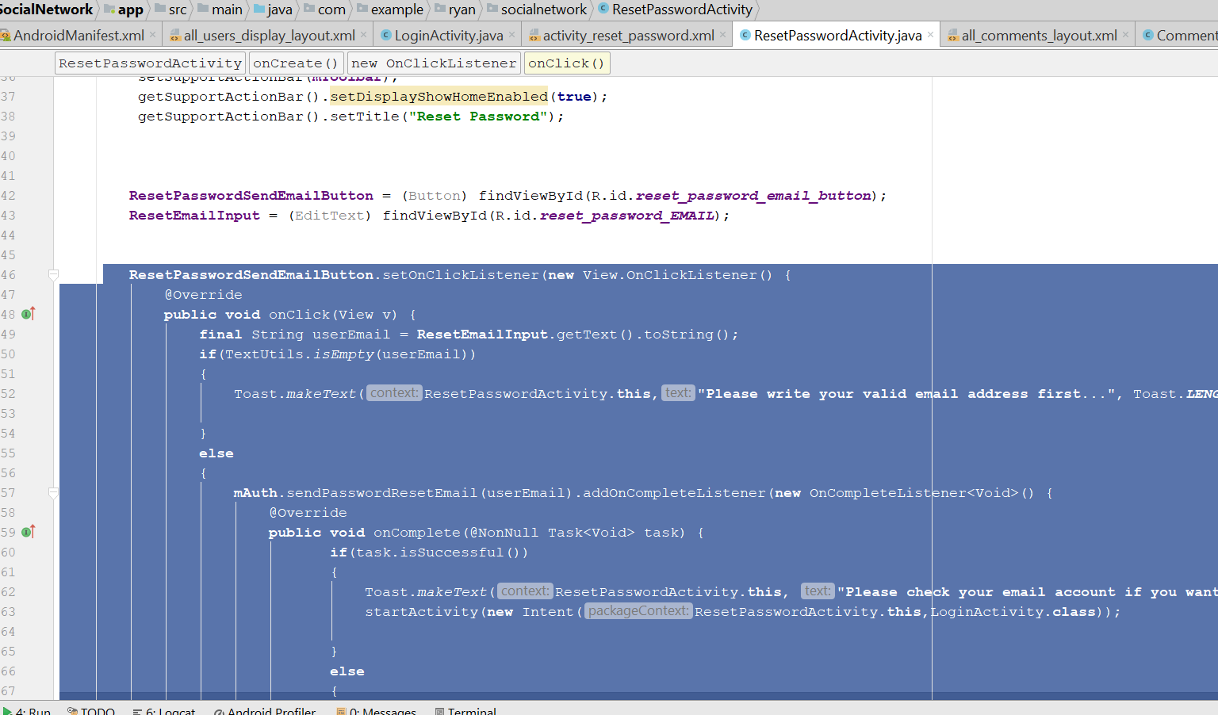
* Rebuild and run, now when u click on reset password, should be able to receive reset password email.

# Peron Profile Activity

* Create a new java activity, > empty activity “PersonProfileActivity.java”
* 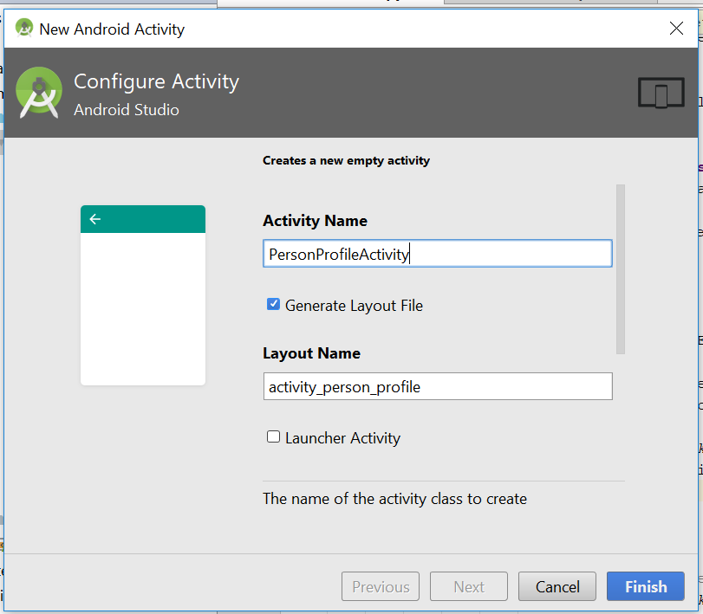
* Click finish
* Now go to activity_person_profile.xml
* Change the layout to relative_layout
* Now go to activity_profile.xml, copy the entire scrollview from TEXT
* Paste inside activity_person_profile.xml
* This is how the whole xml look like
* *<?*xml version="1.0" encoding="utf-8"*?>*<RelativeLayout xmlns:android="http://schemas.android.com/apk/res/android"  
   xmlns:app="http://schemas.android.com/apk/res-auto"  
   xmlns:tools="http://schemas.android.com/tools"  
   android:layout_width="match_parent"  
   android:layout_height="match_parent"  
   android:background="@color/colorProfile"  
   tools:context="com.example.ryan.socialnetwork.PersonProfileActivity">  
   <ScrollView  
   android:layout_width="match_parent"  
   android:layout_height="match_parent"  
   android:layout_alignParentEnd="true"  
   android:layout_alignParentTop="true">  
    
   <RelativeLayout  
   android:layout_width="match_parent"  
   android:layout_height="wrap_content">  
    
   <de.hdodenhof.circleimageview.CircleImageView  
   android:id="@+id/person_profile_pic"  
   android:layout_width="300dp"  
   android:layout_height="300dp"  
   android:layout_alignParentTop="true"  
   android:layout_centerHorizontal="true"  
   android:layout_marginTop="15dp"  
   android:src="@drawable/profile" />  
    
   <TextView  
   android:id="@+id/person_full_name"  
   android:layout_width="match_parent"  
   android:layout_height="wrap_content"  
   android:layout_below="@+id/person_profile_pic"  
   android:layout_marginTop="5dp"  
   android:text="Profile Name"  
   android:textAlignment="center"  
   android:textAllCaps="false"  
   android:textColor="@android:color/background_light"  
   android:textSize="20sp"  
   android:textStyle="bold" />  
    
   <TextView  
   android:id="@+id/person_username"  
   android:layout_width="match_parent"  
   android:layout_height="wrap_content"  
   android:layout_below="@+id/person_full_name"  
   android:text="user name"  
   android:textAlignment="center"  
   android:textAllCaps="false"  
   android:textColor="@android:color/background_light"  
   android:textSize="18sp" />  
    
   <TextView  
   android:id="@+id/person_profile_status"  
   android:layout_width="match_parent"  
   android:layout_height="wrap_content"  
   android:layout_below="@+id/person_username"  
   android:layout_marginTop="5dp"  
   android:text="hey there, I am using social app, developed by Ryan"  
   android:textAlignment="center"  
   android:textAllCaps="false"  
   android:textColor="@android:color/darker_gray"  
   android:textSize="22sp" />  
    
   <TextView  
   android:id="@+id/person_country"  
   android:layout_width="match_parent"  
   android:layout_height="wrap_content"  
   android:layout_below="@+id/person_profile_status"  
   android:layout_marginTop="60dp"  
   android:text="Country"  
   android:textAlignment="center"  
   android:textAllCaps="false"  
   android:textColor="@color/colorAccent"  
   android:textSize="18sp" />  
    
   <TextView  
   android:id="@+id/person_dob"  
   android:layout_width="match_parent"  
   android:layout_height="wrap_content"  
   android:layout_below="@+id/person_country"  
   android:layout_marginTop="2dp"  
   android:text="Date of Birth"  
   android:textAlignment="center"  
   android:textAllCaps="false"  
   android:textColor="@color/colorAccent"  
   android:textSize="18sp" />  
    
   <TextView  
   android:id="@+id/person_gender"  
   android:layout_width="match_parent"  
   android:layout_height="wrap_content"  
   android:layout_below="@+id/person_dob"  
   android:layout_marginTop="2dp"  
   android:text="Gender"  
   android:textAlignment="center"  
   android:textAllCaps="false"  
   android:textColor="@color/colorAccent"  
   android:textSize="18sp" />  
    
   <TextView  
   android:id="@+id/person_relationship_status"  
   android:layout_width="match_parent"  
   android:layout_height="wrap_content"  
   android:layout_below="@+id/person_gender"  
   android:layout_marginTop="2dp"  
   android:text="Relationship status"  
   android:textAlignment="center"  
   android:textAllCaps="false"  
   android:textColor="@color/colorAccent"  
   android:textSize="18sp" />  
     
   <Button  
   android:id="@+id/person_send_friend_request_btn"  
   android:layout_width="230dp"  
   android:layout_height="wrap_content"  
   android:layout_below="@id/person_relationship_status"  
   android:layout_marginTop="45dp"  
   android:background="@color/colorPrimaryDark"  
   android:text="Send Friend Request"  
   android:textColor="@android:color/background_light"  
   android:textSize="16sp"  
   android:layout_centerHorizontal="true"  
   />  
   <Button  
   android:id="@+id/person_decline_friend_request_btn"  
   android:layout_width="230dp"  
   android:layout_height="wrap_content"  
   android:layout_below="@id/person_send_friend_request_btn"  
   android:layout_marginTop="8dp"  
   android:background="@color/colorPrimary"  
   android:text="Decline Friend Request"  
   android:textColor="@android:color/background_light"  
   android:textSize="16sp"  
   android:layout_centerHorizontal="true"  
   />  
   </RelativeLayout>  
   </ScrollView>  
  </RelativeLayout>
* 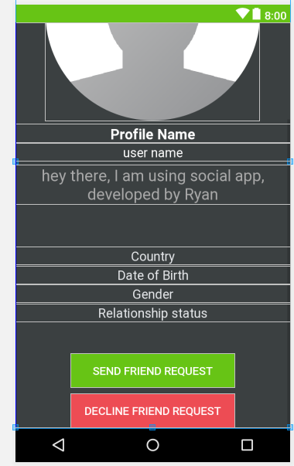
* Now go to FindFriendActivity.java
* Add this code
* viewHolder.**mView**.setOnClickListener(**new** View.OnClickListener() {  
   @Override  
   **public void** onClick(View v) {  
   String visit_user_id = getRef(position).getKey();  
   Intent profileIntent = **new** Intent(FindFriendsActivity.**this**,PersonProfileActivity.**class**);  
   profileIntent.putExtra(**"visit_user_id"**,visit_user_id);  
    
   startActivity(profileIntent);  
    
   }  
  });
* Add it here
* 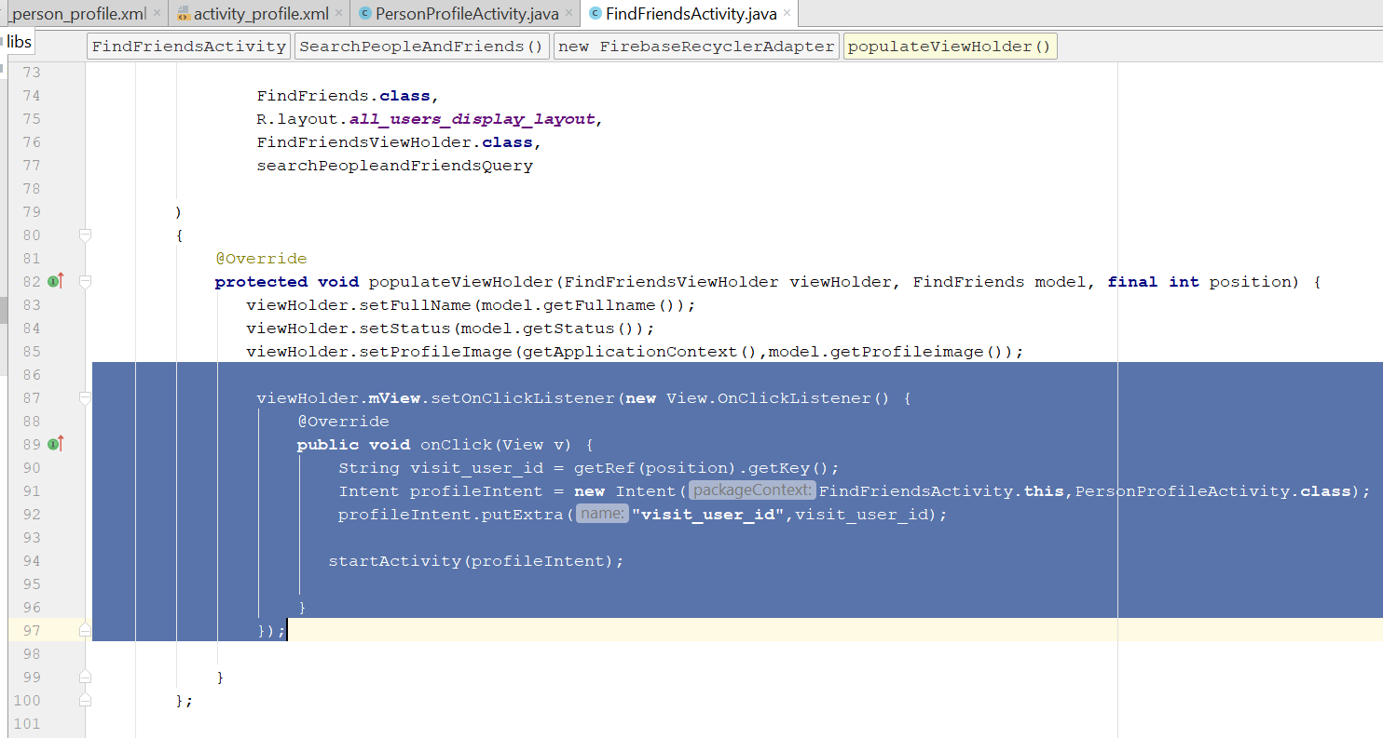
* For the personProfileActivity.java
* This is the whole code
* **package** com.example.ryan.socialnetwork;  
    
  **import** android.support.v7.app.AppCompatActivity;  
  **import** android.os.Bundle;  
  **import** android.widget.Button;  
  **import** android.widget.TextView;  
    
  **import** com.google.firebase.auth.FirebaseAuth;  
  **import** com.google.firebase.database.DataSnapshot;  
  **import** com.google.firebase.database.DatabaseError;  
  **import** com.google.firebase.database.DatabaseReference;  
  **import** com.google.firebase.database.FirebaseDatabase;  
  **import** com.google.firebase.database.ValueEventListener;  
  **import** com.squareup.picasso.Picasso;  
    
  **import** de.hdodenhof.circleimageview.CircleImageView;  
    
  **public class** PersonProfileActivity **extends** AppCompatActivity {  
    
   **private** TextView **userName**, **userProfName**, **userStatus**, **userCountry**, **userGender**, **userRelation**, **userDOB**;  
   **private** CircleImageView **userProfileImage**;  
   **private** Button **SendFriendReqbutton**, **DeclineFriendRequestbutton**;  
   **private** DatabaseReference **profileUserRef**, **UserRef**;  
   **private** FirebaseAuth **mAuth**;  
   **private** String **senderUserID**, **receiverUserId**;  
    
   @Override  
   **protected void** onCreate(Bundle savedInstanceState) {  
   **super**.onCreate(savedInstanceState);  
   setContentView(R.layout.***activity_person_profile***);  
    
   **mAuth** = FirebaseAuth.*getInstance*();  
   **receiverUserId** = getIntent().getExtras().get(**"visit_user_id"**).toString();  
   **UserRef** = FirebaseDatabase.*getInstance*().getReference().child(**"Users"**);  
    
    
   InitializeFields();  
   **UserRef**.child(**receiverUserId**).addValueEventListener(**new** ValueEventListener() {  
   @Override  
   **public void** onDataChange(DataSnapshot dataSnapshot) {  
   **if**(dataSnapshot.exists())  
   {  
   String myProfileImage = dataSnapshot.child(**"profileimage"**).getValue().toString();  
   String myUserName = dataSnapshot.child(**"username"**).getValue().toString();  
   String myProfileName = dataSnapshot.child(**"fullname"**).getValue().toString();  
   String myProfileStatus = dataSnapshot.child(**"status"**).getValue().toString();  
   String myDOB = dataSnapshot.child(**"dob"**).getValue().toString();  
   String myCountry = dataSnapshot.child(**"country"**).getValue().toString();  
   String myGender = dataSnapshot.child(**"gender"**).getValue().toString();  
   String myRelationStatus = dataSnapshot.child(**"relationshipstatus"**).getValue().toString();  
    
    
   Picasso.*get*().load(myProfileImage).placeholder(R.drawable.***profile***).into(**userProfileImage**);  
   **userName**.setText(**"@"**+myUserName);  
   **userProfName**.setText(myProfileName);  
   **userStatus**.setText(myProfileStatus);  
   **userDOB**.setText(**"DOB: "**+myDOB);  
   **userCountry**.setText(**"Country: "**+myCountry);  
   **userGender**.setText(**"Gender: "**+myGender);  
   **userRelation**.setText(**"Relationship: "**+myRelationStatus);  
   }  
   }  
    
   @Override  
   **public void** onCancelled(DatabaseError databaseError) {  
    
   }  
   });  
    
   }  
    
   **private void** InitializeFields() {  
    
   **userName** = (TextView) findViewById(R.id.***person_username***);  
   **userProfName** = (TextView) findViewById(R.id.***person_full_name***);  
   **userStatus** = (TextView) findViewById(R.id.***person_profile_status***);  
   **userCountry** = (TextView) findViewById(R.id.***person_country***);  
   **userGender** = (TextView) findViewById(R.id.***person_gender***);  
   **userRelation** = (TextView) findViewById(R.id.***person_relationship_status***);  
   **userDOB** = (TextView) findViewById(R.id.***person_dob***);  
   **userProfileImage** = (CircleImageView)findViewById(R.id.***person_profile_pic***);  
   **SendFriendReqbutton** = (Button)findViewById(R.id.***person_send_friend_request_btn***);  
   **DeclineFriendRequestbutton** = (Button)findViewById(R.id.***person_decline_friend_request_btn***);  
    
    
    
   }  
  }
* Rebuild and run, you shld able to see the user info, when u search and tap onto the user

# Descending order of the post

* Go to PostActivity.java
* Declare this on top
* private long countPosts = 0;
* Go to SavingPostInformationToDatabase()
* Add this into the method
* **PostRef**.addValueEventListener(**new** ValueEventListener() {  
   @Override  
   **public void** onDataChange(DataSnapshot dataSnapshot) {  
   **if**(dataSnapshot.exists())  
   {  
   **countPosts** = dataSnapshot.getChildrenCount();  
   }  
   **else** {  
   **countPosts** = 0;  
   }  
   }  
    
   @Override  
   **public void** onCancelled(DatabaseError databaseError) {  
    
   }  
  });
* 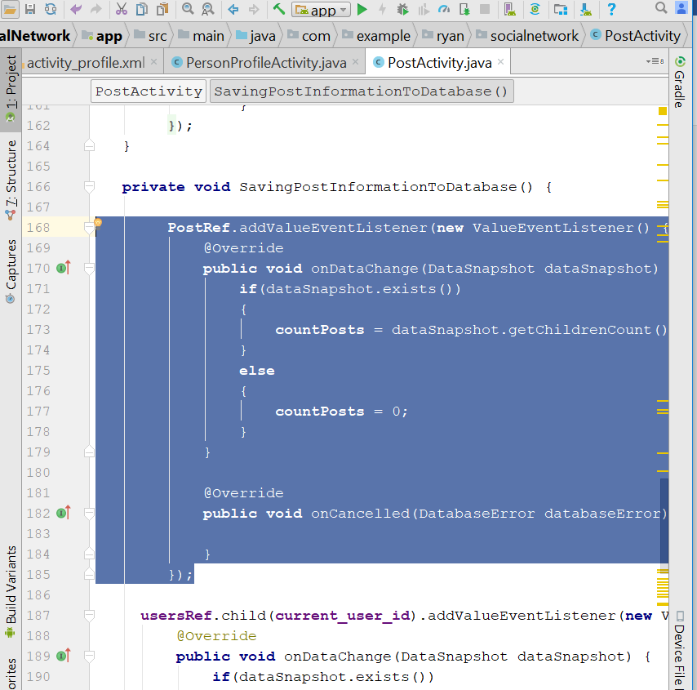
* Add a new line here
* postsmap.put("counter", countPosts);
* 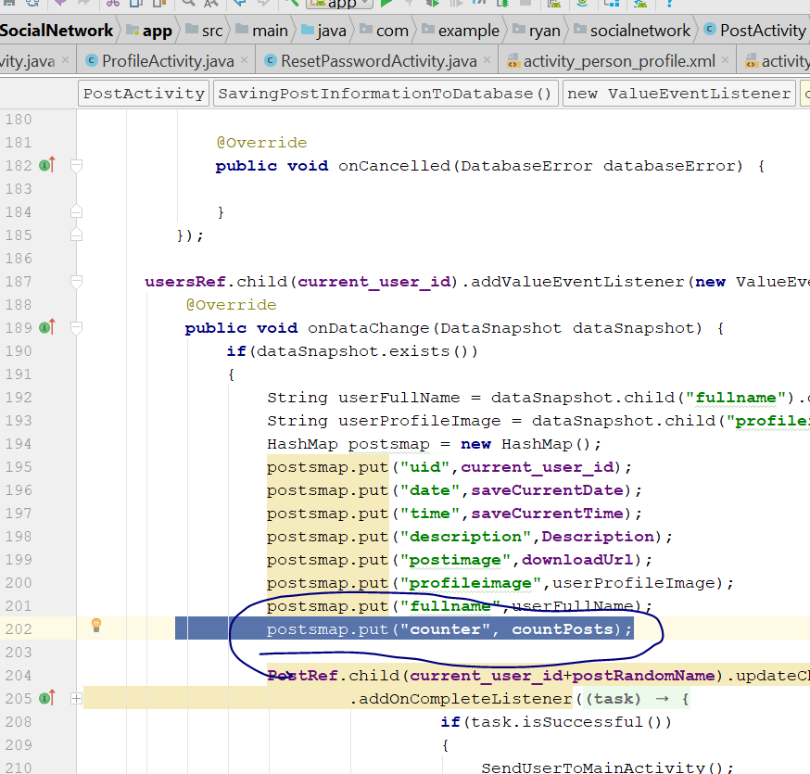
* Now go the MainActivity.java
* Go to DisplayAllUsersPosts()
* Add this line
* Query SortPostsDescendingOrder = **PostsRef**.orderByChild(**"counter"**);
* Change to this
* 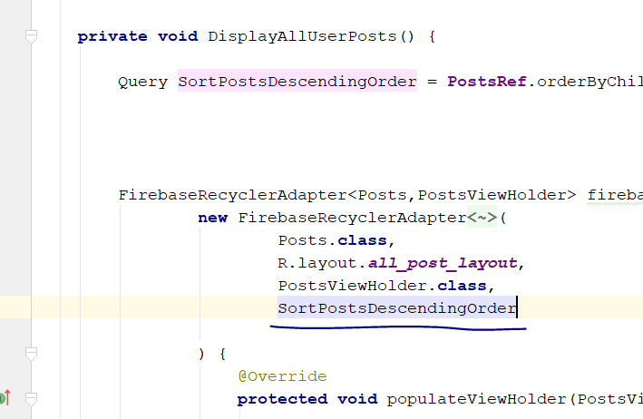
* Now go to PostActivity.java
* Rebuild and run, you see all empty post
* Add a new post, it shld go to the top in descending order

# Send and receive friend Request

* Go to PersonProfileActivity.java
* Add this code
* DeclineFriendRequestbutton.setVisibility(View.***INVISIBLE***);  
  DeclineFriendRequestbutton.setEnabled(**false**);
* Add it here
* 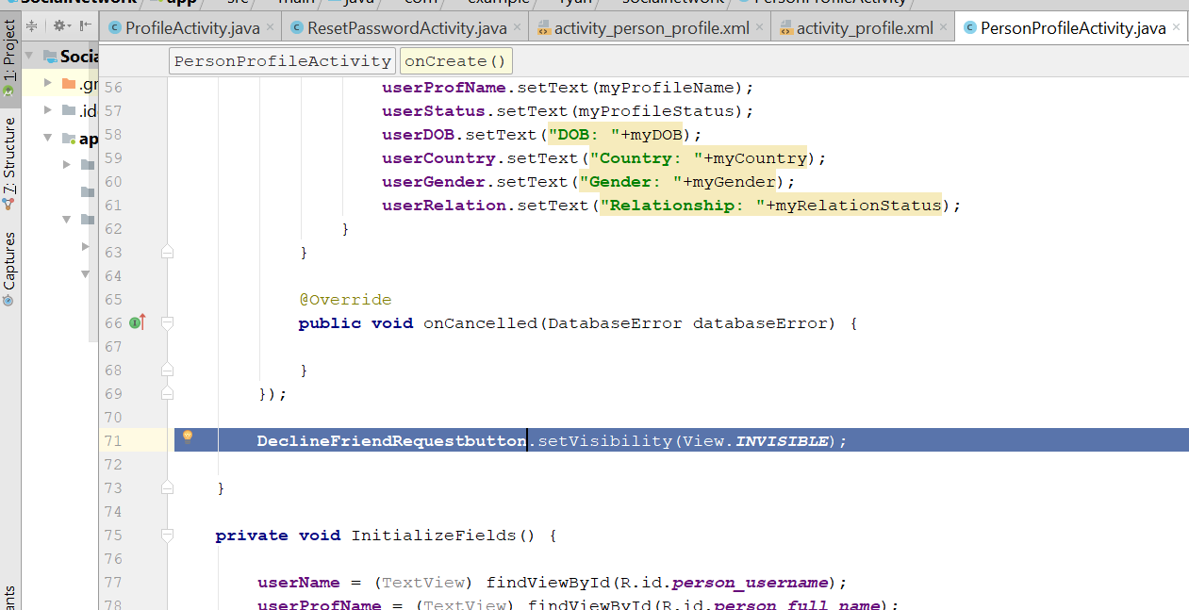
* Add a new string call CURRENT_STATE;
* 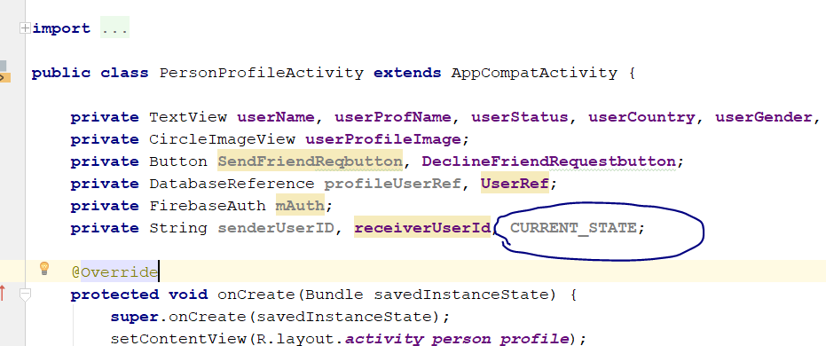
* Add this onCreate()
* **senderUserID** = **mAuth**.getCurrentUser().getUid();
* add those code
* **if**(!**senderUserID**.equals(**receiverUserId**))  
  {  
   **SendFriendReqbutton**.setOnClickListener(**new** View.OnClickListener() {  
   @Override  
   **public void** onClick(View v) {  
   **SendFriendReqbutton**.setEnabled(**false**);  
   }  
   });  
  }  
  **else**{  
   **DeclineFriendRequestbutton**.setVisibility(View.***INVISIBLE***);  
   **SendFriendReqbutton**.setVisibility(View.***INVISIBLE***);  
  }
* 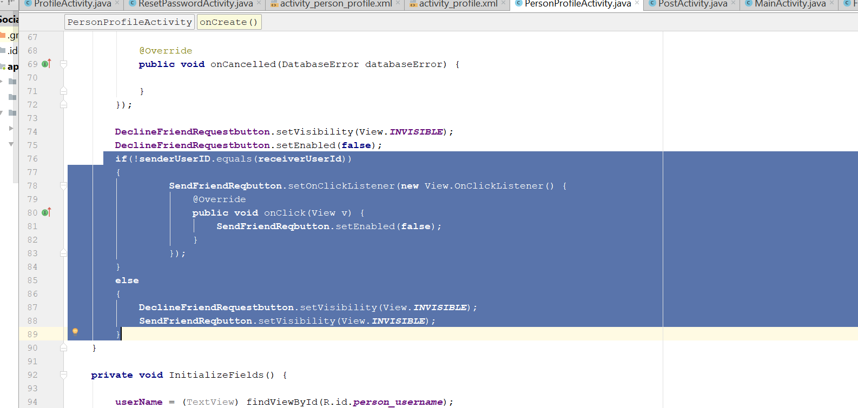
* Add this line at initializeFields()
* CURRENT_STATE = **"not_friends"**;
* 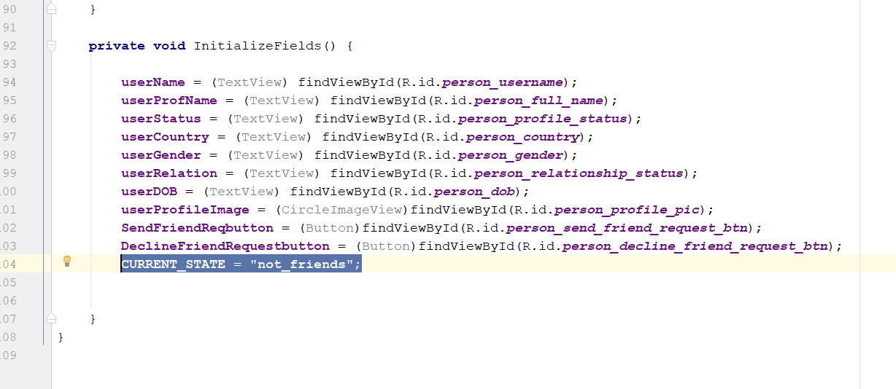
* Rebuild and run

# Send friend Request, cancel request, Accept Request

* Go to personProfileActivity.java
* Declare a new DatabaseReference - FriendRquestRef;
* 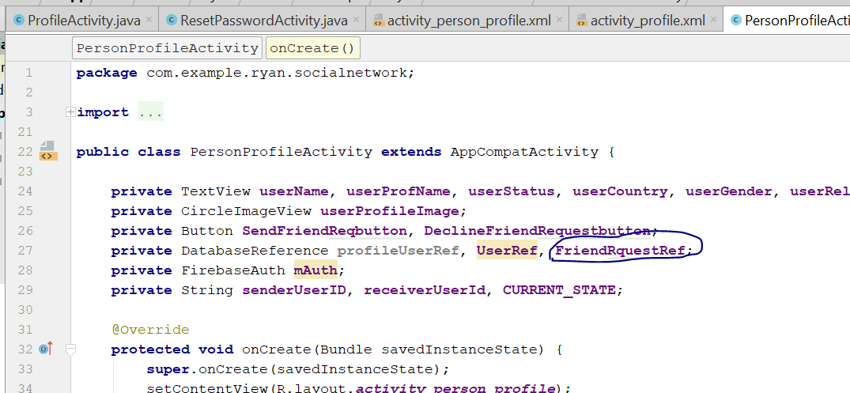
* In the OnCreate(), add this
* FriendRquestRef = FirebaseDatabase.*getInstance*().getReference().child(**"FriendRequests"**);
* 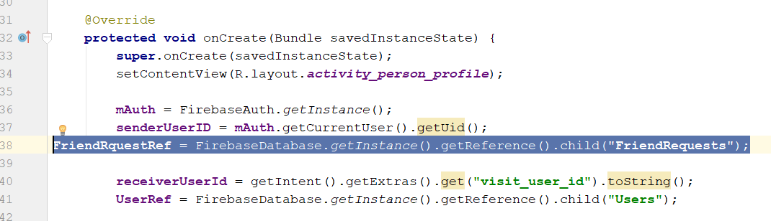
* In the SendFriendReqbutton. Listener, add this
* 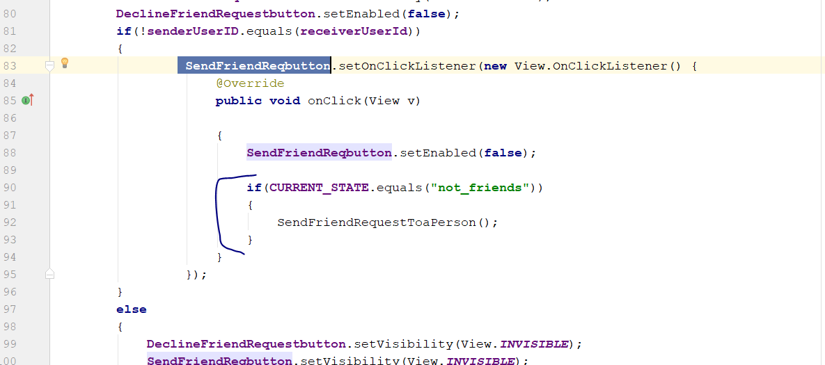
* **if**(**CURRENT_STATE**.equals(**"not_friends"**))  
  {  
   SendFriendRequestToaPerson();  
  }
* then , create a new method in this class, call SendFriendRequestToaPerson()
* **private void** SendFriendRequestToaPerson()  
  {  
   **FriendRquestRef**.child(**senderUserID**).child(**receiverUserId**)  
   .child(**"request_type"**).setValue(**"sent"**)  
   .addOnCompleteListener(**new** OnCompleteListener<Void>() {  
   @Override  
   **public void** onComplete(@NonNull Task<Void> task) {  
   **if**(task.isSuccessful())  
   {  
   **FriendRquestRef**.child(**receiverUserId**).child(**senderUserID**)  
   .child(**"request_type"**).setValue(**"received"**)  
   .addOnCompleteListener(**new** OnCompleteListener<Void>() {  
   @Override  
   **public void** onComplete(@NonNull Task<Void> task) {  
   **if**(task.isSuccessful())  
   {  
   **SendFriendReqbutton**.setEnabled(**true**);  
   **CURRENT_STATE** = **"request_sent"**;  
   **SendFriendReqbutton**.setText(**"Cancel Friend Request"**);  
    
   **DeclineFriendRequestbutton**.setVisibility(View.***INVISIBLE***);  
   **DeclineFriendRequestbutton**.setEnabled(**false**);  
   }  
   }  
   });  
   }  
   }  
   });  
  }
* 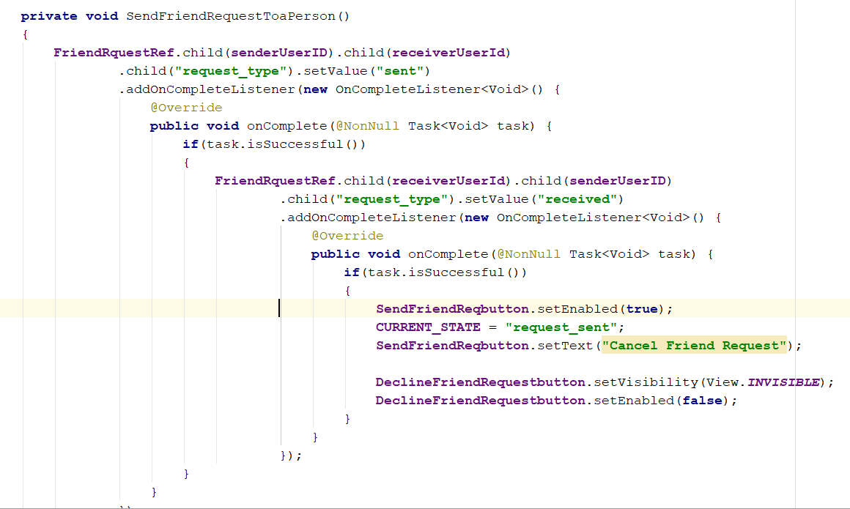
* Add a new method here
* MaintananceofButtons();
* 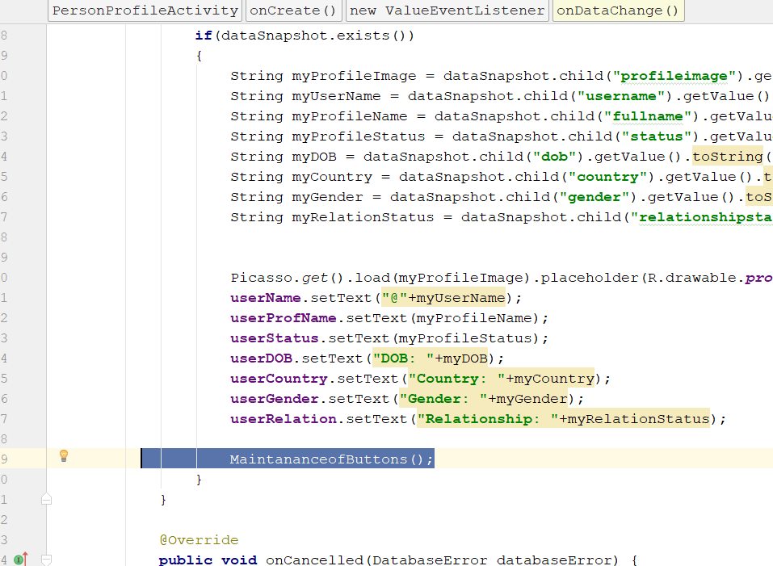
* Create this new method
* **private void** MaintananceofButtons() {  
   **FriendRquestRef**.child(**senderUserID**)  
   .addListenerForSingleValueEvent(**new** ValueEventListener() {  
   @Override  
   **public void** onDataChange(DataSnapshot dataSnapshot) {  
   **if**(dataSnapshot.hasChild(**receiverUserId**))  
   {  
   String request_type = dataSnapshot.child(**receiverUserId**).child(**"request_type"**).getValue().toString();  
    
   **if**(request_type.equals(**"sent"**))  
   {  
   **CURRENT_STATE** = **"request_sent"**;  
   **SendFriendReqbutton**.setText(**"Cancel Friend Request"**);  
   **DeclineFriendRequestbutton**.setVisibility(View.***INVISIBLE***);  
   **DeclineFriendRequestbutton**.setEnabled(**false**);  
   }  
   }  
   }  
    
   @Override  
   **public void** onCancelled(DatabaseError databaseError) {  
    
   }  
   });  
  }
* 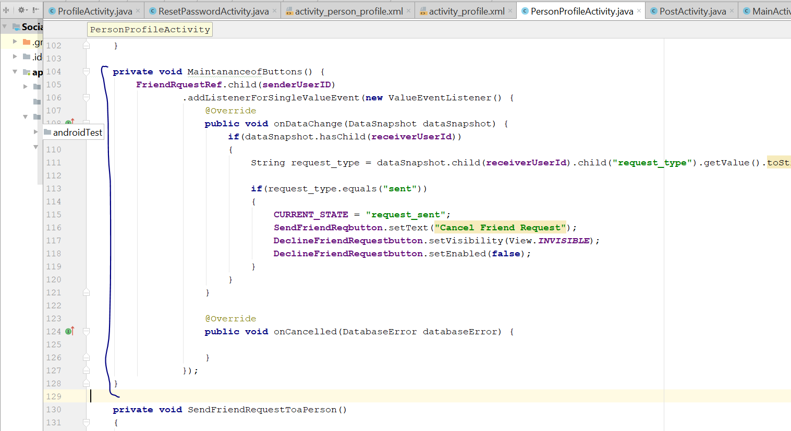
* Rebuild and run, now after you send friend request, you will see this in the firebase
* 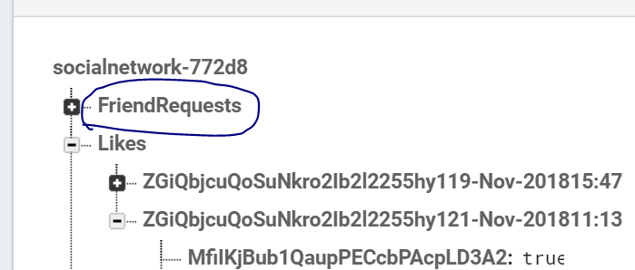
* And the button will change to cancel friend request
* Now talk about cancel friend request
* Add this code here
* **if**(**CURRENT_STATE**.equals(**"request_sent"**))  
  {  
   CancelFriendRequest();  
  }
* 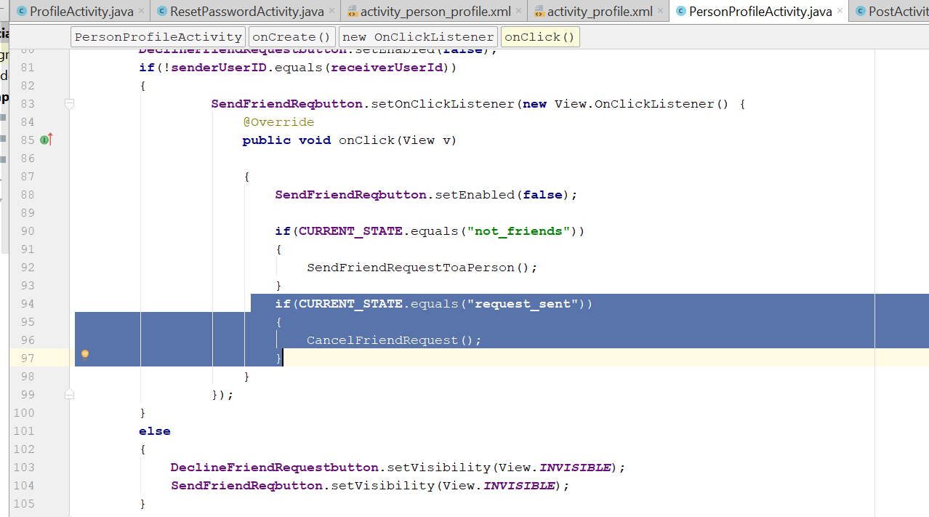
* Add this new method
* **private void** CancelFriendRequest() {  
   **FriendRquestRef**.child(**senderUserID**).child(**receiverUserId**)  
   .removeValue()  
   .addOnCompleteListener(**new** OnCompleteListener<Void>() {  
   @Override  
   **public void** onComplete(@NonNull Task<Void> task) {  
   **if**(task.isSuccessful())  
   {  
   **FriendRquestRef**.child(**receiverUserId**).child(**senderUserID**)  
   .removeValue()  
   .addOnCompleteListener(**new** OnCompleteListener<Void>() {  
   @Override  
   **public void** onComplete(@NonNull Task<Void> task) {  
   **if**(task.isSuccessful())  
   {  
   **SendFriendReqbutton**.setEnabled(**true**);  
   **CURRENT_STATE** = **"not_friends"**;  
   **SendFriendReqbutton**.setText(**"send Friend Request"**);  
    
   **DeclineFriendRequestbutton**.setVisibility(View.***INVISIBLE***);  
   **DeclineFriendRequestbutton**.setEnabled(**false**);  
   }  
   }  
   });  
   }  
   }  
   });  
  }
* 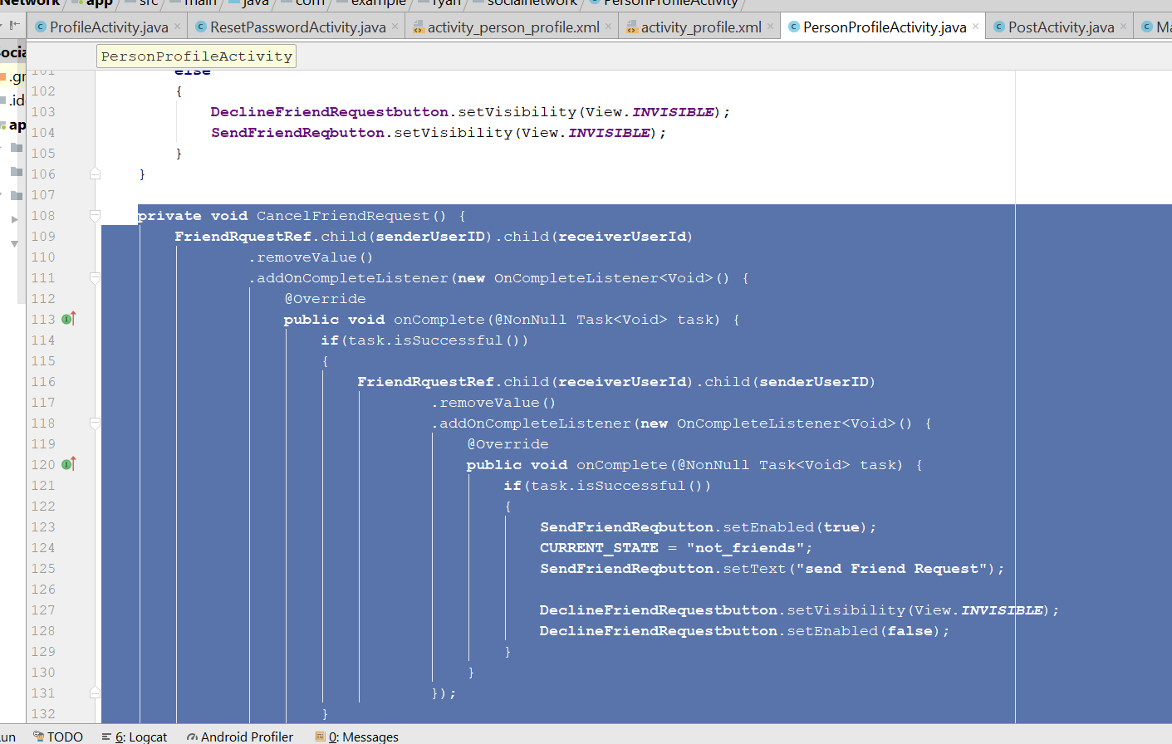
* Rebuild and run
* Now you can cancel friend request and it will reflect in the firebase
* Now talk about Accept friend request
* Now go to MaintananceOfButtons()
* Add this
* else if(request_type.equals("received"))  
  {  
   CURRENT_STATE = "request_received";  
   SendFriendReqbutton.setText("Accept friend Request");  
   DeclineFriendRequestbutton.setVisibility(View.*VISIBLE*);  
   DeclineFriendRequestbutton.setEnabled(true);  
  }
* 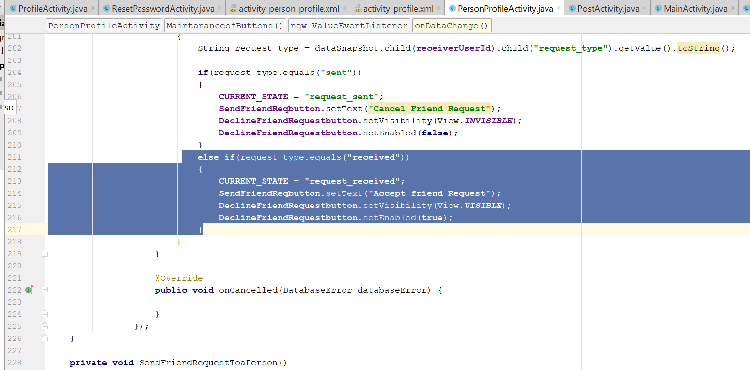
* Add this two variable
* 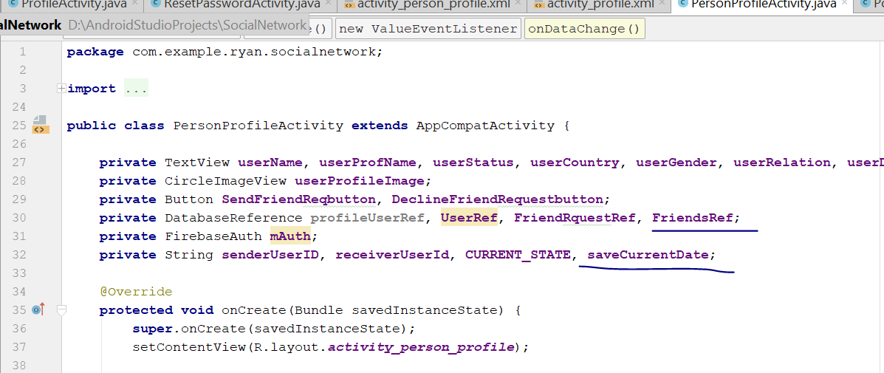
* Add this code here
* **if**(**CURRENT_STATE**.equals(**"request_received"**))  
  {  
   AcceptFriendRequest();  
  }
* 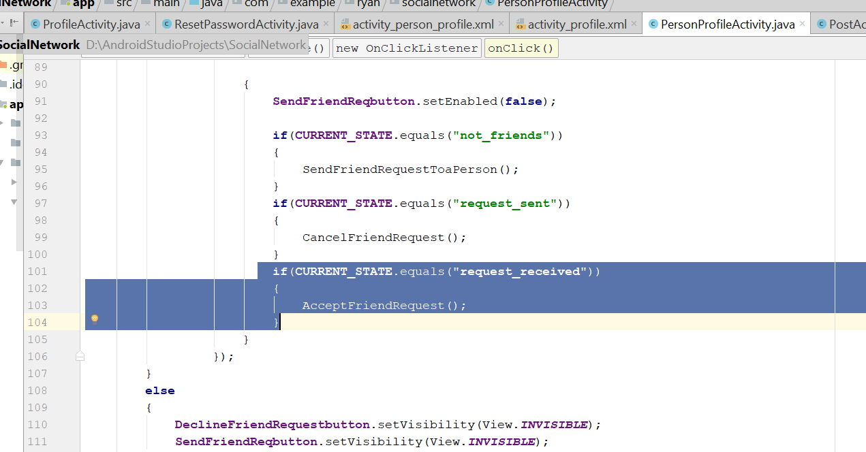
* Create a new Method call AcceptFriendsRequest()
* **private void** AcceptFriendRequest() {  
    
   Calendar calFordDate = Calendar.*getInstance*();  
   SimpleDateFormat currentDate = **new** SimpleDateFormat(**"dd-MMM-yyyy"**);  
   **saveCurrentDate** = currentDate.format(calFordDate.getTime());  
   **FriendsRef**.child(**senderUserID**).child(**receiverUserId**).child(**"date"**).setValue(**saveCurrentDate**)  
   .addOnCompleteListener(**new** OnCompleteListener<Void>() {  
   @Override  
   **public void** onComplete(@NonNull Task<Void> task) {  
   **if**(task.isSuccessful())  
   {  
   **FriendsRef**.child(**receiverUserId**).child(**senderUserID**).child(**"date"**).setValue(**saveCurrentDate**)  
   .addOnCompleteListener(**new** OnCompleteListener<Void>() {  
   @Override  
   **public void** onComplete(@NonNull Task<Void> task) {  
   **if**(task.isSuccessful())  
   {  
   **FriendRquestRef**.child(**senderUserID**).child(**receiverUserId**)  
   .removeValue()  
   .addOnCompleteListener(**new** OnCompleteListener<Void>() {  
   @Override  
   **public void** onComplete(@NonNull Task<Void> task) {  
   **if**(task.isSuccessful())  
   {  
   **FriendRquestRef**.child(**receiverUserId**).child(**senderUserID**)  
   .removeValue()  
   .addOnCompleteListener(**new** OnCompleteListener<Void>() {  
   @Override  
   **public void** onComplete(@NonNull Task<Void> task) {  
   **if**(task.isSuccessful())  
   {  
   **SendFriendReqbutton**.setEnabled(**true**);  
   **CURRENT_STATE** = **"friends"**;  
   **SendFriendReqbutton**.setText(**"Unfriend this Person"**);  
    
   **DeclineFriendRequestbutton**.setVisibility(View.***INVISIBLE***);  
   **DeclineFriendRequestbutton**.setEnabled(**false**);  
   }  
   }  
   });  
   }  
   }  
   });  
   }  
   }  
   });  
   }  
   }  
   });  
  }
* add this somewhere in the class
* rebuild and run
* Now if you select the person who receive the request, he can choose to accept or reject

# Unfriend and decline Friend Request

* Edit the MaintanceofButton()
* Add this code
* **else**{  
   **FriendsRef**.child(**senderUserID**)  
   .addListenerForSingleValueEvent(**new** ValueEventListener() {  
   @Override  
   **public void** onDataChange(DataSnapshot dataSnapshot) {  
   **if**(dataSnapshot.hasChild(**receiverUserId**))  
   {  
   **CURRENT_STATE** = **"friends"**;  
   **SendFriendReqbutton**.setText(**"Unfriend this Person"**);  
    
   **DeclineFriendRequestbutton**.setVisibility(View.***INVISIBLE***);  
   **DeclineFriendRequestbutton**.setEnabled(**false**);  
   }  
   }  
    
   @Override  
   **public void** onCancelled(DatabaseError databaseError) {  
    
   }  
   });  
  }
* add it here
* 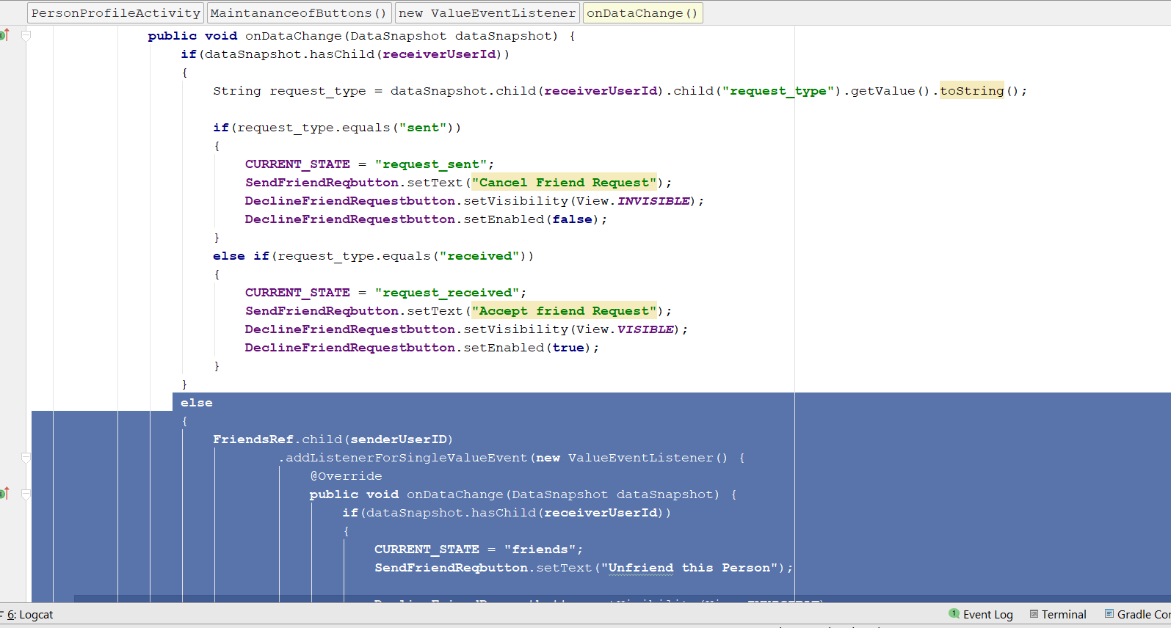
* Add this new code at here
* **DeclineFriendRequestbutton**.setOnClickListener(**new** View.OnClickListener() {  
   @Override  
   **public void** onClick(View v) {  
   CancelFriendRequest();  
   }  
  });
* 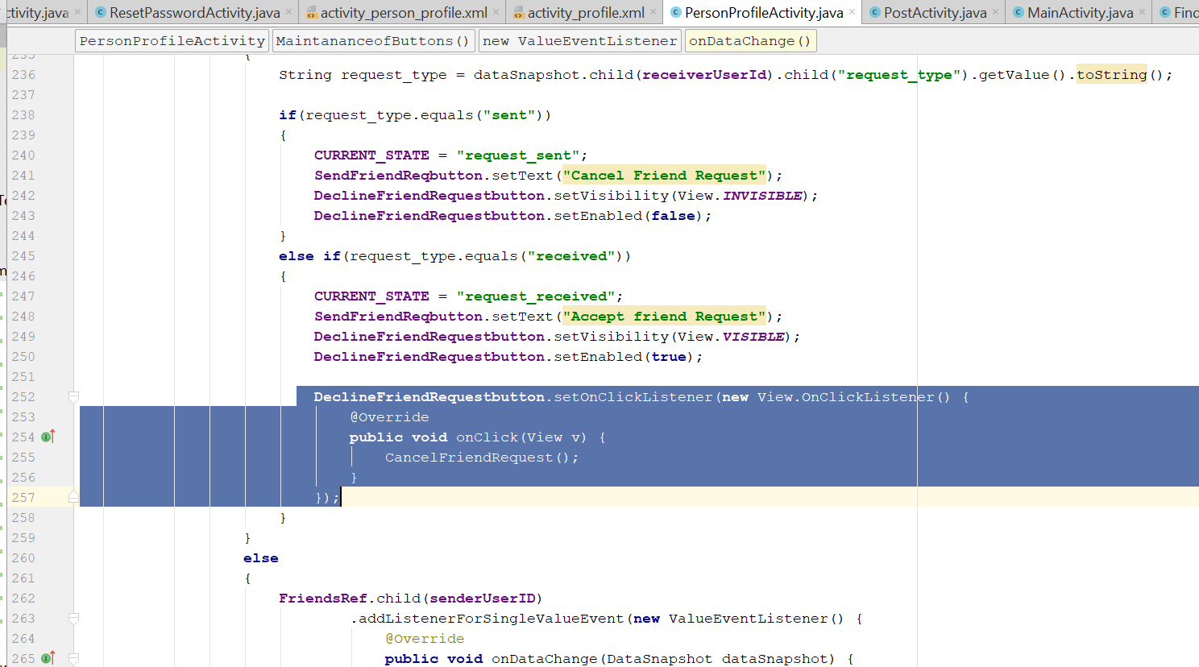
* In the SendFriendReqbutton.setOnClickListener
* Add this condition
* **if**(**CURRENT_STATE**.equals(**"friends"**))  
  {  
   UnfriendAnExistingFriend();  
  }
* 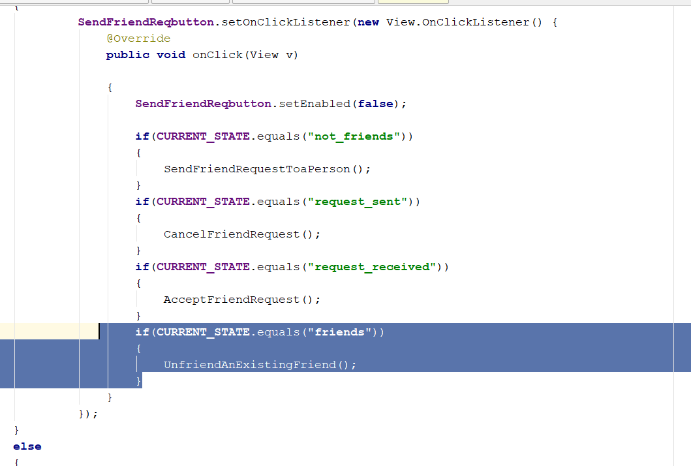
* Create a new method call UnfriendAnExistingFriend();
* **private void** UnfriendAnExistingFriend() {  
   **FriendsRef**.child(**senderUserID**).child(**receiverUserId**)  
   .removeValue()  
   .addOnCompleteListener(**new** OnCompleteListener<Void>() {  
   @Override  
   **public void** onComplete(@NonNull Task<Void> task) {  
   **if**(task.isSuccessful())  
   {  
   **FriendsRef**.child(**receiverUserId**).child(**senderUserID**)  
   .removeValue()  
   .addOnCompleteListener(**new** OnCompleteListener<Void>() {  
   @Override  
   **public void** onComplete(@NonNull Task<Void> task) {  
   **if**(task.isSuccessful())  
   {  
   **SendFriendReqbutton**.setEnabled(**true**);  
   **CURRENT_STATE** = **"not_friends"**;  
   **SendFriendReqbutton**.setText(**"send Friend Request"**);  
    
   **DeclineFriendRequestbutton**.setVisibility(View.***INVISIBLE***);  
   **DeclineFriendRequestbutton**.setEnabled(**false**);  
   }  
   }  
   });  
   }  
   }  
   });  
    
  }
* rebuild and run, now you are able to cancel/decline friend request

# FriendList

* Create new activity>empty activity
* Call it FriendsActivity
* 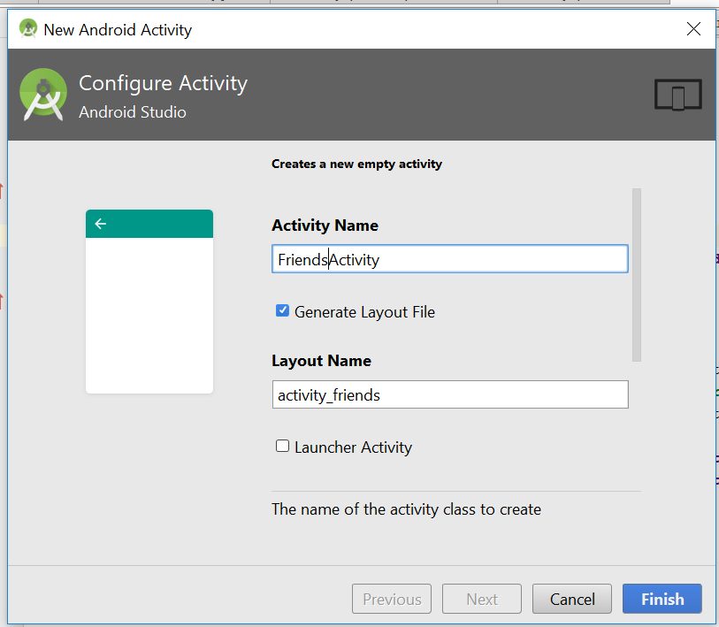
* Go to activity_friends.xml
* Change the layout to this
* *<?*xml version="1.0" encoding="utf-8"*?>*<RelativeLayout xmlns:android="http://schemas.android.com/apk/res/android"  
   xmlns:app="http://schemas.android.com/apk/res-auto"  
   xmlns:tools="http://schemas.android.com/tools"  
   android:layout_width="match_parent"  
   android:layout_height="match_parent"  
   android:background="@color/colorProfile"  
   tools:context="com.example.ryan.socialnetwork.FriendsActivity">  
    
  </RelativeLayout>
* Now drag and drop a textView to the layout
* The layout_width should be match parent
* 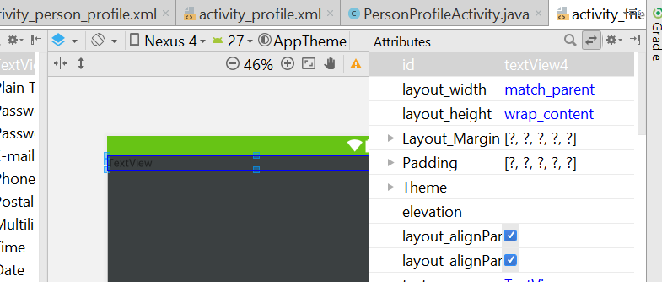
* The Text View, the property of the TextView change to this
* <TextView  
   android:id="@+id/all_friends"  
   android:layout_width="match_parent"  
   android:layout_height="wrap_content"  
   android:layout_alignParentTop="true"  
   android:layout_centerHorizontal="true"  
   android:textColor="@android:color/background_light"  
   android:textSize="25sp"  
   android:textStyle="bold"  
   android:textAlignment="center"  
   android:text="Friends" />
* You should see something like this
* 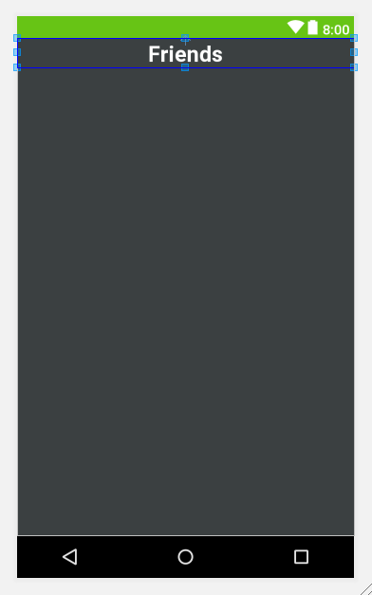
* Now drag and drop a recycleView in the layout
* 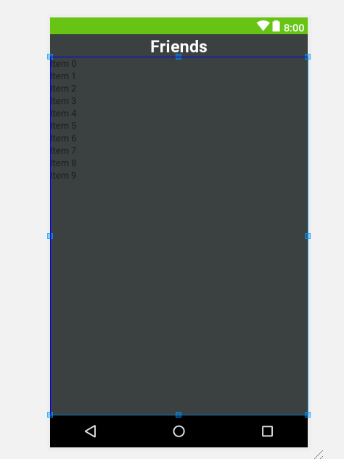
* Now go the TEXT view and change the property of the recycleView
* <android.support.v7.widget.RecyclerView  
   android:id="@+id/friend_list"  
   android:layout_width="match_parent"  
   android:layout_height="match_parent"  
   android:layout_alignParentStart="true"  
   android:layout_below="@+id/all_friends"  
   android:layout_margin="15dp"/>
* Now create a new class – Friends.java
* This will be code for the Friends class
* **package** com.example.ryan.socialnetwork;  
    
  */**  
   * Created by Ryan on 1/6/2019.  
   */***public class** Friends {  
    
   **public** String **date**;  
    
   **public** Friends(String date) {  
   **this**.**date** = date;  
   }  
    
   **public** Friends()  
   {  
    
   }  
    
   **public** String getDate() {  
   **return date**;  
   }  
    
   **public void** setDate(String date) {  
   **this**.**date** = date;  
   }  
  }
* Now go to FriendsActivity.java
* Add in those code
* **package** com.example.ryan.socialnetwork;  
    
  **import** android.support.v7.app.AppCompatActivity;  
  **import** android.os.Bundle;  
  **import** android.support.v7.widget.LinearLayoutManager;  
  **import** android.support.v7.widget.RecyclerView;  
  **import** android.view.View;  
    
  **public class** FriendsActivity **extends** AppCompatActivity {  
    
   **private** RecyclerView **myFriendList**;  
   @Override  
   **protected void** onCreate(Bundle savedInstanceState) {  
   **super**.onCreate(savedInstanceState);  
   setContentView(R.layout.***activity_friends***);  
    
   **myFriendList** = (RecyclerView)findViewById(R.id.***friend_list***);  
   **myFriendList**.setHasFixedSize(**true**);  
   LinearLayoutManager linearLayoutManager = **new** LinearLayoutManager(**this**);  
   linearLayoutManager.setReverseLayout(**true**);  
   linearLayoutManager.setStackFromEnd(**true**);  
   **myFriendList**.setLayoutManager(linearLayoutManager);  
   }  
    
   **public static class** FriendsViewHolder **extends** RecyclerView.ViewHolder  
   {  
   View **mView**;  
    
   **public** FriendsViewHolder(View itemView) {  
   **super**(itemView);  
   **mView** = itemView;  
   }  
   }  
  }
* Declare those on top
* private DatabaseReference FriendsRef, UsersRef;  
  private FirebaseAuth mAuth;  
  private String online_user_id;
* 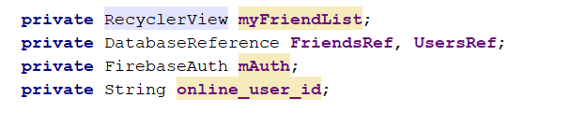
* Add this in the onCreate()
* **mAuth** = FirebaseAuth.*getInstance*();  
  **online_user_id** = **mAuth**.getCurrentUser().getUid();  
  **FriendsRef** = FirebaseDatabase.*getInstance*().getReference().child(**"Friends"**).child(**online_user_id**);  
  **UsersRef** = FirebaseDatabase.*getInstance*().getReference().child(**"Users"**);
* add this new method
* DisplayAllFriends();
* 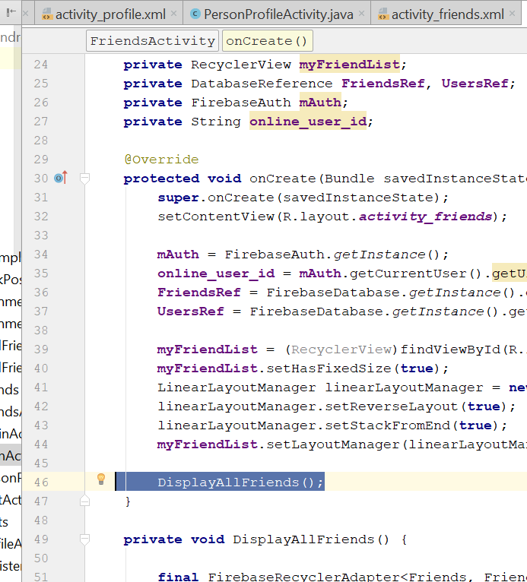
* Add this new method outside
* **private void** DisplayAllFriends() {  
    
   **final** FirebaseRecyclerAdapter<Friends, FriendsViewHolder> firebaseRecyclerAdapter  
   = **new** FirebaseRecyclerAdapter<Friends, FriendsViewHolder>  
   (  
   Friends.**class**,  
   R.layout.***all_users_display_layout***,  
   FriendsViewHolder.**class**,  
   **FriendsRef** ) {  
   @Override  
   **protected void** populateViewHolder(**final** FriendsViewHolder viewHolder, Friends model, **int** position) {  
    
   viewHolder.setDate(model.getDate());  
    
   **final** String usersIDS = getRef(position).getKey();  
   **UsersRef**.child(usersIDS).addListenerForSingleValueEvent(**new** ValueEventListener() {  
   @Override  
   **public void** onDataChange(DataSnapshot dataSnapshot) {  
   **if**(dataSnapshot.exists())  
   {  
   **final** String userName = dataSnapshot.child(**"fullname"**).getValue().toString();  
   **final** String profileImage = dataSnapshot.child(**"profileimage"**).getValue().toString();

viewHolder.setFullName(userName);

viewHolder.setProfileImage(getApplicationContext(),profileImage);  
  
 }  
 }  
  
 @Override  
 **public void** onCancelled(DatabaseError databaseError) {  
  
 }  
 });  
 }  
 };  
 **myFriendList**.setAdapter(firebaseRecyclerAdapter);  
}

* in the FriendViewHolder(), add this

**public void** setProfileImage(Context ctx, String profileImage) {  
  
 CircleImageView myImage = (CircleImageView) **mView**.findViewById(R.id.***all_user_profile_image***);  
 Picasso.*get*().load(profileImage).placeholder(R.drawable.***profile***).into(myImage);  
  
}  
**public void** setFullName(String fullname){  
 TextView myName = (TextView) **mView**.findViewById(R.id.***all_user_profile_full_name***);  
 myName.setText(fullname);  
}  
**public void** setDate(String date){  
 TextView friendsDate = (TextView) **mView**.findViewById(R.id.***all_user_status***);  
 friendsDate.setText(**"Friends Since: "** +date);  
}

* 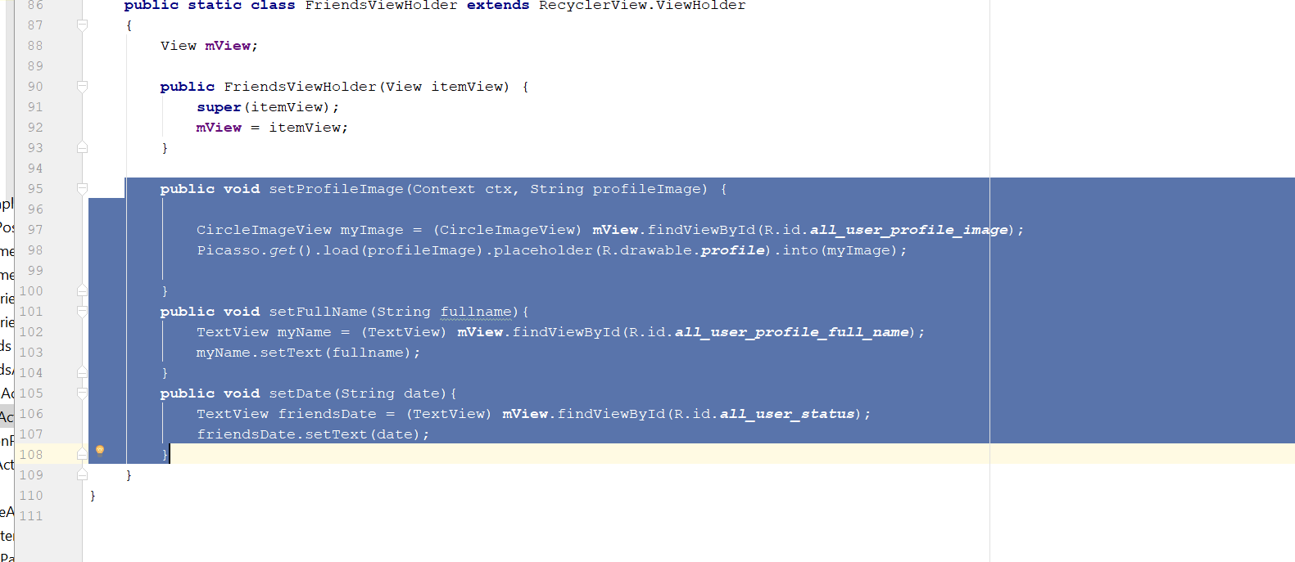
* Now go to the MainActivity.java
* Add this new method
* **private void** SendUserToFriendsActivity() {  
   Intent friendsIntent = **new** Intent(MainActivity.**this**,FriendsActivity.**class**);  
   startActivity(friendsIntent);  
    
  }
* 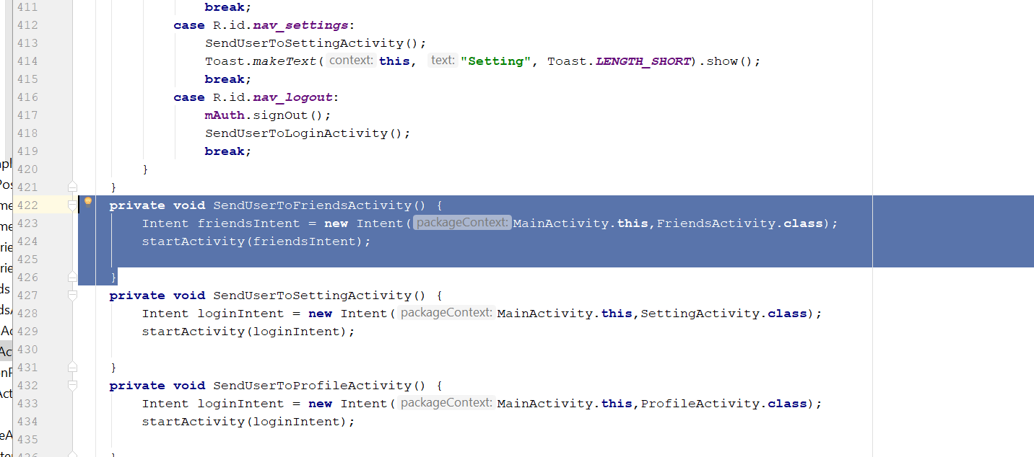
* Add this new method here
* 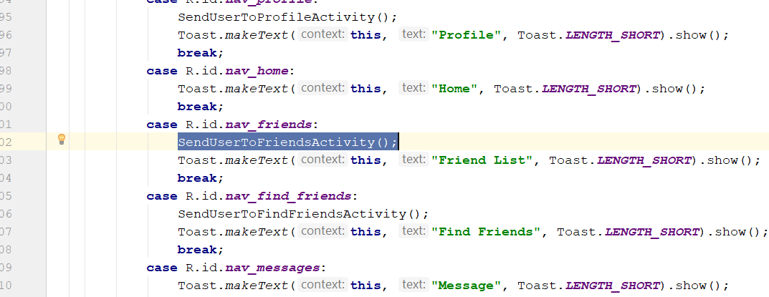
* Rebuild and run
* Tap on the Friends button, shld see the friend name
* Now work on the alert dialog box
* Create a new EmptyActivity> chatActivity
* Now go to the FriendsActivity.java
* Add this code
* viewHolder.**mView**.setOnClickListener(**new** View.OnClickListener() {  
   @Override  
   **public void** onClick(View v) {  
   CharSequence options[] = **new** CharSequence[]  
   {  
   userName + **"'s Profile"**,  
   **"Send Message"** };  
   AlertDialog.Builder builder = **new** AlertDialog.Builder(FriendsActivity.**this**);  
   builder.setTitle(**"Select Option"**);  
   builder.setItems(options, **new** DialogInterface.OnClickListener() {  
   @Override  
   **public void** onClick(DialogInterface dialog, **int** which) {  
   **if**(which == 0)  
   {  
   Intent profileintent = **new** Intent(FriendsActivity.**this**, PersonProfileActivity.**class**);  
   profileintent.putExtra(**"visit_user_id"**,usersIDS);  
   startActivity(profileintent);  
   }  
   **if**(which == 1)  
   {  
   Intent Chatintent = **new** Intent(FriendsActivity.**this**, ChatActivity.**class**);  
   Chatintent .putExtra(**"visit_user_id"**,usersIDS);  
   startActivity(Chatintent );  
   }  
   }  
   });  
   builder.show();  
   }  
  });
* add it here
* 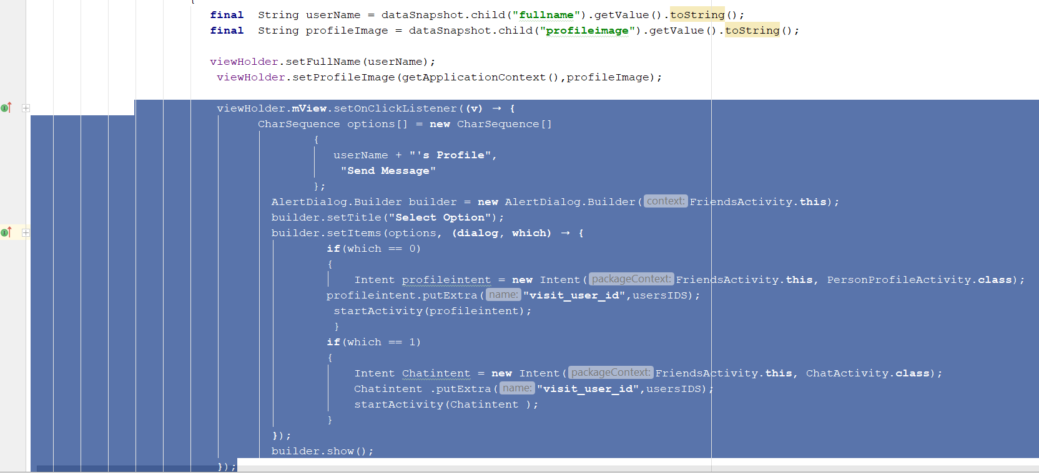
* Rebuild and run, u shld see a alert dialog box

# Chat Activity

* Go to activity_chat.xml
* Change the code to this
* *<?*xml version="1.0" encoding="utf-8"*?>*<RelativeLayout xmlns:android="http://schemas.android.com/apk/res/android"  
   xmlns:app="http://schemas.android.com/apk/res-auto"  
   xmlns:tools="http://schemas.android.com/tools"  
   android:layout_width="match_parent"  
   android:layout_height="match_parent"  
   tools:context="com.example.ryan.socialnetwork.ChatActivity">  
    
   <include  
   android:id="@+id/chat_bar_layout"  
   layout="@layout/app_bar_layout">  
    
   </include>  
  </RelativeLayout>
* Now drag and drop a recycleView to the xml
* 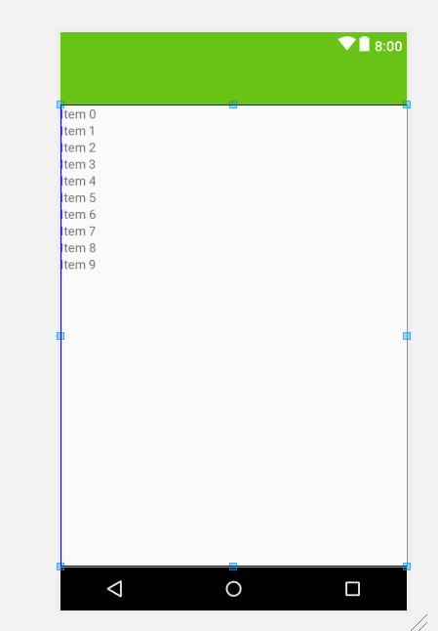
* Now go to the text View part
* Go to this link and download this 2 icon
* <https://drive.google.com/drive/folders/1WsxVHrmAU0XW34MPZ1YpJNnIS2HjyO9A>
* 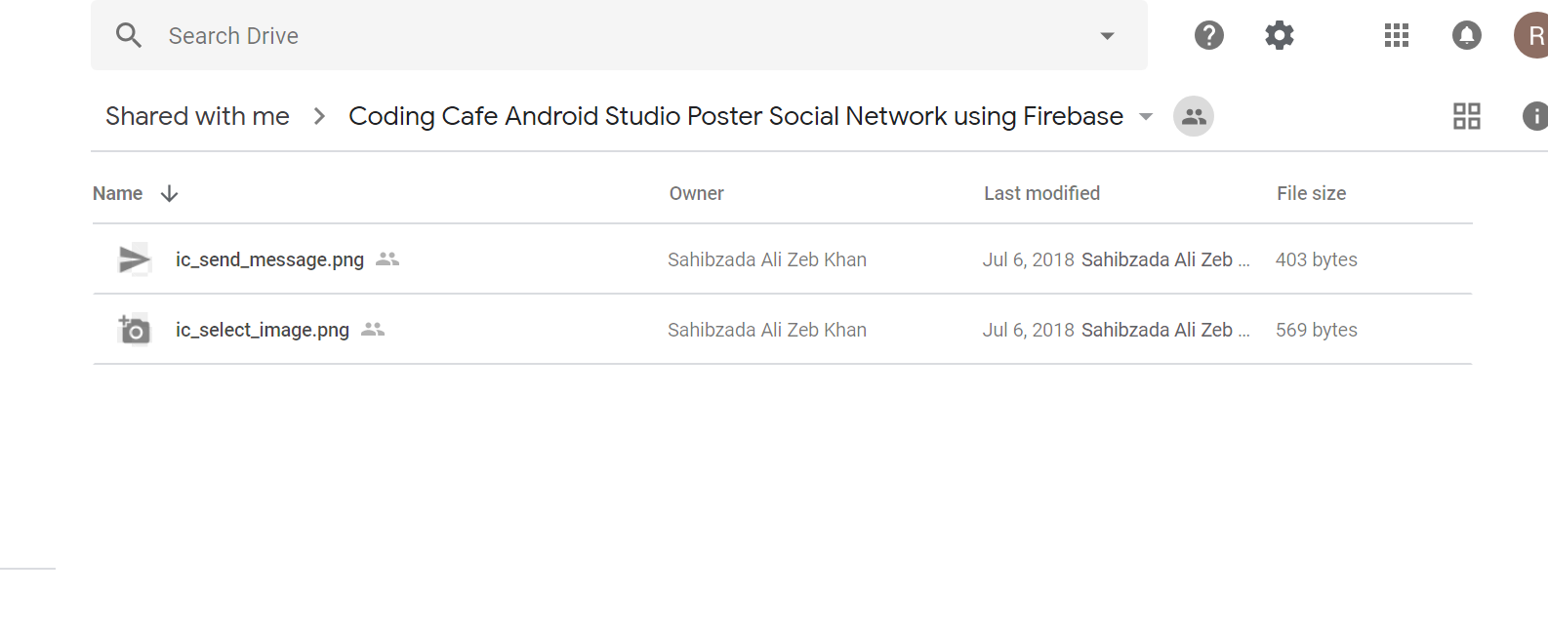
* Copy and paste into the drawable folder of android
* Then now edit the Text of the activity_chat.xml file
* *<?*xml version="1.0" encoding="utf-8"*?>*<RelativeLayout xmlns:android="http://schemas.android.com/apk/res/android"  
   xmlns:app="http://schemas.android.com/apk/res-auto"  
   xmlns:tools="http://schemas.android.com/tools"  
   android:layout_width="match_parent"  
   android:layout_height="match_parent"  
   tools:context="com.example.ryan.socialnetwork.ChatActivity">  
    
   <include  
   android:id="@+id/chat_bar_layout"  
   layout="@layout/app_bar_layout">  
    
   </include>  
    
   <android.support.v7.widget.RecyclerView  
   android:id="@+id/messages_list_users"  
   android:layout_width="match_parent"  
   android:layout_height="match_parent"  
   android:layout_above="@+id/myLinearLayout"  
   android:layout_alignParentStart="true"  
   android:layout_below="@+id/chat_bar_layout"  
   android:background="@android:color/darker_gray"  
   android:layout_centerHorizontal="true"  
   />  
   <LinearLayout  
   android:id="@+id/myLinearLayout"  
   android:layout_width="match_parent"  
   android:layout_height="wrap_content"  
   android:layout_alignParentBottom="true"  
   android:layout_alignParentStart="true"  
   android:background="@android:color/background_light"  
   android:orientation="horizontal"  
   >  
    
    
   <ImageButton  
   android:id="@+id/send_image_file_button"  
   android:layout_width="50dp"  
   android:layout_height="wrap_content"  
   android:src="@drawable/ic_select_image"/>  
   <EditText

android:id="@+id/input_message"  
 android:layout_width="280dp"  
 android:layout_height="wrap_content"  
 android:hint="write your message here..."  
 android:padding="17dp"  
  
 />  
 <ImageButton  
 android:id="@+id/send_message_button"  
 android:layout_width="50dp"  
 android:layout_height="wrap_content"  
 android:src="@drawable/ic_send_message"/>  
  
  
 </LinearLayout>  
</RelativeLayout>

* It should look something like this
* 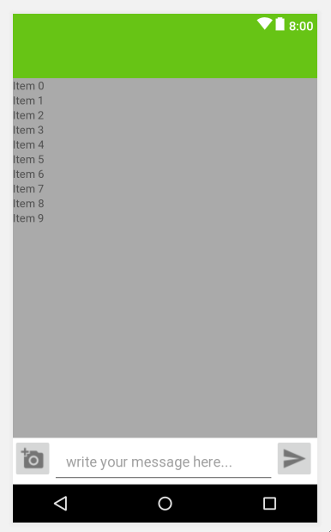
* Now go to ChatActivity.java, add in those code
* **package** com.example.ryan.socialnetwork;  
    
  **import** android.support.v7.app.AppCompatActivity;  
  **import** android.os.Bundle;  
  **import** android.support.v7.widget.RecyclerView;  
  **import** android.widget.EditText;  
  **import** android.widget.ImageButton;  
  **import** android.support.v7.widget.Toolbar;  
    
  **public class** ChatActivity **extends** AppCompatActivity {  
    
   **private** Toolbar **ChattoolBar**;  
   **private** ImageButton **SendMessageButton**, **SendImagefileButton**;  
   **private** EditText **userMessageInput**;  
   **private** RecyclerView **userMessagesList**;  
    
   **private** String **messageReceiverID**, **messageReceiverName**;  
    
   @Override  
   **protected void** onCreate(Bundle savedInstanceState) {  
   **super**.onCreate(savedInstanceState);  
   setContentView(R.layout.***activity_chat***);  
    
   **messageReceiverID** = getIntent().getExtras().get(**"visit_user_id"**).toString();  
   **messageReceiverName** = getIntent().getExtras().get(**"userName"**).toString();  
    
    
   InitializeFields();  
   }  
    
   **private void** InitializeFields() {  
   **ChattoolBar** = (Toolbar)findViewById(R.id.***chat_bar_layout***);  
   setSupportActionBar(**ChattoolBar**);  
    
   **SendMessageButton** = (ImageButton) findViewById(R.id.***send_message_button***);  
   **SendImagefileButton** = (ImageButton) findViewById(R.id.***send_image_file_button***);  
   **userMessageInput** = (EditText)findViewById(R.id.***input_message***);  
   }  
  }
* Now go to FriendsActivity.java, add in this line
* Chatintent .putExtra(**"username"**,userName);
* 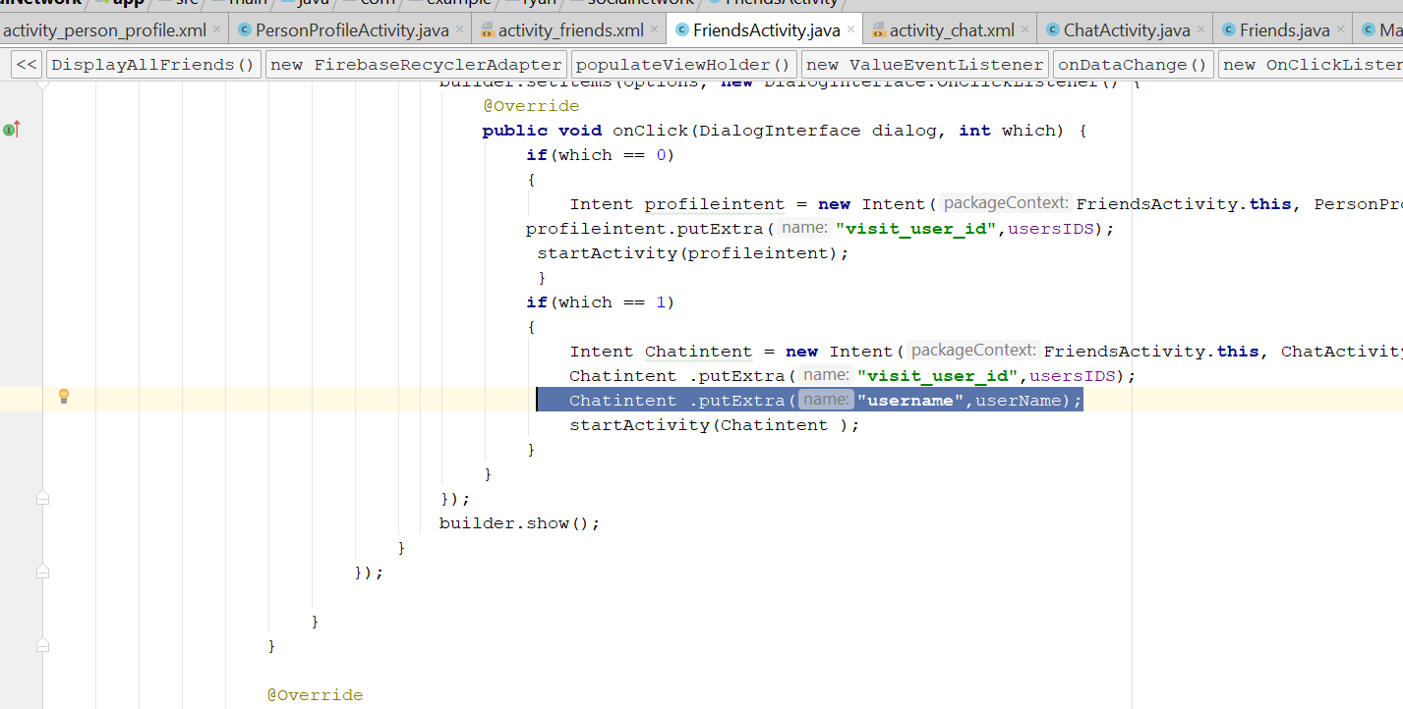
* Rebuild and run
* See if you see the chat activity
* Create new Layout Resource file, on the layout folder
* 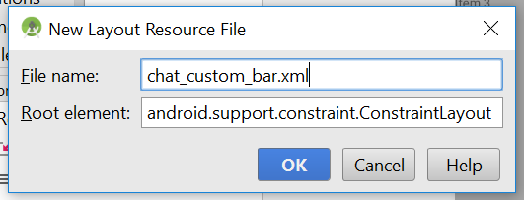
* Call it chat_custom_bar.xml
* Edit the TEXT of the chat_custom_bar.xml
* *<?*xml version="1.0" encoding="utf-8"*?>*<RelativeLayout  
   xmlns:android="http://schemas.android.com/apk/res/android" android:layout_width="match_parent"  
   android:layout_height="match_parent"  
   android:background="@color/colorPrimaryDark"  
   >  
    
   <de.hdodenhof.circleimageview.CircleImageView  
   android:layout_width="40dp"  
   android:layout_height="40dp"  
   android:id="@+id/custom_profile_image"  
   android:src="@drawable/profile"  
   android:layout_alignParentEnd="true"  
   android:layout_alignParentTop="true"  
   android:layout_marginRight="15dp"  
   android:cropToPadding="true"  
   />  
  <TextView  
   android:id="@+id/custom_profile_name"  
   android:layout_width="wrap_content"  
   android:layout_height="wrap_content"  
   android:text="display userName"  
   android:textColor="@android:color/background_light"  
   android:textSize="18sp"  
   android:layout_marginTop="8dp"  
   android:textStyle="bold"  
   android:layout_alignParentTop="true"  
   android:layout_alignParentStart="true"  
    
   />  
    
  </RelativeLayout>
* You will see this
* 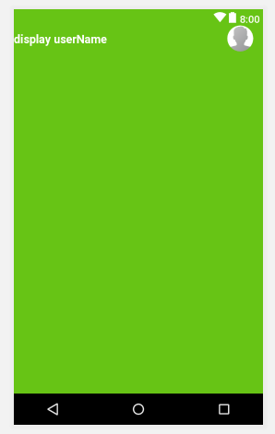
* Go to ChatActivity.java, declare this two variable
* private TextView receiverName;  
  private CircleImageView receiverProfileImage;
* 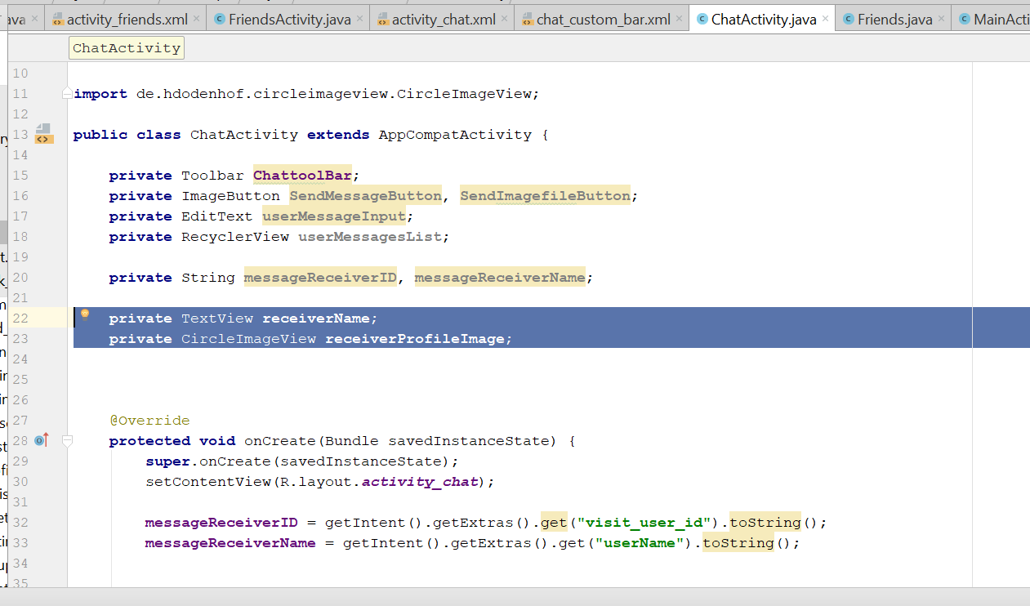
* then in the initializefield, add this
* **receiverName** = (TextView) findViewById(R.id.***custom_profile_name***);  
  **receiverProfileImage** = (CircleImageView) findViewById(R.id.***custom_profile_image***);
* 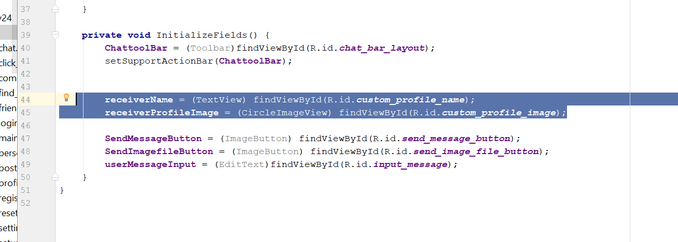
* Copy this code into the initialize field
* ActionBar actionBar = getSupportActionBar();  
  actionBar.setDisplayShowHomeEnabled(**true**);  
  actionBar.setDisplayShowCustomEnabled(**true**);  
  LayoutInflater layoutInflater = (LayoutInflater) **this**.getSystemService(Context.***LAYOUT_INFLATER_SERVICE***);  
  View action_bar_view = layoutInflater.inflate(R.layout.***chat_custom_bar***, **null**);  
  actionBar.setCustomView(action_bar_view);
* Now go to Android Manifest
* Add this line in the chatActivity
* android:parentActivityName=".MainActivity"
* 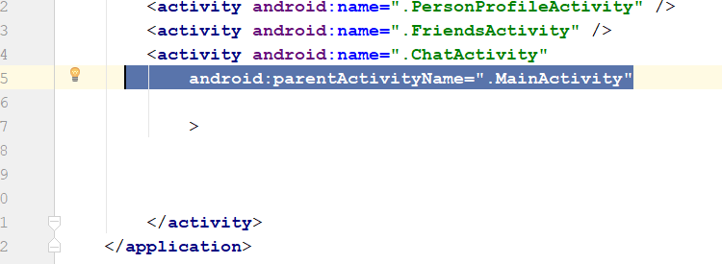
* Now go to chatActivity.java
* Create this new method
* **private void** DisplayReceiverInfo() {  
    
   **receiverName**.setText(**messageReceiverName**);  
   **RootRef**.child(**"Users"**).child(**messageReceiverID**).addValueEventListener(**new** ValueEventListener() {  
   @Override  
   **public void** onDataChange(DataSnapshot dataSnapshot) {  
   **final** String profileImage = dataSnapshot.child(**"profileimage"**).getValue().toString();  
   Picasso.*get*().load(profileImage).placeholder(R.drawable.***profile***).into(**receiverProfileImage**);  
   }  
    
   @Override  
   **public void** onCancelled(DatabaseError databaseError) {  
    
   }  
   });  
  }
* 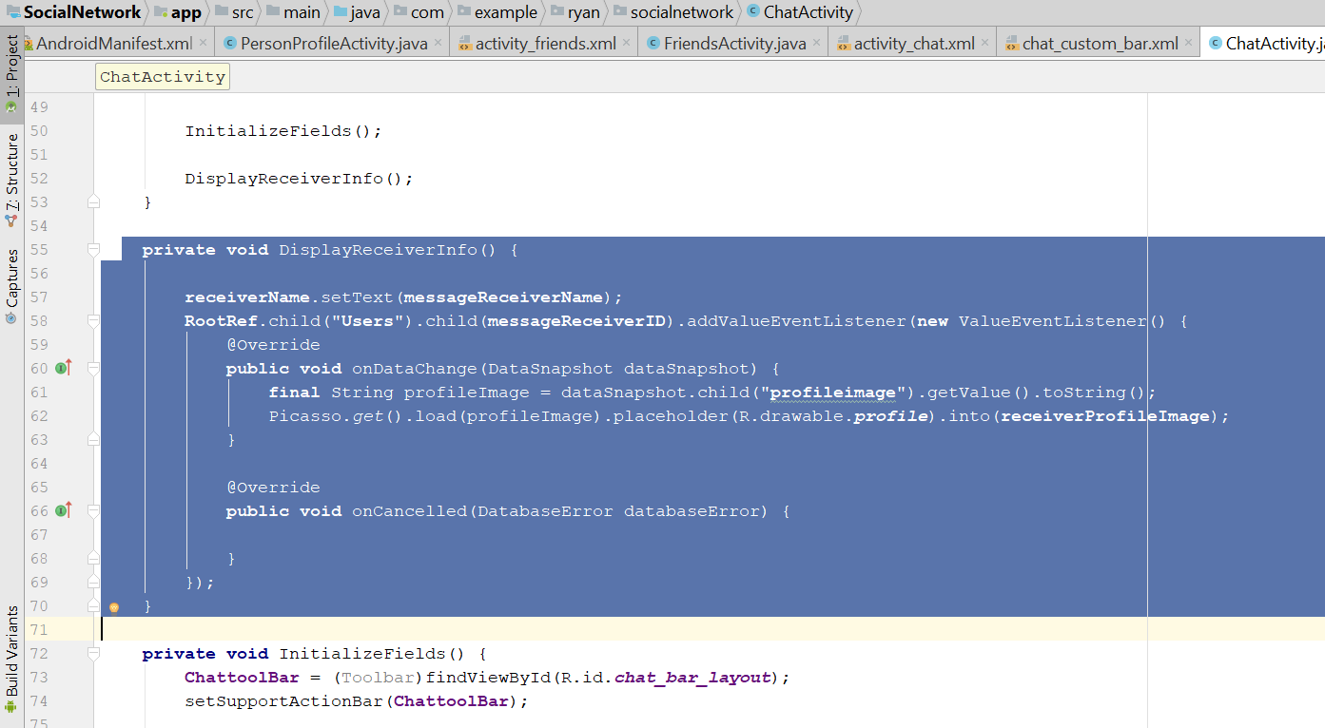
* Add this code into the onCreate()
* **RootRef** = FirebaseDatabase.*getInstance*().getReference();
* DisplayReceiverInfo();
* 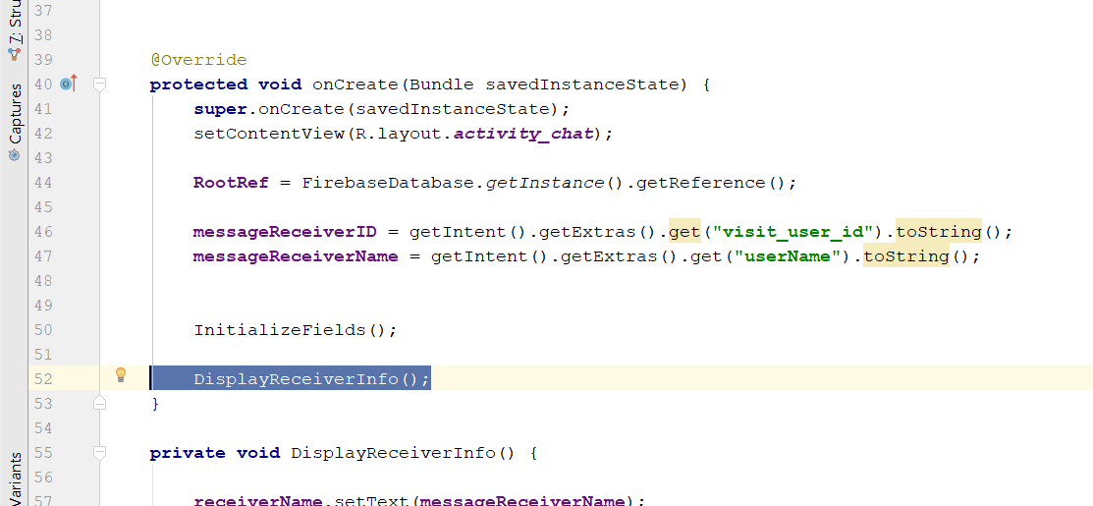
* Rebuild and run, you should see the friend image and name appear on the toolbar

# Send Chat Message

* Now go to ChatActivity.java
* Add this new variable
* messageSenderID, saveCurrentDate, saveCurrentTime;
* 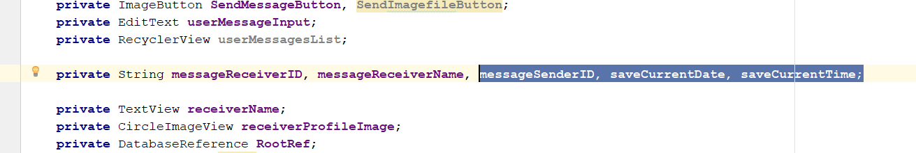
* Then add this line
* **private** FirebaseAuth **mAuth**;
* in the onCreate add this
* **mAuth** = FirebaseAuth.*getInstance*();  
  **messageSenderID** = **mAuth**.getCurrentUser().getUid();
* **SendMessageButton**.setOnClickListener(**new** View.OnClickListener() {  
   @Override  
   **public void** onClick(View v) {  
   SendMessage();  
   }  
  });
* Create the new method
* **private void** SendMessage() {  
   String messageText = **userMessageInput**.getText().toString();  
   **if**(TextUtils.*isEmpty*(messageText))  
   {  
   Toast.*makeText*(**this**,**"Please type a message first..."**, Toast.***LENGTH_SHORT***).show();  
   }  
   **else** {  
   String message_sender_ref = **"Message/"** + **messageSenderID** + **"/"** + **messageReceiverID**;  
   String message_receiver_ref = **"Message/"** + **messageReceiverID** + **"/"** + **messageSenderID** ;  
    
   DatabaseReference user_message_key = **RootRef**.child(**"Messages"**).child(**messageSenderID**)  
   .child(**messageReceiverID**).push();  
   String message_push_id = user_message_key.getKey();  
    
   Calendar calFordDate = Calendar.*getInstance*();  
   SimpleDateFormat currentDate = **new** SimpleDateFormat(**"dd-MMM-yyyy"**);  
   **saveCurrentDate** = currentDate.format(calFordDate.getTime());  
    
   Calendar calFordTime = Calendar.*getInstance*();  
   SimpleDateFormat currentTime = **new** SimpleDateFormat(**"HH:mm aa"**);  
   **saveCurrentTime** = currentTime.format(calFordDate.getTime());  
    
   Map messageTextBody = **new** HashMap();  
   messageTextBody.put(**"message"**, messageText);  
   messageTextBody.put(**"time"**, **saveCurrentTime**);  
   messageTextBody.put(**"date"**, **saveCurrentDate**);  
   messageTextBody.put(**"type"**, **"text"**);  
   messageTextBody.put(**"from"**, **messageSenderID**);  
    
   Map messageBodyDetails = **new** HashMap();  
   messageBodyDetails.put(message_sender_ref + **"/"**+ message_push_id, messageTextBody);  
   messageBodyDetails.put(message_receiver_ref + **"/"**+ message_push_id, messageTextBody);  
    
    
   **RootRef**.updateChildren(messageBodyDetails).addOnCompleteListener(**new** OnCompleteListener() {  
   @Override  
   **public void** onComplete(@NonNull Task task) {  
   **if**(task.isSuccessful())  
   {  
   Toast.*makeText*(ChatActivity.**this**, **"Message sent successfully"**, Toast.***LENGTH_SHORT***).show();  
   }  
   **else** {  
   String message = task.getException().getMessage();  
   Toast.*makeText*(ChatActivity.**this**, **"Error: "**+ message, Toast.***LENGTH_SHORT***).show();  
   }  
    
   **userMessageInput**.setText(**""**);  
   }  
   });  
   }  
  }
* rebuild and run, now u try send message, u shld see something like this in Firebase
* 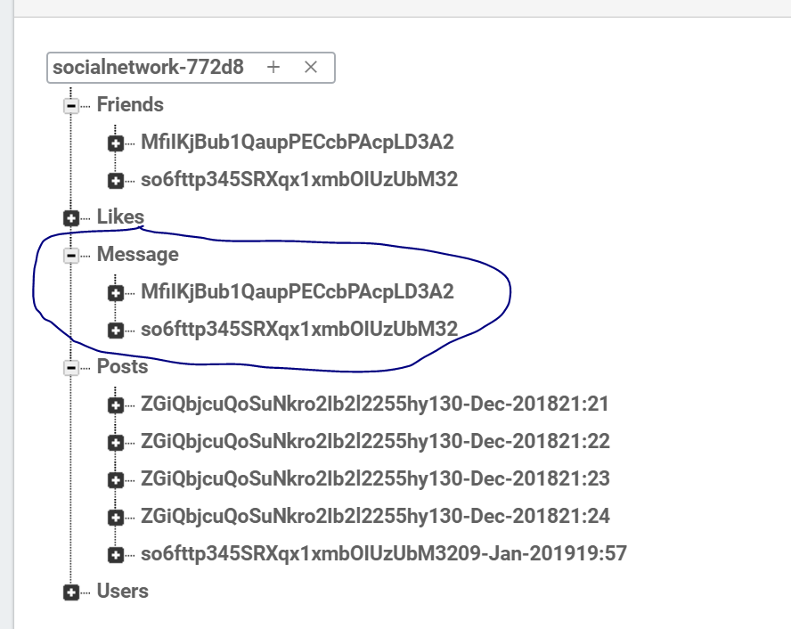
* Now Create a beautiful professional layout
* Now go to color.xml
* 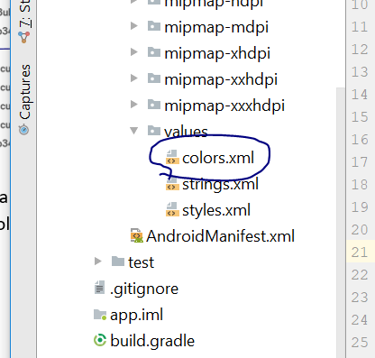
* Add this line
* <color name="sendercolor">#A0179E</color>
* Now drawable folder> new> drawable resources file
* Call it “sender_message_text_background.xml”
* 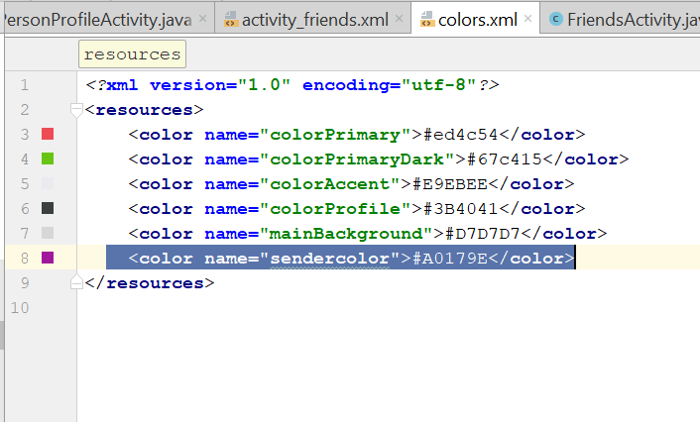
* Now on the TEXT
* Change to this
* *<?*xml version="1.0" encoding="utf-8"*?>*<shape xmlns:android="http://schemas.android.com/apk/res/android">  
    
   <solid android:color="@color/sendercolor"></solid>  
    
   <corners android:radius="15dp"></corners>  
  </shape>
* 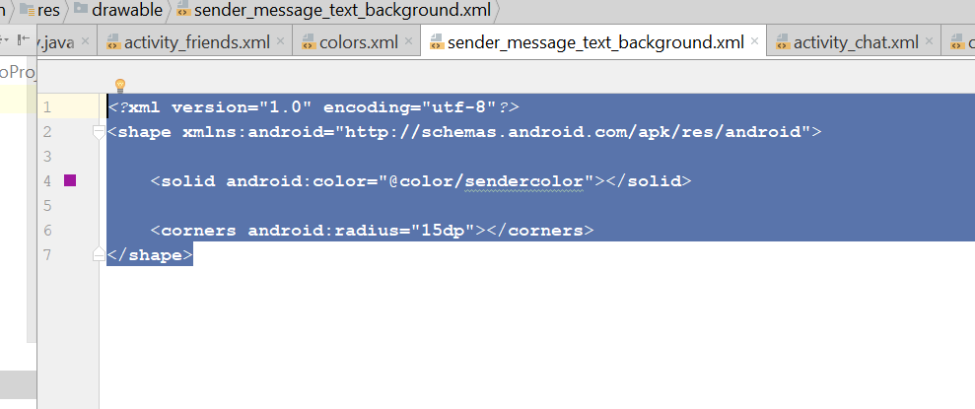
* Now create new xml, in the drawable folder > new drawable resources file
* Receiver_message_text_background.xml
* Change the Text to this
* *<?*xml version="1.0" encoding="utf-8"*?>*<shape xmlns:android="http://schemas.android.com/apk/res/android">  
    
   <solid android:color="@color/colorPrimary">  
    
   </solid>  
    
   <corners android:radius="15dp"></corners>  
    
  </shape>
* 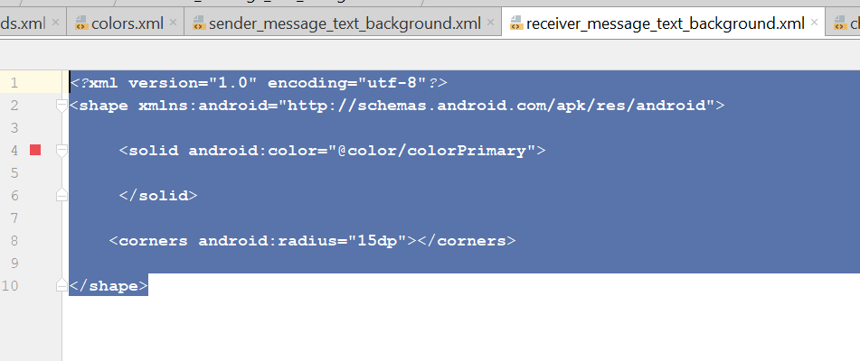
* Now go to layout>new layout resources file> message_layout_of_users.xml
* 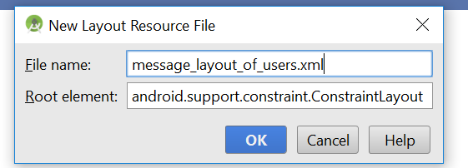
* Edit the text to this
* *<?*xml version="1.0" encoding="utf-8"*?>*<RelativeLayout  
   xmlns:android="http://schemas.android.com/apk/res/android" android:layout_width="match_parent"  
   android:layout_height="wrap_content">  
    
   <de.hdodenhof.circleimageview.CircleImageView  
   android:id="@+id/message_profile_image"  
   android:layout_width="50dp"  
   android:layout_height="40dp"  
   android:src="@drawable/profile"  
   />  
   <TextView  
   android:id="@+id/receiver_message_text"  
   android:layout_width="wrap_content"  
   android:layout_height="wrap_content"  
   android:layout_alignParentTop="true"  
   android:layout_marginTop="2dp"  
   android:layout_toEndOf="@+id/message_profile_image"  
   android:background="@drawable/receiver_message_text_background"  
   android:text="receiver message"  
   android:textColor="@android:color/background_light"  
   android:padding="10dp"  
   android:textSize="14sp"  
   android:textStyle="bold"  
   />  
    
   <TextView  
   android:id="@+id/sender_message_text"  
   android:layout_width="wrap_content"  
   android:layout_height="wrap_content"  
   android:layout_alignParentEnd="true"  
   android:layout_marginTop="2dp"  
   android:layout_alignParentTop="@+id/receiver_message_text"  
   android:background="@drawable/sender_message_text_background"  
   android:text="receiver message"  
   android:textColor="@android:color/background_light"  
   android:padding="10dp"  
   android:textSize="14sp"  
   android:textStyle="bold"  
   />  
  </RelativeLayout>
* You should see something like this
* 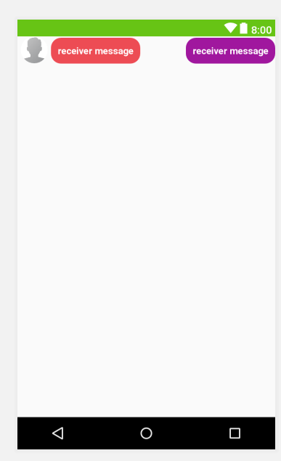
* Create a new class
* Call it messages
* 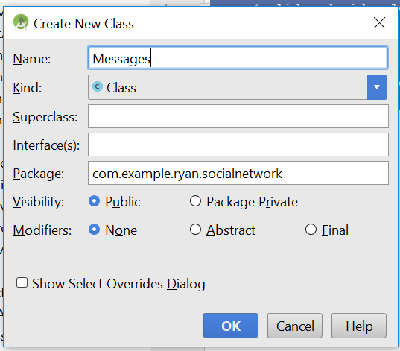
* This is the code of the Messages class
* **package** com.example.ryan.socialnetwork;  
    
  */**  
   * Created by Ryan on 1/26/2019.  
   */***public class** Messages {  
    
   **public** String **data**, **time**, **type**, **message**, **from**;  
   **public** Messages()  
   {  
    
   }  
    
   **public** Messages(String data, String time, String type, String message, String from) {  
   **this**.**data** = data;  
   **this**.**time** = time;  
   **this**.**type** = type;  
   **this**.**message** = message;  
   **this**.**from** = from;  
   }  
    
   **public** String getData() {  
   **return data**;  
   }  
    
   **public void** setData(String data) {  
   **this**.**data** = data;  
   }  
    
   **public** String getTime() {  
   **return time**;  
   }  
    
   **public void** setTime(String time) {  
   **this**.**time** = time;  
   }  
    
   **public** String getType() {  
   **return type**;  
   }  
    
   **public void** setType(String type) {  
   **this**.**type** = type;  
   }  
    
   **public** String getMessage() {  
   **return message**;  
   }  
    
   **public void** setMessage(String message) {  
   **this**.**message** = message;  
   }  
    
   **public** String getFrom() {  
   **return from**;  
   }  
    
   **public void** setFrom(String from) {  
   **this**.**from** = from;  
   }  
  }
* Now create another class
* MessagesAdapter
* 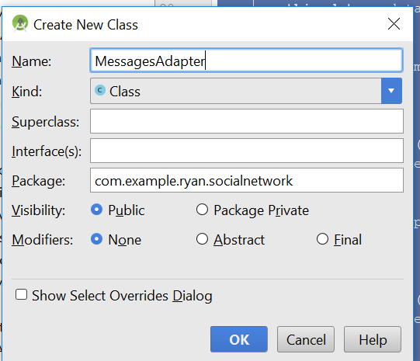
* This is the code in the class
* **package** com.example.ryan.socialnetwork;  
    
  **import** android.graphics.Color;  
  **import** android.support.annotation.NonNull;  
  **import** android.support.v7.widget.RecyclerView;  
  **import** android.view.Gravity;  
  **import** android.view.LayoutInflater;  
  **import** android.view.View;  
  **import** android.view.ViewGroup;  
  **import** android.widget.TextView;  
    
  **import** com.google.firebase.auth.FirebaseAuth;  
  **import** com.google.firebase.database.DataSnapshot;  
  **import** com.google.firebase.database.DatabaseError;  
  **import** com.google.firebase.database.DatabaseReference;  
  **import** com.google.firebase.database.FirebaseDatabase;  
  **import** com.google.firebase.database.ValueEventListener;  
  **import** com.squareup.picasso.Picasso;  
    
  **import** java.util.List;  
    
  **import** de.hdodenhof.circleimageview.CircleImageView;  
    
  */**  
   * Created by Ryan on 1/26/2019.  
   */***public class** MessagesAdapter **extends** RecyclerView.Adapter<MessagesAdapter.MessageViewHolder> {  
    
   **private** List<Messages> **userMessagesList**;  
   **private** FirebaseAuth **mAuth**;  
   **private** DatabaseReference **userDatabaseRef**;  
    
   **public** MessagesAdapter (List<Messages> userMessagesList)  
   {  
   **this**.**userMessagesList** = userMessagesList;  
   }  
    
   **public class** MessageViewHolder **extends** RecyclerView.ViewHolder {  
    
   **public** TextView **SenderMessageText**, **ReceiverMessageText**;  
   **public** CircleImageView **receiverProfileImage**;  
    
   **public** MessageViewHolder(View itemView) {  
    
    
   **super**(itemView);  
   **SenderMessageText** = (TextView) itemView.findViewById(R.id.***sender_message_text***);  
   **ReceiverMessageText** = (TextView) itemView.findViewById(R.id.***receiver_message_text***);  
   **receiverProfileImage** = (CircleImageView) itemView.findViewById(R.id.***message_profile_image***);  
   }  
   }  
    
   @NonNull  
   @Override  
   **public** MessageViewHolder onCreateViewHolder(@NonNull ViewGroup parent, **int** viewType) {  
   View v = LayoutInflater.*from*(parent.getContext())  
   .inflate(R.layout.***message_layout_of_users***, parent, **false**);  
   **mAuth** = FirebaseAuth.*getInstance*();  
   **return new** MessageViewHolder(v);  
   }  
    
   @Override  
   **public void** onBindViewHolder(@NonNull **final** MessageViewHolder holder, **int** position) {  
   String messageSenderID = **mAuth**.getCurrentUser().getUid();  
   Messages messages = **userMessagesList**.get(position);  
    
   String fromUserID = messages.getFrom();  
   String fromMessageType = messages.getType();  
    
   **userDatabaseRef** = FirebaseDatabase.*getInstance*().getReference().child(**"Users"**).child(fromUserID);  
   **userDatabaseRef**.addValueEventListener(**new** ValueEventListener() {  
   @Override  
   **public void** onDataChange(DataSnapshot dataSnapshot) {  
   **if**(dataSnapshot.exists())  
   {  
   String image = dataSnapshot.child(**"profileimage"**).getValue().toString();  
   Picasso.*get*().load(image)  
   .placeholder(R.drawable.***profile***).into(holder.**receiverProfileImage**);  
    
   }  
   }  
    
   @Override  
   **public void** onCancelled(DatabaseError databaseError) {  
    
   }  
   });  
    
   **if**(fromMessageType.equals(**"text"**))  
   {  
   holder.**ReceiverMessageText**.setVisibility(View.***INVISIBLE***);  
   holder.**receiverProfileImage**.setVisibility(View.***INVISIBLE***);  
    
   **if**(fromUserID.equals(messageSenderID))  
   {  
   holder.**SenderMessageText**.setBackgroundResource(R.drawable.***sender_message_text_background***);  
   holder.**SenderMessageText**.setTextColor(Color.***WHITE***);  
   holder.**SenderMessageText**.setGravity(Gravity.***LEFT***);  
   holder.**SenderMessageText**.setText(messages.getMessage());  
   }  
   **else** {  
   holder.**SenderMessageText**.setVisibility(View.***INVISIBLE***);  
    
   holder.**ReceiverMessageText**.setVisibility(View.***VISIBLE***);  
   holder.**receiverProfileImage**.setVisibility(View.***VISIBLE***);  
    
   holder.**ReceiverMessageText**.setBackgroundResource(R.drawable.***receiver_message_text_background***);  
   holder.**ReceiverMessageText**.setTextColor(Color.***WHITE***);  
   holder.**ReceiverMessageText**.setGravity(Gravity.***LEFT***);  
   holder.**ReceiverMessageText**.setText(messages.getMessage());  
   }  
    
   }  
    
   }  
    
   @Override  
   **public int** getItemCount() {  
   **return userMessagesList**.size();  
   }  
  }
* Now go to chatActivity.java
* First add in this few variable
* private final List<Messages> messagesList = new ArrayList<>();  
  private LinearLayoutManager linearLayoutManager;  
  private MessagesAdapter messagesAdapter;
* In the onCreate(), add in this
* FetchMessages();
* 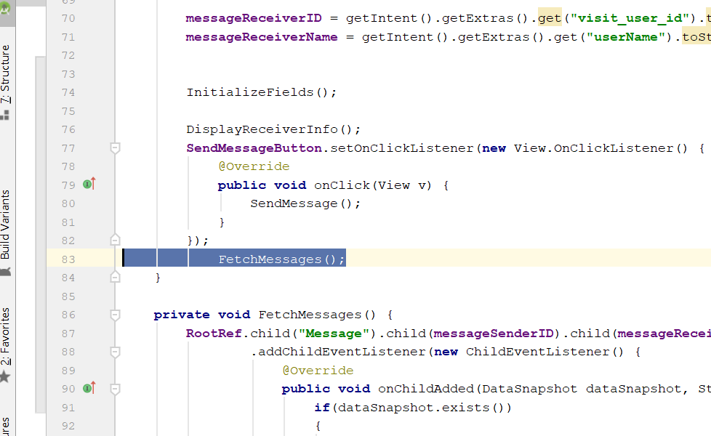
* Then add this FetchMessages() method
* **private void** FetchMessages() {  
   **RootRef**.child(**"Message"**).child(**messageSenderID**).child(**messageReceiverID**)  
   .addChildEventListener(**new** ChildEventListener() {  
   @Override  
   **public void** onChildAdded(DataSnapshot dataSnapshot, String s) {  
   **if**(dataSnapshot.exists())  
   {  
   Messages messages = dataSnapshot.getValue(Messages.**class**);  
   **messagesList**.add(messages);  
   **messagesAdapter**.notifyDataSetChanged();  
   }  
   }  
    
   @Override  
   **public void** onChildChanged(DataSnapshot dataSnapshot, String s) {  
    
   }  
    
   @Override  
   **public void** onChildRemoved(DataSnapshot dataSnapshot) {  
    
   }  
    
   @Override  
   **public void** onChildMoved(DataSnapshot dataSnapshot, String s) {  
    
   }  
    
   @Override  
   **public void** onCancelled(DatabaseError databaseError) {  
    
   }  
   });  
  }
* Then go to InitializeFields()
* Add this few line
* messagesAdapter = new MessagesAdapter(messagesList);  
  userMessagesList = (RecyclerView)findViewById(R.id.*messages_list_users*);  
  linearLayoutManager = new LinearLayoutManager(this);  
  userMessagesList.setHasFixedSize(true);  
  userMessagesList.setLayoutManager(linearLayoutManager);  
  userMessagesList.setAdapter(messagesAdapter);
* 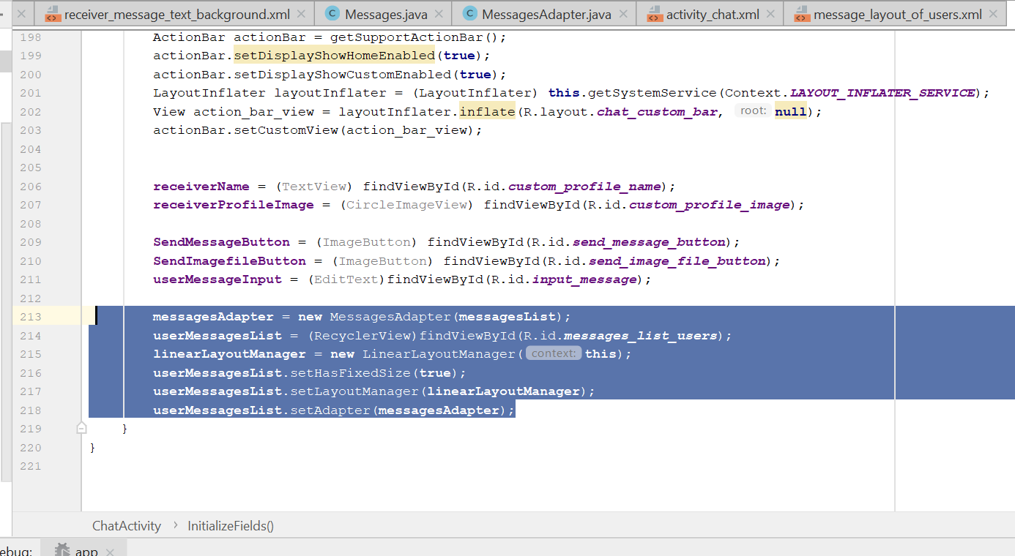
* Now go to private void SendMessage()
* Change to this
* 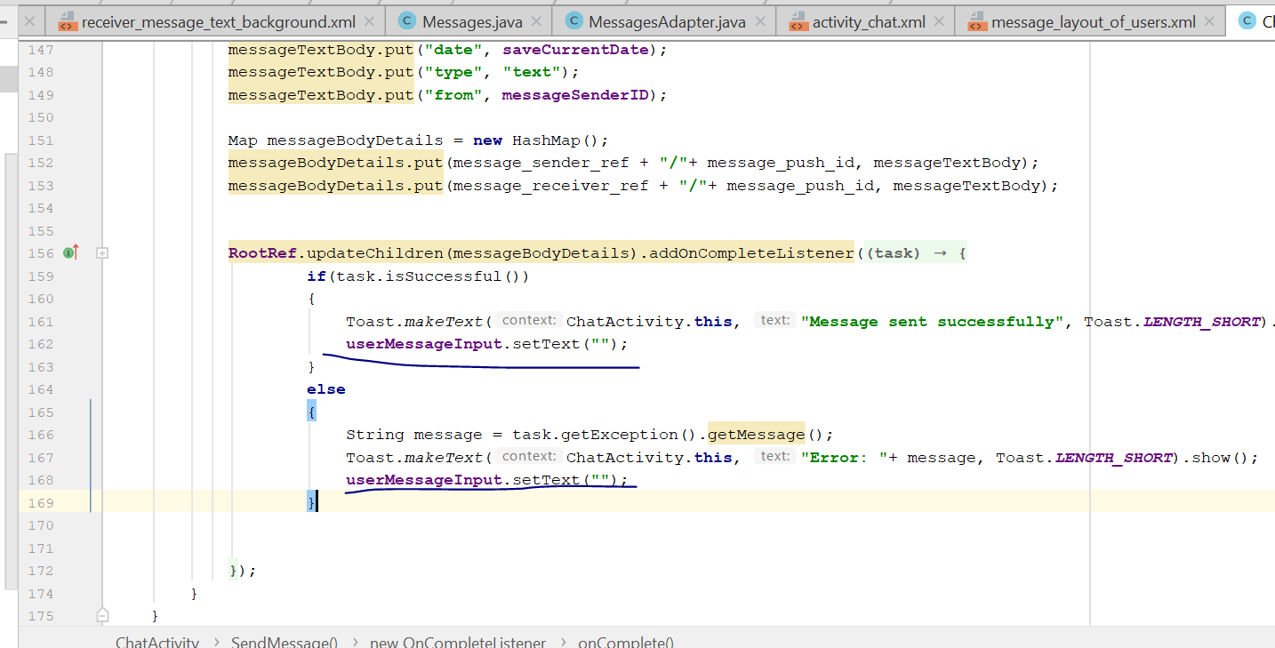
* Rebuild and run, now you should see chatting bubble showing when u chat

# Display total Number of Friend a user has

* Go to activity_profile.xml
* Go to Text
* Add this line
* <Button  
   android:id="@+id/my_post_button"  
   android:layout_width="170dp"  
   android:layout_height="wrap_content"  
   android:layout_alignParentBottom="true"  
   android:layout_alignParentStart="true"  
   android:layout_marginStart="20dp"  
   android:layout_marginTop="50dp"  
   android:text="Posts"  
   android:layout_below="@+id/my_relationship_status"  
   android:background="@color/colorPrimaryDark"  
   android:textSize="16sp"  
   android:textColor="@android:color/background_light"  
   android:textStyle="bold"  
    
  />  
  <Button  
   android:id="@+id/my_friends_button"  
   android:layout_width="170dp"  
   android:layout_height="wrap_content"  
   android:layout_alignParentBottom="true"  
   android:layout_alignParentEnd="true"  
   android:layout_marginEnd="20dp"  
   android:layout_marginTop="50dp"  
   android:text="No of Friends"  
   android:layout_below="@+id/my_relationship_status"  
   android:background="@color/colorPrimaryDark"  
   android:textSize="16sp"  
   android:textColor="@android:color/background_light"  
   android:textStyle="bold"  
    
   />
* You will see something like this
* 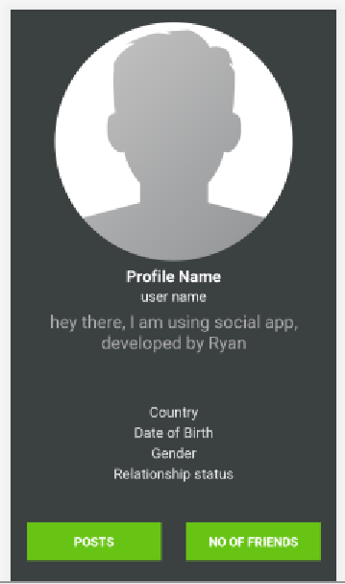
* Now go to profileactivity.java
* Declare on top these two variables
* private Button MyPosts, MyFriends;
* 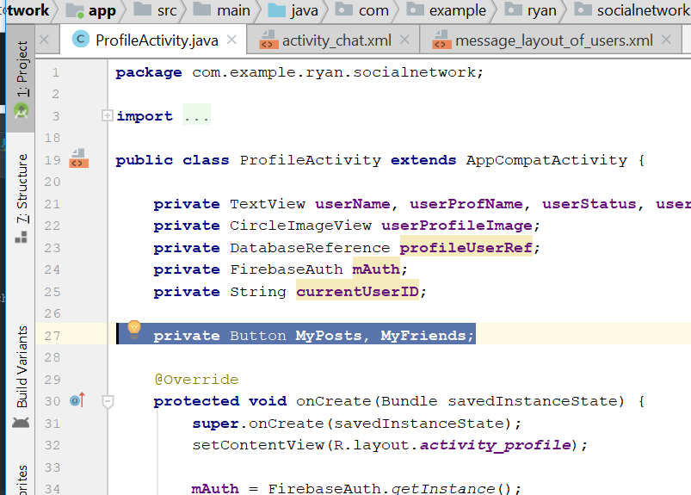
* Now create a new Activity call myPostActivity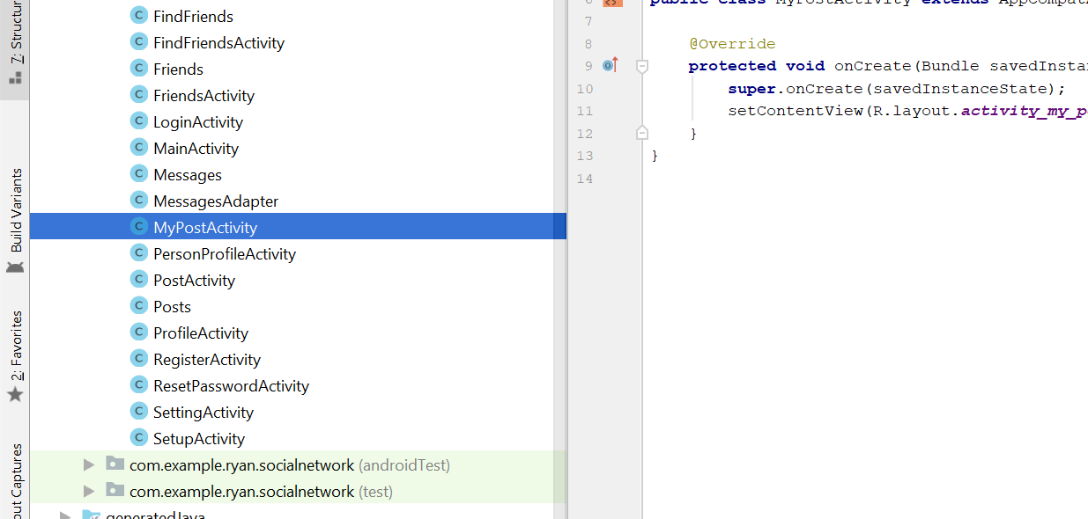
* Add this two code below the ProfileActivity.java
* **private void** SendUserToFriendsActivity() {  
   Intent friendsIntent = **new** Intent(ProfileActivity.**this**,FriendsActivity.**class**);  
   startActivity(friendsIntent);  
    
  }  
    
  **private void** SendUserToMyPostsActivity() {  
   Intent friendsIntent = **new** Intent(ProfileActivity.**this**,MyPostActivity.**class**);  
   startActivity(friendsIntent);  
    
  }
* 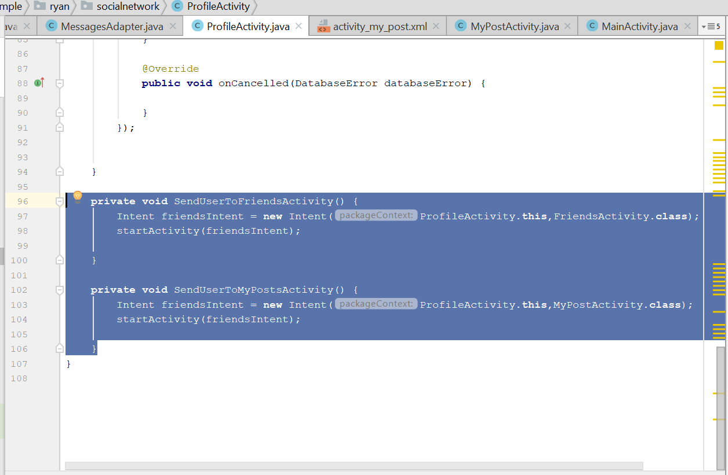
* In the onCreate()
* Add this
* **MyFriends** = (Button)findViewById(R.id.***my_friends_button***);  
  **MyPosts** = (Button) findViewById(R.id.***my_post_button***);  
    
  **MyFriends**.setOnClickListener(**new** View.OnClickListener() {  
   @Override  
   **public void** onClick(View v) {  
   SendUserToFriendsActivity();  
   }  
  });  
  **MyPosts**.setOnClickListener(**new** View.OnClickListener() {  
   @Override  
   **public void** onClick(View v) {  
   SendUserToMyPostsActivity();  
   }  
  });
* 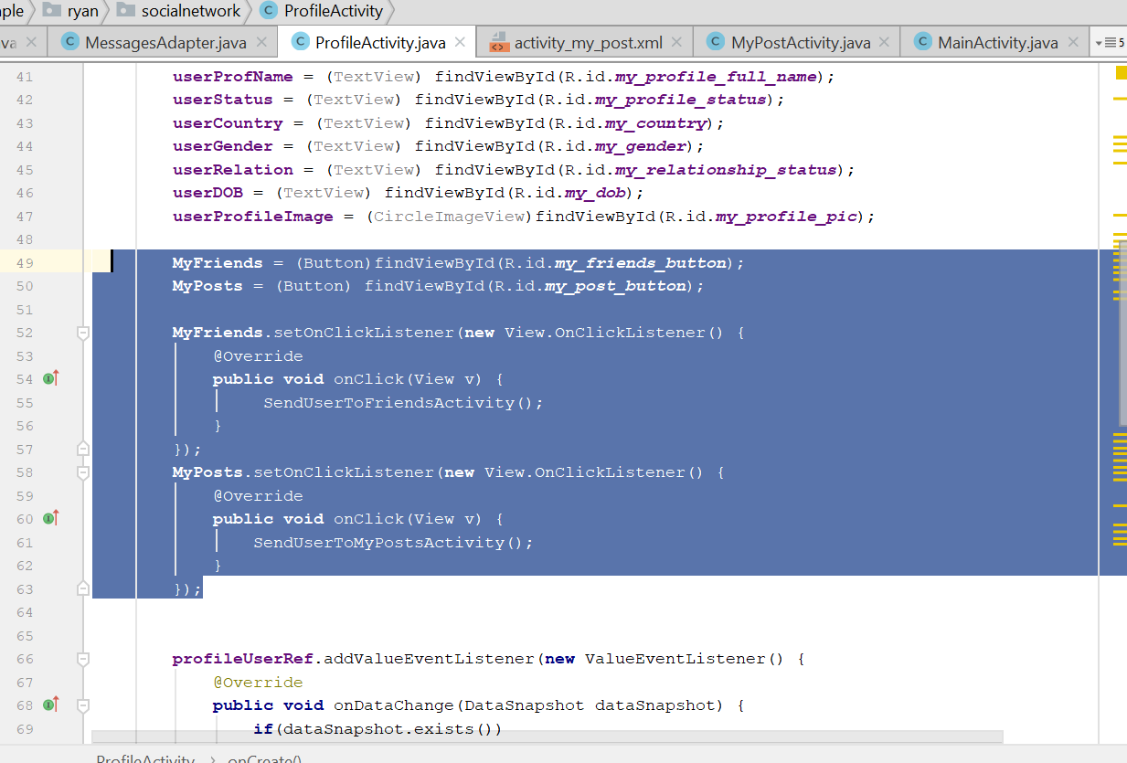
* Rebuild and run
* No of friend button will show the friends list
* Now go to ProfileActivity.java
* Add this new line
* private DatabaseReference profileUserRef, FriendsRef;
* 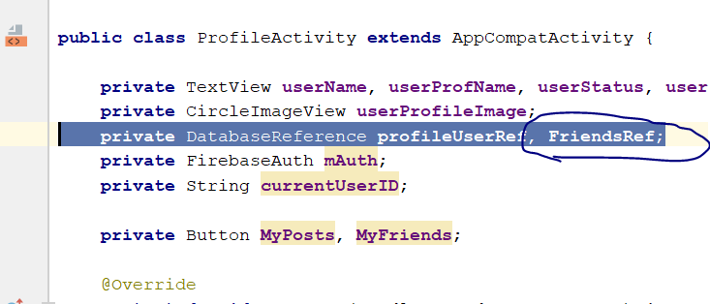
* Declare this line
* private int countFriends = 0;
* in the onCreate(), add this
* **FriendsRef** = FirebaseDatabase.*getInstance*().getReference().child(**"Friends"**);
* **PostsRef**.orderByChild(**"uid"**)  
   .startAt(**currentUserID**)  
   .addValueEventListener(**new** ValueEventListener() {  
   @Override  
   **public void** onDataChange(DataSnapshot dataSnapshot) {  
    
   **if**(dataSnapshot.exists())  
   {  
   **countPosts** = (**int**)dataSnapshot.getChildrenCount();  
   **MyPosts**.setText(Integer.*toString*(**countPosts**)+**" Posts"**);  
   }  
   **else** {  
   **MyPosts**.setText(**"0 Posts"**);  
   }  
   }  
    
   @Override  
   **public void** onCancelled(DatabaseError databaseError) {  
    
   }  
   });
* 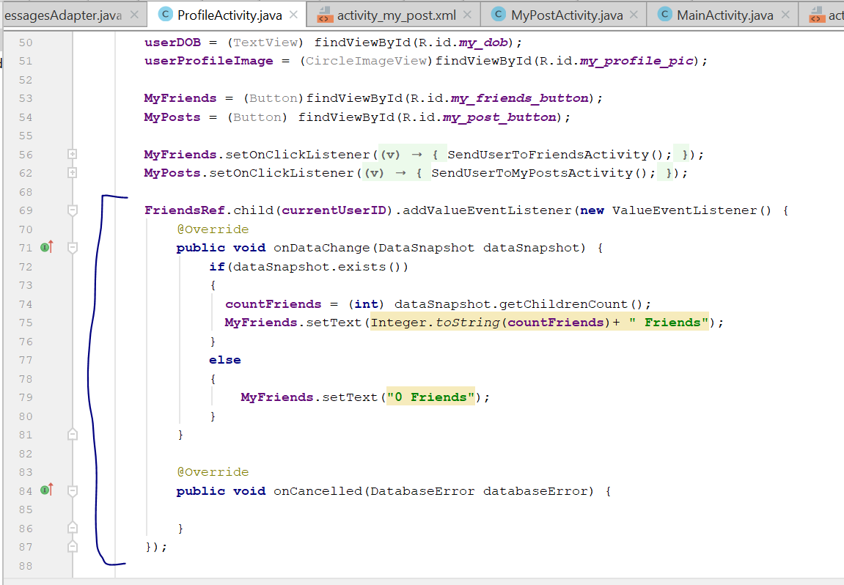
* Rebuild and run, you see the number of friend appear on the myFriend Button

# Display total number of posts a user has

* Add this new line
* private DatabaseReference PostsRef;
* 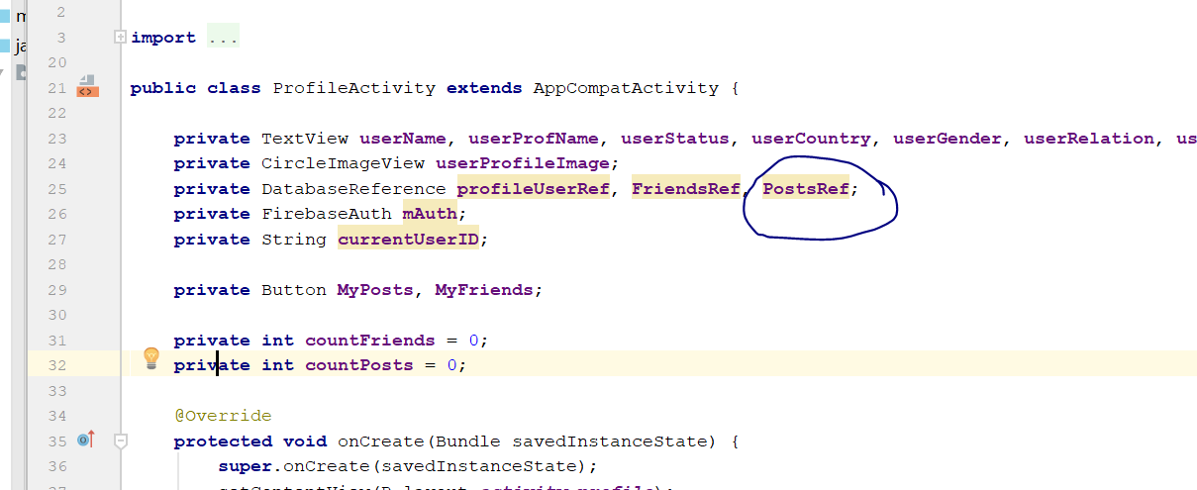
* Add this
* **private int countPosts** = 0;
* 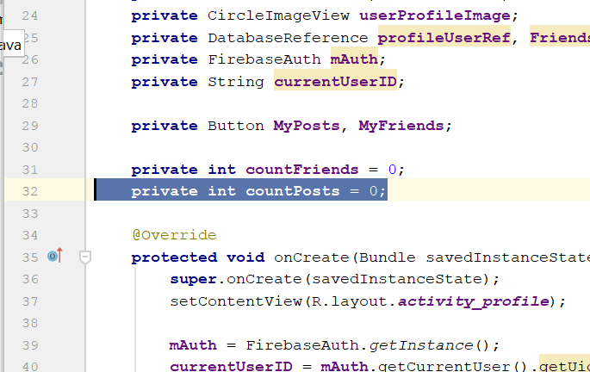
* In the onCreate(), add this
* **PostsRef** = FirebaseDatabase.*getInstance*().getReference().child(**"Posts"**);
* **MyPosts** = (Button) findViewById(R.id.***my_post_button***);
* 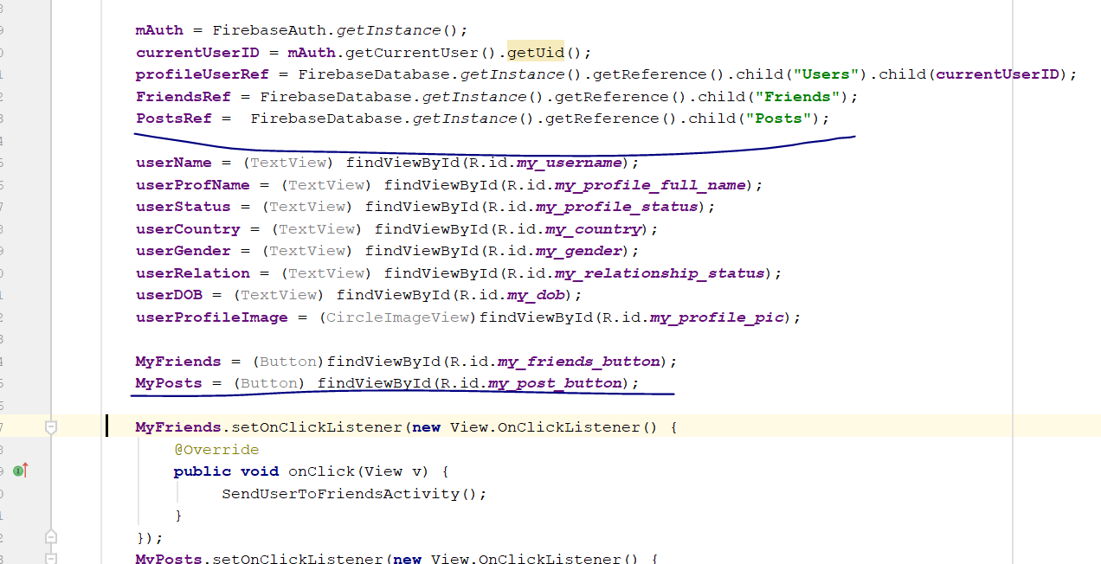
* Then add this method below
* **PostsRef**.child(**currentUserID**).orderByChild(**"uid"**)  
   .startAt(**currentUserID**).endAt(**currentUserID**+**"\uf8ff"**)  
   .addValueEventListener(**new** ValueEventListener() {  
   @Override  
   **public void** onDataChange(DataSnapshot dataSnapshot) {  
    
   **if**(dataSnapshot.exists())  
   {  
   **countPosts** = (**int**)dataSnapshot.getChildrenCount();  
   **MyPosts**.setText(Integer.*toString*(**countPosts**)+**" Posts"**);  
   }  
   **else** {  
   **MyPosts**.setText(**"0 Posts"**);  
   }  
   }  
    
   @Override  
   **public void** onCancelled(DatabaseError databaseError) {  
    
   }  
   });
* 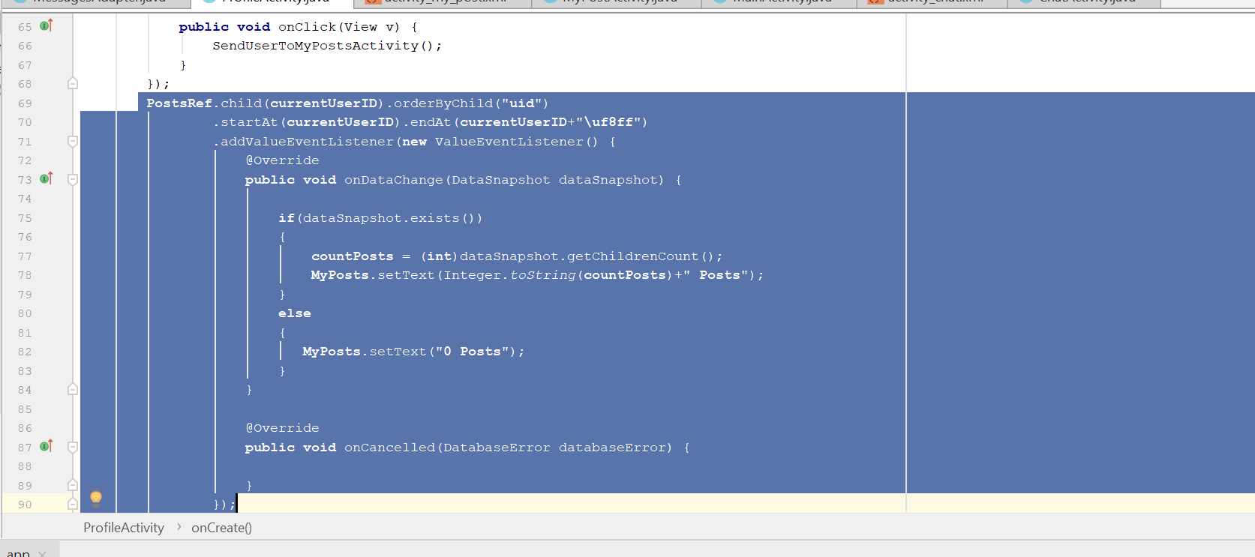
* Rebuild and run
* Now go to Activity_my_post.xml
* Add those code
* *<?***xml version="1.0" encoding="utf-8"***?>*<**RelativeLayout xmlns:android="http://schemas.android.com/apk/res/android"  
   xmlns:app="http://schemas.android.com/apk/res-auto"  
   xmlns:tools="http://schemas.android.com/tools"  
   android:layout_width="match_parent"  
   android:layout_height="match_parent"  
   tools:context=".MyPostActivity"**>  
    
   <**include  
   layout="@layout/app_bar_layout"  
   android:id="@+id/my_post_bar_layout"** >  
    
   </**include**>  
    
  </**RelativeLayout**>
* Now go to MyPostActivity.java
* **package** com.example.ryan.socialnetwork;  
    
  **import** android.support.v7.app.AppCompatActivity;  
  **import** android.os.Bundle;  
  **import** android.support.v7.widget.Toolbar;  
    
  **public class** MyPostActivity **extends** AppCompatActivity {  
    
   **private** Toolbar **mToolbar**;  
   @Override  
   **protected void** onCreate(Bundle savedInstanceState) {  
   **super**.onCreate(savedInstanceState);  
   setContentView(R.layout.***activity_my_post***);  
    
   **mToolbar** = (Toolbar) findViewById(R.id.***my_post_bar_layout***);  
   setSupportActionBar(**mToolbar**);  
   getSupportActionBar().setDisplayHomeAsUpEnabled(**true**);  
   getSupportActionBar().setDisplayShowHomeEnabled(**true**);  
   getSupportActionBar().setTitle(**"My Posts"**);  
   }  
  }
* now go to androidManifest.xml
* change the activity code to this
* <**activity android:name=".MyPostActivity"  
   android:parentActivityName=".MainActivity"** ></**activity**>
* 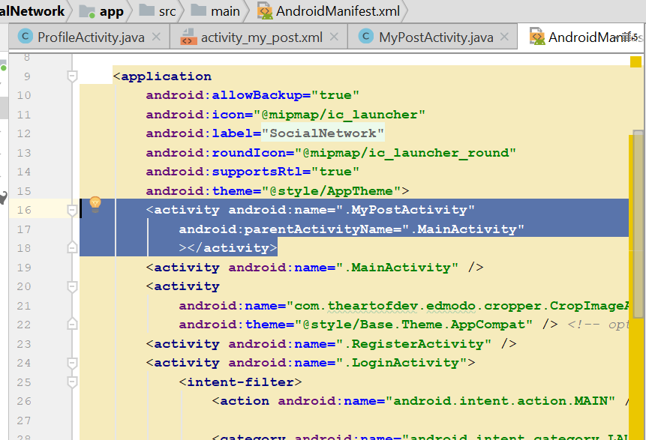
* Rebuild and run, the post button shld be working
* Now go to activity_my_post.xml, drag and drop a recycleView
* 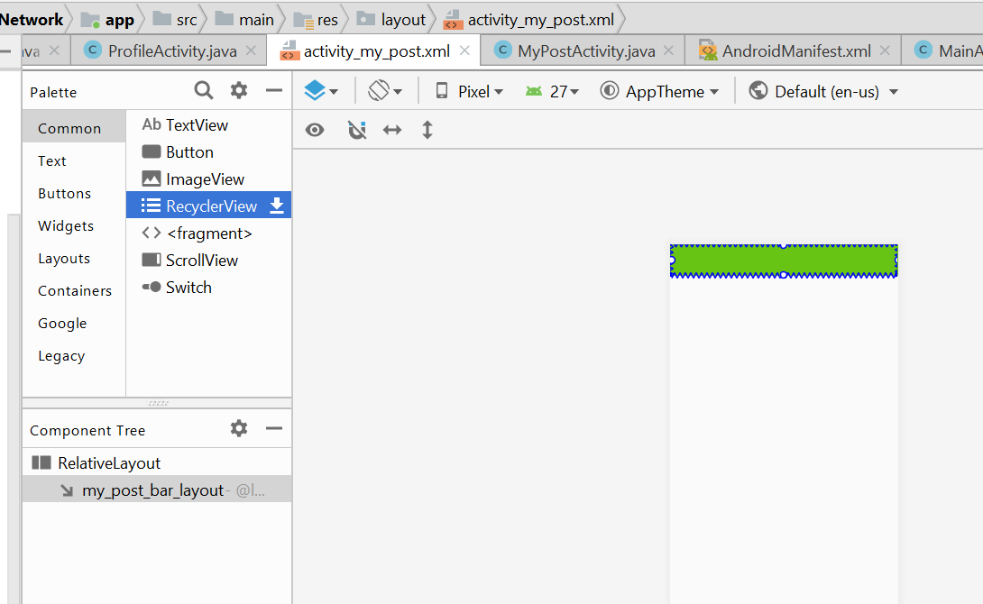
* 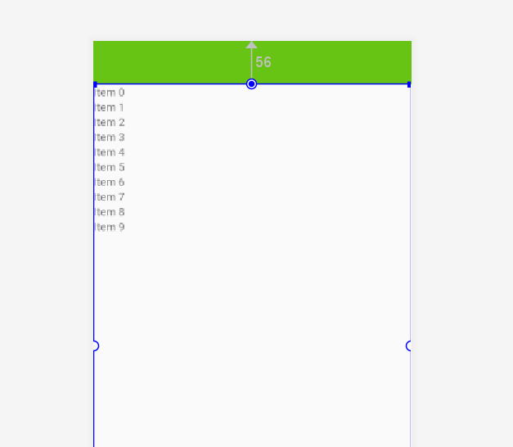
* Call it my_all_post_list for it id
* 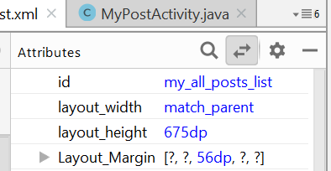
* Now go to the MyPostActivity.java
* Declare this
* **private** RecyclerView **myPostList**;  
  **private** FirebaseAuth **mAuth**;  
  **private** DatabaseReference **PostsRef**;  
  **private** String **currentUserID**;
* add this in the onCreate()
* **myPostList** = (RecyclerView) findViewById(R.id.***my_all_posts_list***);  
  **myPostList**.setHasFixedSize(**true**);  
  LinearLayoutManager linearLayoutManager = **new** LinearLayoutManager(**this**);  
  linearLayoutManager.setReverseLayout(**true**);  
  linearLayoutManager.setStackFromEnd(**true**);  
  **myPostList**.setLayoutManager(linearLayoutManager);  
    
  DisplayMyAllPosts();
* 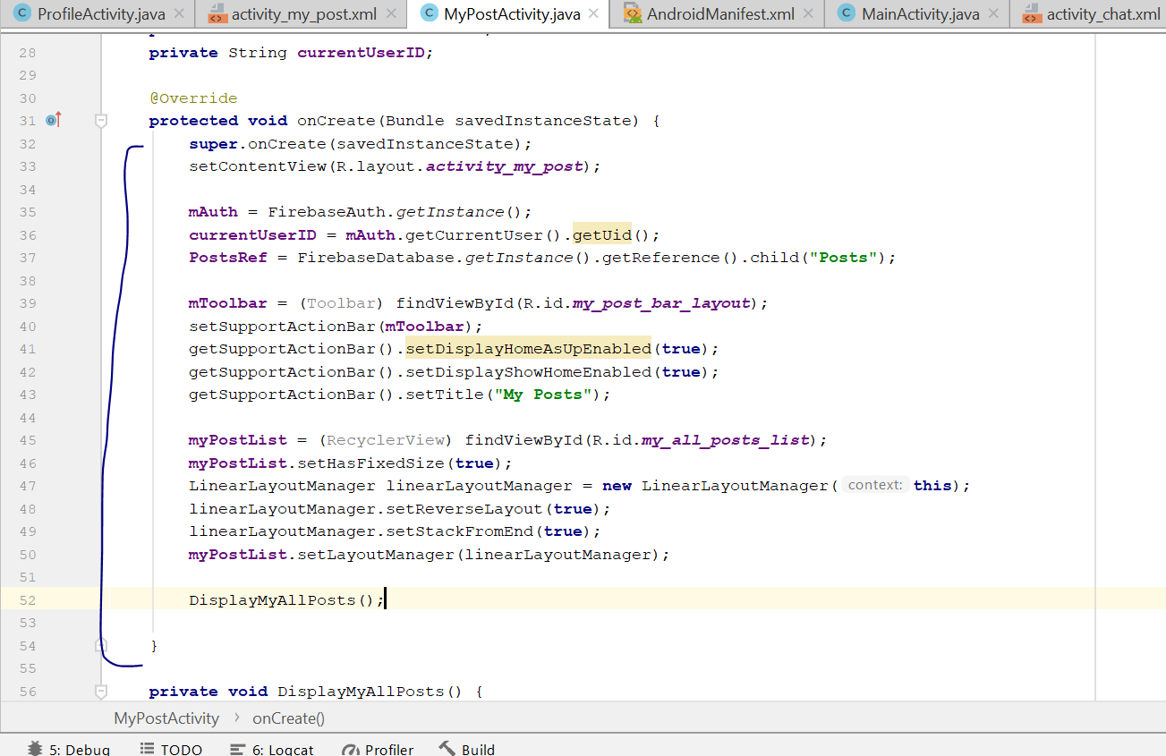
* then add this method in the class
* **private void** DisplayMyAllPosts() {  
    
   Query myPostsQuery = **PostsRef**.orderByChild(**"uid"**)  
   .startAt(**currentUserID**);  
   FirebaseRecyclerAdapter<Posts, MyPostsViewHolder> firebaseRecyclerAdapter  
   = **new** FirebaseRecyclerAdapter<Posts, MyPostsViewHolder>(  
   Posts.**class**,  
   R.layout.***all_post_layout***,  
   MyPostsViewHolder.**class**,  
   myPostsQuery  
    
   ) {  
   @Override  
   **protected void** populateViewHolder(MyPostsViewHolder viewHolder, Posts model, **int** position) {  
   viewHolder.setFullname(model.getFullname());  
   viewHolder.setTime(model.getTime());  
   viewHolder.setDate(model.getDate());  
   viewHolder.setDescription(model.getDescription());  
   viewHolder.setProfileimage(getApplicationContext(), model.getProfileimage());  
   viewHolder.setPostimage(getApplicationContext(), model.getPostimage());  
   }  
   };  
    
   **myPostList**.setAdapter(firebaseRecyclerAdapter);  
  }
* **public static class** MyPostsViewHolder **extends** RecyclerView.ViewHolder  
  {  
    
   View **mView**;  
   **public** MyPostsViewHolder(View itemView)  
   {  
   **super**(itemView);  
   **mView** = itemView;  
    
   }  
    
   **public void** setFullname(String fullname)  
   {  
   TextView username = (TextView) **mView**.findViewById(R.id.***post_user_name***);  
   username.setText(fullname);  
   }  
   **public void** setProfileimage(Context ctx, String profileimage)  
   {  
   CircleImageView image = (CircleImageView) **mView**.findViewById(R.id.***post_profile_image***);  
   Picasso.*get*().load(profileimage).into(image);  
   }  
   **public void** setTime(String time)  
   {  
   TextView PostTime = (TextView) **mView**.findViewById(R.id.***post_time***);  
   PostTime.setText(**" "** +time);  
   }  
   **public void** setDate(String date)  
   {  
   TextView PostDate = (TextView) **mView**.findViewById(R.id.***post_date***);  
   PostDate.setText(**" "**+date);  
   }  
   **public void** setDescription(String description)  
   {  
   TextView PostDescription = (TextView) **mView**.findViewById(R.id.***post_description***);  
   PostDescription.setText(description);  
   }  
   **public void** setPostimage(Context ctx,String postimage)  
   {  
   ImageView PostImage = (ImageView) **mView**.findViewById(R.id.***post_image***);  
   Picasso.*get*().load(postimage).into(PostImage);  
   }
* Rebuild and Run, now when u click on the number of post, you will see the post that the user post
* Now add this line on the top, in MyPostActivity.java
* **private** DatabaseReference **UsersRef**,**LikesRef**;
* 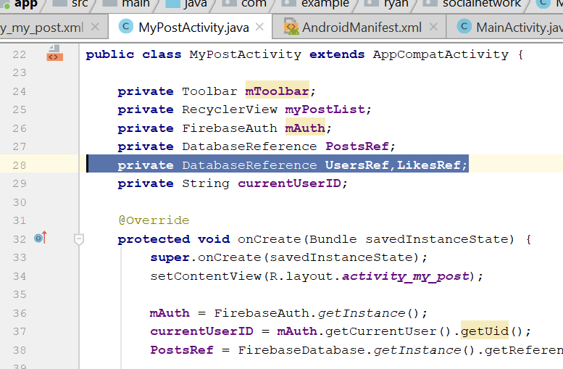
* Then add this
* Boolean **LikeChecker** = **false**;
* 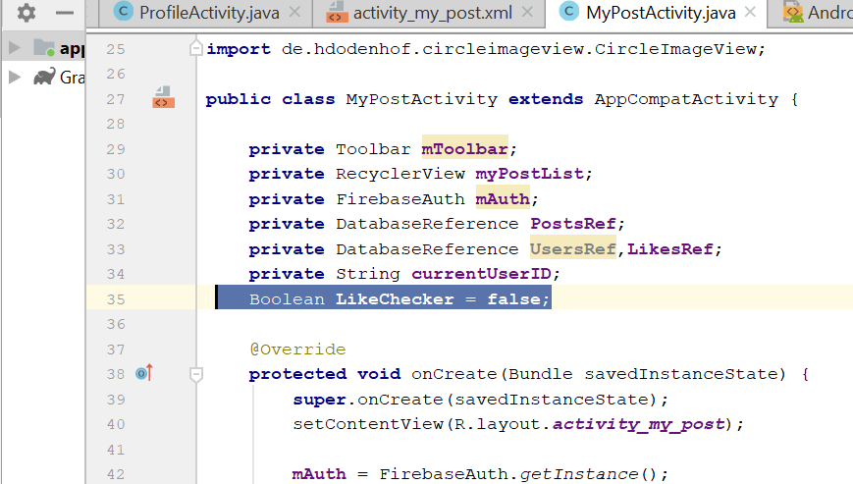
* In the onCreate(), add this
* **UsersRef** = FirebaseDatabase.*getInstance*().getReference().child(**"Users"**);  
  **LikesRef** = FirebaseDatabase.*getInstance*().getReference().child(**"Likes"**);
* Now go to the method, populateViewHolder
* Add the following code
* **final** String PostKey = getRef(position).getKey();
* viewHolder.setLikeButtonStatus(PostKey);  
    
    
  viewHolder.**mView**.setOnClickListener(**new** View.OnClickListener() {  
   @Override  
   **public void** onClick(View v) {  
   Intent clickPostIntent = **new** Intent(MyPostActivity.**this**, ClickPostActivity.**class**);  
   clickPostIntent.putExtra(**"PostKey"**,PostKey);  
   startActivity(clickPostIntent);  
   }  
  });  
    
  viewHolder.**CommentPostButton**.setOnClickListener(**new** View.OnClickListener() {  
   @Override  
   **public void** onClick(View v) {  
   Intent commentsIntent = **new** Intent(MyPostActivity.**this**, CommentActivity.**class**);  
   commentsIntent.putExtra(**"PostKey"**,PostKey);  
   startActivity(commentsIntent);  
   }  
  });  
    
  viewHolder.**LikePostButton**.setOnClickListener(**new** View.OnClickListener() {  
   @Override  
   **public void** onClick(View v) {  
   **LikeChecker** = **true**;  
   **LikesRef**.addValueEventListener(**new** ValueEventListener() {  
   @Override  
   **public void** onDataChange(DataSnapshot dataSnapshot) {  
   **if**(**LikeChecker**.equals(**true**))  
   {  
   **if**(dataSnapshot.child(PostKey).hasChild(**currentUserID**))  
   {  
   **LikesRef**.child(PostKey).child(**currentUserID**).removeValue();  
   **LikeChecker** = **false**;  
   }  
   **else** {  
   **LikesRef**.child(PostKey).child(**currentUserID**).setValue(**true**);  
   **LikeChecker** = **false**;  
   }  
   }  
   }  
    
   @Override  
   **public void** onCancelled(DatabaseError databaseError) {  
    
   }  
   });  
   }  
  });
* 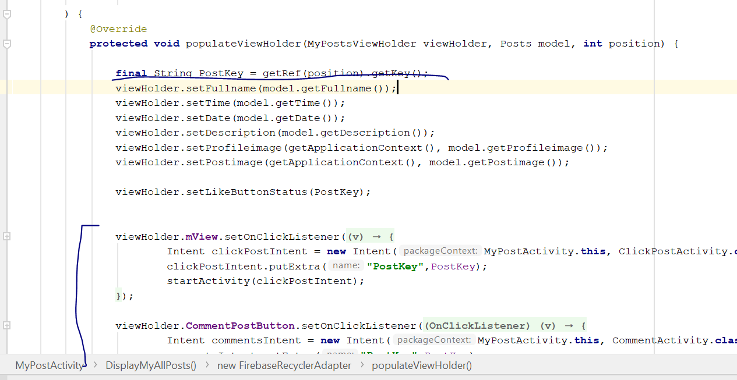
* Now go to MyPostsViewHolder method
* Add this line
* ImageButton **LikePostButton**, **CommentPostButton**;  
  TextView **DisplayNoOfLikes**;  
  **int countLikes**;  
  String **currentUserId**;  
  DatabaseReference **LikesRef**;
* In the MyPostsViewHolder, add in the constructor
* **LikePostButton** = (ImageButton)**mView**.findViewById(R.id.***like_button***);  
  **CommentPostButton** = (ImageButton)**mView**.findViewById(R.id.***comment_button***);  
  **DisplayNoOfLikes** = (TextView)**mView**.findViewById(R.id.***display_no_of_likes***);  
    
  **LikesRef** = FirebaseDatabase.*getInstance*().getReference().child(**"Likes"**);  
  **currentUserId** = FirebaseAuth.*getInstance*().getCurrentUser().getUid();
* 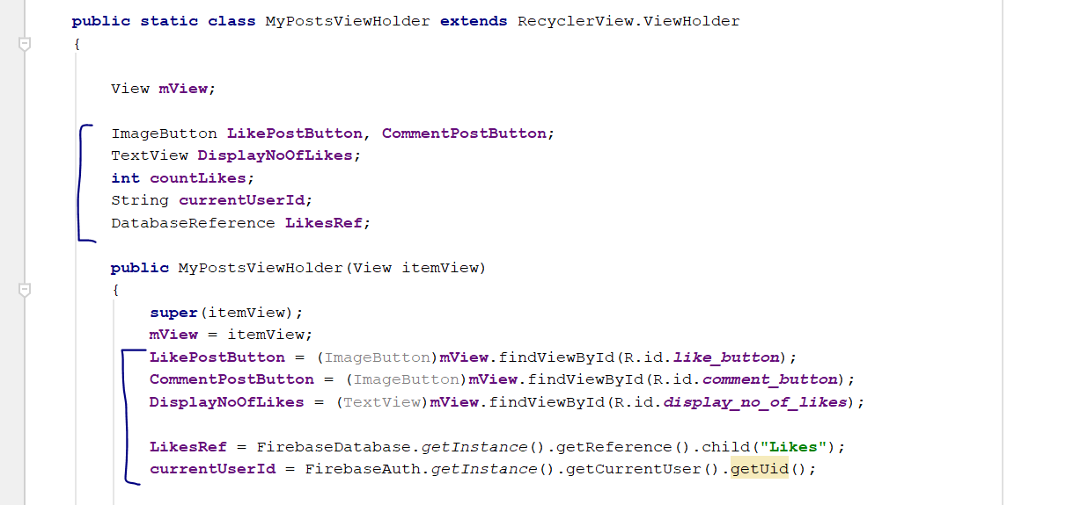
* Add this new code after the constructor
* **public void** setLikeButtonStatus(**final** String PostKey)  
  {  
   **LikesRef**.addValueEventListener(**new** ValueEventListener() {  
   @Override  
   **public void** onDataChange(DataSnapshot dataSnapshot) {  
   **if**(dataSnapshot.child(PostKey).hasChild(**currentUserId**))  
   {  
   **countLikes** = (**int**) dataSnapshot.child(PostKey).getChildrenCount();  
   **LikePostButton**.setImageResource(R.drawable.***like***);  
   **DisplayNoOfLikes**.setText(Integer.*toString*(**countLikes**)+ **" Likes"**);  
   }  
   **else** {  
   **countLikes** = (**int**) dataSnapshot.child(PostKey).getChildrenCount();  
   **LikePostButton**.setImageResource(R.drawable.***dislike***);  
   **DisplayNoOfLikes**.setText(Integer.*toString*(**countLikes**)+**" Likes"**);  
   }  
   }  
    
   @Override  
   **public void** onCancelled(DatabaseError databaseError) {  
    
   }  
   });  
  }
* 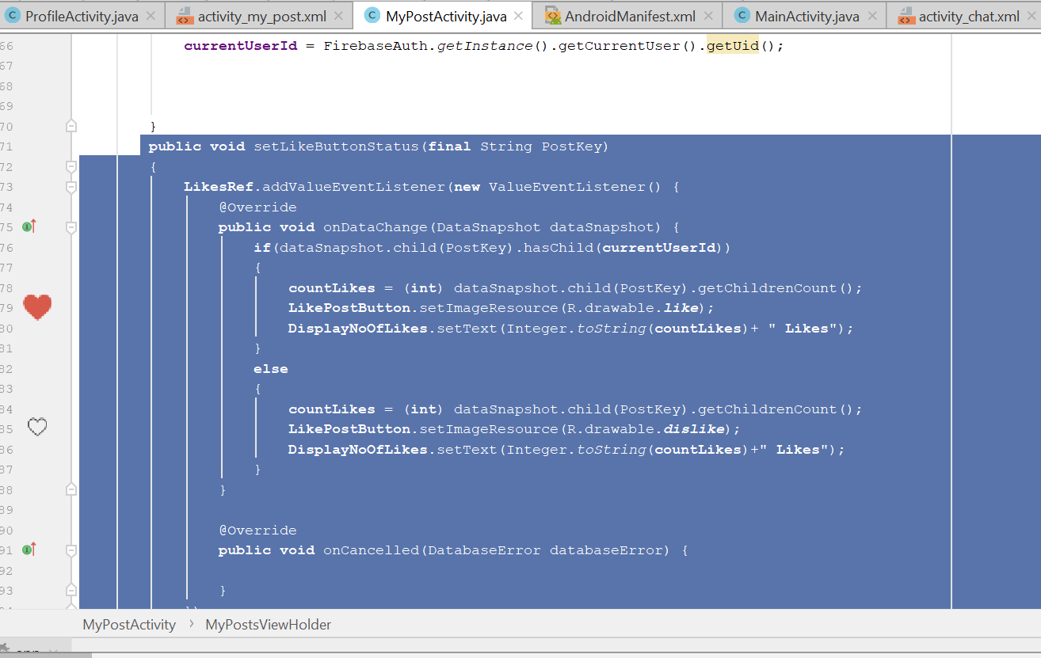
* Rebuild and run, now the like and comment should be able to work when u click on the number of post.

# Email verification

* Go to Login Activity
* Declare this variable
* **private** Boolean **emailAddressChecker**;
* 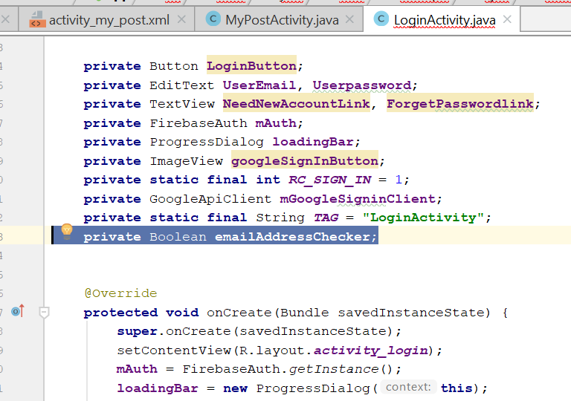
* Remove this two line
* 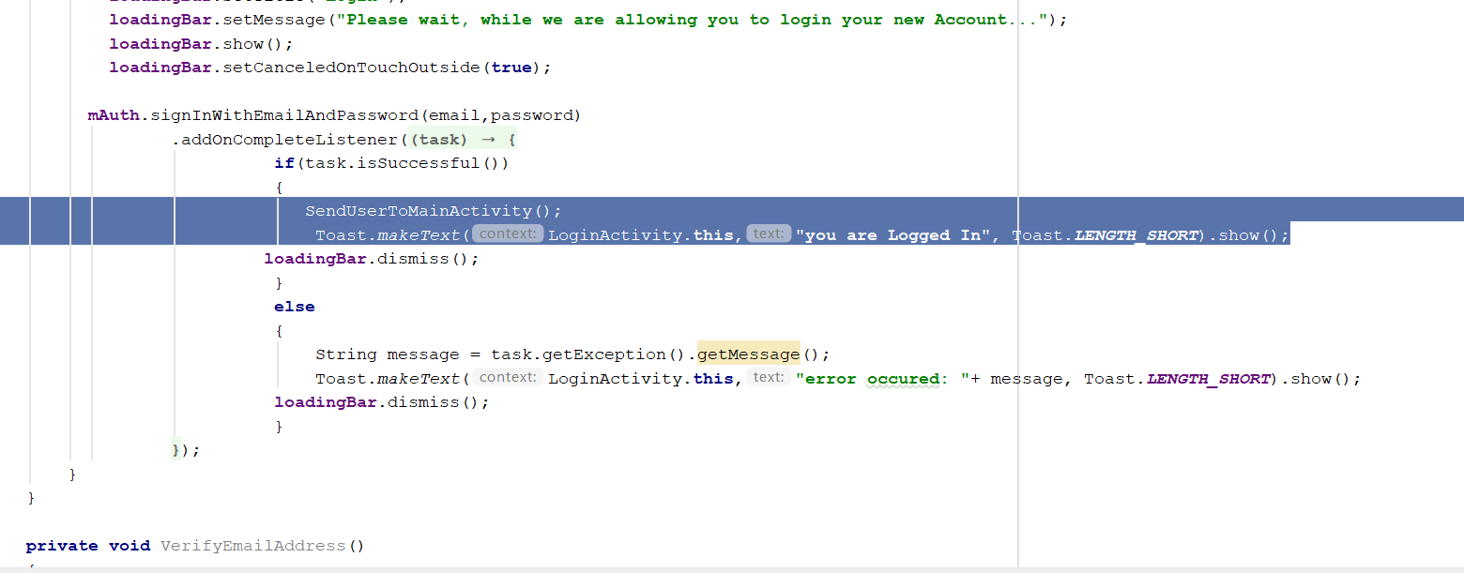
* Add a new method below
* **private void** VerifyEmailAddress()  
  {  
   FirebaseUser user = **mAuth**.getCurrentUser();  
   **emailAddressChecker** = user.isEmailVerified();  
   **if**(**emailAddressChecker**)  
   {  
   SendUserToMainActivity();  
     
   }  
   **else** {  
   Toast.*makeText*(**this**,**"Please verify your address first..."**, Toast.***LENGTH_SHORT***);  
   **mAuth**.signOut();  
   }  
  }
* 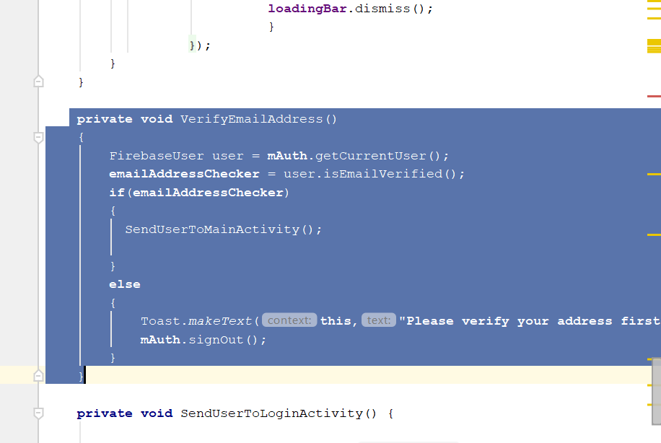
* Now go to the registration activity
* First of all, go to firebase website
* Go to authentication> template
* 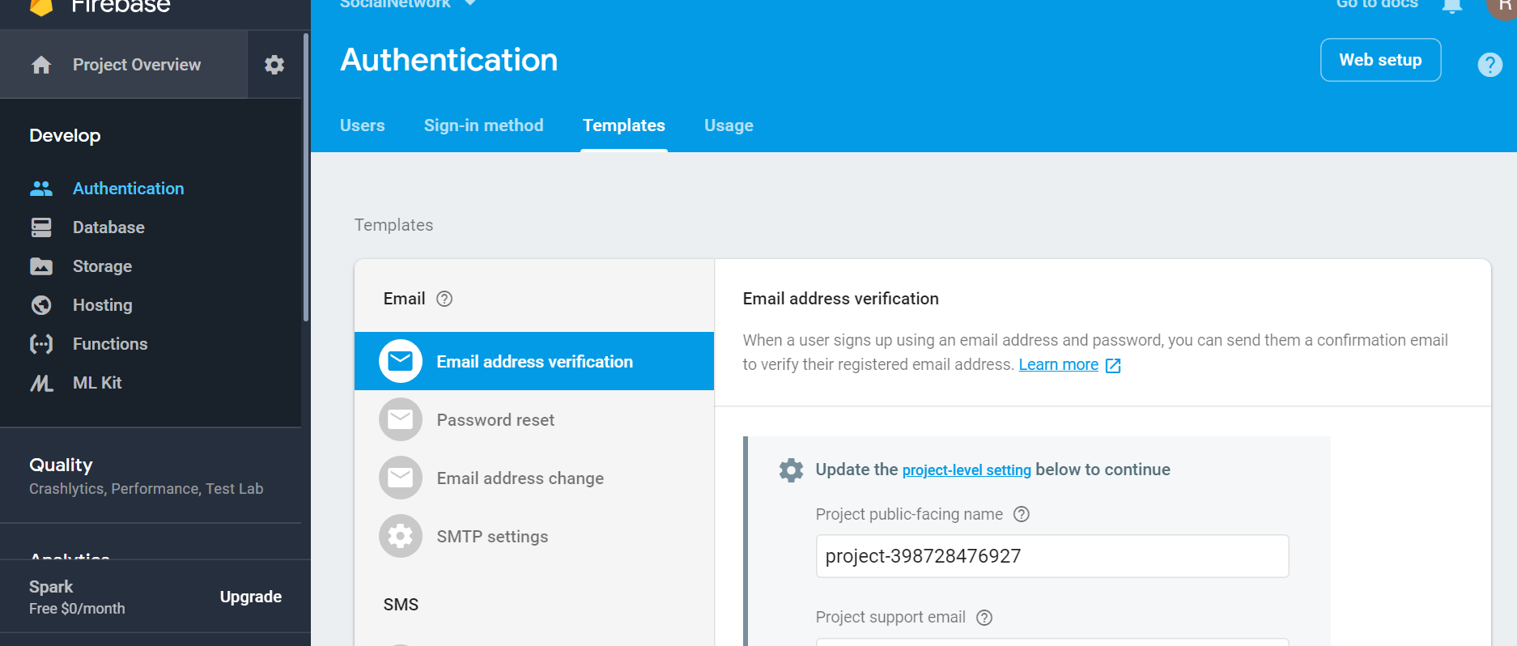
* Change the project name, to whoever you want to display when people receive your email
* Into something like that
* 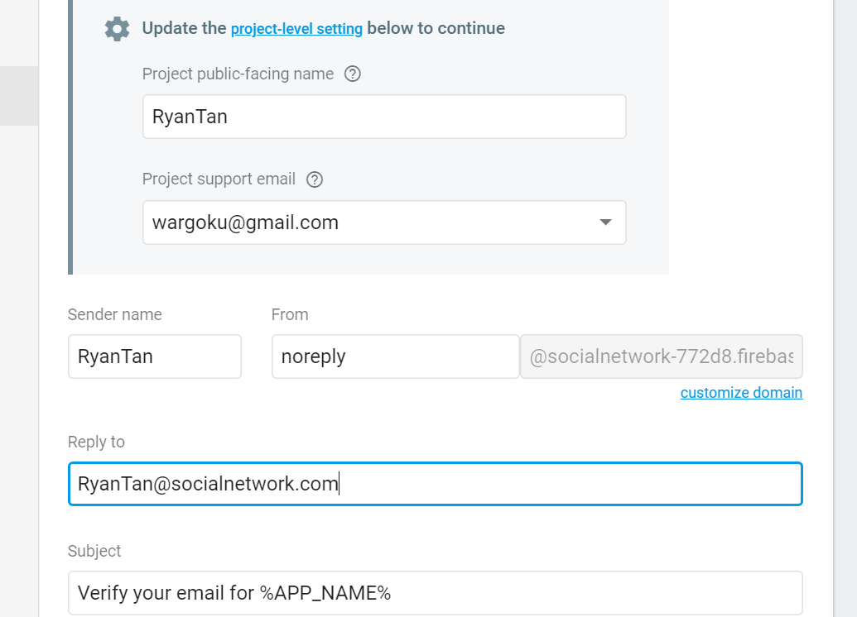
* Now go to registerActivity.java
* Remove this two line
* 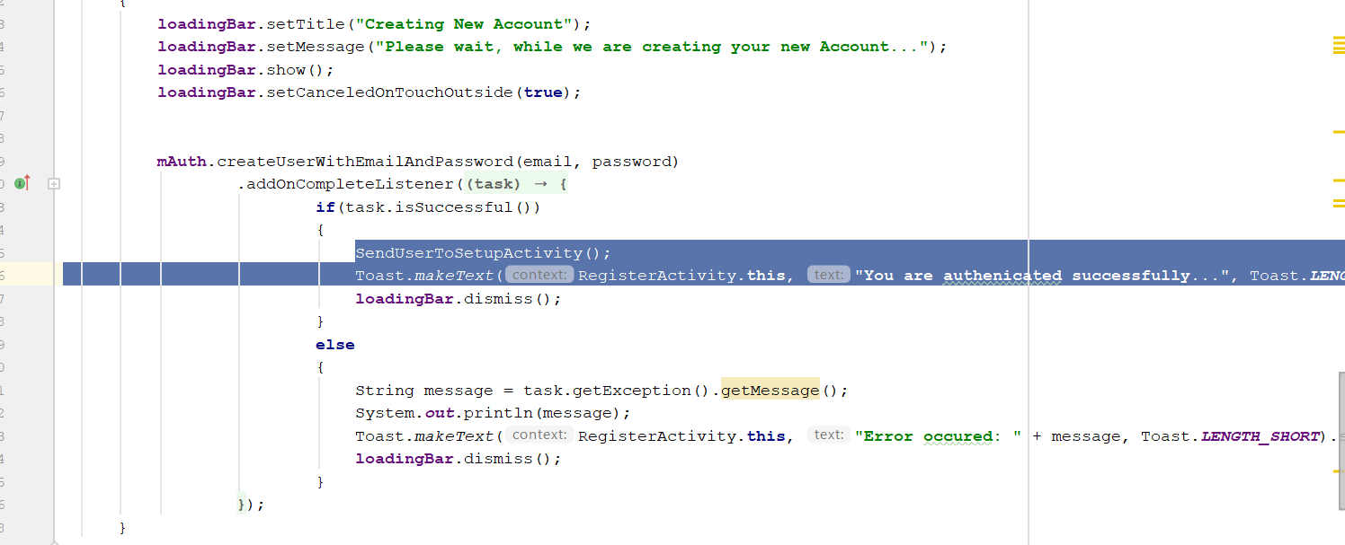
* Replace it with
* SendEmailVerificationMessage
* 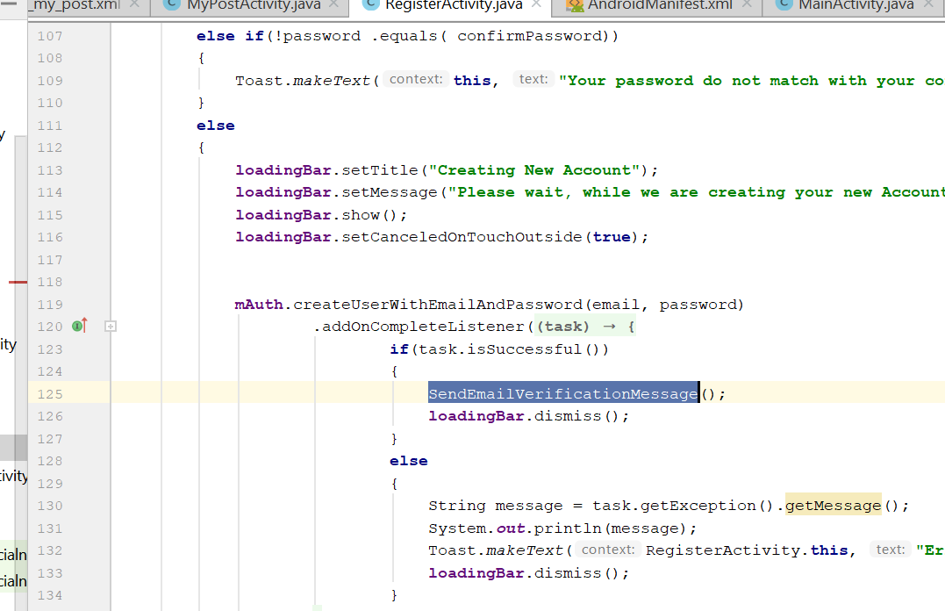
* Create a new method
* **private void** SendUserToLoginActivity() {  
   Intent LoginIntent = **new** Intent(RegisterActivity.**this**,LoginActivity.**class**);  
   LoginIntent.addFlags(Intent.***FLAG_ACTIVITY_NEW_TASK***|Intent.***FLAG_ACTIVITY_CLEAR_TASK***);  
   startActivity(LoginIntent);  
   finish();  
  }
* Then create this method
* **private void** SendEmailVerificationMessage()  
  {  
   FirebaseUser user = **mAuth**.getCurrentUser();  
   **if**(user != **null**)  
   {  
   user.sendEmailVerification().addOnCompleteListener(**new** OnCompleteListener<Void>() {  
   @Override  
   **public void** onComplete(@NonNull Task<Void> task) {  
   **if**(task.isSuccessful())  
   {  
   Toast.*makeText*(RegisterActivity.**this**, **"Registration Successful, We have send you a mail "**, Toast.***LENGTH_SHORT***).show();  
   SendUserToLoginActivity();  
   **mAuth**.signOut();  
    
   }  
   **else** {  
   String error = task.getException().getMessage();  
   Toast.*makeText*(RegisterActivity.**this**, **"Error: "**+ error, Toast.***LENGTH_SHORT***).show();  
   **mAuth**.signOut();  
   }  
   }  
   });  
   }  
  }
* Rebuild and run
* Now when u login they will ask u verify the email

# Online and Offline status, last seen

* First go to MainActivity.java
* Add this method

**public void** updateUserStatus(String state)  
{  
 String saveCurrentDate, saveCurrentTime;  
 Calendar calForDate = Calendar.*getInstance*();  
 SimpleDateFormat currentDate = **new** SimpleDateFormat(**"MMM dd, yyyy"**);  
 saveCurrentDate = currentDate.format(calForDate.getTime());  
  
 Calendar calForTime = Calendar.*getInstance*();  
 SimpleDateFormat currentTime = **new** SimpleDateFormat(**"hh:mm a"**);  
 saveCurrentTime = currentTime.format(calForTime.getTime());  
  
 Map currentStateMap = **new** HashMap();  
currentStateMap.put(**"time"**, saveCurrentTime);  
currentStateMap.put(**"date"**, saveCurrentDate);  
currentStateMap.put(**"type"**, state);

* **UsersRef**.child(**currentUserID**).child(**"userState"**)  
   .updateChildren(currentStateMap);  
    
    
  }
* 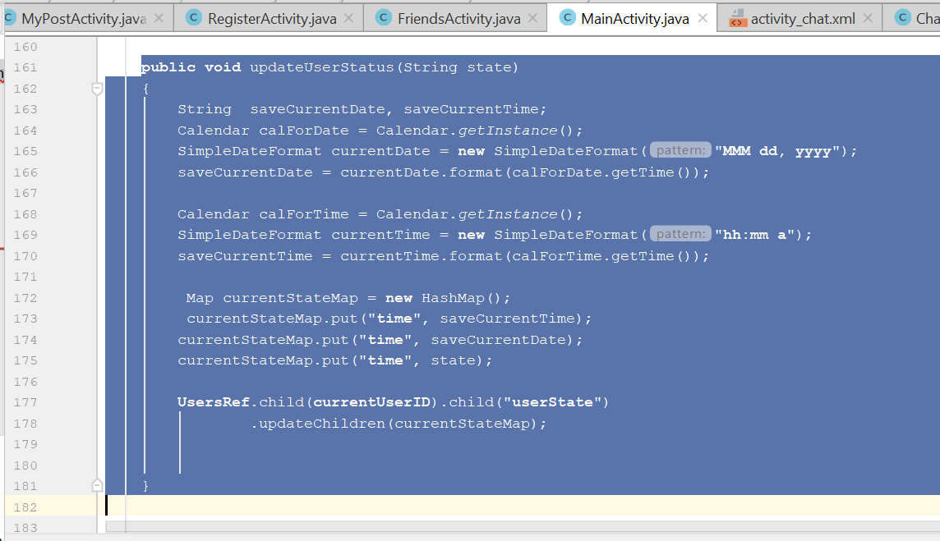
* Now go to displayAllUserpost(), add this line
* updateUserStatus(**"online"**);
* 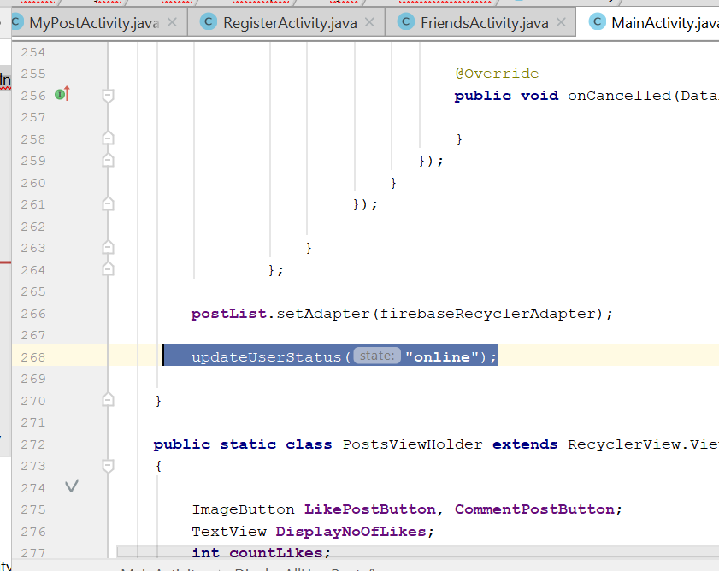
* Now go to private void UserMenuSelector(MenuItem item)
* Add this line
* updateUserStatus(**"offline"**);
* 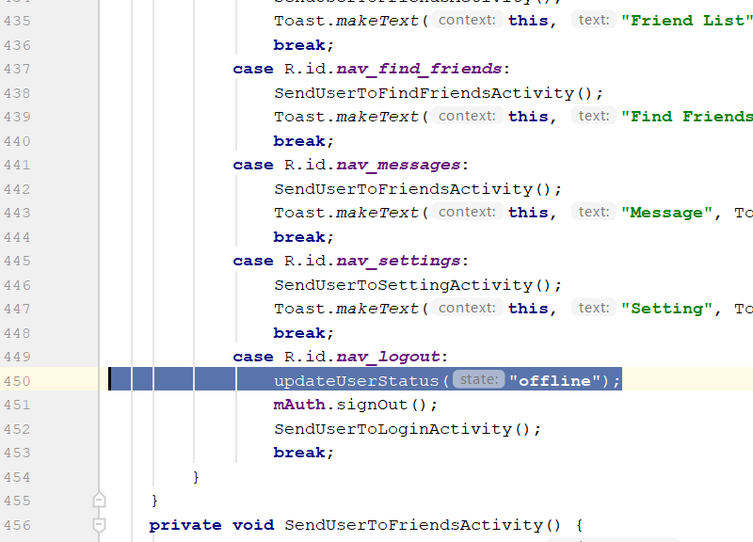
* Now go to FriendsActivity
* Add this

**public void** updateUserStatus(String state)  
{  
 String saveCurrentDate, saveCurrentTime;  
 Calendar calForDate = Calendar.*getInstance*();  
 SimpleDateFormat currentDate = **new** SimpleDateFormat(**"MMM dd, yyyy"**);  
 saveCurrentDate = currentDate.format(calForDate.getTime());  
  
 Calendar calForTime = Calendar.*getInstance*();  
 SimpleDateFormat currentTime = **new** SimpleDateFormat(**"hh:mm a"**);  
 saveCurrentTime = currentTime.format(calForTime.getTime());  
  
 Map currentStateMap = **new** HashMap();  
currentStateMap.put(**"time"**, saveCurrentTime);  
currentStateMap.put(**"date"**, saveCurrentDate);  
currentStateMap.put(**"type"**, state);

* **UsersRef**.child(**online_user_id**).child(**"userState"**)  
   .updateChildren(currentStateMap);  
    
    
  }
* 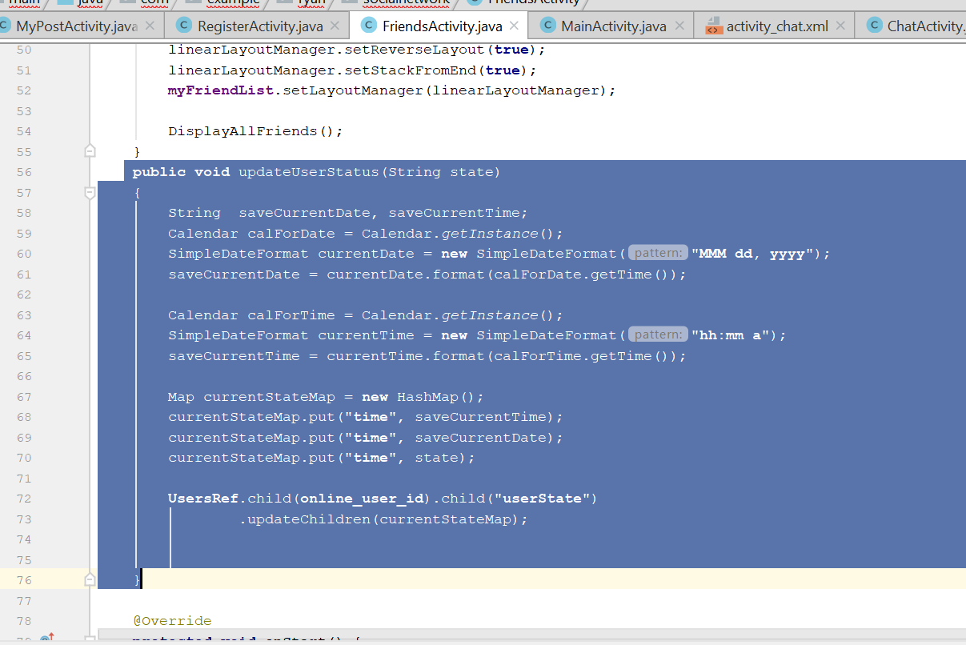
* Add this code below
* @Override  
  **protected void** onStart() {  
   **super**.onStart();  
   updateUserStatus(**"online"**);  
  }  
    
  @Override  
  **protected void** onStop() {  
   **super**.onStop();  
   updateUserStatus(**"offline"**);  
  }  
    
  @Override  
  **protected void** onDestroy() {  
   **super**.onDestroy();  
   updateUserStatus(**"offline"**);  
  }
* 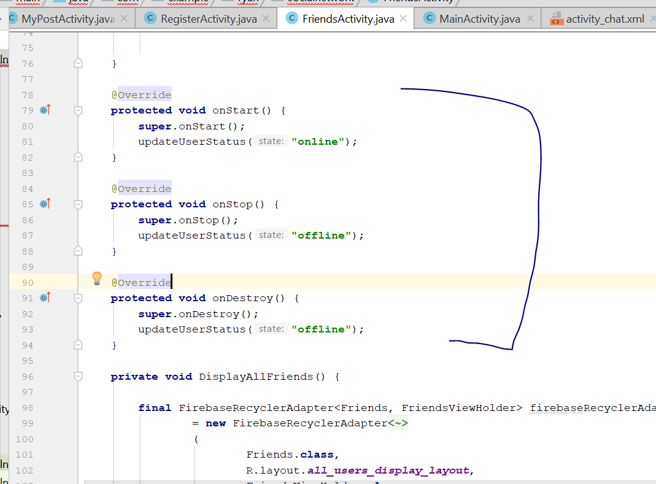
* Rebuild and run, when u sign in, you shld be able to see the status change in firebase
* 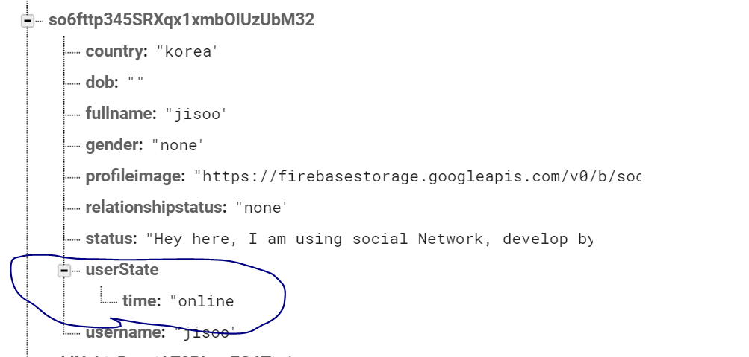
* Now go to chat custom bar
* Change the custom_profile_name properties
* **android:layout_marginTop="4dp"**
* 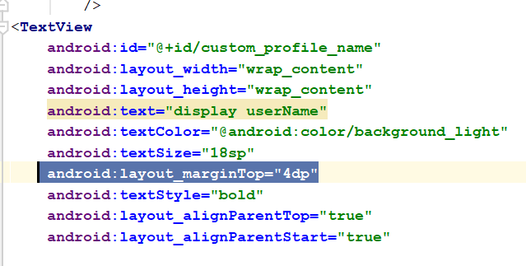
* Add this below
* <**TextView  
   android:id="@+id/custom_user_last_seen"  
   android:layout_width="wrap_content"  
   android:layout_height="wrap_content"  
   android:layout_below="@id/custom_profile_name"  
   android:text="last seen"  
   android:textColor="@android:color/background_light"  
   android:textSize="16sp"  
   android:layout_marginTop="25dp"  
   android:layout_alignParentTop="true"  
   android:layout_alignParentStart="true"** />
* 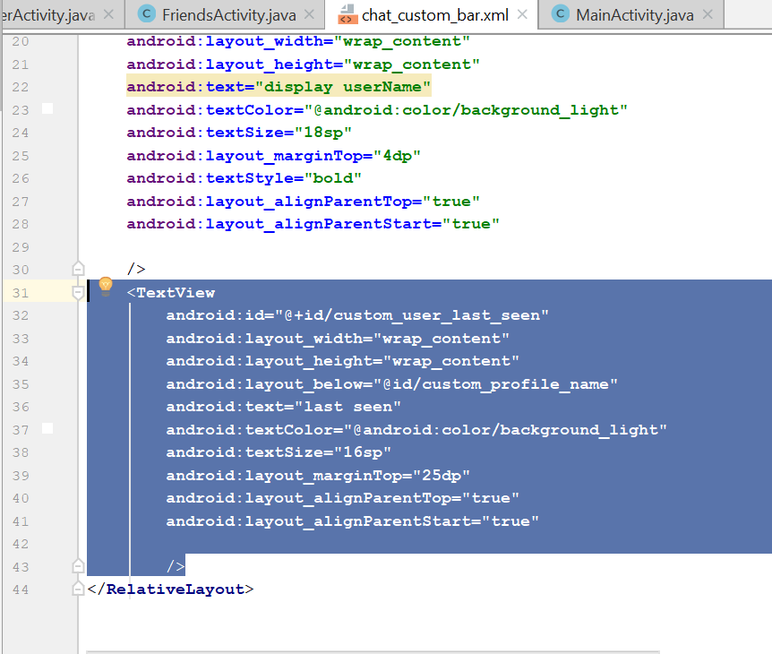
* Change the width and height to 50dp of the circleImageview
* 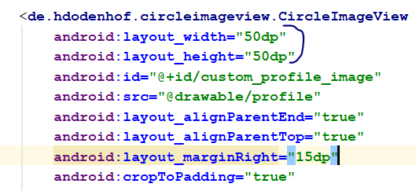
* Now shld look like this
* 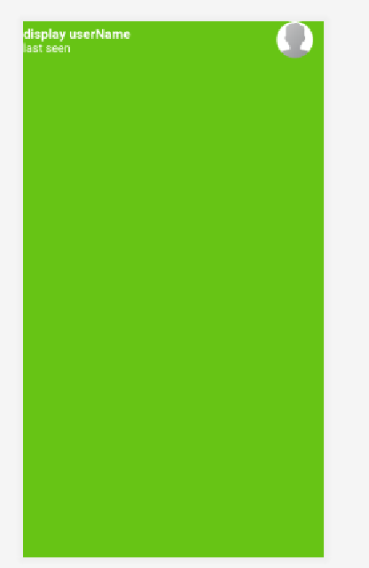
* Now go to the chatactivity.java
* Declare this variable
* **private** TextView **userLastSeen**;
* **private** DatabaseReference **RootRef**, **UserRef**;
* in the onCreate(), add this
* **UserRef** = FirebaseDatabase.*getInstance*().getReference().child(**"Users"**);
* 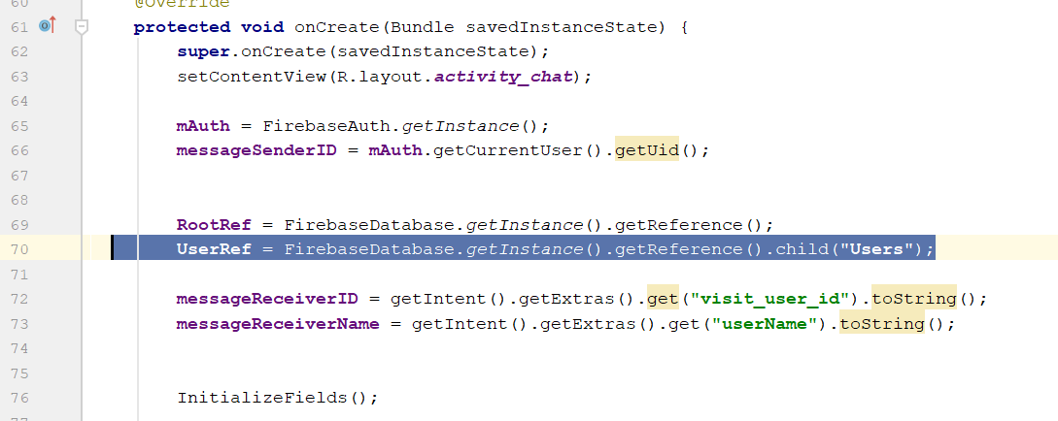
* Go to InitializeFields()
* Add this line
* **userLastSeen** = (TextView) findViewById(R.id.***custom_user_last_seen***);
* In the displayReceiverInfo()
* Add this
* **if**(dataSnapshot.exists()) {  
   **final** String profileImage = dataSnapshot.child(**"profileimage"**).getValue().toString();  
   **final** String type = dataSnapshot.child(**"userState"**).child(**"type"**).getValue().toString();  
   **final** String lastDate = dataSnapshot.child(**"userState"**).child(**"date"**).getValue().toString();  
   **final** String lastTime = dataSnapshot.child(**"userState"**).child(**"time"**).getValue().toString();  
    
    
   **if** (type.equals(**"online"**)) {  
   **userLastSeen**.setText(**"online"**);  
   } **else** {  
   **userLastSeen**.setText(**"last seen: "** + lastTime + **" "** + lastDate);  
   }  
   Picasso.*get*().load(profileImage).placeholder(R.drawable.***profile***).into(**receiverProfileImage**);  
  }
* 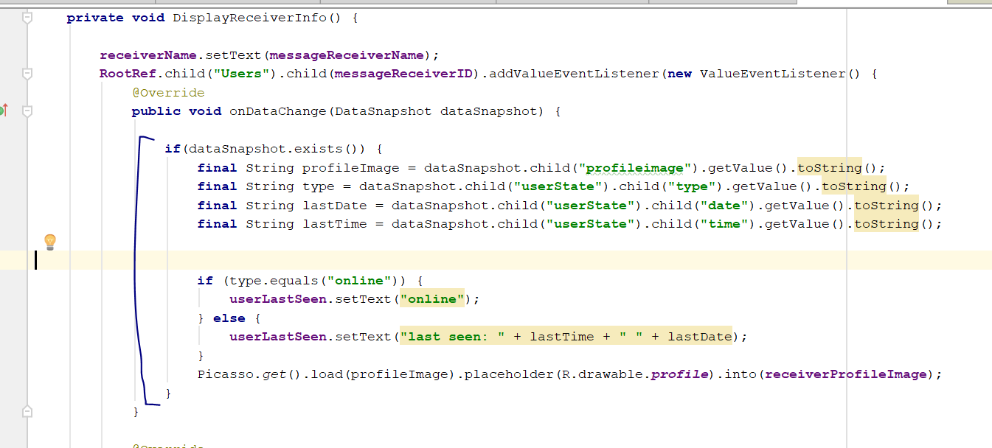
* Then u add this method
* **public void** updateUserStatus(String state)  
  {  
   String saveCurrentDate, saveCurrentTime;  
   Calendar calForDate = Calendar.*getInstance*();  
   SimpleDateFormat currentDate = **new** SimpleDateFormat(**"MMM dd, yyyy"**);  
   saveCurrentDate = currentDate.format(calForDate.getTime());  
    
   Calendar calForTime = Calendar.*getInstance*();  
   SimpleDateFormat currentTime = **new** SimpleDateFormat(**"hh:mm a"**);  
   saveCurrentTime = currentTime.format(calForTime.getTime());  
    
   Map currentStateMap = **new** HashMap();  
   currentStateMap.put(**"time"**, saveCurrentTime);  
   currentStateMap.put(**"date"**, saveCurrentDate);  
   currentStateMap.put(**"type"**, state);  
    
   **UserRef**.child(**messageSenderID**).child(**"userState"**)  
   .updateChildren(currentStateMap);  
    
    
  }
* 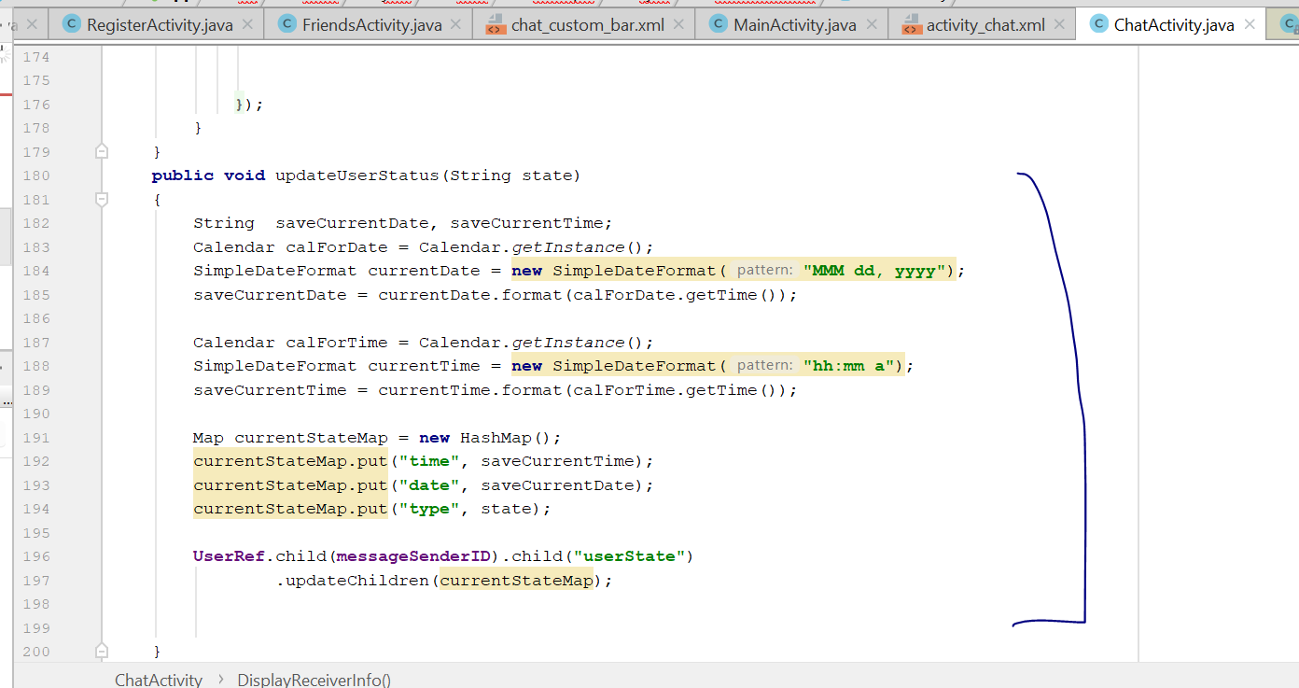
* Go the sendMessage, add this line
* updateUserStatus(**"online"**);
* 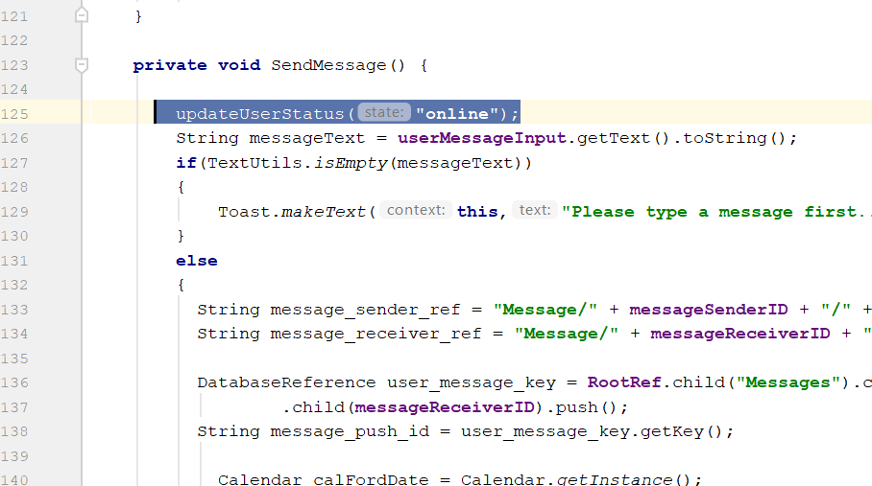
* Rebuild and run, now if you send message, u will see the receiver online status and last seen, if you test with two phone
* Now go all_user_display_layout.xml file
* 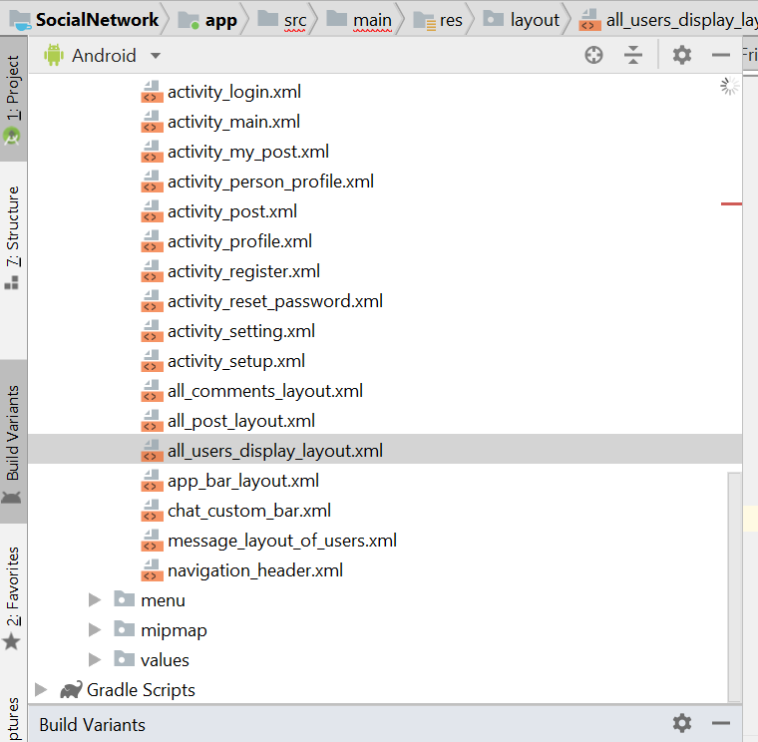
* Change the whole XML to this code
* *<?***xml version="1.0" encoding="utf-8"***?>*<**LinearLayout  
   xmlns:android="http://schemas.android.com/apk/res/android"  
   android:layout_width="match_parent"  
   android:layout_height="wrap_content"  
   android:layout_margin="10dp"  
   android:background="@color/colorProfile"** >  
   <**de.hdodenhof.circleimageview.CircleImageView  
   android:id="@+id/all_user_profile_image"  
   android:layout_width="85dp"  
   android:layout_height="85dp"  
   android:layout_marginLeft="10dp"  
   android:src="@drawable/profile"**/>  
    
   <**LinearLayout  
   android:layout_width="match_parent"  
   android:layout_height="wrap_content"  
   android:orientation="vertical"**>  
   <**LinearLayout  
   android:layout_width="match_parent"  
   android:layout_height="wrap_content"  
   android:orientation="horizontal"  
   android:layout_margin="5dp"** >  
   <**TextView  
   android:id="@+id/all_user_profile_full_name"  
   android:layout_width="190dp"  
   android:layout_height="wrap_content"  
   android:text="user full name"  
   android:textAlignment="textStart"  
   android:textColor="@android:color/background_light"  
   android:textSize="18sp"  
   android:textStyle="bold"** />  
   <**ImageView  
   android:id="@+id/all_user_online_icon"  
   android:layout_width="20dp"  
   android:layout_height="20dp"  
   android:src="@drawable/online"  
   android:visibility="invisible"** />  
    
    
   </**LinearLayout**>  
   <**TextView  
   android:id="@+id/all_user_status"  
   android:layout_width="match_parent"  
   android:layout_height="wrap_content"  
   android:text="status"  
   android:textAlignment="textStart"  
   android:textColor="@android:color/background_light"  
   android:textSize="16sp"** />  
    
   </**LinearLayout**>  
    
  </**LinearLayout**>
* Download online.png from this link and copy to the drawable folder
* <https://drive.google.com/drive/folders/1SS8plszKPkyiR5CfeKufhUrCSVl_z5pY>
* Now go to FriendsActivity.java
* Go to class FriendsViewHolder
* Add this
* ImageView **onlineStatusView**;
* **mView** = itemView;
* **onlineStatusView** = (ImageView) itemView.findViewById(R.id.***all_user_online_icon***);
* add those here
* 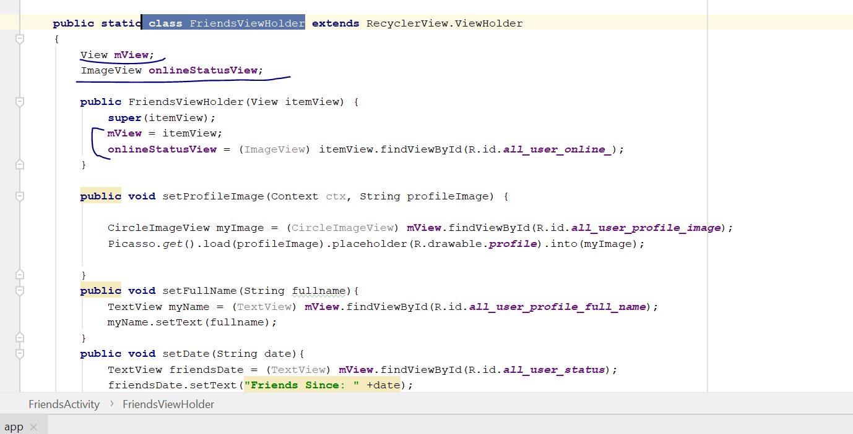
* Now go to DisplayAllFriends()
* Add this
* **if**(dataSnapshot.exists())  
  {  
   **final** String userName = dataSnapshot.child(**"fullname"**).getValue().toString();  
   **final** String profileImage = dataSnapshot.child(**"profileimage"**).getValue().toString();  
    
    
   **final** String type;  
   **if**(dataSnapshot.hasChild(**"userState"**))  
   {  
   type = dataSnapshot.child(**"userState"**).child(**"type"**).getValue().toString();  
   **if**(type.equals(**"online"**))  
   {  
   viewHolder.**onlineStatusView**.setVisibility(View.***VISIBLE***);  
    
   }  
   **else** {  
   viewHolder.**onlineStatusView**.setVisibility(View.***INVISIBLE***);  
   }  
   }
* add this here
* 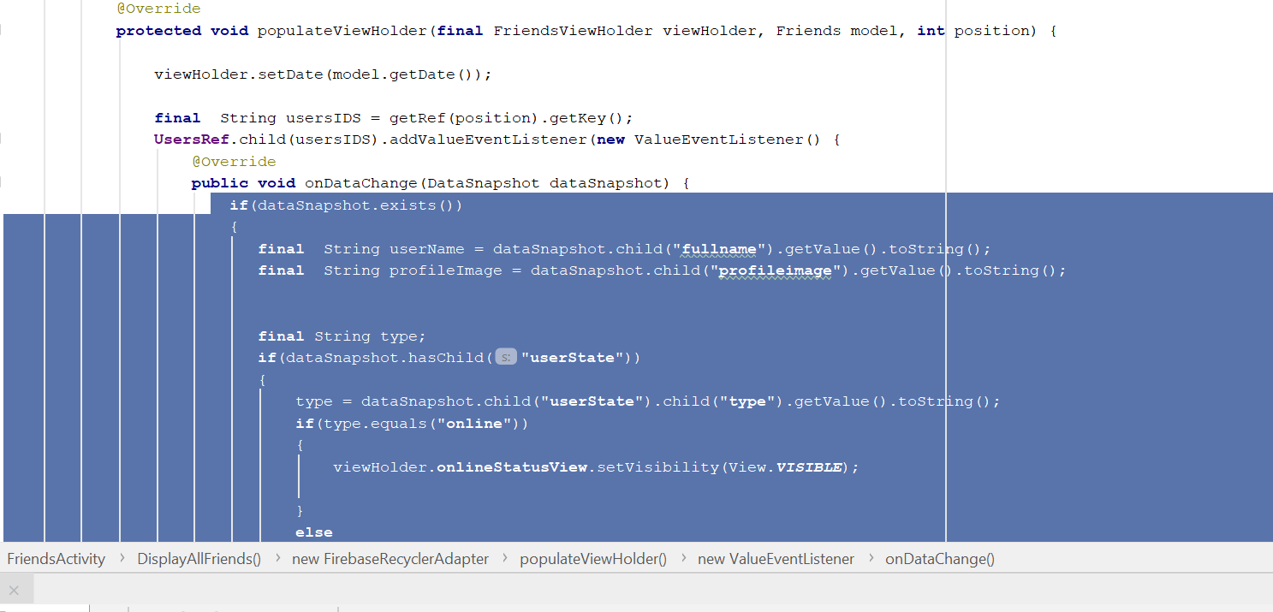
* Rebuild and run, now if u use two devices, login to two different account, you will see the online and offline status of the friends
* This is when they are offline
* 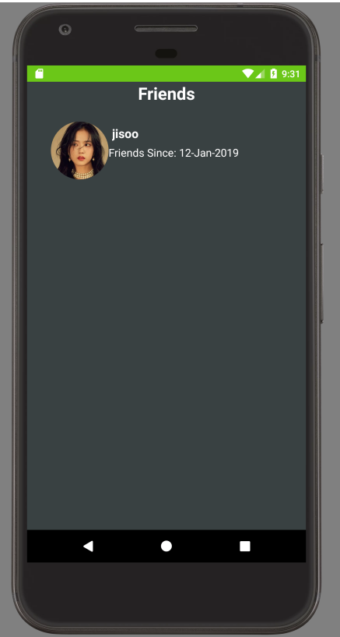
* This is when they are online
* 